|  |  |
| --- | --- |
| Name: | EE-272L Digital Systems Design |
| Reg. No.: | Marks Obtained: ____________ |

**Lab Manual 4b**

**Combinational Logic Design on Seven Segment**

**Task1(Truth Table for Displaying Number):**

|  |  |  |  |  |  |  |  |  |  |  |
| --- | --- | --- | --- | --- | --- | --- | --- | --- | --- | --- |
| **Num3** | **Num2** | **Num1** | **Num0** | **A** | **B** | **C** | **D** | **E** | **F** | **G** |
| 0 | 0 | 0 | 0 | 0 | 0 | 0 | 0 | 0 | 0 | 1 |
| 0 | 0 | 0 | 1 | 1 | 0 | 0 | 1 | 1 | 1 | 1 |
| 0 | 0 | 1 | 0 | 0 | 0 | 1 | 0 | 0 | 1 | 0 |
| 0 | 0 | 1 | 1 | 0 | 0 | 0 | 0 | 1 | 1 | 0 |
| 0 | 1 | 0 | 0 | 1 | 0 | 0 | 1 | 1 | 0 | 0 |
| 0 | 1 | 0 | 1 | 0 | 1 | 0 | 0 | 1 | 0 | 0 |
| 0 | 1 | 1 | 0 | 0 | 1 | 0 | 0 | 0 | 0 | 0 |
| 0 | 1 | 1 | 1 | 0 | 0 | 0 | 1 | 1 | 1 | 1 |
| 1 | 0 | 0 | 0 | 0 | 0 | 0 | 0 | 0 | 0 | 0 |
| 1 | 0 | 0 | 1 | 0 | 0 | 0 | 0 | 1 | 0 | 0 |
| 1 | 0 | 1 | 0 | 0 | 0 | 0 | 1 | 0 | 0 | 0 |
| 1 | 0 | 1 | 1 | 1 | 1 | 1 | 0 | 0 | 0 | 0 |
| 1 | 1 | 0 | 0 | 0 | 1 | 1 | 0 | 0 | 0 | 1 |
| 1 | 1 | 0 | 1 | 1 | 0 | 0 | 0 | 0 | 1 | 0 |
| 1 | 1 | 1 | 0 | 0 | 1 | 1 | 0 | 0 | 0 | 0 |
| 1 | 1 | 1 | 1 | 0 | 1 | 1 | 1 | 0 | 0 | 0 |

**Task1(Truth Table for choosing the Segment):**

|  |  |  |  |  |  |  |  |  |  |  |
| --- | --- | --- | --- | --- | --- | --- | --- | --- | --- | --- |
| **a2** | **a1** | **a0** | **AN0** | **AN1** | **AN2** | **AN3** | **AN4** | **AN5** | **AN6** | **AN7** |
| 0 | 0 | 0 | 0 | 1 | 1 | 1 | 1 | 1 | 1 | 1 |
| 0 | 0 | 1 | 1 | 0 | 1 | 1 | 1 | 1 | 1 | 1 |
| 0 | 1 | 0 | 1 | 1 | 0 | 1 | 1 | 1 | 1 | 1 |
| 0 | 1 | 1 | 1 | 1 | 1 | 0 | 1 | 1 | 1 | 1 |
| 1 | 0 | 0 | 1 | 1 | 1 | 1 | 0 | 1 | 1 | 1 |
| 1 | 0 | 1 | 1 | 1 | 1 | 1 | 1 | 0 | 1 | 1 |
| 1 | 1 | 0 | 1 | 1 | 1 | 1 | 1 | 1 | 0 | 1 |
| 1 | 1 | 1 | 1 | 1 | 1 | 1 | 1 | 1 | 1 | 0 |

**Task2(K-Maps):**

|  |  |  |  |
| --- | --- | --- | --- |
| 0 | 0 | 1 | 0 |
| 0 | 1 | 0 | 0 |
| 0 | 0 | 1 | 1 |
| 0 | 1 | 1 | 0 |

|  |  |  |  |
| --- | --- | --- | --- |
| 0 | 1 | 0 | 0 |
| 1 | 0 | 1 | 0 |
| 0 | 0 | 0 | 1 |
| 0 | 0 | 0 | 0 |

|  |  |  |  |
| --- | --- | --- | --- |
| 0 | 0 | 1 | 0 |
| 0 | 0 | 0 | 0 |
| 0 | 0 | 1 | 1 |
| 1 | 0 | 1 | 0 |

|  |  |  |  |
| --- | --- | --- | --- |
| 0 | 1 | 0 | 0 |
| 1 | 0 | 0 | 0 |
| 0 | 1 | 1 | 0 |
| 0 | 0 | 0 | 1 |

|  |  |  |  |
| --- | --- | --- | --- |
| 0 | 1 | 0 | 0 |
| 1 | 1 | 0 | 1 |
| 1 | 1 | 0 | 0 |
| 0 | 0 | 0 | 0 |

|  |  |  |  |
| --- | --- | --- | --- |
| 0 | 0 | 0 | 0 |
| 1 | 0 | 1 | 0 |
| 1 | 1 | 0 | 0 |
| 1 | 0 | 0 | 0 |

**G**

|  |  |  |  |
| --- | --- | --- | --- |
| 1 | 0 | 1 | 0 |
| 1 | 0 | 0 | 0 |
| 0 | 1 | 0 | 0 |
| 0 | 0 | 0 | 0 |

**Equations of choosing the seven segment:**

AN0 = a+b+c

AN1 = a+b+c`

AN2 = a+b`+c

AN3 = a+b`+c`

AN4 = a`+b+c

AN5 = a`+b+c`

AN6 = a`+b`+c

AN7 = a`+b`+c`

**Verilog Code:**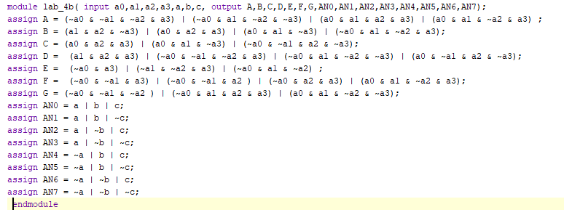

**Schematic:**

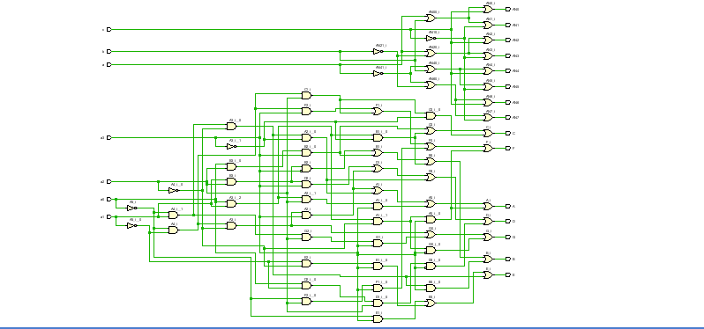

**Maximum Delay:**

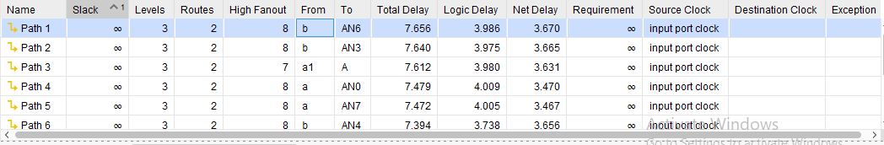

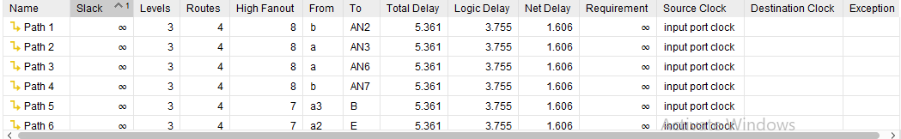

**Report Utilization:**

