OCR human-review model
The aim
Use previous human review decisions to identify which new OCR-captured answers are most likely to need human checking. The model prioritises work; it does not correct answers or replace the reviewer.
What it is trained on
- Source: data/hitl/human.csv - 341,190 reviewed rows.
- Captured is the original OCR answer. Published is the human-verified answer.
- Training label - no correction: normalised Captured equals Published.
- Training label - review needed: normalised Captured differs from Published.
- There are 7,857 corrected rows (about 2.3%), so corrected examples receive extra weight.
- Validation is split by scan_id, keeping answers from the same scan together.
Training workflow
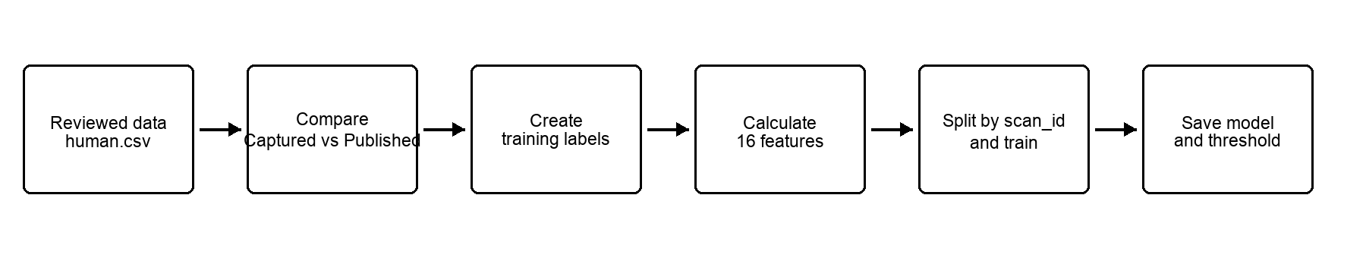
Important rules
- Published creates training labels but is never a scoring input.
- Answer-key parsing is independent of Captured and bounded for very large keys.
- Blank non-MCQ captures have no distance or similarity; the blank indicator is used.
- MCQ correction types can only be assigned to single-letter MCQ answer keys.

Features used by the main review model
- ocr_confidence - OCR engine confidence.
- edit_similarity - normalised similarity to the closest accepted variation.
- char_ngram_similarity - similarity between short overlapping character groups.
- token_similarity - overlap between words/tokens.
- answer_exact - whether Captured exactly matches an accepted variation.
- is_blank - whether Captured is empty or --blank--.
- is_mcq - whether the answer key is a single-letter MCQ key.
- captured_length and best_answer_length.
- length_difference - difference between the two lengths.
- digit_fraction, alpha_fraction and punctuation_fraction.
- variation_count - number of bounded accepted variations considered.
- known_confusion_score - strength of the strongest historical character confusion.
- known_confusion_fraction - share of required edits recognised from history.
min_distance is also logged in the scored CSV as supporting evidence. It is left empty for blank non-MCQ captures.
Possible labels and correction types
- Review flag: requires_human_review is True or False.
- Risk label: low, medium or high.
- Correction type: no_correction, substitution, insertion, deletion, transposition or multiple_edits.
- Blank-related type: blank_to_text or text_to_blank.
- MCQ type: mcq_correction, only for MCQ answer keys.
The correction type is supporting guidance. It is not an automatic correction and does not determine the risk label.
Current risk rules
- Low: probability is below review_threshold; requires_human_review is False.
- Medium: probability is at or above review_threshold but below max(0.8, review_threshold).
- High: probability is at or above max(0.8, review_threshold).
The threshold targets 95% correction recall by default. This favours catching errors but can create a larger review queue.

Scoring and review workflow
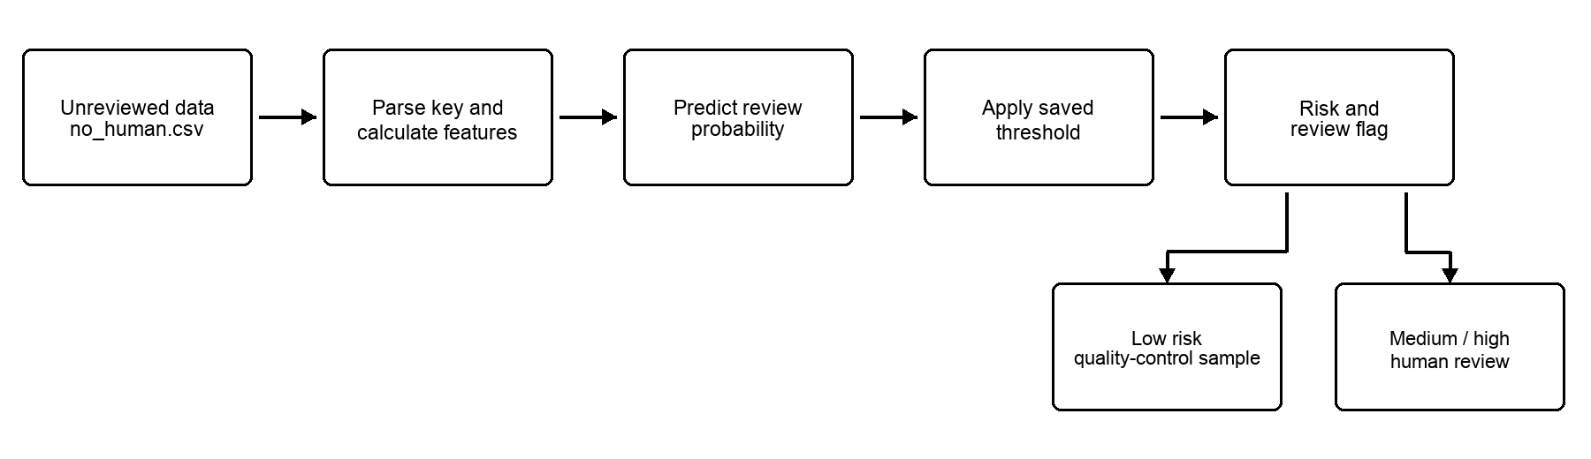
How the flagged CSV should be used
- Filter requires_human_review = True and sort review_probability from highest to lowest.
- Show Captured, ANSWER Key, OCR confidence, similarity evidence and the original scan image.
- Record the verified result in new human-review fields; do not overwrite Captured.
- Audit low-risk rows, especially those just below the threshold.
- Add completed reviews to future training data after quality checks.
Outputs to keep
- review_probability, requires_human_review and risk_label.
- predicted_correction_type, as supporting guidance only.
- min_distance, edit_similarity, char_ngram_similarity and token_similarity.
- known_confusion_score and known_confusion_fraction.
- UID, scan_id, model version, threshold, reviewer decision and review timestamp.
Points to agree
- What missed-correction rate is acceptable?
- How many rows can reviewers handle?
- What percentage of low-risk rows should be quality checked?
- Who can approve threshold changes and retraining?
- Which measures will be reported: recall, review precision, review rate, low-risk miss rate and reviewer time?

