OCR review and answer-key coverage pipeline
Purpose
Prioritise OCR answers for human review while separately identifying possible valid answers missing from the answer key. Both outputs are suggestions for reviewers; neither changes an answer automatically.
Two independent decisions
- OCR review: predicts whether Captured is likely to need correction, using patterns learned from human-reviewed data.
- Answer-key coverage: uses whole-string semantic comparison and conservative conflict rules to suggest possible missing AK variations.
- Combined routing: requires_any_human_review joins the queues while review_reasons preserves why each row was flagged.
OCR training data
- Source: data/hitl/human.csv - 341,190 reviewed rows.
- Captured is the original OCR answer; Published is the human-verified answer.
- OCR label: review needed when normalised Captured differs from Published; otherwise no correction.
- Only 7,857 rows were corrected (2.3%); class weights compensate for the imbalance.
- The AK-gap rule is not trained because accepted/rejected AK-suggestion feedback is not yet available.
Training workflow
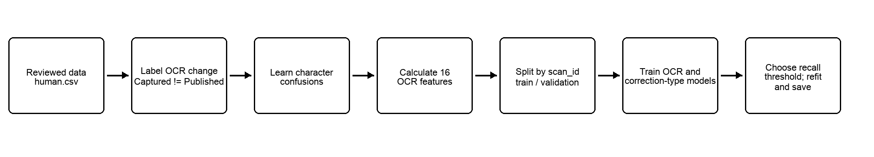
Latest validation results
- Split by scan_id so related rows remain in one fold.
- Target recall 98%; measured validation recall 98.03% at review probability threshold 0.6814.
- Validation precision 24.95%, review rate 8.84%, and average precision 0.6127.
Data rules
- Published creates labels but is never a scoring feature.
- AK parsing is independent of Captured and bounded to 100 variations by default.
- Blank non-MCQ captures have no distance or similarity; is_blank carries the state.

Evidence used by the OCR model
- ocr_confidence: OCR engine confidence.
- edit_similarity: normalised Levenshtein similarity to the closest answer key variation.
- char_ngram_similarity: overlap between short character sequences.
- token_similarity: exact word overlap (not semantic embedding).
- answer_exact, is_blank, and is_mcq: structural indicators.
- captured_length, best_answer_length, and length_difference.
- digit_fraction, alpha_fraction and punctuation_fraction.
- variation_count - bounded accepted variations considered.
- known_confusion_score and known_confusion_fraction: evidence from historical character changes.
min_distance: shortest Levenshtein edit distance to any answer key variation. It is logged as evidence but is not a model feature. It remains empty for blank non-MCQ captures.
Scoring workflow
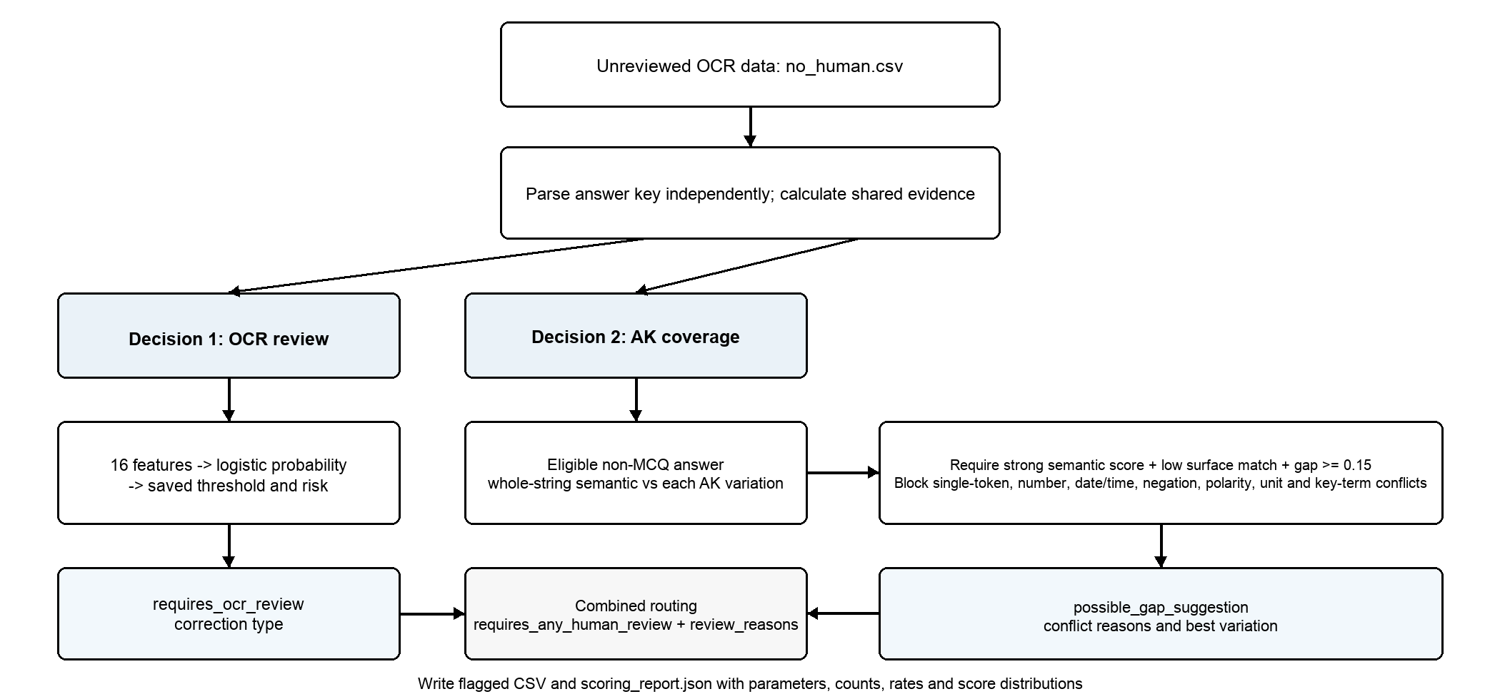
OCR review outputs
- ocr_review_probability: calculated from the trained model and saved threshold.
- requires_ocr_review: Thresholding review probability with the trained model threshold.
- ocr_risk_label: low below threshold; medium from threshold to max(0.8, threshold); high above that boundary (default is 0.8).
- predicted_ocr_correction_type: no_correction, substitution, insertion, deletion, transposition, multiple_edits, blank_to_text, text_to_blank, case_or_whitespace or mcq_correction.

Answer-key coverage outputs
- Eligible rows are non-MCQ, non-blank and not an exact accepted-answer match.
- MiniLM-L6-v2 embeds the complete Captured string and every complete AK variation; the highest cosine similarity is retained.
- possible_gap_suggestion: requires semantic similarity at least 0.789(tunable) for single-word-versus-phrase or 0.80 for multi-word pairs, surface similarity at most 0.60, and semantic-surface gap at least 0.15.
- Conflicts block different single words, numbers, dates/times, negation, polarity, units or a changed key term in a short near-duplicate (e.g. when answer key is “cat” but captured “dog”, the gap suggestion is blocked).
- Blocked rows keep semantic_similarity, best_semantic_variation and ak_conflict_reasons for audit.
AK labels
- possible_answer_key_gap - passes all semantic, surface-gap and conflict gates.
- blocked_by_conflict - semantically related but materially inconsistent.
- semantic_below_threshold, surface_match_existing_ak or insufficient_semantic_surface_gap - fails an evidence gate.
- semantic_not_scored - AK coverage was intentionally skipped.
Using the review queue
- Route requires_any_human_review = True; use review_reasons to separate OCR correction, possible AK gap or both.
- For OCR review, prioritise high risk and show the scan plus similarity evidence.
- For AK review, show Captured, best semantic variation, semantic and surface scores, and conflict reasons.
- Record reviewer outcomes in new fields without overwriting Captured; keep a low-risk quality-control sample.
Run audit and latest scoring snapshot
- Each run writes the flagged CSV and scoring_report.json with model hash, parameters, thresholds, counts, rates and distributions.
- Latest run: 138,810 rows; 5,477 OCR flags, 193 AK-gap flags, and 5,501 combined review rows (3.96%).
- Recall and precision require verified Published truth and explicit --evaluate-with-published.
Points to consider
- Acceptable missed-correction rate and available reviewer capacity.
- Quality-control sample for low-risk and conflict-blocked AK rows.
- Reviewer labels to collect so AK-gap logic can later be trained and validated.
- Ownership of threshold changes, model versions and answer-key updates.

