Campus Area Network Design and Implementation

# Introduction

A Campus Area Network (CAN) is a network infrastructure that connects multiple local area networks (LANs) within a limited geographical area such as a university, college, or corporate campus. The purpose of a CAN is to enable resource sharing, centralized management, and efficient communication across departments or buildings. In educational institutions, a well-designed CAN is essential for supporting academic, administrative, and research activities.  
  
This project focuses on the design and simulation of a campus network using Cisco Packet Tracer. The network incorporates key components such as routers, switches, servers (DNS, FTP, HTTP, Mail), DHCP services, and inter-building connectivity. Additionally, routing protocols like OSPF are used for dynamic routing between routers, and a cloud connection simulates internet access.

# Problem Statement

Many educational institutions struggle with fragmented and inefficient network setups that hinder communication, data sharing, and centralized resource management. Without a cohesive network infrastructure, tasks such as file transfers, remote access to resources, and real-time communication become unreliable.  
The lack of a structured campus network leads to:  
- Poor network performance and scalability.  
- Limited access to shared services (like web, email, and file servers).  
- Increased administrative overhead for network maintenance.  
- Challenges in implementing security and access control.  
  
This project aims to address these issues by designing a scalable and robust Campus Area Network using Cisco Packet Tracer, ensuring efficient communication, centralized services, and secure access across the campus.

# Idea Description

The core idea of this project is to design and simulate a reliable and efficient Campus Area Network (CAN) for a college or university using Cisco Packet Tracer. The goal is to interconnect various departments and administrative buildings within the campus through a structured network layout that supports secure communication, centralized services, and scalable infrastructure.

The network will include:  
- Multiple LAN segments representing different departments (e.g., Computer Science, Administration, Library).  
- Core and distribution layer switches to manage internal traffic efficiently.  
- Routers configured with RIP to ensure dynamic routing between network segments.  
- Servers to provide essential services such as:  
 - HTTP Server for hosting the college website or intranet.  
 - FTP Server for file sharing and resource distribution.  
 - DNS Server to resolve domain names within the network.  
 - Mail Server for campus-wide communication.  
 - DHCP Server to automate IP address assignment.  
- End devices such as PCs and printers connected to each department's LAN.  
  
By simulating this network in Packet Tracer, we can analyze its performance, troubleshoot potential issues, and ensure that it meets the needs of a real-world campus environment.

## Workflow of the Project:

1. Requirement Gathering (6 March – 12 March):  
2. Network Design (13 March – 19 March):  
3. Device Placement and Initial Configuration (20 March – 26 March):  
4. Server Setup (27 March – 2 April):  
5. Testing Phase (3 April – 9 April):  
6. Optimization (10 April – 16 April):  
7. Documentation and Reporting (17 April – 23 April):

**Project Features:**

The **Campus Area Network (CAN)** designed in this project incorporates a variety of advanced features to ensure efficiency, scalability, and ease of management across a college environment:

1. **Multi-LAN Architecture:**
   * Each department or building has its own Local Area Network (LAN) segment, improving organization and network traffic management.
2. **Hierarchical Network Design:**
   * A layered design (core, distribution, access) is implemented to improve scalability, performance, and troubleshooting.
3. **Dynamic Routing with RIP:**
   * Routers are configured using the RIP protocol, enabling dynamic route calculation and efficient data transmission across network segments.
4. **Server Integration:**
   * Multiple servers are included to provide centralized services:
     + **DNS Server** – Resolves domain names for internal network access.
     + **HTTP Server** – Hosts internal websites or portals.
     + **FTP Server** – Facilitates file sharing among departments.
     + **Mail Server** – Provides email communication across campus.
5. **DHCP Configuration:**
   * A DHCP server dynamically assigns IP addresses to devices, reducing manual configuration and IP conflicts.
6. **Network Security:**
   * Basic access control lists (ACLs) can be applied to restrict unauthorized access to sensitive parts of the network.
7. **Efficient Resource Sharing:**
   * Shared devices (e.g., networked printers and storage) are accessible across departments.
8. **Realistic Topology Simulation:**
   * The Packet Tracer simulation closely mimics a real-world deployment, allowing for comprehensive testing and validation.
9. **Scalability and Flexibility:**
   * The network can easily be expanded to accommodate more departments, users, or new technologies in the future.

**Components:**

The **Campus Area Network (CAN)** in this project uses a variety of hardware and software components to simulate a real-world college network. The key components are:

**1. Networking Devices:**

* **Routers:**
  + Used to connect different LANs and route data between departments and to the internet.
  + Configured with RIP for dynamic routing.
* **Switches:**
  + Facilitate internal communication within departments.

**2. End Devices:**

* **PCs (Clients):**
  + Represent student and staff computers across different departments.
* **Laptops and Tablets:**
  + Optional devices to simulate mobile users.
* **Printers:**
  + Shared printers connected to departmental LANs.

**3. Servers:**

* **DNS Server:**
  + Resolves hostnames into IP addresses.
* **HTTP Server:**
  + Hosts the college website or internal portals.
* **FTP Server:**
  + Used for file sharing and backups.
* **Mail Server:**
  + Handles internal communication through email.
* **DHCP Server:**
  + Automatically assigns IP addresses to client devices.

**4. Network Infrastructure:**

* **Cabling:**
  + Copper (Ethernet) and Fiber cables for connecting devices.
* **Access Points (optional):**
  + Used to simulate wireless network access in open areas.
* **Patch Panels & Racks (optional):**
  + For structured cabling design.

**6. Software Tools:**

* **Cisco Packet Tracer:**
  + Used to design, configure, and simulate the entire campus network.
* **Command Line Interface (CLI):**
  + Used for device configuration (e.g., router and switch setup).

**Working Steps:**

The following steps outline the process of designing and simulating the **Campus Area Network (CAN)** using Cisco Packet Tracer:

**1. Network Planning and Topology Design**

* Identify the departments and buildings to be included in the network (e.g., Admin, Library, Computer Lab).
* Decide the number of PCs, servers, and other devices per department.
* Design a logical and physical network topology including routers, switches, and LANs.

**2. Device Placement in Cisco Packet Tracer**

* Place routers, switches, PCs, printers, and servers on the workspace.
* Organize devices according to departments or building zones.

**3. Cable Connections**

* Use appropriate cables (copper straight-through, cross-over, fiber) to connect:
  + PCs to switches
  + Switches to routers
  + Servers to core switches
  + Routers to cloud/internet

**4. IP Addressing Scheme**

* Design an IP addressing plan (using IPv4 or IPv6).
* Subnet the IP range based on departments.
* Assign static IPs to servers and routers, and dynamic IPs (via DHCP) to end devices.

**5. Configure Routers and Switches**

* Assign IP addresses to router interfaces.
* Enable and configure routing protocols like **RIP**.
* Configure basic switch settings (VLANs, port assignments if needed).

**6. Configure DHCP Server**

* Set up the DHCP server with the IP address pools for different subnets.
* Enable DHCP services to allow automatic IP allocation to end devices.

**7. Configure Network Services**

* **DNS Server**: Assign domain names to devices (e.g., mail.college.edu).
* **HTTP Server**: Upload web pages and test website access.
* **FTP Server**: Set up shared folders and test file uploads/downloads.
* **Mail Server**: Create user accounts and test sending/receiving emails.

**8. Test Network Connectivity**

* Use the **ping** and **traceroute** commands to test connectivity between:
  + Devices within a LAN
  + Devices across different LANs
  + Devices to servers
* Verify DNS resolution, DHCP operation, website access, file sharing, and email.

**9. Apply Basic Security Measures (Optional)**

* Use Access Control Lists (ACLs) on routers to restrict access to certain services or subnets.
* Configure passwords for console and remote (Telnet/SSH) access to devices.

**10. Save and Document the Network**

* Save the final Packet Tracer file.
* Create documentation including:
  + IP addressing table
  + Topology diagram
  + Device configurations
  + Test results

**Network Design Architecture:**

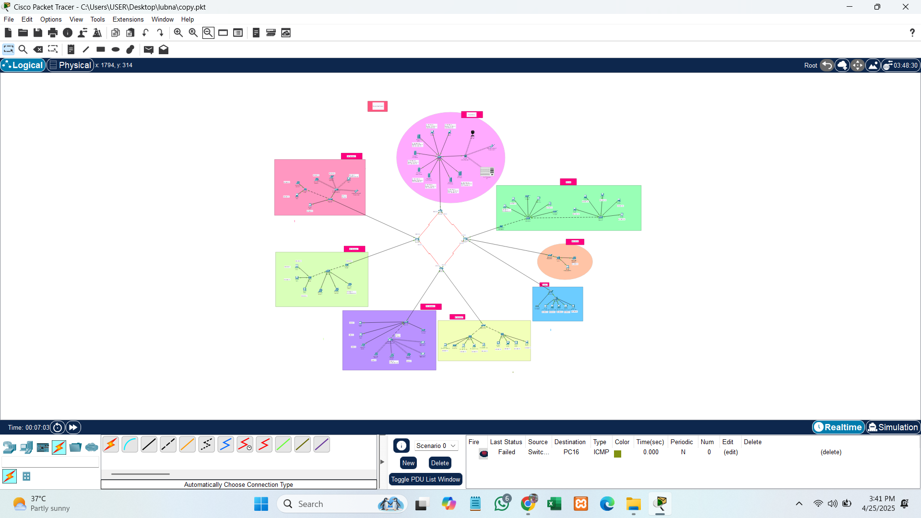

**Fig. No. 4.1: Network Design Architecture**

This is the network design of our campus area network. We have divided our network into 8 different departments i.e. Main server room, EEE department, ME department ,CSE department,CIVIL department,Library,Receiption,CSE lab. We have used different server for each service i.e., DHCP, DNS, IoT, Email and FTP. We have used 8 switches .switch is connected to an one router and another switchs is connected to another routers. We use IoT components web cam and Air Conditioner, it is controlled remotely by smartphone. Also, we have assigned Default Gateway for each room.

**DHCP:**

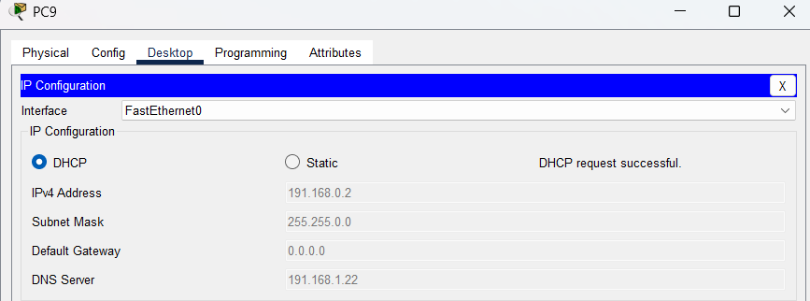

**Fig. No. 4.2 DHCP**

**DNS:**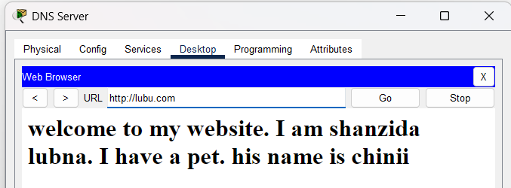

**Fig. No. 4.3 DNS**

**Email:**

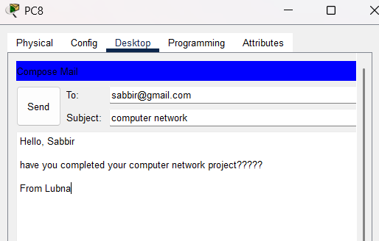

**Fig. No. 4.4 E-Mail Send**

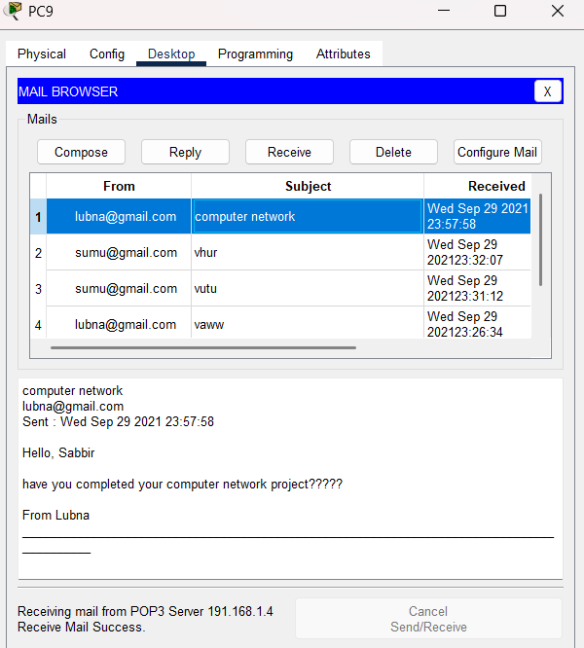

**Fig. No. 4.5 E-Mail Receive**

**FTP:**

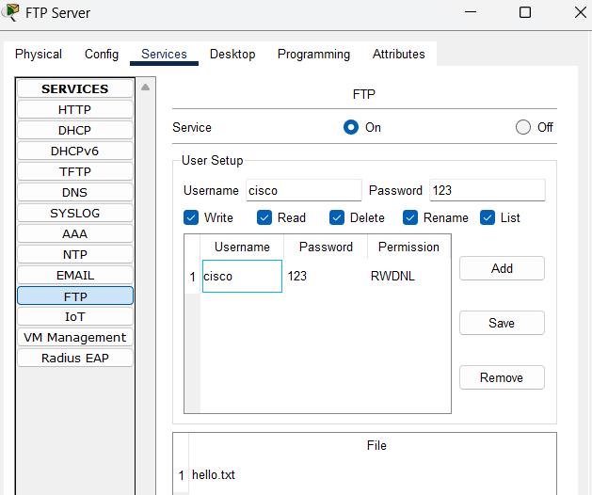

**Fig. No. 4.6 FTP 1**

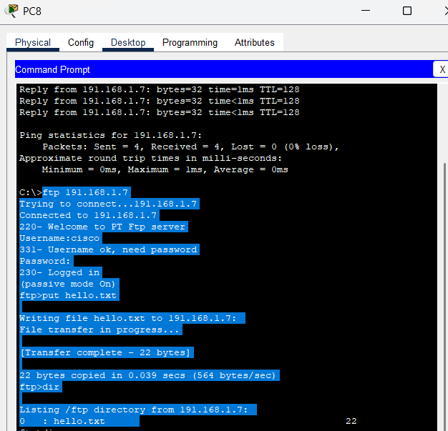

**Fig. No. 4.7 FTP 2**

**IOT:**

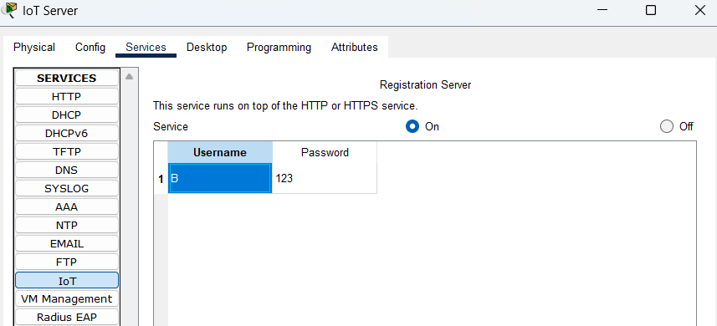

**Fig. No. 4.8 IoT 1**

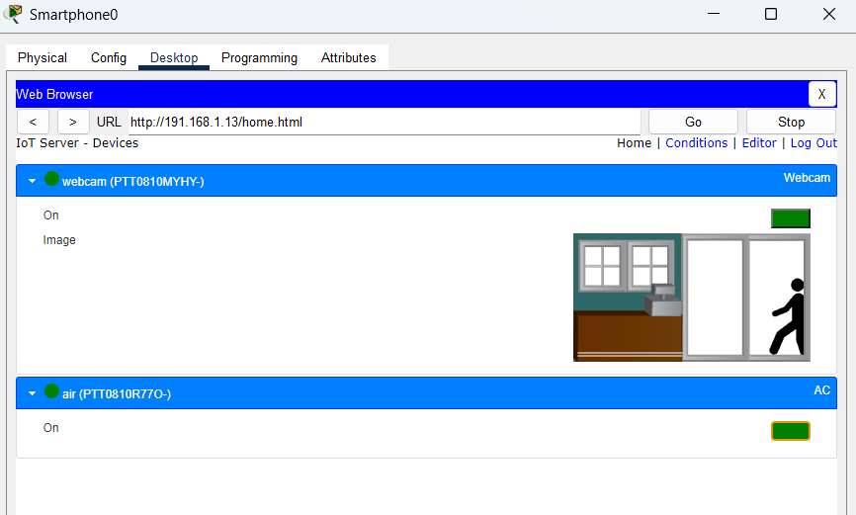

**Fig. No. 4.9 IoT 2**

**Target Users:**

The **Campus Area Network (CAN)** is designed to serve the following primary user groups within a college or university environment:

**1. Students**

* Access educational resources such as e-learning platforms, online libraries, and departmental websites.
* Use shared devices (printers, file servers) and communicate via email within the campus.
* Connect to the internet and intranet for research and academic work.

**2. Faculty and Staff**

* Share and access teaching materials and administrative documents via centralized servers (FTP, HTTP).
* Use email and internal communication tools for collaboration.
* Connect securely to departmental resources, printers, and student management systems.

**3. Administrative Personnel**

* Manage student records, financial systems, and internal communication tools.
* Use secured access to servers and databases through reliable network infrastructure.

**4. IT Department**

* Monitor, maintain, and troubleshoot the network.
* Ensure proper configuration of devices and services (DNS, DHCP, Mail, etc.).
* Apply updates, manage user access, and implement security protocols.

**5. External Visitors and Guests (Optional Access)**

* With restricted access to the internet and limited services via guest VLANs or separate networks.

This network is designed to support all these users with a focus on **reliability, scalability, security, and ease of access** to essential services.

**Socio-Economic Value:**

The implementation of a **Campus Area Network (CAN)** in an educational institution brings significant social and economic benefits, both immediately and in the long term. These benefits impact students, faculty, administration, and the broader community.

**1. Enhanced Access to Education**

* Provides students and staff with **seamless access to digital learning resources**, online courses, and academic databases.
* Supports **blended learning and remote education**, reducing educational inequality, especially in under-resourced areas.

**2. Improved Communication and Collaboration**

* Enables faster, more reliable **internal communication** between departments and individuals via email and shared platforms.
* Encourages **collaborative projects** and knowledge sharing among students and faculty, fostering innovation and teamwork.

**3. Operational Efficiency**

* Reduces paperwork and manual processes by supporting **automated systems** for registration, records, and resource management.
* Saves time and reduces human errors in daily operations, leading to better administrative performance.

**4. Cost Savings**

* Centralized services like file storage, printing, and internet sharing **reduce redundant infrastructure** and operational costs.
* Long-term savings on maintenance and upgrades due to the **scalable network design**.

**5. Employment and Skill Development**

* Students gain **hands-on networking and IT skills**, increasing their employability.
* The need for network management opens **technical job opportunities** for IT professionals within the institution.

**6. Community Engagement**

* The network can be extended to support **community learning centers** or local outreach programs.
* Encourages partnerships with tech companies, NGOs, or government bodies supporting digital education.

**7. Sustainability and Environmental Impact**

* Digital systems help reduce the use of paper and physical storage, contributing to **environmental sustainability**.

In summary, a well-designed Campus Area Network not only supports the academic goals of an institution but also contributes to economic development, digital literacy, and social progress.

**Platform:**

The **Campus Area Network (CAN)** project is designed and simulated using **Cisco Packet Tracer**, a powerful network simulation tool developed by Cisco Systems. It provides a virtual environment to:

* Design network topologies.
* Configure routers, switches, and end devices.
* Simulate real-time data flow, communication, and server functionalities.
* Practice and test configurations using CLI (Command Line Interface).
* Troubleshoot connectivity and routing issues.

**Key Reasons for Using Cisco Packet Tracer:**

* User-friendly graphical interface for creating and managing network designs.
* Support for various protocols including DHCP, DNS, FTP, HTTP, OSPF, and more.
* Realistic simulation environment to visualize how data moves across the network.
* Excellent platform for students and network administrators to learn, test, and validate network infrastructure before real-world deployment.

**Conclusion:**

The **Campus Area Network** project successfully demonstrates the design and simulation of a functional, scalable, and secure network infrastructure tailored for a college or university environment. It ensures seamless communication between departments, centralized access to educational and administrative resources, and efficient network management.

By integrating essential services such as DNS, FTP, HTTP, DHCP, and Mail servers, the network supports both academic and operational needs. The use of dynamic routing protocols like OSPF and proper IP management improves data flow and system performance.

Ultimately, this project provides a **realistic model of how modern educational institutions can leverage networking technologies** to enhance learning, streamline operations, and contribute to broader social and economic development.

**References:**

1. https://github.com/Dhanashrimachhi/College-Computer-Network/blob/main/College_Computer_Network_Design