

**Table of contents**

|  |  |
| --- | --- |
| **1** | **Abstract** |
| **2** | **Features & Components** |
| **3** | **Project Description** |
| **4** | **Schematic** |
| **5** | **Programming & Setting up the Raspberry Pi, Webcam And servomotor** |
| **6** | **Results & Discussion** |
| **7** | **Conclusion & Future Scope** |
| **8** | **Reference** |

**1. Abstract**

In today's post pandemic world, the importance of covid-19 safety and standards are more important than ever. As people must maintain masks as well as safety in mind when entering any public space and this safety must be strictly enforced but manually implementing checks can be a haste as well as resource intensive. So, to fix this issue of manual monitoring, we think that a security system that uses image recognition to identify individuals with covid-19 protection and a locking system that ensures security all integrated through the raspberry Pi to showcase a modern, modular, and secure IoT solution.

**2. Features and Components**

**Features of face mask detection:**

1. Monitoring people putting mask on to enter a specific area or not
2. On and off lights for confirmation.
3. On and off door with the help of servo meter.
4. Push notification to enter or exit

**Component List:**

* Raspberry pi 4 (4 GB RAM)
* Web Cam
* Servomotor
* LED light
* Adapter
* Memory

**Visual Components:**

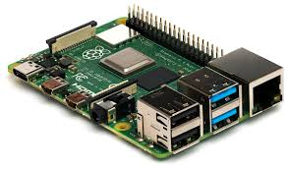 Raspberry pi 4 with 4 GB RAM.

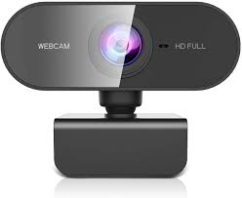 Webcam.

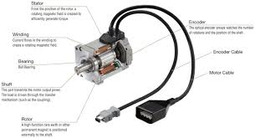 Servomotor

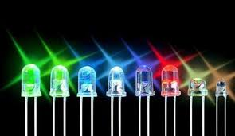 LED lights

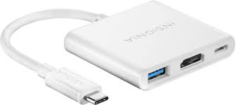 Adapter

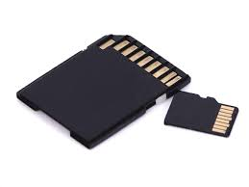 MemoryCard

**3. Project description and working principles:**

The System will Raspberry Pi for its main computation. The system will be built using Raspbian as well as python. It will use python and various of its image processing and image recognition modules including python image processing library tensor follow, NumPy, openCV2and a dataset for comparison. The system will source its information through the webcam. The system will also be integrated with a motorized locking mechanism as well using servomotor. When the system recognizes a person while active it will show whether the person is safe or not through a LED. If the LED is red, it will signal that the person is unsafe and without protection, so the motorized system will lock the door. If the person is found to be wearing a mask, the LED will be green which will signal that they are safe, and the motorized system will unlock. In the future, a thermal camera sensor may be further integrated with the system to measure a high body temperature and such symptoms of covid-19 as well but as of now this is not part of the system because of time constraints as well as availability.

**4. Schematic**

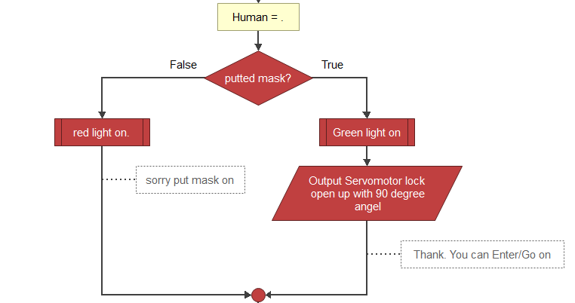

**Fig: Entering position Flow Chart**

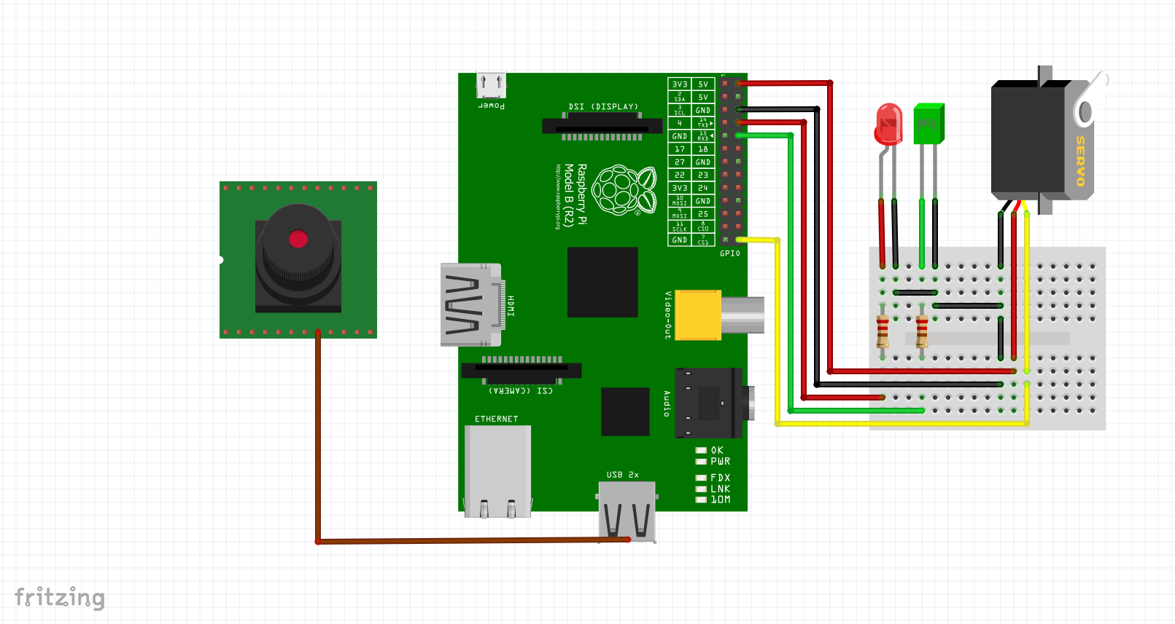

**Figure: circuit diagram**

**5. Programming and Setting up the Raspberry Pi, Webcam And servomotor**

Components of the system modules

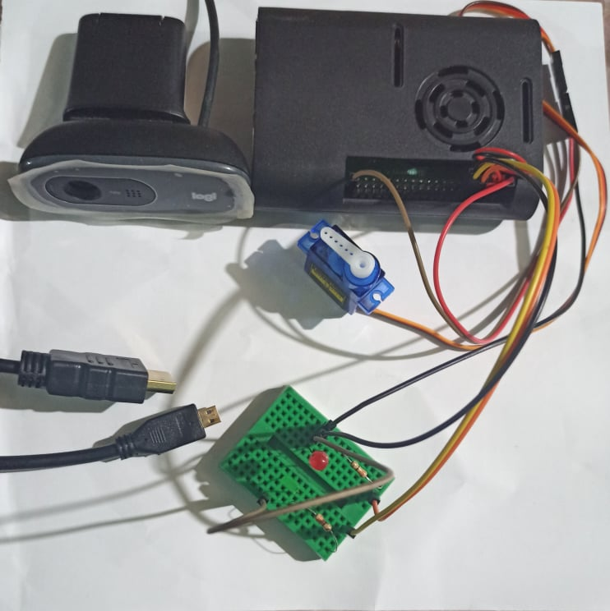

Initializing the mask detecting, servo motor and LEDs with raspberry pi.

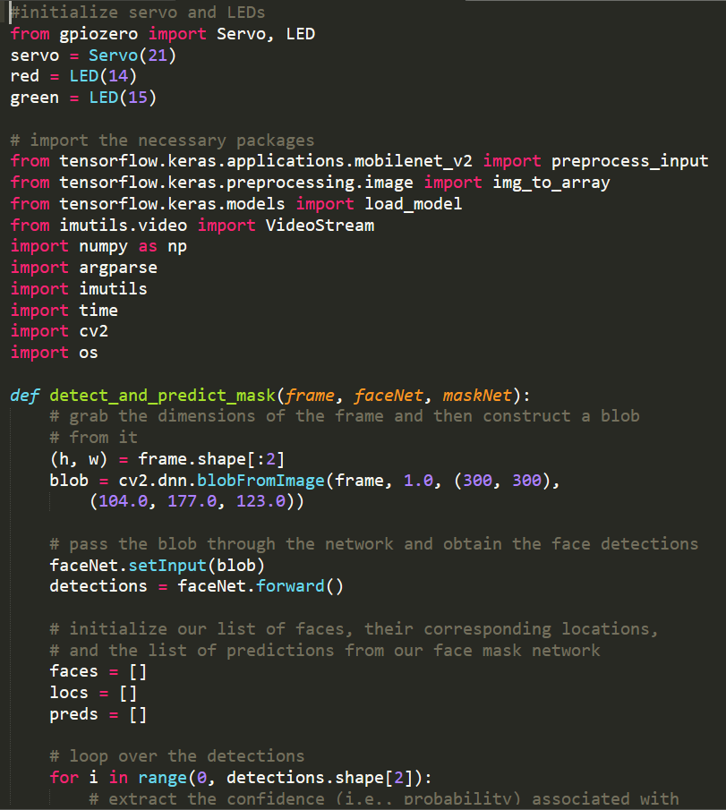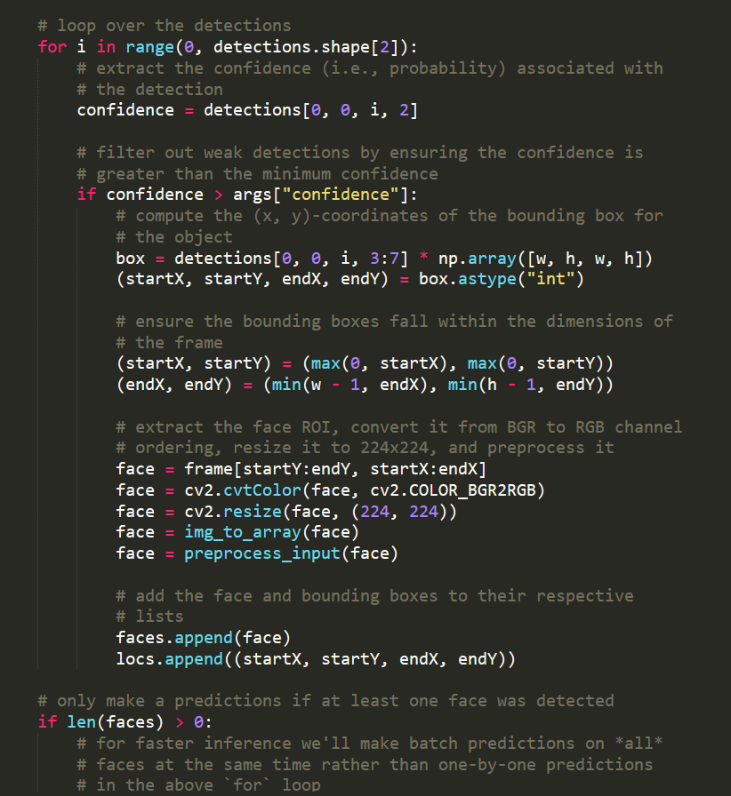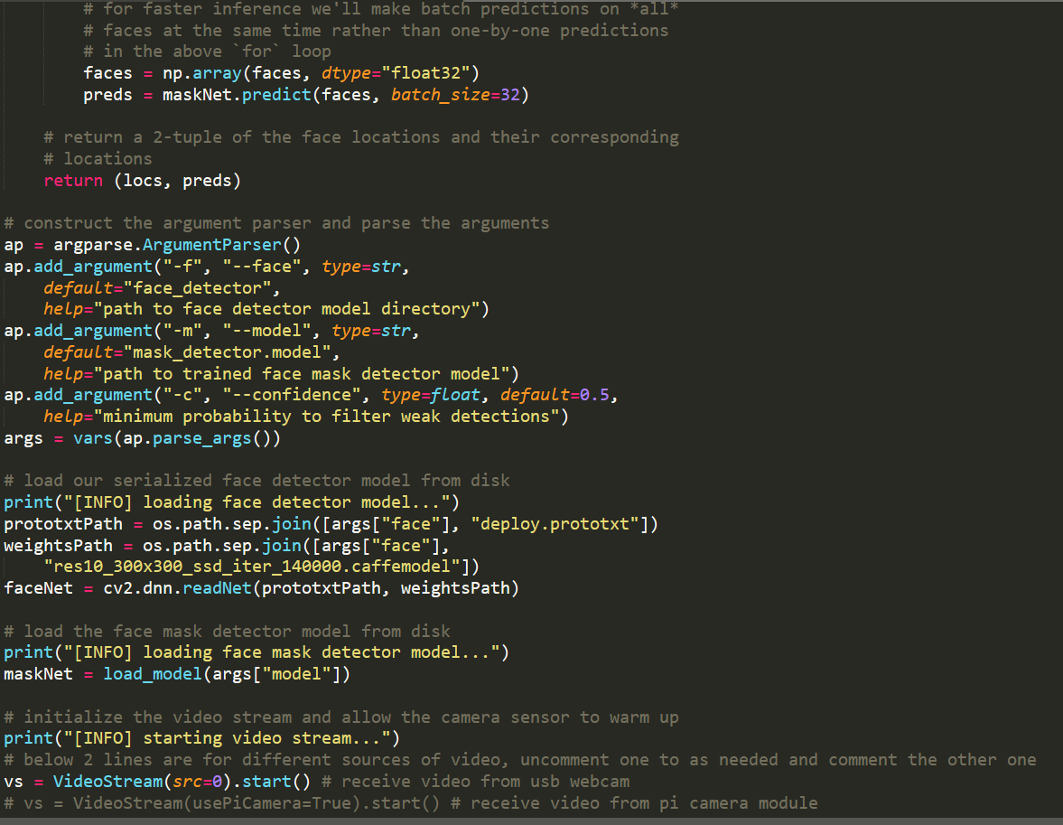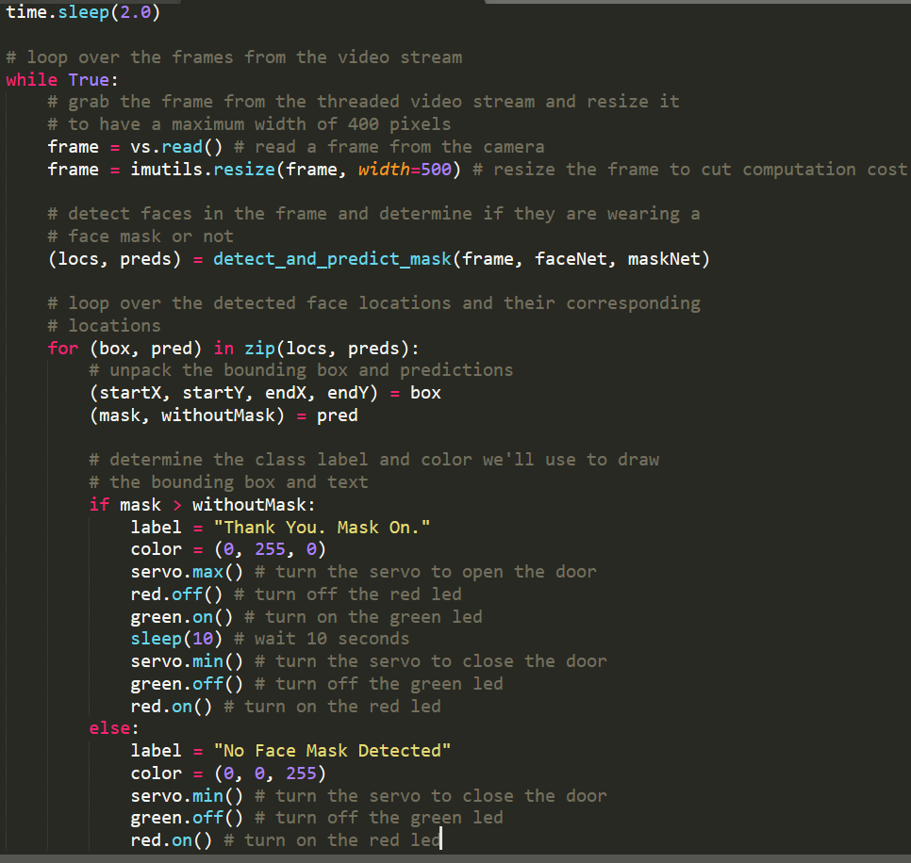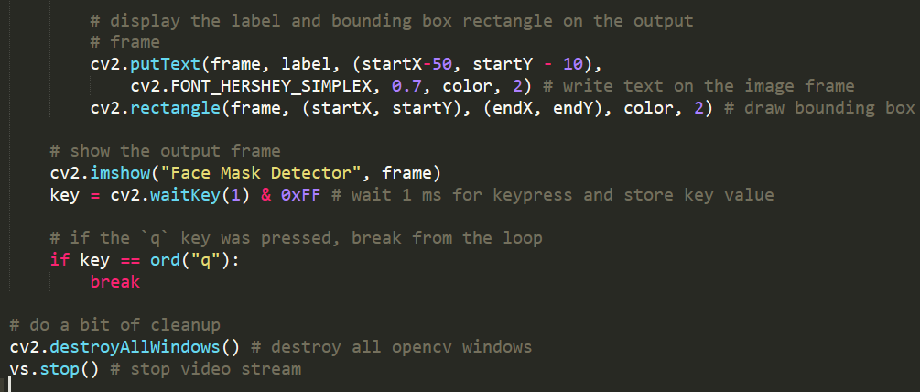

6. Results & Discussion:

We have identified model which has made of consists of different sensor devices and other modules, their functionalities are shown in figure in previously. Here we detect human with the web cam if the object wearing mask or not. If the object putting face mask, then green light will be on and servo motor helps to open the door. Otherwise, without mask, red light will be on and servo motor doesn’t allow to open door with the help of angle measurement

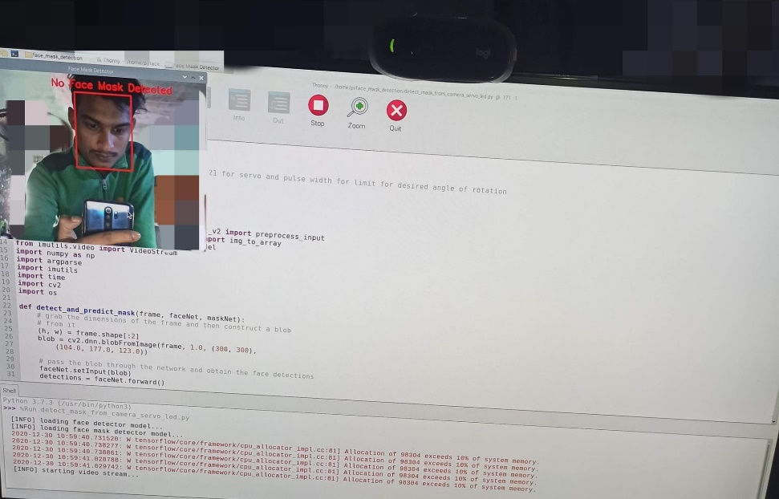 **Without mask.**

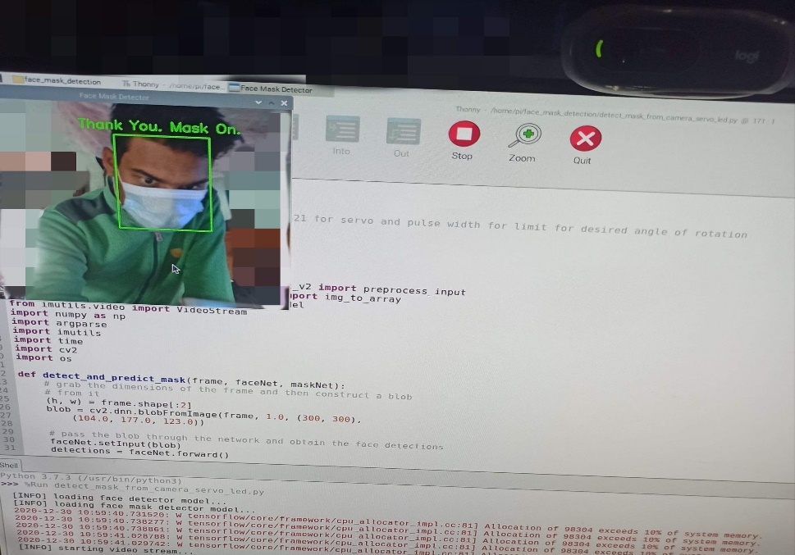 **with the mask.**

**7. Conclusion & Future Scope:**

The system has a very influencing feature. We can secure the whole area by checking and ensuring the entering place with this system. It can reduce the risk level of current even if futuristic problems. By producing it in industrial level

Future Scope:

• In future people can enter though the automated door with help signal and servo meter.

• Detecting the more parameters of mask for most secure purpose

• Increasing parameters like body temperature with the addition of multiple sensors

• By upgrading components, we can use it for public purpose.

**8.Reference:**

* <https://pypi.org/project/face-recognition/>
* <https://medium.com/analytics-vidhya/create-your-own-real-image-dataset-with-pythondeep-learning-b2576b63da1e>
* <https://stackabuse.com/image-recognition-in-python-with-tensorflow-and-keras/>
* <https://www.pyimagesearch.com/2020/05/04/covid-19-face-mask-detector-with-opencv-keras-tensorflow-and-deep-learning/>
* <https://pypi.org/project/face-mask-detector/>