

American International University-Bangladesh (AIUB)  
Department of Computer Science  
Faculty of Science &Technology (FST)  
Fall20-21

Section: A  
Software Quality Assurance and Testing

**Project:** Test Plan for Student Registration System for a University (AIUB).

A Report submitted

By

|  |  |  |
| --- | --- | --- |
| SN | Student Name | Student ID |
| 1 | **Sarah Khanom** | **17-33620-1** |
| 2 | **RifaTasfia** | **17-33612-1** |
| 3 | **PornaMondal** | **17-33653-1** |
| 4 | **Shaon Ahmed** | **15-30027-2** |

Under the supervision of

ABHIJIT BHOWMIK

Faculty of Engineering

Department of CS  
American International University-Bangladesh

Software Test Plan

for

Student Registration System for a University (AIUB).

Version 1.0 approved

Prepared by:*Sarah Khanom, RifaTasfia, PornaMondal, Shaon Ahmed*

American International University-Bangladesh

Date: 15-12-2020

Table of Contents

Revision History 3

1. TEST PLAN IDENTIFIER: RS-MTP01.3 3

2. REFERENCES 3

3. INTRODUCTION 3

Background to the Problem 3

Solution to the Problem 4

4. REQUEIREMNT SPECIFICATION 4

4.1 System Features 4

4.2 System Quality Attributes 4

4.3 System Interface 5

4.4 Project Requirements 5

5. FEATURES NOT TO BE TESTED 5

6. TESTING APPROACH 5

6.1 Testing Levels 5

6.2 Test Tools 6

6.3 Meetings 6

7. TEST CASES/TEST ITEMS 6

8. ITEM PASS/FAIL CRITERIA 7

9. TEST DELIVERABLES 7

10. STAFFING AND TRAINING NEEDS 8

11. RESPONSIBILITIES 8

12. TESTING SCHEDULE 8

13. PLANNING RISKS AND CONTINGENCIES 9

14. APROVALS 9

# Revision History

|  |  |  |  |
| --- | --- | --- | --- |
| Revision | Date | Updated by | Update Comments |
| 0.1 | 2020.12.22 | All group members | First Draft |
| 0.2 | 2020.12.26 | All group members | Second Draft |
| 0.3 | 2020.12.30 | All group members | Last Draft |
|  |  |  |  |
|  |  |  |  |
|  |  |  |  |
|  |  |  |  |
|  |  |  |  |
|  |  |  |  |

# TEST PLAN IDENTIFIER:TP_Student Registration System_1.7

# REFERENCES

Project Plan

Test plan template IEEE-829 Requirements specifications

# INTRODUCTION

## Background to the Problem

We have to make a test plan for the system where student can do their registration online. It is a Web-based Online Course Registration system where there will be show offered courses name and many sections along with their times. Every section should have a class room and time span assigned for it.

The purpose of this test is to evaluate the system’s compliance with the business requirements and assess whether it is acceptable fordelivery.

## Solution to the Problem

Every section should have a maximum number of 40 seats for the student to register. After selecting 37 students, no student can choose this section. Every student and faculty have to belong to single/multiple departments, and their information will be recorded in this system. Every course can have many sections any particular year also in different semester. Students must have to complete the prerequisite otherwise he/she will not able to registration for the course. We are going to test this system up to acceptance testing where we can make sure the acceptability. The purpose of this test is to evaluate the system’s compliance with the business requirements and assess whether it is acceptable fordelivery.

# REQUEIREMNT SPECIFICATION

## System Features

**1**. Login to the AIUB portal  
Functional Requirements

* 1. The software shall allow students to login with their given username and password
  2. If the username and/or password has been inserted wrong for more than three times, the random verification code will be generated by the system to retry login.
  3. If the number of login attempt exceed its limit (5 times), the system shall block the user account login for one hour *[optional function]*

Priority Level: Medium  
Precondition: user have valid user id and password

1. studentprofile

Functional Requirements

* 1. Displaying the details for a student

Priority Level: Medium

1. Registration System

Functional Requirements

* 1. Show selected courses, section, timing as per as credithour.
  2. Semester registration done by students. (after deadline registration will beoff)
  3. Can be done by advisor for complicated cases. (probation, student less then minimum credit)
  4. Confirm registration

Priority Level: Medium

Precondition: Student cannot register before their schedule time

1. Choosingcourse

Functional Requirements

* 1. Student cannot choose more than one section of acourse.
  2. Student cannot choose two course section at a time. (timeclash)
  3. Number of students in each section of a course to be identified. (<=40).

1. Add and Drop course
2. Displaying the routine for anystudent.
3. Logout to the AIUB portal.

## System Quality Attributes

* Usability:The usability of Online Courses Registration Systems is the subject of this framework and a model for evaluating their usability is proposed. This system will satisfy all users and meet their needs.
* Availability: This system focuses on the accessibility of registration processes for online courses and suggests a model for measuring where enrolled students can have access to the Student Course Registration System.
* Correctness: This system will operate correctly from user log in and should reach the checkout page when ready to register.
* Maintainability: System admin will maintain and correct student information to ensure teachers, schedules, classes are current and up to date.
* Reliability: this system is reliable as this system shall not be down more than years.
* Security: this system handled only by the administrator and authorized users.

## System Interface

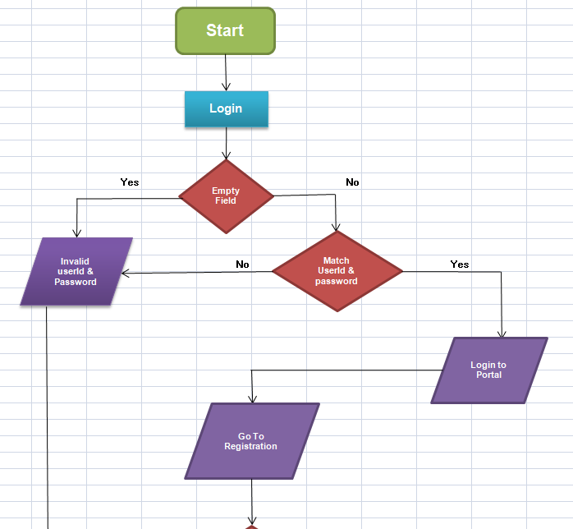

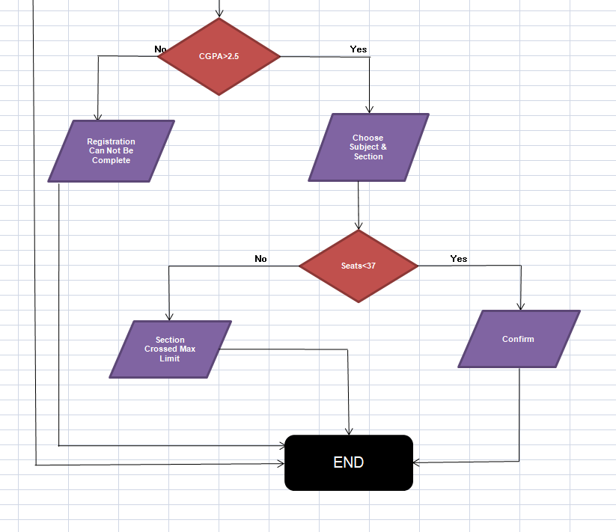

**Diagram: Flow Chart**

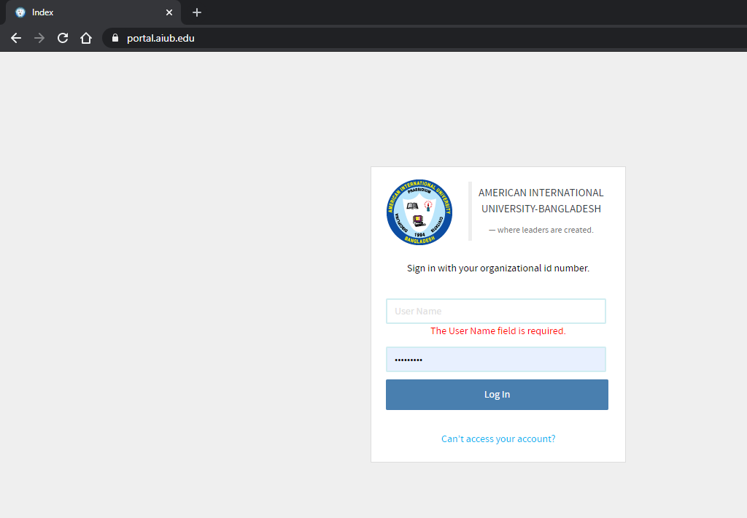

**Fig: Log In session**

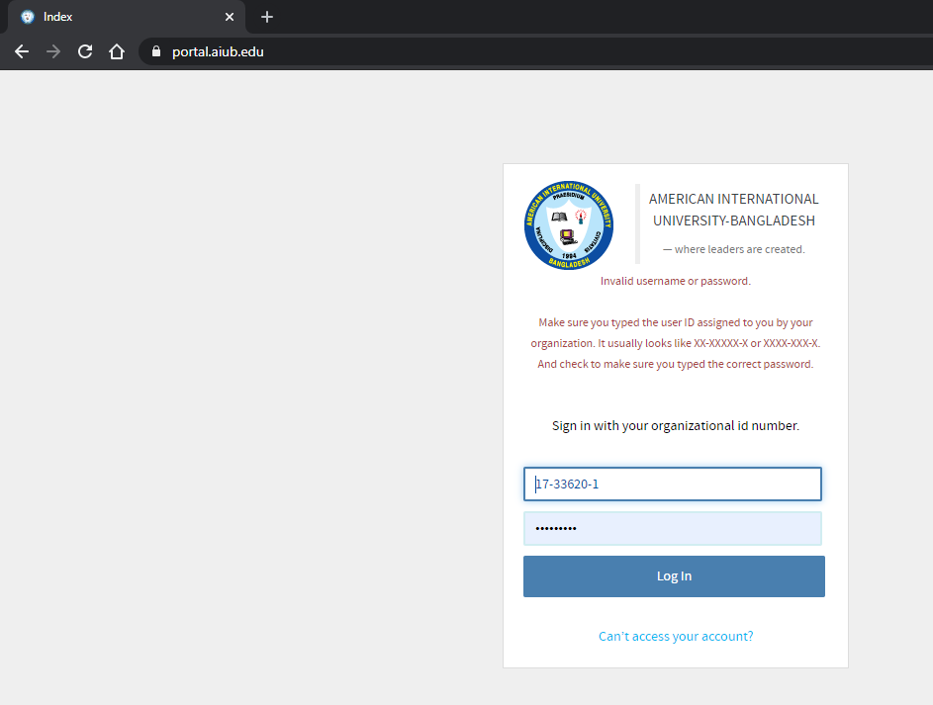

**Fig: Log In session**

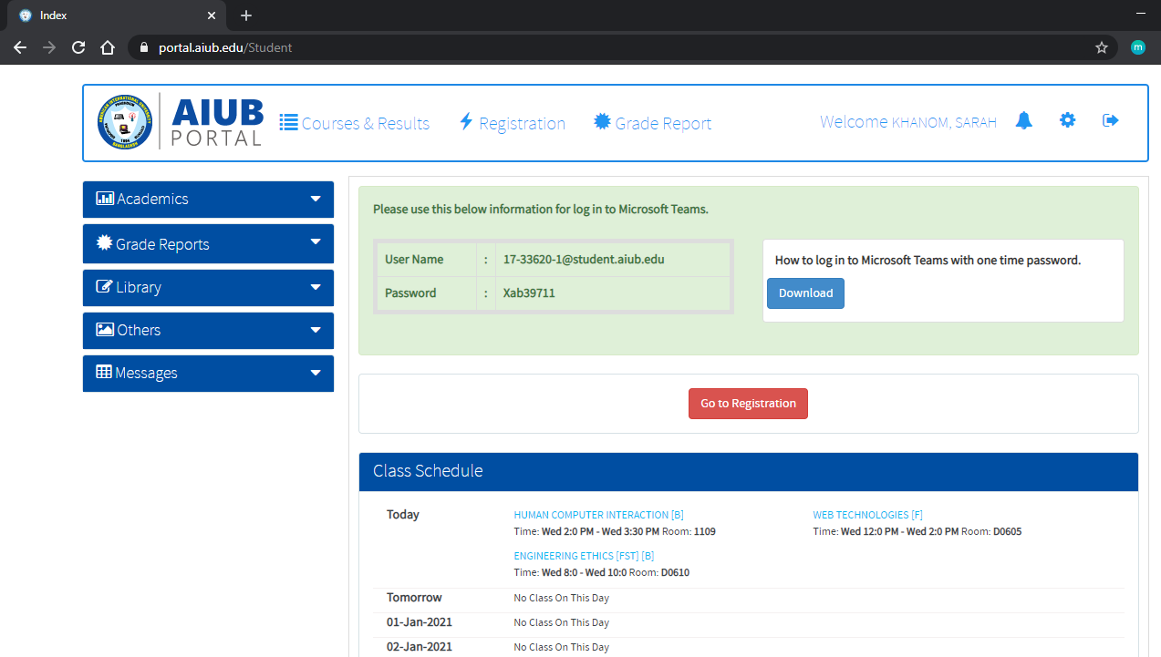

**Fig: Student Page**

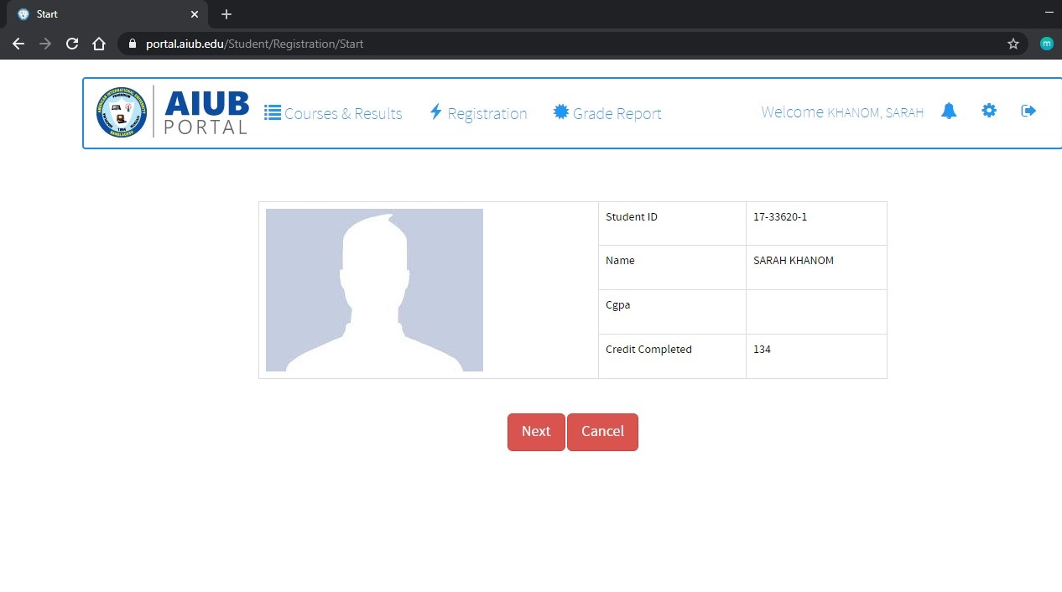

**Fig: Registration page**

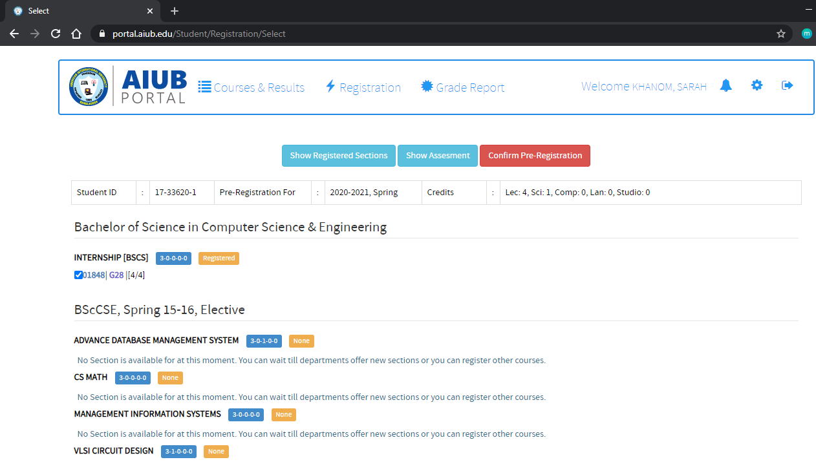

**Fig: Confirm registration**

## Project Requirements

Total budget 7,50,000 BDT  
 Total Development Time 1 year 7 months

# FEATURES NOT TO BE TESTED

* + Open a newcourse
  + Open a newsection
  + Cancel asection
  + Change sectiontiming
  + Gradereport
  + NetworkIssues
  + Databasemanagement

# TESTING APPROACH

## Testing Level

* White Box and Black Box both testing strategy will be followed. Black Box testing verify that it results in the right outputs using the software as an end-user. Integration and system testing are the main testing strategy. In system testing, it will be tested that whether all the functionality is working properly or not. Besides integration and system testing, performance, efficiency, security, usability will also betested.It is hoped that there will be at least one full time independent test person for system/integration testing. However, with the budget constraints and timeline established; most testing will be done by the test manager with the development teams’ participation.

## Test Tools

* JIRA Testing & QA Tool will be used to manage test cases and reporting.
* Microsoft Excel will be used to write test cases.

## Meetings

The test team will meet once every one week to evaluate progress to date and to identify error trends and problems as early as possible. The test team leader will meet with development and the project manager once every one week as well. Additional meetings can be called as required for emergencysituations.

# TEST CASES/TEST ITEMS

|  |  |  |  |  |  |
| --- | --- | --- | --- | --- | --- |
| Project Name: Test Plan for Student Registration System for a University (AIUB). | | | Test Designed by: Sarah Khanom | | |
| Test Case ID: TP_SRS_1 | | | Test Designed Date: 12-12-2020 | | |
| Test Priority (Low, Medium, High): High | | | Test Executed by:RifaTasfia | | |
| Module Name: Login Session | | | Test Execution date: 16-12-2020 | | |
| Test Title: verify login with valid username and password | | |  | | |
| Description: Test website login page | | |  | | |
| Precondition (If any): User must have valid username and password | | | | | |
| Test Steps | Test Data | Expected Results | | Actual Results | Status (Pass/Fail) |
| 1. Go to the website 2. Enter username 3. Enter password 4. Click submit | Username:  17-33620-1  Password: 321 | User should login into the application | | As expected, | Pass |

|  |
| --- |
| **Post Condition:** User is validated with database and successfully login to account. The account session details are logged in the database |

|  |  |  |  |  |  |
| --- | --- | --- | --- | --- | --- |
| Project Name: Test Plan for Student Registration System for a University (AIUB). | | | Test Designed by:Rifatasfia | | |
| Test Case ID: TP_SRS_3 | | | Test Designed Date: 13-12-2020 | | |
| Test Priority (Low, Medium, High): Medium | | | Test Executed by:Porna Modal | | |
| Module Name: Logout Session | | | Test Execution date: 19-12-2020 | | |
| Test Title: verify logout is done with session destroy | | |  | | |
| Description: Test website logout page | | |  | | |
| Precondition (If any): User must be logged in | | | | | |
| Test Steps | Test Data | Expected Results | | Actual Results | Status (Pass/Fail) |
| 1. Go to the website 2. Press logout button | Username:  17-33620-1  Password: 321 | User must logout and return to login page | | As expected, | Pass |

|  |
| --- |
| **Post Condition:** User return to login page. The account session details are logged out the database |

|  |  |  |  |  |  |
| --- | --- | --- | --- | --- | --- |
| Project Name: | | | Test Designed by:Shaon Ahmed | | |
| Test Case ID: TP_SRS_7 | | | Test Designed Date: 15-12-2020 | | |
| Test Priority (Low, Medium, High): Medium | | | Test Executed by: Sarah Khanom | | |
| Module Name: Registration | | | Test Execution date: 25-12-2020 | | |
| Test Title: verify registration section with valid course | | |  | | |
| Description: Test website registration page | | |  | | |
| Precondition (If any): User has to be valid student, complete prerequisite courses and logged in to the application | | | | | |
| Test Steps | Test Data | Expected Results | | Actual Results | Status (Pass/Fail) |
| 1. Go to the website 2. Login 3. Go to registration 4. Choose course 5. Click confirm | Username:  17-33620-1  Password: 321 | User should Select course and confirm | | As expected, | Pass |

|  |
| --- |
| **Post Condition:** User successfully select courses and registration is confirmed. |

|  |  |  |  |  |  |
| --- | --- | --- | --- | --- | --- |
| Project Name: | | | Test Designed by:Pornamondal | | |
| Test Case ID: TP_SRS_9 | | | Test Designed Date: 17-12-2020 | | |
| Test Priority (Low, Medium, High): Medium | | | Test Executed by:Shaon Ahmad | | |
| Module Name: Add courseSession | | | Test Execution date: 30-12-2020 | | |
| Test Title: verify Add course are showing with subject | | |  | | |
| Description: Test website registration add course | | |  | | |
| Precondition (If any): User must have to logged in | | | | | |
| Test Steps | Test Data | Expected Results | | Actual Results | Status (Pass/Fail) |
| 1. Go to the website 2. Login 3. Go to registration 4. Click Add 5. Select courses 6. Click confirm | Username:  17-33620-1  Password: 321 | New course should be added | | As expected, | Pass |

|  |
| --- |
| **Post Condition:** User successfully complete registration. |

# ITEM PASS/FAIL CRITERIA

The test process will be completed once it is ensured all the features and functionality are correctly implemented and working perfectly and providing accurate results.

# TEST DELIVERABLES

The initial test schedule follows -

* + TestPlanning
  + Review Requirementsdocuments
  + Create initial testestimates
  + Staff and train new testresources
  + First deploy to QA testenvironment
  + Functional testing – Iteration1
  + Iteration 2 deploy to QA testenvironment
  + Functional testing – Iteration2
  + Systemtesting
  + Regressiontesting
  + Resolution of final defects and final buildtesting
  + Deploy to Stagingenvironment

# STAFFING AND TRAINING NEEDS

For the implementation of "AIUB Student Registration System" a dedicated tester is highly recommended who can be recruited as a part time employee initially and can be started as full time after a month.

# RESPONSIBILITIES

The Test lead will build up the Test Plan. He is additionally in charge of masterminding the work force required for the entire undertaking. He has the obligation of likewise dealing with the assets, getting ready, auditing and executing the arrangement. He is additionally viewed as the venture chief since he has the total diagram of the task. The improvement group will build up the framework as arranged. They will finish white box testing all the while. Test Team individuals will execute the discharged test plan and test contents. They will likewise pursue the suspension criteria and be in a state of harmony with the improvement group. The analyzers incorporate the client base i.e. understudies and educatorstoo.

|  |  |  |  |  |  |
| --- | --- | --- | --- | --- | --- |
|  | TM | PM | DEV TEAM | TEST TEAM | CLIENT |
| Acceptance test Documentation & Execution | X |  | X | X |  |
| System/Integration test documentation & Exec. | X | X |  |  | X |
| Unit test documentation & Execution | X | X | * (80%) | X | * (less responsible) |
| System, Design Reviews |  |  |  |  |  |
| Details Design Reviews |  |  | X | X |  |
| Test Procedures and rules | X | X | X |  | X |
| Screen & Report Prototype reviews |  |  | X |  | X |
| Change Control and regression testing |  |  |  |  |  |

# TESTING SCHEDULE

Deadline is strictly followed. Under all circumstances project should be done before the deadline. Thus, the last two months are considered and reserved for testing purposes. Moreover, along with development, developers are said to check functionalities- sort of validation of modules. The Project manager is the major planner who deals with team managements, decision making and monitors testing necessities and tasks.

Following are the testing activities that are grouped together and is supposed to take place during the project testing phases:

* + **Breaking down the necessities of the customer:** Requirements specification is clearly understood by the testing team in order to visualize the project’sobjectives.
  + **Build a test plan:** Testing team manager develops a testing plan and approximate time is allocated that includes a minimum of two sets ofreviews.
  + **Make test cases:** Development of the mentioned test plans and testing criterions such as System testing/Integration testing or Acceptance testing by the individuals who are held responsible for (the above section deals with theresponsibilities).
  + **Make Test reports:** Developers in the meantime continues with the unit testing to make sure functionalities actually provides desiredoutcomes.
  + **Make Test Summary report:** Once all the test cases are performed, defects are figured out and resolved successfully. The process is repeated to look for further defects as theirs is no end of testing/ nothing said as completetesting.

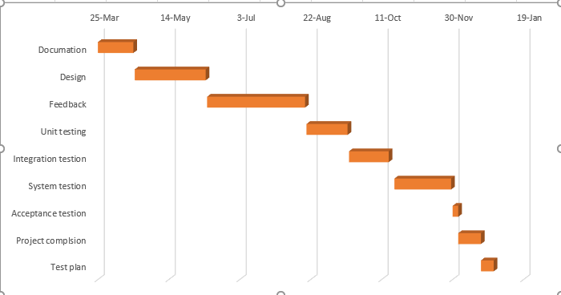

# PLANNING RISKS AND CONTINGENCIES

|  |  |  |
| --- | --- | --- |
| **Risk** | **Impact** | **Preparation** |
| **Change in requirements of clients:** Clients sometimes tend to change requirements out of nowhere. This is a huge problem and results in increase of development jobs as well as testing jobs. | High | Testing team members with knowledge of programming can start working to help developers. |
| **Budget issues:** Due to lack of resources or time, resources were hired that increases cost. The planning did not work as it was supposed to do. Third party involvement increases cost as a result overall budget increase. | High | Manage client about increase in payment. In case of system testing, use clients and get the worksdone. |
| **Inappropriate requirements understanding of the testing team lead:** As a result, the objection is totallyblur. | Medium | Manage two or three testing team members while discussing about the requirements specifications. |
| **Staff Shortage:** Incomplete works that results in delay of submission. | Medium | Use clients for testing wherever it is possible to ensure their satisfaction is met or not.  Hire resources based on the project’s progress. |
| **Lack of testing tools:** Advanced testing tools makes testing easier, less time consumption. | Medium | Talk with PM to arrange testing tools to make testing more efficient. |

.

# APROVALS

|  |  |
| --- | --- |
| Project sponsor – Sarah Khanom | Project Manager- Adel Kontar |
| Development Management – RifaTasfia | Project Manager- Mohamed Yoursry Moussa Hafez |
| EDI project Manager- PornaMondal | Project Manage- Gregory L Pittman |
| RS test manager – Shaon Ahmed | Project Manager-Amir Sajid |
| RS Development Team Manager | Project Manager- Muhammed Shafi Jalal |
| Reassigned Sales | Project Manager- Ravi Kumar |
| Order Entry EDI Team Manager | Project Manager- Melissa Panadevo |