10/9/2020

# **Developing the Software Development Project Management Plan**

## **For Dhaka Subway Automated Ticket Issuing System**

|  |  |  |
| --- | --- | --- |
|  | Group Members | ID |
| 01 | MD.Shaon Ahmed | 15-30027-2 |
| 02 | Sarder Abdullah | 17-35305-2 |
| 03 | MD.Riyad Ahmed | 17-35443-3 |
| 04 | Antu Saha | 17-35653-3 |
| 05 | MD.Sazzad Hossain | 17-35652-3 |

# **Revision History**

|  |  |  |  |
| --- | --- | --- | --- |
| Revision | Author | Description | Date |
| D.S.0.1 | Shaon Ahmed | First Draft | 10 September 2020 |

# **Introduction**

This is the documentation of the software project management plan for Dhaka Subway (DS) automated ticket issuing system. This Software Project Management Plan will be explaining the software development lifecycle which our group members will take to complete the projected software product. This document will try to cover detailed information about management plan used to this project. The intended audiences for this document are the designers and the people of IT department. It specifies technical and marginal approaches to develop the software product. All technical and managerial activities required to turn over the deliverables to Dhaka Subway (DS) Systems Management. This includes scheduling, identification of tasks, and factors that may impact the project and planning.

# **Process Model**

For Process model agile method is comfortable for our project. The agile method helps to deliver features at a faster rate. Also, the development model also stays connected with clients throughout the project. The continuous connection between Software Team and stakeholders helps to get feedback at a rapid rate. Essentially it helps validate the requirements. Again the Incremental process model helps to reduce risk since agile development technique to encourage active user, the customer. In this way, we see the reasonable perspective of the advancement Progress and furthermore the necessities.

# **Quality Gate for each phase of Software Development:**

|  |  |
| --- | --- |
| Product | SQA Methods |
| Software Project Management Plan | Inspection |
| Scheduling | Inspection |
| Designing |  |
| Testing |  |
| Coding | Code Review / Inspection |
| System testing | Test Coverage Measurement |
| Acceptance Testing | By actual users |
| Alpha test | 2/3-week field test |
| Beta test | 3-week field test |

# **List of Task**

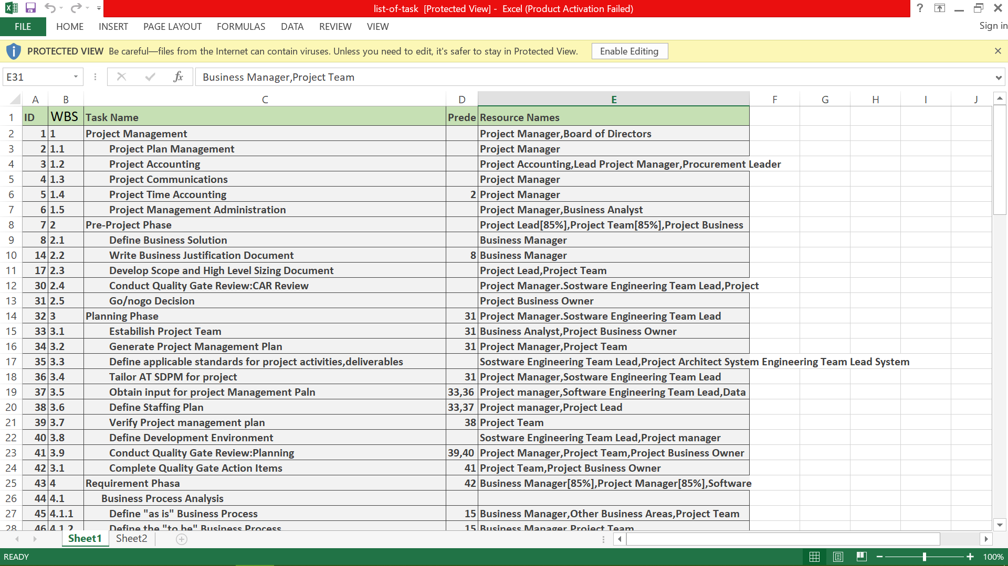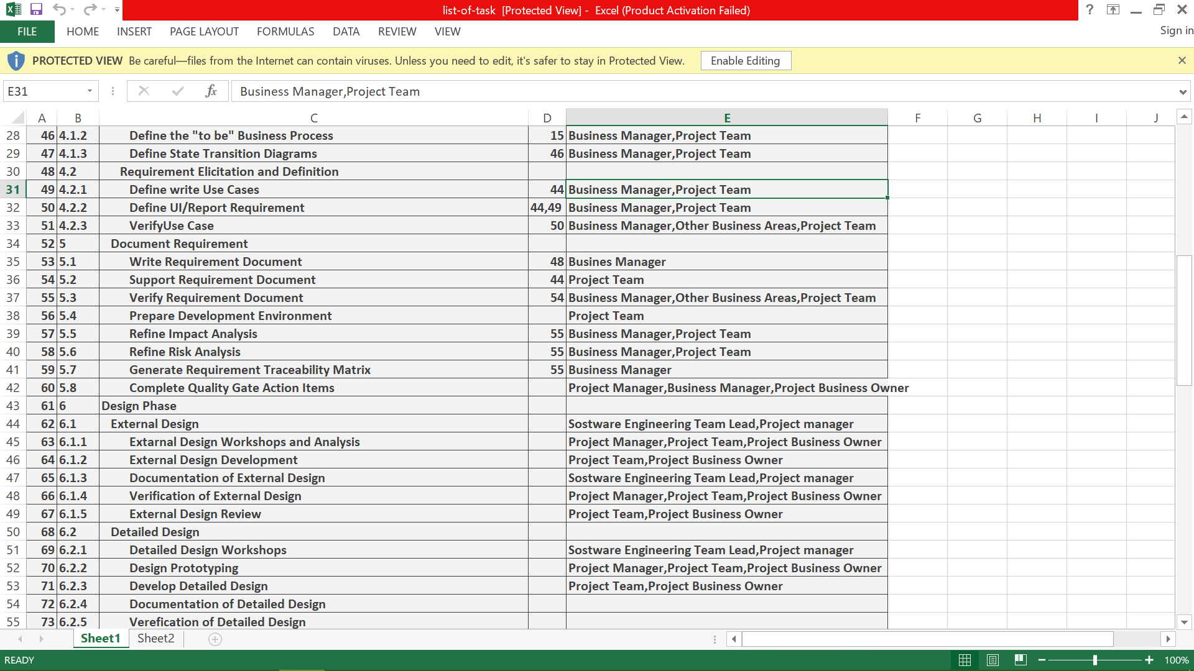

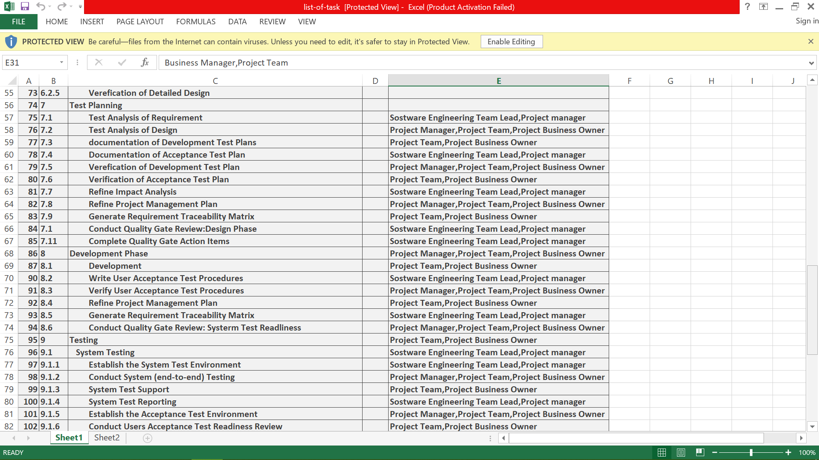

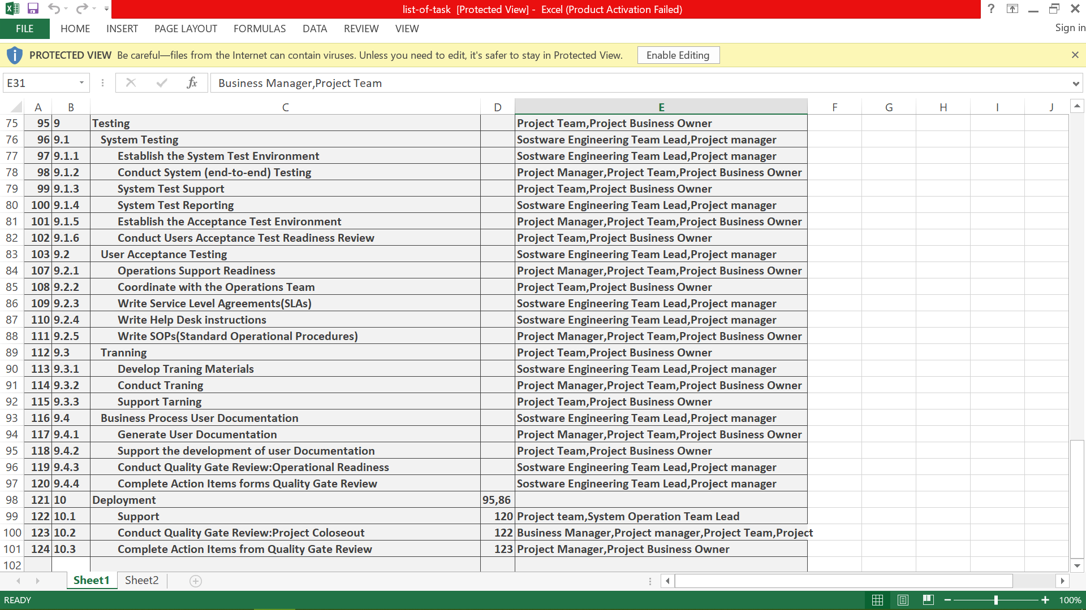

# **Estimation**

Object point

|  |  |  |  |  |
| --- | --- | --- | --- | --- |
| **object** | **count** | **complexity** | **Weight factor** | **Total object** |
| **Screen** | **15** | **Simple** | **1** | **15** |
| **Report** | **12** | **Simple** | **2** | **24** |
| **3GL components** | **0** | **N/A** | **N/A** |  |
|  |  | **Total object points:** |  | **39** |

**NOP= (object points)*[(100-%reuse)/100]**

**=39*[(100-20)/100]**

**=31.1 OP**

**We assume PROD=13 (Normal)**

**Effort=NOP/PROD =31.1/13=2.39 PM**

**Development time=2.5*(2.39) ^.38 =~3 M**

We assume that average salary of software engineer 30000 BDT.

**COST of the product 3*30,000=90,000 BDT**

# **Schedule Tasks**

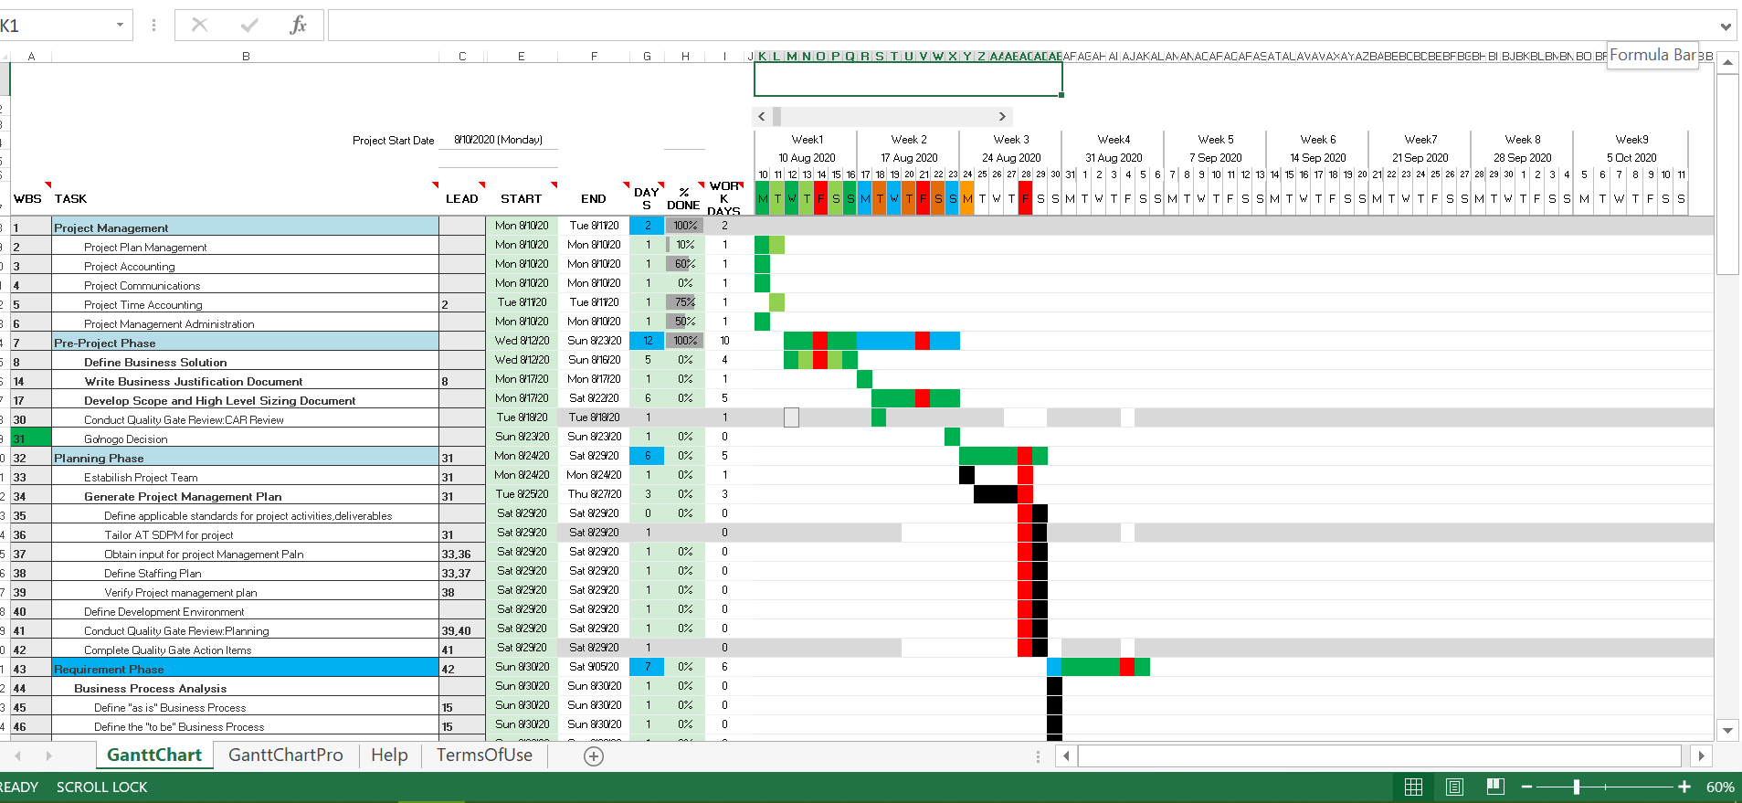

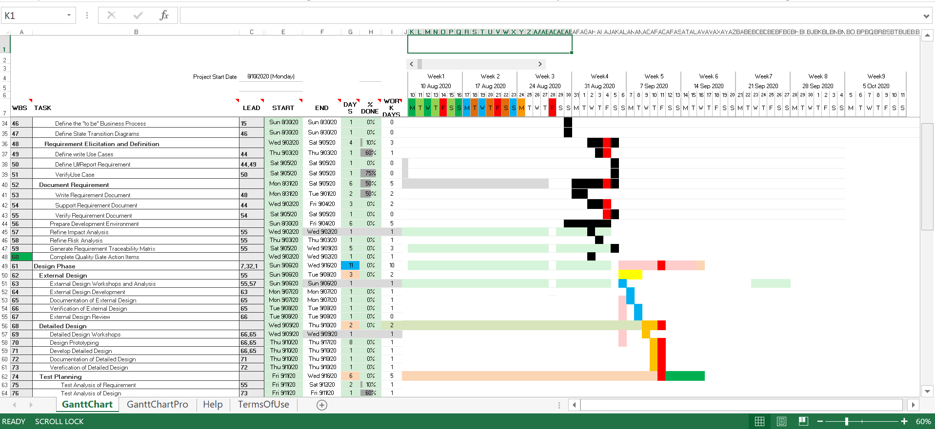

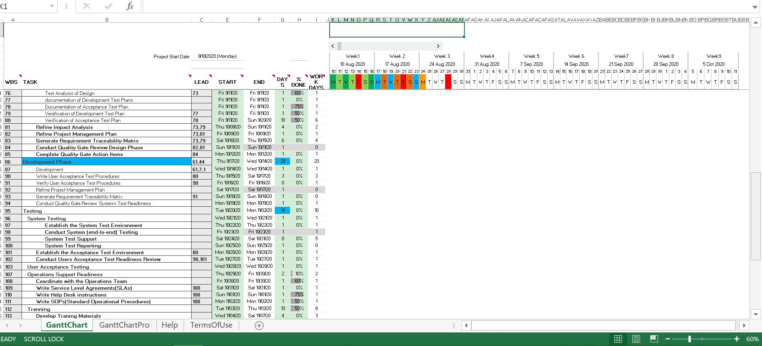

# **List of Major Milestones**

|  |  |  |
| --- | --- | --- |
| SL. | Date | Project Milestones |
| 1. | August 10 | Project Presentation |
| 2. | August 12– August 13 | Analysis Review |
| 3. | August 15 | Project Review |
| 4. | September 4 | Object Design Review |
| 5. | September 15 | Demo Software |
| 6. | September 30 | Internal Project Review (functional prototype) |
| 7. | October 15 | Project Acceptance |

# **Staffing Planning**

|  |  |  |  |
| --- | --- | --- | --- |
| No | Author | Assign | Backup |
| 1 | Shaon Ahmed | Project Manager | Sarder Abdullah |
| 2 | Sarder Abdullah | Test manager | MD Sazzad Hossain |
| 3 | Antu Saha | Developer | MD Riyad Ahmed |
| 4 | MD Riyad Ahmed | Designer | Sarder Abdullah |
| 5 | Shaon Ahmed | Tester | MD Sazzad Hossain |

# **Monitoring and Controlling Mechanism**

Monitoring of progress is done by the Project Manager (PM) using the following means:

* Weekly Project Meetings will take place at the lead Project Manager’s room.
* Meetings are held on Monday at 11 am and inform each of the progress made on the various tasks. New tasks are assigned by the Project Manager during these meetings. Before project group meetings, the Project Manager will review previous meetings and compose an agenda for the meeting. Team members can purpose additional agenda points before or during the meeting.
* These meetings are scheduled once a week. During these meetings, the project manager and Quality Assurance Manager meet with the Senior Management. The following things need to be, done before a progress meeting:
  + A progress report of the last reporting period is written by the Project Manager.
  + The Project Manager and The Quality Assurance Manager read minutes of the previous meeting.

A hard copy version of the progress report is delivered to the senior management.

# **List of Deliverables**

|  |  |  |
| --- | --- | --- |
| No | Item Description | Date |
| 1 | Details of requirement document | 10 August, 2020 |
| 2 | Details of design document | 15 August, 2020 |
|  | Software development | 20 August, 2020 |
| 4 | System Testing | 2 September,2020 |
| 5 | User Acceptance Testing | 15 September,2020 |
| 4 | Alpha version of the software | 25 September, 2020 |
| 5 | Beta version | 1 October, 2020 |
| 6 | Final version | 15 October, 2020 |
| 7 | User guide | 15 October, 2020 |

# **Risk Management:**

|  |  |  |  |
| --- | --- | --- | --- |
| Risk No | Description | Probability | Impact |
| Risk ID:1 | Software team does not do a good job with database management. There might be database design issues. | 40% | Medium |
| Risk ID:2 | Cost increase | 60% | High |
| Risk ID:3 | Project contains bug | 85% | High |
| Risk ID:4 | Delay to distribute components | 30% | Medium |
| Risk ID:5 | Security system | 60% | High |
| Risk ID:6 | Project quality | 45% | Medium |
| Risk ID:7 | Unable to acquire hardware & software tools | 40% | Medium |

# **Defect Tracking Process**

We use online tools **“Jira Software”** for defect tracking

# **Metrics**

|  |  |  |  |  |  |
| --- | --- | --- | --- | --- | --- |
| **Item** | **Description** | **Price** | **Quantity** | **Time length** | **Total (Est.)** |
| 1 | Hardware |  |  |  | 6,000,00 |
|  | Processor core i7 | - | 50 | 8 months |  |
|  | Hard disk - 1T | - | 50 | 8 months |  |
|  | RAM - 8 GB | - | 50 | 8 months |  |
|  | Graphics card | - | 50 | 8 months |  |
|  | Mouse & keyboard | - | 60 | 8 months |  |
|  | Monitor – 22’ | - | 50 | 8 months |  |
|  | Others | - | 50 | 8 months |  |
|  |  |  |  |  |  |
| 2 | Software |  |  |  | 1,500,00 |
|  | License | - | 1 | 8 months |  |
|  | Developing tools | - | 1 | 8 months |  |
|  | Testing tools | - | 1 | 8 months |  |
|  | others | - | 1 | 8 months |  |
|  |  |  |  |  |  |
| 3 | Personal |  |  |  |  |
|  | Project manager | 2,50,000 | 1 | 8 months | 2,000,00 |
|  | Functional manager | 70,000 | 10 | 8 months | 5,600,00 |
|  | Engineers | 40,000 | 80 | 8 months | 25,600,0 |
|  | Stuff | 25,000 | 150 | 8 months | 30,000,0 |
|  | Office rent | 70,000 | - | 8 months | 5,60,00 |
|  |  |  |  |  |  |
| 4 | Others | - | - | 8 months | 10,000,0 |
|  | Total | - | - | - | 2,222,000 |

# **Postmortem**

We faced many problems such as time estimation problem, cost estimation problem, schedule problem, budget problem, etc. We saw that the most money goes into design phase although at first, we thought development would have taken more money. Also, we found out risks to this project. If database engineers cannot do his job efficiently to design the software, the risk impact is much higher. We learned many small things from this project like time management, resource management. We have applied tools for solving this problem. Last of all project, future projects of the same kind will be better in future because we have collected the matrices. Also, the risk will be lesser.