

American International University-Bangladesh (AIUB)  
**Department of Computer Science  
Faculty of Science &Technology (FST)  
Summer 19_20**

## < Bangladesh Railway Automated Ticket Issuing System>

Software Requirement Engineering

Sec: **A**

Project submitted

By

*Ahmed MD Shaon (15-30027-2)*

*Chowdhury Sarihan (16-32800-3)*

*Mahamudul Hasan(17-33321-1)*

*Antu Saha (17-35653-3)*

## Bangladesh Railway Automated Ticket Issuing System

* 1. **Background to the Problem**
* Write the background description that helps putting the project into the right context of a problem domainand gives everyone involved a common view of the project
* What is the root cause of this problem? Why this problem is so important to consider?
  1. **Solution to the Problem**

We are going to propose an embedded Software solution where we develop a Web portal for online Ticket issuing and also a machine set up in the railway station so that people can use the machine for Ticket issuing and also do payment by their credit/debit card or online payment getaways. For this project people can easily buy ticket and tracking the train schedule and with the train track device people can see where the train is and the destination of train. it’s helps people lot to budget and maintain to their time table and they don’t need to time kill and wait for the long time and it’s also avoid and don’t need to gathering in front the railway ticket counters and don’t need to wait for a long time in lines to collect the ticket.

An automated ticket issuing system sells Railway tickets. Users select their destination, and input a credit card and a PIN (personal identification number) number. The railway ticket is issued and their credit card account charged with its cost. When the user presses the start button, a menu display of potential destinations is activated along with a message to the user to select a destination. Once a destination has been selected, users are requested to insert their credit card. Its validity is checked and the user is then requested to input a PIN number. When the credit transaction has been validated, the ticket is issued. It can also happen in online web portal and the train id number provide the customer so that they can track the trains destination and It’s also provide customer to verify their ticket and they can also payment by online with credit/debit cards and online payment getaways that’s support in our country.

There are a Web portal For Online Train ticket Issuing in Bangladesh railway (<https://www.esheba.cnsbd.com/#/>) but it’s hardly see the vendor machine system in our county railway stations. Bangladesh railway ticket issuing web portal don’t provide a train tracking device that can’t help customer to see the destination of train by google map

1. **SOLUTION DESCRIPTION**
   1. **System Features**

**The software has the following set of requirements:**

* The software will support interface to touch screen monitors as well as keyboard interface.
* The software will support display of the list of incoming trains, their destinations and arrival and departure times, fare, expected travel time
* The software will support multiple ticket purchase simultaneously.
* The software will support limiting the number of tickets purchased at the same time. This privilege control will be done by the administrator access only.
* The software will support ticket cancellation before final confirmation of the purchase.
* The software will support purchased ticket cancellation by the administrator.
* The software will support credit card transaction and validation.
* The software will support online payment gateway that support in our country.
* The software will support transaction using bill(taka) /coin
* The software will support next and previous navigation during ticket purchase process.
* The software will support ticket availability information.
* The software have also an online web portal that can easily access and use the most functionality
* The software will support information display via web.
* The software will tracking the train destination bye google map.

The major functionalities of the system are as follows:

* 24/7 service
* Ticket availability information display
* Train arrival and departure time display
* Touch screen menu selection
* Source and destination selection
* Multiple ticket issue in one transaction
* Limit the number of ticket issue at the same time
* Cancellation of transactions any time during transaction
* Credit card transaction
* Online payments gateway that’s support in our country

1. **Social Impact**

Its helps the society with the advancement of Bangladesh railway. Society will benefited by the system and people can easily and comfortably collect the ticket and faith to Bangladesh Railways and don’t need to buying ticket with high price and black ticket that’s available in ours station and also is price is high. People can collect ticket any time use the vendor and don’t need to wait in the lines Mostly people can save their time and don’t need to wait for a long time in the stations. After all it’s can be possible the railway is become to our main and popular transport for availability ticket and maintains time schedule because in the modern era Time is most valuable thing.

1. **Development Plan**

In your document you should provide proper development plan that presents in every SDLC including project schedule.

This is the documentation of the software project management plan for Bangladesh Railway automated ticket issuing system. This Software Project Management Plan will be explaining the software development lifecycle.This document will try to cover detailed information about management plan used to this project. It specifies technical and marginal approaches to develop the software product. This includes scheduling, identification of tasks, and factors that may impact the project and planning.

# **Process Model**

For Process model agile method is comfortable for our project. The agile method helps to deliver features at a faster rate. Also, the development model also stays connected with clients throughout the project. The continuous connection between Software Team and stakeholders helps to get feedback at a rapid rate. Essentially it helps validate the requirements. Again the Incremental process model helps to reduce risk since agile development technique to encourage active user, the customer. In this way, we see the reasonable perspective of the advancement Progress and furthermore the necessities.

**List of Task**

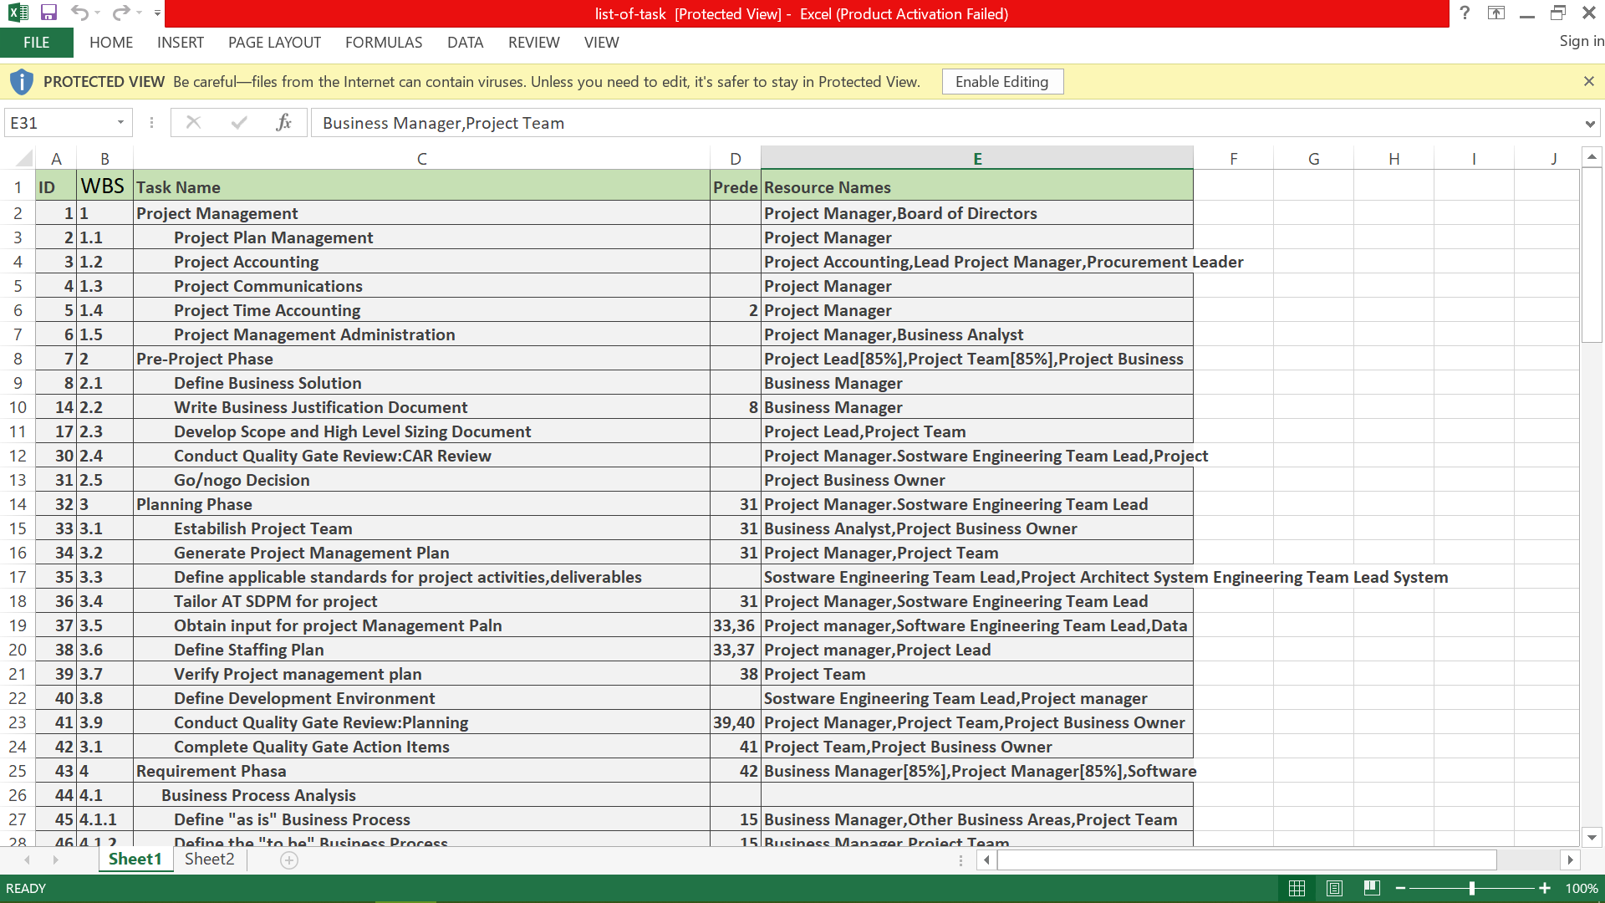

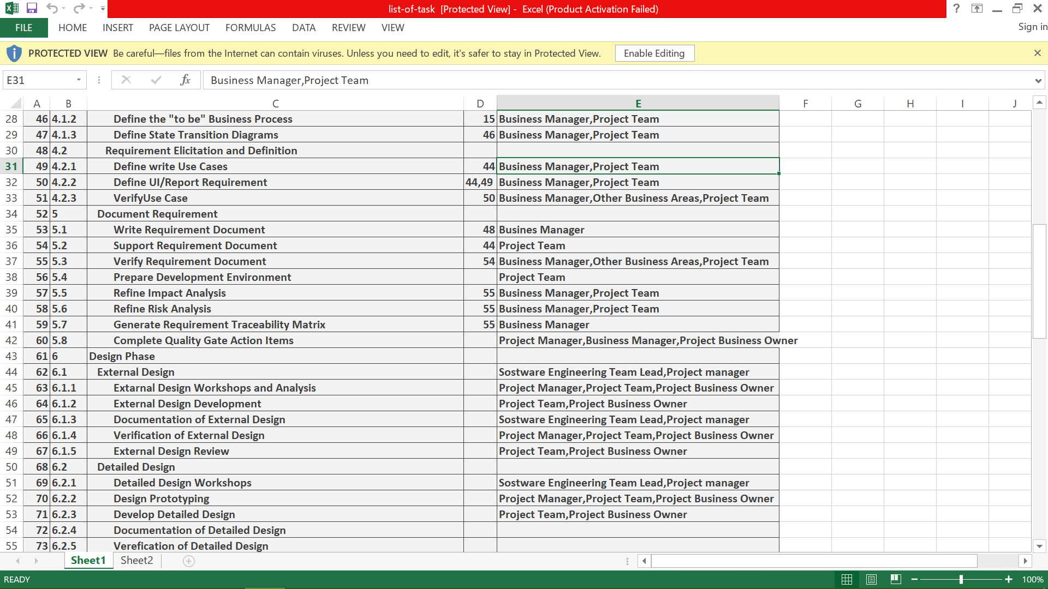

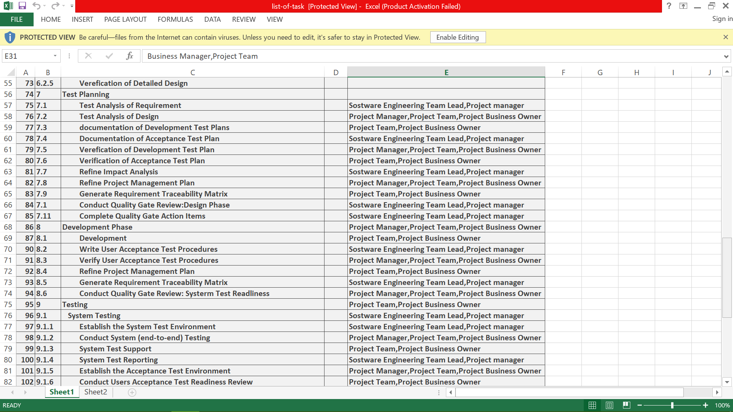

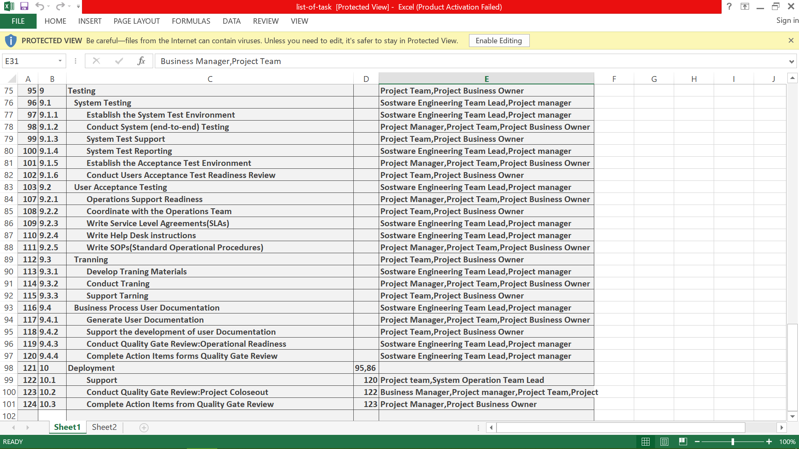

# **Schedule Tasks**

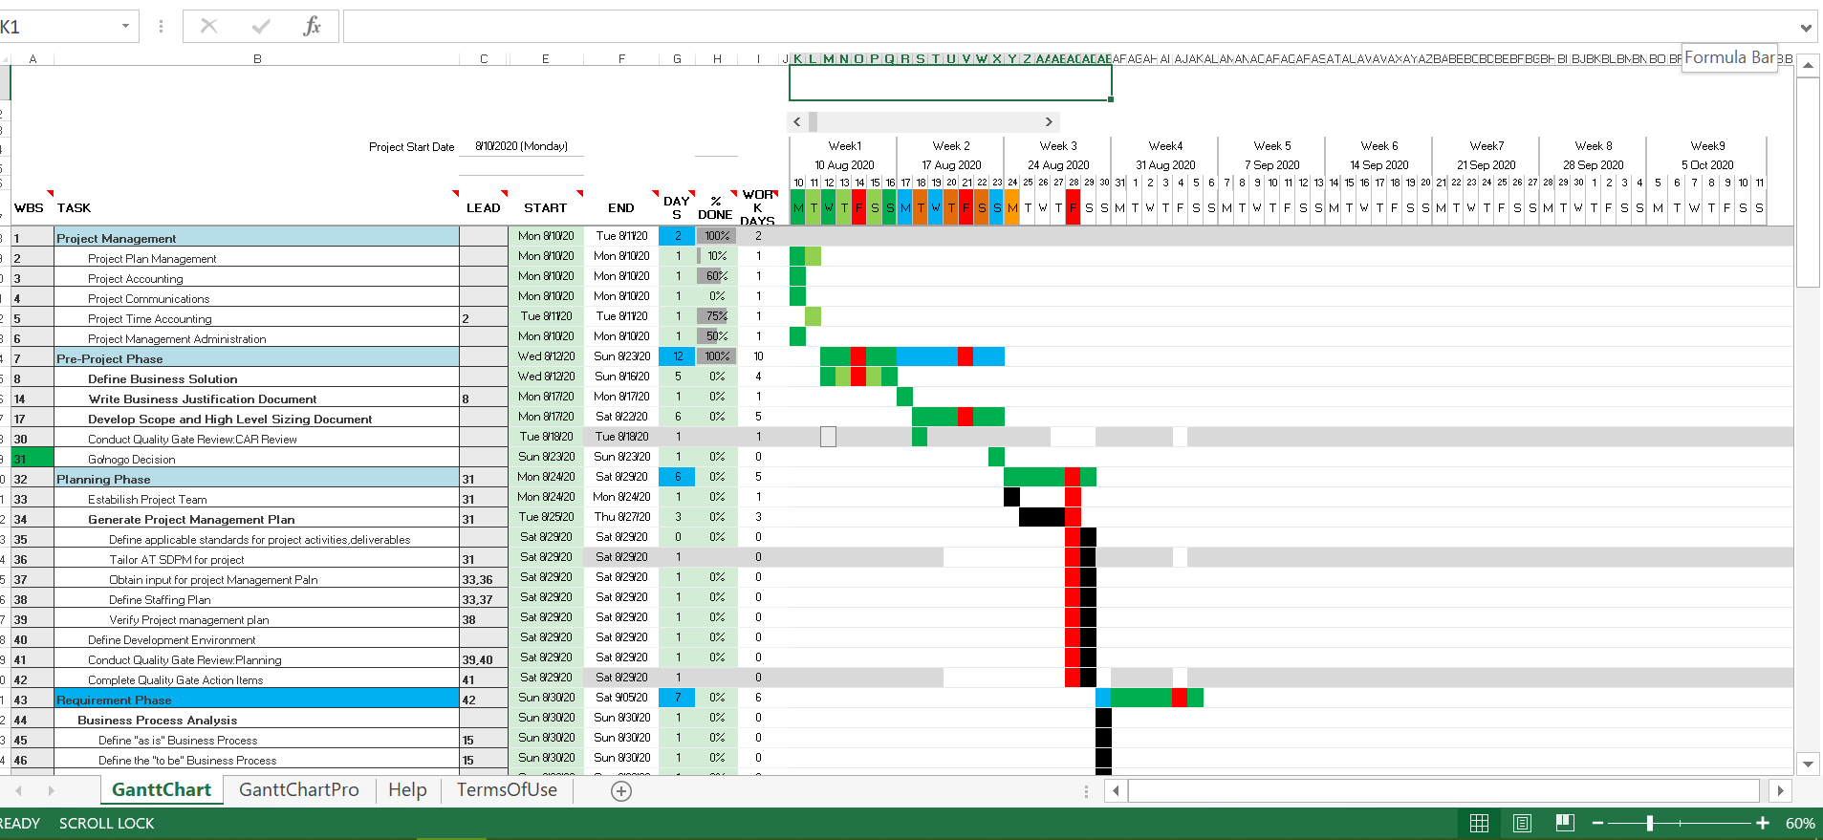

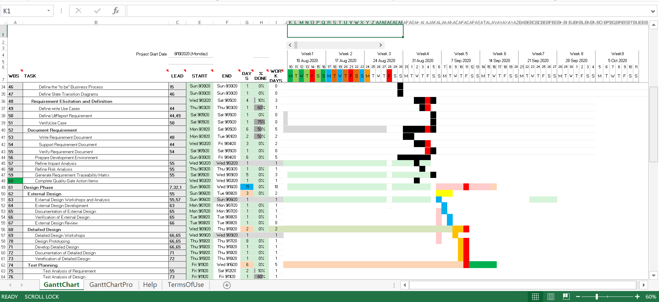

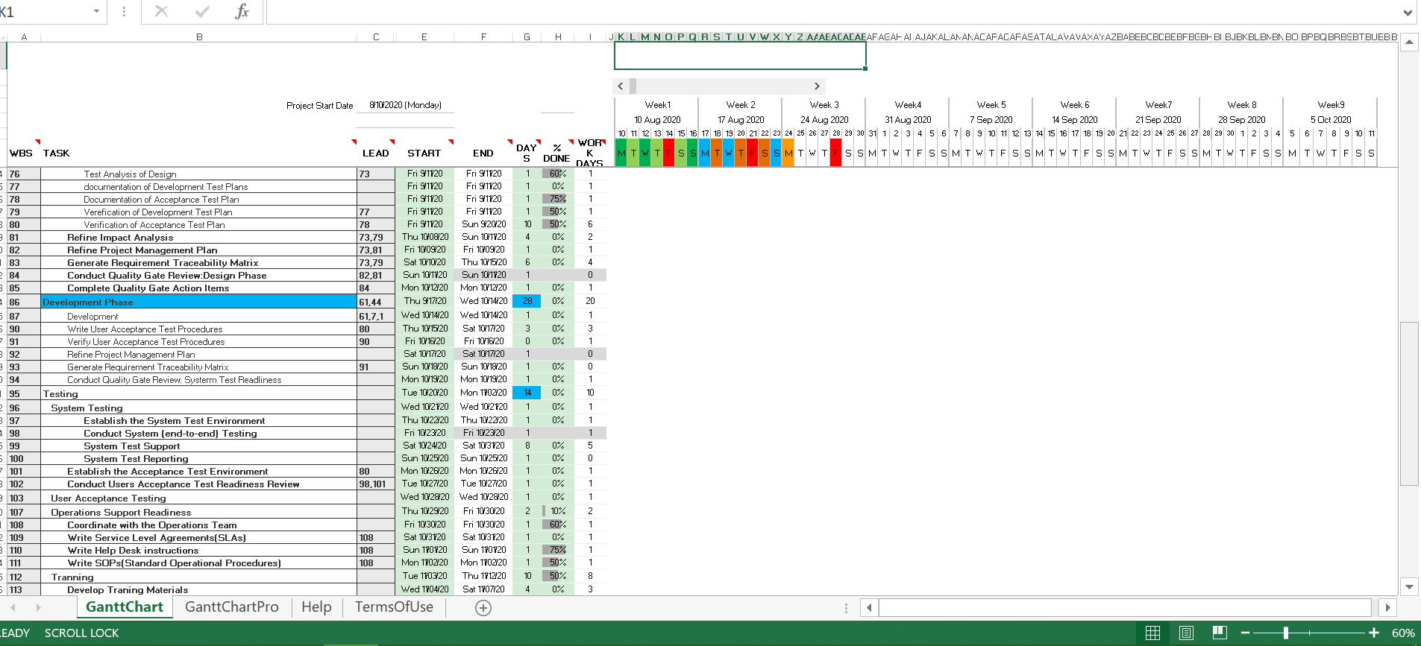

# **Estimation**

COCOMO II estimation

|  |  |  |  |  |
| --- | --- | --- | --- | --- |
| **object** | **count** | **complexity** | **Weight factor** | **Total object** |
| **Screen** | **15** | **Simple** | **1** | **15** |
| **Report** | **12** | **Simple** | **2** | **24** |
| **3GL components** | **0** | **N/A** | **N/A** |  |
|  |  | **Total object points:** |  | **39** |

**NOP= (object points)*[(100-%reuse)/100]**

**=39*[(100-20)/100]**

**=31.1 OP**

**We assume PROD=13 (Normal)**

**Effort=NOP/PROD =31.1/13=2.39 PM**

**Development time=2.5*(2.39) ^.38 =~3 M**

We assume that average salary of software engineer 30000 BDT.

**COST of the product 3*30,000=90,000 BDT**

# **Monitoring and Controlling Mechanism**

Monitoring of progress is done by the Project Manager (PM) using the following means:

* Weekly Project Meetings will take place at the lead Project Manager’s room.
* Meetings are held on Monday at 11 am and inform each of the progress made on the various tasks. New tasks are assigned by the Project Manager during these meetings. Before project group meetings, the Project Manager will review previous meetings and compose an agenda for the meeting. Team members can purpose additional agenda points before or during the meeting.
* These meetings are scheduled once a week. During these meetings, the project manager and Quality Assurance Manager meet with the Senior Management. The following things need to be, done before a progress meeting:
  + A progress report of the last reporting period is written by the Project Manager.
  + The Project Manager and The Quality Assurance Manager read minutes of the previous meeting.

A hard copy version of the progress report is delivered to the senior management.

# **List of Deliverables**

|  |  |  |
| --- | --- | --- |
| No | Item Description | Date |
| 1 | Details of requirement document | 10 August, 2020 |
| 2 | Details of design document | 15 August, 2020 |
|  | Software development | 20 August, 2020 |
| 4 | System Testing | 2 September,2020 |
| 5 | User Acceptance Testing | 15 September,2020 |
| 4 | Alpha version of the software | 25 September, 2020 |
| 5 | Beta version | 1 October, 2020 |
| 6 | Final version | 15 October, 2020 |
| 7 | User guide | 15 October, 2020 |

# **Risk Management:**

|  |  |  |  |
| --- | --- | --- | --- |
| Risk No | Description | Probability | Impact |
| Risk ID:1 | Software team does not do a good job with database management. There might be database design issues. | 40% | Medium |
| Risk ID:2 | Cost increase | 60% | High |
| Risk ID:3 | Project contains bug | 85% | High |
| Risk ID:4 | Delay to distribute components | 30% | Medium |
| Risk ID:5 | Security system | 60% | High |
| Risk ID:6 | Project quality | 45% | Medium |
| Risk ID:7 | Unable to acquire hardware & software tools | 40% | Medium |

# **Defect Tracking Process**

The online database server will be kept up to follow HD quality counter will be utilized to monitor deserts. Using some software for bug tracking. Finding the problem and solve it.

**Marketing Plan**

In your document you should provide proper marketing plan that will make your idea popular among the community so that you can make business. Marketing plan should have short term, long term and continuous plan.

**Cost and Profit Analysis**

In your document you should provide proper cost analysis including development and marketing cost. Then you can show profit analysis. Based on your profit analysis investors will be agreed to invest on your idea.