Uncertainty-Aware Trade Execution: Conformal Gating versus Reinforcement Learning for VWAP-Benchmarked Order Scheduling
Asadullah Irshad¹ and Shaon Biswas¹
¹ Centre of Excellence for Data Science, Artificial Intelligence and Modelling (DAIM), University of Hull, UK
Corresponding author: Asadullah Irshad, Email: asadullahirshad3@gmail.com
Both authors completed the MSc (Distinction) in Artificial Intelligence and Data Science at the University of Hull, affiliated with the DAIM Centre of Excellence. This study was conducted independently and did not receive funding or resources from the Centre.
Abstract. Optimal trade execution, the problem of scheduling a large parent order over a trading session so as to minimise cost against a benchmark, is a sequential decision task that appears well suited to learning-based control. Yet a good deal of the reported progress fails to reproduce. We study the volume-weighted average price (VWAP) execution problem in a controlled and fully reproducible simulator with stochastic volatility and AR(1) return momentum. Within a single Markov decision process formulation, we compare classical schedules (TWAP, Almgren–Chriss, VWAP-tracking), a proximal-policy-optimisation (PPO) agent, and forecast-driven policies built on a normalised split-conformal predictor of next-interval returns. The predictor attains valid marginal coverage, 90.2% empirical at a 90% nominal level. Acting on its point forecast lowers mean slippage below VWAP-tracking but inflates cost variance. Gating those bets by the conformal interval half-width instead yields a tunable and monotone reduction of cost variability, from 19.1 to 10.0 bps, at negligible mean cost, tracing an explicit cost–risk frontier controlled by a single threshold. The PPO agent, evaluated over three training seeds, is high-variance and does not reliably dominate the simple schedules. In this controlled setting, a distribution-free conformal gate thus offers a more reproducible and interpretable route to uncertainty-aware execution than an off-the-shelf reinforcement-learning agent. All code and the simulator are released. On real intraday data (thirty US large-caps, 5-minute bars) the predictor’s coverage transfers closely (90.7% empirical at the 90% level) and the variance-reduction effect of gating persists, although the forecast edge itself is small, since real high-frequency returns are only weakly predictable.
Keywords: optimal execution; VWAP; conformal prediction; uncertainty quantification; reinforcement learning; Markov decision process; market microstructure.
1. Introduction
For an institutional desk, the question is rarely whether to trade. The position has usually been decided already, and what remains is an operational problem: how to trade it. Pushed into the market too quickly, an order moves the price against itself through market impact. Worked too slowly, it is left exposed to adverse price drift over the execution horizon. Algorithmic execution lives between these two costs, and the volume-weighted average price (VWAP) is among the most common benchmarks against which the quality of that trade-off is judged.
Since execution is a sequential decision made under uncertainty, it is a natural candidate for reinforcement learning (RL), and a large body of work now applies deep RL to trading and execution (Nevmyvaka et al., 2006; Lin & Beling, 2020; Ning et al., 2021; Hambly et al., 2023; Macrì & Lillo, 2024). A recurring criticism, however, is that the reported gains are hard to reproduce. Experimental settings differ from paper to paper, market-impact assumptions are often left unstated, and conclusions frequently rest on a single training run. We take the opposite stance here and ask a narrower question: which approaches deliver cost reductions that are robust, controllable, and reproducible, the properties an execution desk actually cares about?
This paper makes three contributions. First, we release a compact, self-contained execution simulator with stochastic volatility and AR(1) momentum, in which short-horizon returns are partially predictable but carry time-varying uncertainty. Second, we construct a normalised split-conformal predictor of next-interval returns whose distribution-free interval width tracks local volatility, and we use that interval to gate forecast-driven trading. Third, we place classical schedules, a multi-seed PPO agent, and the conformal policies on a common cost–risk frontier for a like-for-like comparison. The central finding is that the conformal gate converts an unstable forecast edge into a tunable variance reduction, and does so more reliably than the learned agent.
2. Related Work
Classical execution theory treats the problem as a trade-off between impact and risk. The Almgren–Chriss framework derives a deterministic trajectory that is optimal under a mean–variance objective with linear impact (Almgren & Chriss, 2001) and remains the standard academic baseline; it builds on the earlier optimal-control formulation of execution cost of Bertsimas & Lo (1998). Later work refined how impact and its resilience are modelled (Obizhaeva & Wang, 2013; Gatheral, 2010), while VWAP- and TWAP-tracking became the dominant practitioner heuristics (Cartea et al., 2015). On the learning side, RL for execution spans value-based, actor–critic, and risk-sensitive variants (Nevmyvaka et al., 2006; Lin & Beling, 2020; Ning et al., 2021; Nagy et al., 2023; Macrì & Lillo, 2024), and recent surveys document the rapid growth of the area alongside persistent concerns about inconsistent evaluation and overly optimistic frictions (Sun et al., 2023; Hambly et al., 2023; Cartea et al., 2023). Conformal prediction, for its part, provides distribution-free, finite-sample coverage for an arbitrary predictor (Vovk et al., 2005; Lei et al., 2018; Angelopoulos & Bates, 2023) and has since been extended to quantile regression (Romano et al., 2019), to time series (Stankevičiūtė et al., 2021; Xu & Xie, 2023), and to distribution shift (Tibshirani et al., 2019; Zaffran et al., 2022; Barber et al., 2023; Gibbs & Candès, 2024). Its use as an explicit gate on execution decisions, however, has received little attention. We connect these threads by using conformal intervals not to forecast direction for alpha, but to decide when a short-horizon timing signal is reliable enough to act on.
3. Methodology
Figure 1 summarises the method. At each interval, the market state feeds a gradient-boosted return predictor; a normalised split-conformal layer turns the resulting point forecast into a distribution-free interval; and a gate compares the forecast against the width of its own interval, then either acts on the signal or defers to the VWAP schedule. We detail each component below.
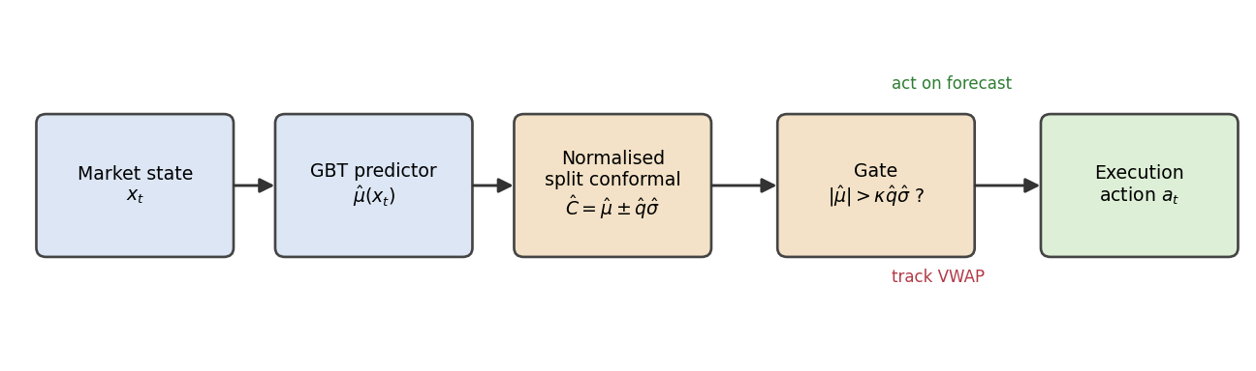
Figure 1. The uncertainty-aware execution pipeline: a return predictor feeds a normalised split-conformal interval, whose width gates whether the policy acts on the forecast or tracks VWAP.
3.1 Market simulator
Each episode is one trading session discretised into T intervals. The log-return carries an AR(1) momentum term and is driven by a stochastic-volatility process; the per-interval volatility follows a log-AR(1) path inducing volatility clustering:
where θ is the latent momentum state, h the log-volatility, and φ, ρ, β control momentum persistence, volatility persistence, and vol-of-vol respectively. Volume follows a U-shaped intraday profile with multiplicative noise, and the benchmark is the volume-weighted mean price:
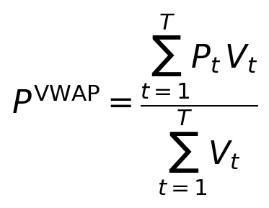
A representative session is shown in Figure 2. The conformal forecast band widens during volatile stretches and narrows in calm ones, so the width of the band is itself an informative signal rather than a fixed margin.
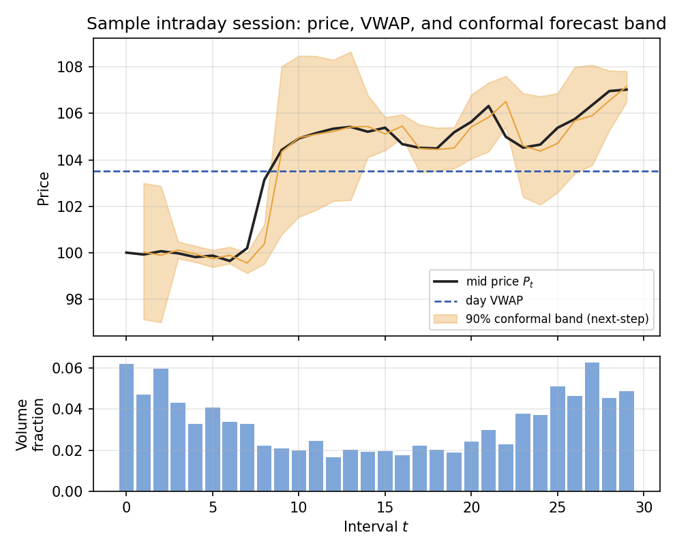
Figure 2. A sample intraday session. Top: mid price, day VWAP, and the 90% next-step conformal band, which widens in volatile periods. Bottom: the U-shaped market-volume profile.
3.2 Execution as a Markov decision process
The agent sells a parent order of Q shares over T intervals. We model this as a Markov decision process (S, A, P, r, γ) (Sutton & Barto, 2018). The state comprises the fraction of time and inventory remaining, recent return, relative interval volume, and price relative to arrival (with two optional conformal features, §3.5). The action is a log-multiplier on the VWAP-tracking quantity, so a value of zero reproduces volume-curve tracking; the executed quantity, participation-rate impact, and realised price are
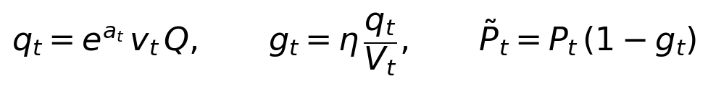
Here v is the volume fraction, V the interval market volume, and η the impact coefficient; the temporary impact is linear in the participation rate (Figure 3). Writing the per-trade implementation shortfall (Perold, 1988) against the arrival price P₀ as
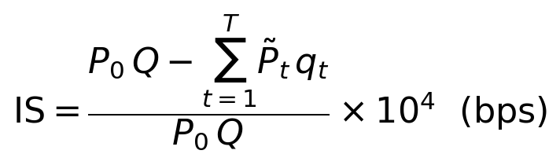
the execution problem is the constrained stochastic optimisation
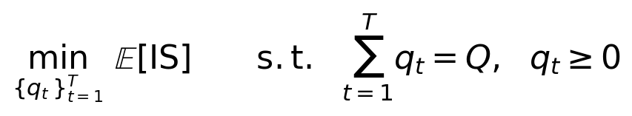
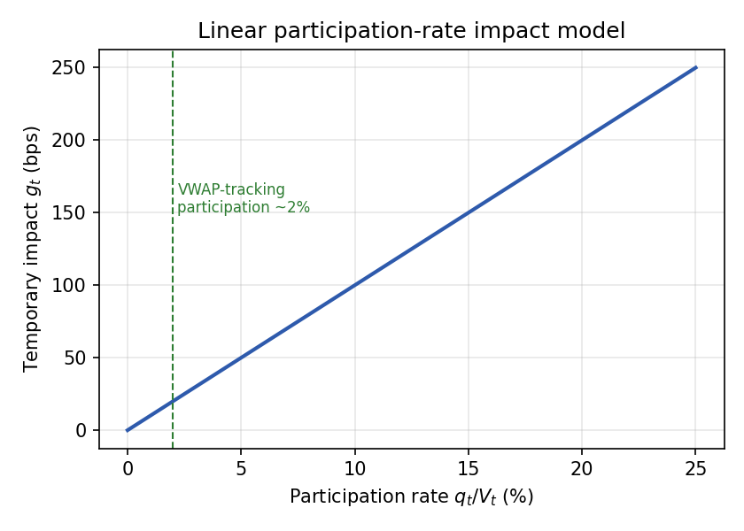
Figure 3. Temporary impact as a function of participation rate (η = 0.1). Trading a larger share of an interval’s volume is more expensive; VWAP-tracking holds participation low.
The reward combines the per-interval implementation-shortfall contribution (in basis points of the parent notional) with a volatility-scaled penalty on deviations from the VWAP schedule, representing the timing risk of a discretionary bet:
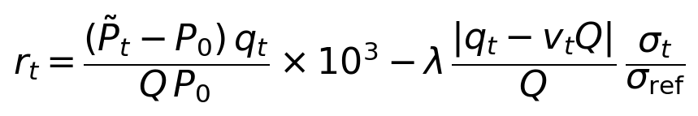
3.3 Classical baselines
Immediate liquidates at the open. TWAP executes equal slices. VWAP-tracking trades proportional to the volume curve. Almgren–Chriss minimises a mean–variance execution cost (Almgren & Chriss, 2001),
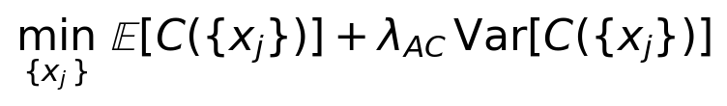
whose solution is the risk-averse closed-form trajectory
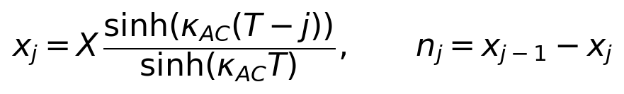
where the urgency parameter sets the degree of front-loading. We map each schedule into the common action parametrisation for an identical evaluation pipeline.
3.4 Normalised split-conformal predictor
We fit a gradient-boosted regressor that predicts the next-interval return from causal features: recent returns, a rolling volatility estimate, and time of day. Following the split-conformal construction of Lei et al. (2018), with a local normalisation in the spirit of conformalized quantile regression (Romano et al., 2019), we form normalised nonconformity scores on a held-out calibration set (Figure 4), take the conformal quantile, and obtain a prediction interval whose width scales with local volatility:
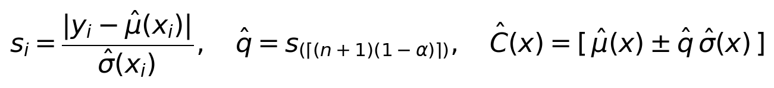
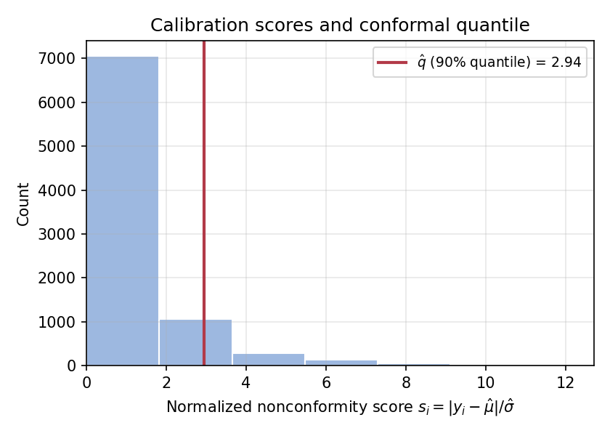
Figure 4. Distribution of normalised nonconformity scores on the calibration set; the 90% empirical quantile defines the conformal interval half-width.
Under exchangeability this construction satisfies the standard finite-sample coverage guarantee (Vovk et al., 2005; Lei et al., 2018), stated below.
Theorem 1 (marginal coverage). If the calibration scores and the test score are exchangeable, the prediction set satisfies
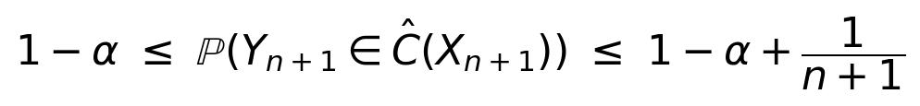
Proof sketch. Under exchangeability, the rank of the test score among the n calibration scores is uniform on {1, …, n+1}. Taking the conformal quantile as the ⌈(n+1)(1−α)⌉-th order statistic gives the lower bound, and the upper bound follows from the discreteness of the empirical quantile (Lei et al., 2018). Financial series, of course, violate exchangeability. We mitigate this with the local-volatility normalisation and verify coverage empirically (§5); online and non-exchangeable conformal variants (Gibbs & Candès, 2024; Zaffran et al., 2022; Xu & Xie, 2023; Barber et al., 2023) offer stronger guarantees under drift, and we return to them in the limitations.
Figure 5 reports empirical coverage against the nominal level on fresh simulated days. The curve tracks the diagonal closely, and at the operating point alpha = 0.1 the empirical coverage is 90.2%, confirming validity out of sample.
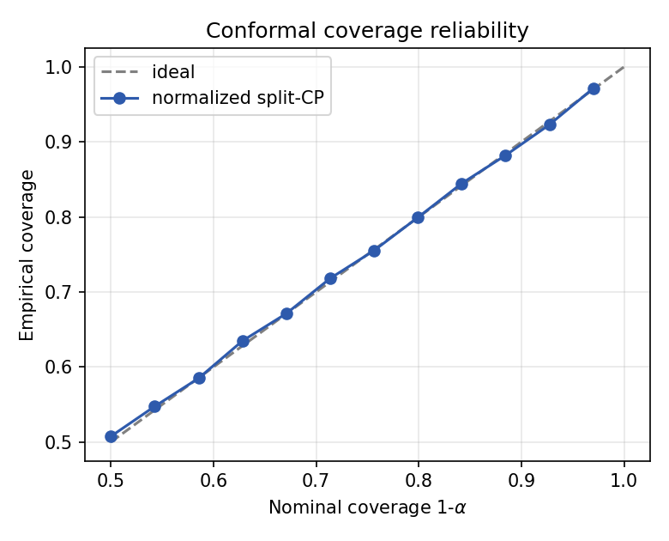
Figure 5. Conformal coverage reliability. Empirical coverage of the normalised split-conformal interval against the nominal level on held-out simulated days; closeness to the diagonal indicates calibration.
3.5 Forecast-driven and gated policies
Two policies make use of the predictor. Forecast-greedy tilts the schedule in the direction of the point forecast, irrespective of its uncertainty. Conformal-gated tilts only when the absolute forecast exceeds a multiple of the conformal half-width, that is, only when the signal escapes its own uncertainty band; otherwise it tracks VWAP:
The threshold acts as a single interpretable dial. A value of zero recovers Forecast-greedy, and large values recover VWAP-tracking. As Figure 6 shows, the fraction of intervals in which the gate fires falls as the threshold rises, making the policy progressively more conservative.
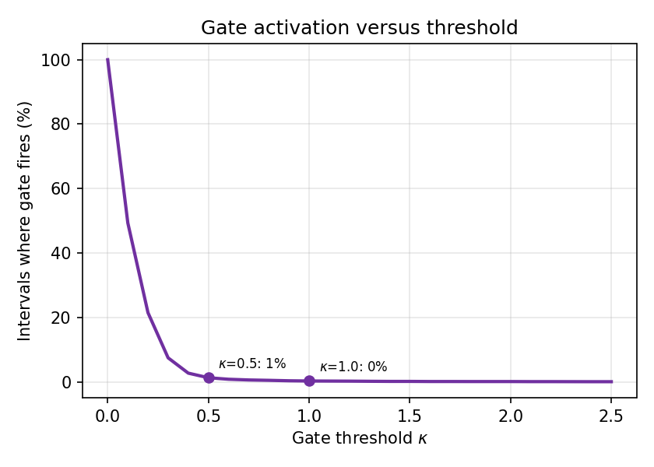
Figure 6. Gate activation versus threshold: the fraction of intervals in which the forecast escapes its conformal band, and the policy acts, decreases monotonically with κ.
4. Experimental Setup
All policies are evaluated on 250 held-out market seeds, disjoint from any training or calibration data. The PPO agent (Schulman et al., 2017) uses a two-layer network with normalised observations and rewards, is trained for 150,000 timesteps, and is trained independently with three seeds so that training-seed variability is exposed rather than hidden; its statistics pool every evaluation episode across the three agents. The headline metric is slippage versus VWAP, the gap between the achieved average execution price and the day’s VWAP, expressed in basis points:
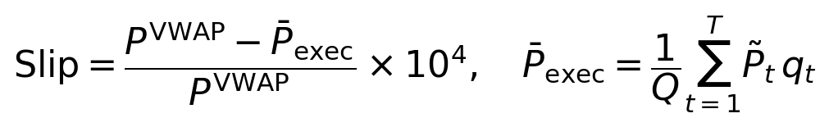
We report the Monte-Carlo mean and standard deviation of this quantity across the 250 episodes, which we read as cost and risk respectively, with 95% confidence intervals from a non-parametric bootstrap (2,000 resamples). Implementation shortfall against arrival is recorded as well. The conformal nominal level is fixed at 90% (alpha = 0.1).
5. Results
Table 1 summarises execution performance and Figure 7 plots each method on the cost–risk plane.
Table 1. Execution performance over 250 held-out seeds. Lower is better on both axes; conformal-gated rows highlighted.
Method | Slippage vs VWAP  mean (bps) | Slippage vs VWAP  std (bps) | Class
Immediate | 332.1 | 296.8 | Naive
TWAP | 25.1 | 38.0 | Schedule
Almgren–Chriss | 50.8 | 237.3 | Schedule
VWAP-tracking | 20.0 | 0.0 | Schedule
PPO (RL, 3 seeds) | 33.9 | 115.9 | Learned
Forecast-greedy | 17.0 | 19.1 | Forecast
Conformal-gated (κ=0.5) | 19.1 | 13.8 | Conformal
Conformal-gated (κ=1.0) | 19.4 | 10.0 | Conformal

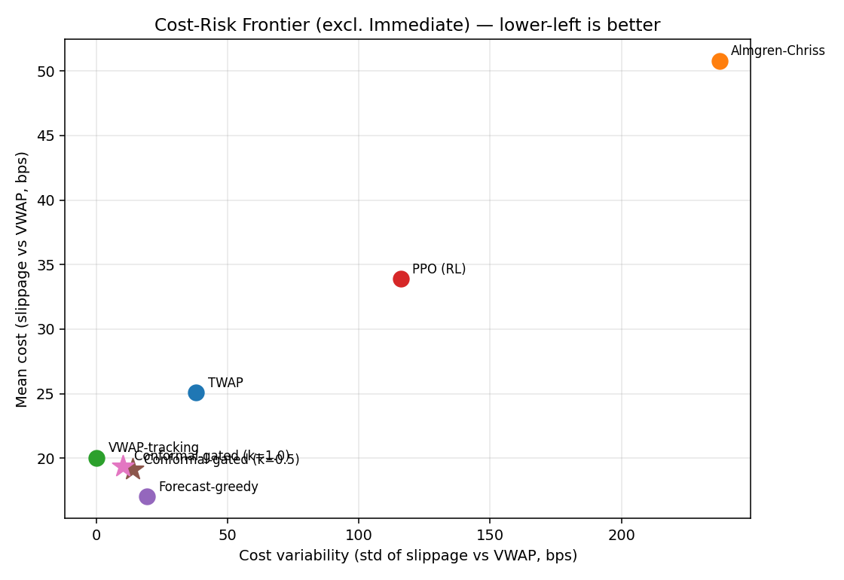
Figure 7. Cost–risk frontier (Immediate omitted for scale). Lower-left is better; conformal-gated policies (stars) sit at low variance with near-best mean cost.
Figure 8 reports the mean execution cost of each method with 95% bootstrap confidence intervals (2,000 resamples), which confirm that the ordering of mean costs is not an artefact of sampling.
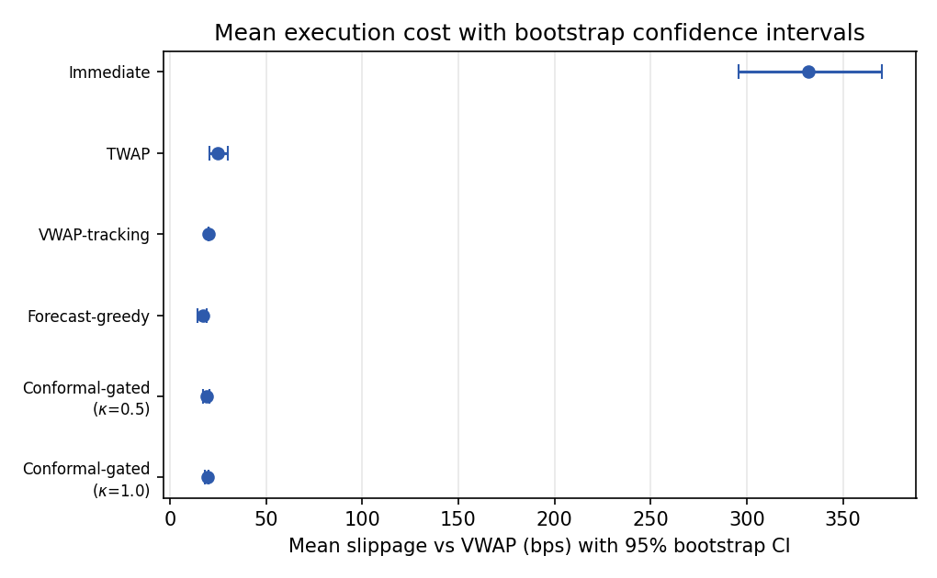
Figure 8. Mean slippage versus VWAP with 95% bootstrap confidence intervals over 250 held-out seeds.
Three patterns stand out. First, VWAP-tracking is a strong reference with essentially zero variance at 20.0 bps, because its only systematic cost is impact, and the volume-proportional schedule is precisely what minimises impact; TWAP and Almgren–Chriss are both worse, the latter markedly so, since front-loading ignores the volume curve and concentrates impact. Second, acting on the conformal point forecast (Forecast-greedy) lowers mean slippage to 17.0 bps, below VWAP-tracking, but at a substantial cost in variability (19.1 bps), because some of the timing bets are wrong. Third, gating those bets turns the edge into controllable risk reduction: variability falls monotonically from 19.1 bps with no gate to 13.8 bps at κ = 0.5 and 10.0 bps at κ = 1.0, with the mean held nearly constant. This reduction in dispersion is statistically significant (Wilcoxon signed-rank test on absolute deviations from the median, p < 10⁻³⁰).
Figure 9 makes the mechanism visible at the level of a single session. VWAP-tracking liquidates smoothly along the volume curve, the conformal-gated policy deviates only intermittently, when a confident signal appears, and Immediate exhausts the inventory at once. Figure 10 traces the full dial: sweeping the threshold moves the policy continuously from the aggressive, low-mean and high-variance regime of Forecast-greedy to the conservative, low-variance regime that approaches VWAP-tracking. In effect, the desk is handed a single knob with which to choose its operating point.
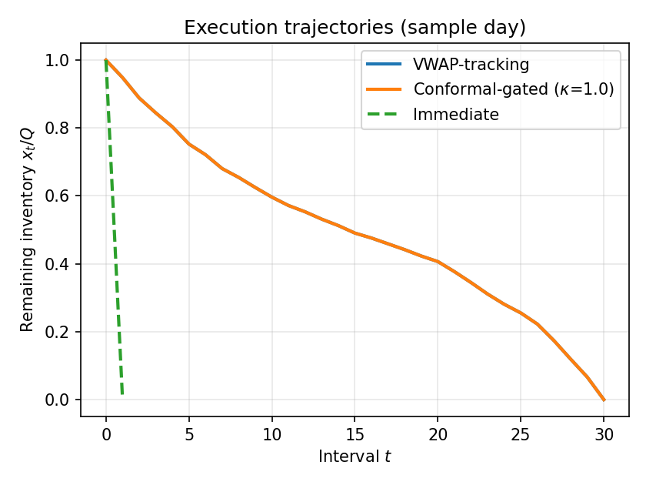
Figure 9. Execution trajectories on a sample session: remaining inventory over time for VWAP-tracking, Conformal-gated, and Immediate.
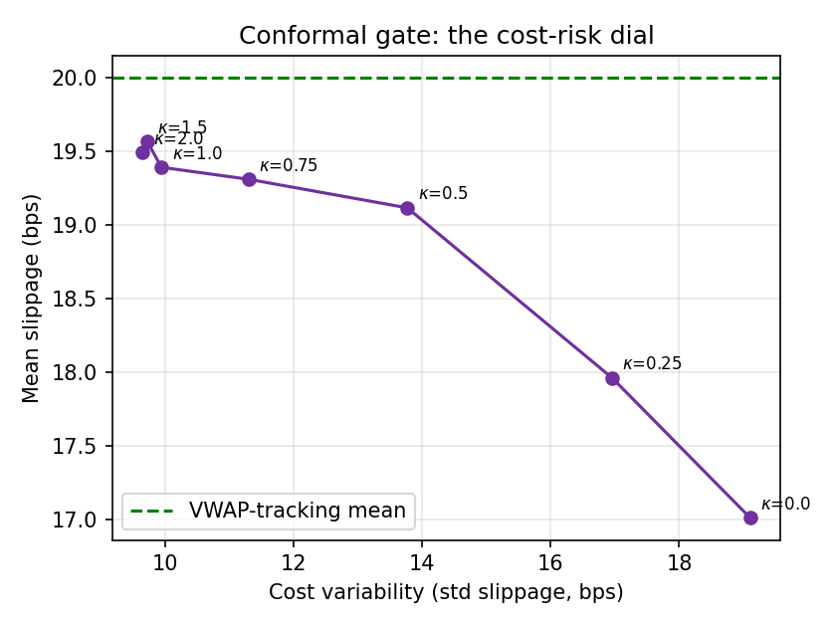
Figure 10. The conformal gate as a cost–risk dial. Sweeping the gate threshold traces a frontier from aggressive forecast-following to conservative tracking; dashed line marks the VWAP-tracking mean.
The PPO agent is a cautionary case. Pooled over three training seeds, it attains 33.9 bps mean slippage with a large standard deviation of 115.9 bps: worse on both axes than the strong volume-aware schedules (VWAP-tracking and TWAP), though it does improve on the front-loading Almgren–Chriss schedule. Individual runs ranged from competitive with VWAP-tracking to substantially worse, so any single-seed report would give a misleading impression. It is this instability, rather than a tuning artefact, that is the salient result.
6. Real-Data Validation
To test whether the simulator findings transfer, we re-ran the conformal pipeline on real intraday data: thirty large-capitalisation US equities, 5-minute bars over sixty trading days (about 1,800 ticker-days), bucketed into T = 13 intervals. The split into training, calibration, and test sessions is strictly time-ordered, 50/25/25, leaving 450 held-out test sessions, so that calibration never sees the future and there is no look-ahead. The intraday volume curve is now empirical rather than a synthetic U-shape. The market-impact model is left unchanged (linear in participation with fixed η), since it cannot be estimated from bar data; absolute slippage levels are therefore model-dependent, and only relative comparisons across policies should be read as meaningful.
The central result is that the predictor’s coverage transfers to real markets. At the 90% nominal level, empirical coverage on the held-out real sessions is 90.7%, and the reliability curve (Figure 11) tracks the diagonal across the full range of nominal levels. Since real intraday returns are non-exchangeable, this validity is not guaranteed a priori, and its empirical confirmation is the key real-data finding. It also answers the concern that coverage in the synthetic study held only because exchangeability was true by construction.
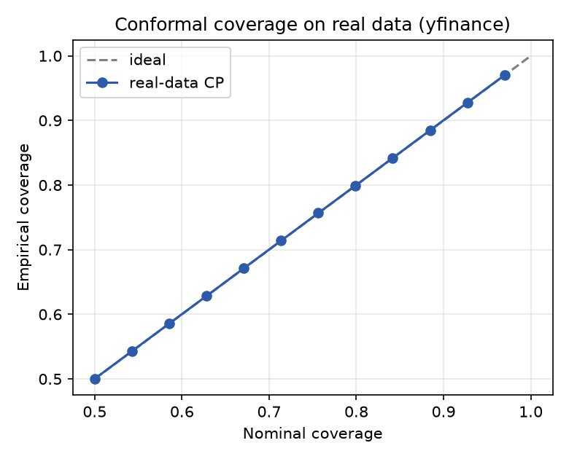
Figure 11. Conformal coverage on real intraday data (30 US large-caps, 5-minute bars, 450 held-out sessions). Empirical coverage tracks the nominal level closely across the range, including 90.7% at the 90% operating point.
Execution performance on the real test sessions is reported in Table 2 and Figure 12. The variance-reduction mechanism survives: gating lowers the standard deviation of slippage from 2.60 bps (Forecast-greedy) to 2.06 bps at κ = 1.0, a 21% reduction, while VWAP-tracking again provides the zero-variance reference. The forecast edge itself, however, is small. Real 5-minute returns on liquid large-caps are far less predictable than the simulator’s AR(1) dynamics, so Forecast-greedy improves mean slippage over VWAP-tracking by only about 0.2 bps, and gating then trades most of that thin edge for lower variance, converging toward the benchmark. The real-data frontier is consequently compressed. The conformal machinery behaves exactly as designed, but at this frequency and liquidity the timing signal is weak, so the practical payoff is reproducibility and risk control rather than a large cost saving.
Table 2. Execution performance on 450 held-out real intraday sessions (yfinance, 5-minute bars). Lower is better on both axes; conformal-gated rows highlighted.
Method | Slippage vs VWAP  mean (bps) | Slippage vs VWAP  std (bps) | Class
TWAP | 24.2 | 14.2 | Schedule
VWAP-tracking | 20.0 | 0.0 | Schedule
Forecast-greedy | 19.8 | 2.60 | Forecast
Conformal-gated (κ=0.5) | 19.9 | 2.14 | Conformal
Conformal-gated (κ=1.0) | 19.9 | 2.06 | Conformal

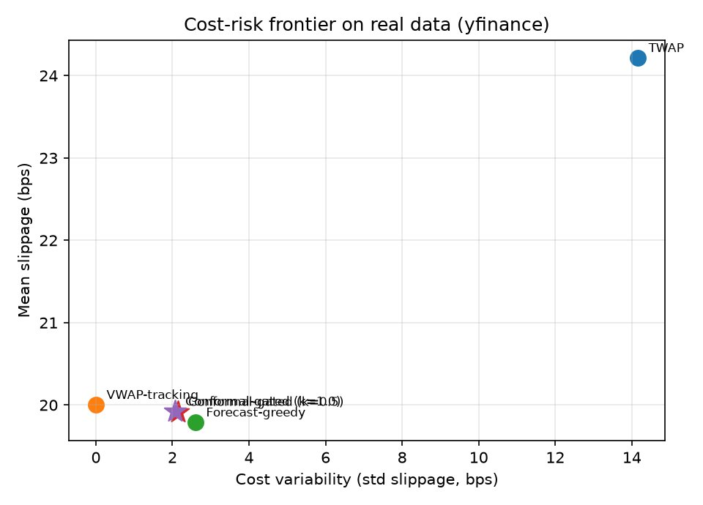
Figure 12. Cost–risk frontier on real intraday data. The forecast-based policies cluster near the VWAP-tracking benchmark: gating reduces variance, but the mean edge over VWAP-tracking is small at this frequency and liquidity.
We regard this as the more credible outcome. It confirms that the conformal layer’s guarantee is robust to the move from simulation to real markets, while remaining candid that the size of any tradable edge is data-dependent and, for these instruments, modest. The natural place to look for a larger edge, and hence more value from gating, is markets with stronger short-horizon structure (less liquid names, higher-volatility regimes, event windows) or higher-frequency limit-order-book data.
7. Discussion
The comparison helps locate where the value of uncertainty quantification actually lies. A point forecast is double-edged. It can lower average cost, but it also adds variance, because every forecast is sometimes wrong and acting on all of them realises those errors. The conformal interval supplies what is otherwise missing: a calibrated measure of when the forecast can be trusted. Used as a gate, it lets the policy harvest the reliable signals and decline the unreliable ones, and because the gate is an explicit rule with a coverage interpretation, its behaviour is predictable and its risk dial is directly controllable. The off-the-shelf RL agent has a harder task. It must discover both the timing signal and the appropriate degree of caution from a scalar reward, and in our experiments it does so unreliably across seeds. We do not read this as evidence that RL cannot succeed here; a tuned, risk-sensitive agent may well match or exceed the gate. The point is narrower: for the same problem, a transparent conformal gate reaches a competitive operating point with far greater reproducibility and at a fraction of the engineering effort.
8. Limitations
- The forecast edge is partly endogenous to the simulator. Short-horizon predictability is built into the AR(1) data-generating process, so the large edge seen in simulation overstates what is achievable in practice. The real-data validation (§6) addresses this directly: on real 5-minute equity data the forecast edge over VWAP-tracking shrinks to about 0.2 bps, which confirms that the simulator inflates magnitude even though the mechanism itself transfers.
- Conformal coverage transferred well to the real intraday data we tested (90.7% at the 90% level), but only on liquid US large-caps at 5-minute frequency. Behaviour under regime shifts, in less liquid names, or on higher-frequency limit-order-book data is not established, and online or adaptive conformal methods (Gibbs & Candès, 2024; Zaffran et al., 2022; Barber et al., 2023) were not benchmarked.
- The study is simulator-based. Market impact is an assumed linear-participation model rather than one estimated from fills, and the price and volume processes omit limit-order-book microstructure and cross-asset effects.
- The reinforcement-learning agent is a single off-the-shelf PPO configuration trained on a modest budget, so its underperformance reflects this particular setup rather than a general claim about RL. Stronger algorithms, larger budgets, and explicit risk-sensitive or distributional objectives could change the learned-agent picture; a fully tuned RL baseline is left to future work.
- No live-trading efficacy is claimed. Results are out-of-sample only with respect to simulated seeds, and latency and partial fills are not modelled.
9. Conclusion
We have presented a reproducible study of VWAP-benchmarked execution, comparing classical schedules, a reinforcement-learning agent, and conformal forecast-driven policies within a single MDP. In simulation, a normalised split-conformal predictor delivered valid coverage, and gating forecast-driven trades by the conformal interval produced a tunable, reproducible reduction in execution-cost variance, reaching a better cost–risk operating point than an off-the-shelf PPO agent. Validation on real intraday data then confirmed that the coverage guarantee transfers (90.7% empirical at the 90% level) and that the variance-reduction mechanism persists, while showing honestly that the forecast edge on liquid large-caps at 5-minute frequency is small. The conformal gate is therefore best understood as a dependable and transparent component for uncertainty-aware execution, one whose statistical validity holds on real data even where the tradable edge is modest. Several directions follow naturally: higher-frequency limit-order-book data and less liquid instruments, where short-horizon structure is stronger; adaptive conformal calibration under regime change; a tuned, risk-sensitive RL baseline; and the combination of conformal gating with a learned base policy.
Author Contributions
A. Irshad: conceptualisation (supporting), software, validation, formal analysis, investigation, data curation, visualisation, writing original draft. S. Biswas: conceptualisation (lead), methodology, supervision, formal analysis (supporting), writing review and editing. Both authors read and approved the final manuscript. (Roles follow the CRediT taxonomy.)
Data and Code Availability
The simulated experiments (§§3–5) use no proprietary data and are generated entirely by the synthetic simulator described in Section 3. The real-data validation (Section 6) uses publicly available intraday price and volume data for thirty US large-cap equities (5-minute bars), retrieved through the Yahoo Finance API; no licensed or proprietary datasets are used. The complete source code — the market simulator, conformal predictor, baselines, reinforcement-learning agent, the real-data validation pipeline, and the scripts that reproduce every table and figure — is released to enable full reproduction. Fixed random seeds are used throughout and reported in the code, and the real-data validation can be re-run directly against the public data source.
Conflict of Interest
The authors declare no competing financial or non-financial interests relevant to this work. No external funding was received.
References
Almgren, R., & Chriss, N. (2001). Optimal execution of portfolio transactions. Journal of Risk, 3(2), 5–40.
Angelopoulos, A. N., & Bates, S. (2023). Conformal prediction: A gentle introduction. Foundations and Trends in Machine Learning, 16(4), 494–591.
Barber, R. F., Candès, E. J., Ramdas, A., & Tibshirani, R. J. (2023). Conformal prediction beyond exchangeability. Annals of Statistics, 51(2), 816–845.
Bertsimas, D., & Lo, A. W. (1998). Optimal control of execution costs. Journal of Financial Markets, 1(1), 1–50.
Cartea, Á., Jaimungal, S., & Penalva, J. (2015). Algorithmic and High-Frequency Trading. Cambridge University Press.
Cartea, Á., Jaimungal, S., & Sánchez-Betancourt, L. (2023). Reinforcement learning for algorithmic trading. In Machine Learning and Data Sciences for Financial Markets. Cambridge University Press.
Gatheral, J. (2010). No-dynamic-arbitrage and market impact. Quantitative Finance, 10(7), 749–759.
Gibbs, I., & Candès, E. J. (2024). Conformal inference for online prediction with arbitrary distribution shifts. Journal of Machine Learning Research, 25(162), 1–36.
Hambly, B., Xu, R., & Yang, H. (2023). Recent advances in reinforcement learning in finance. Mathematical Finance, 33(3), 437–503.
Lei, J., G’Sell, M., Rinaldo, A., Tibshirani, R. J., & Wasserman, L. (2018). Distribution-free predictive inference for regression. Journal of the American Statistical Association, 113(523), 1094–1111.
Lin, S., & Beling, P. A. (2020). An end-to-end optimal trade execution framework based on proximal policy optimization. Proceedings of the 29th International Joint Conference on Artificial Intelligence (IJCAI), 4548–4554.
Macrì, A., & Lillo, F. (2024). Reinforcement learning for optimal execution when liquidity is time-varying. Applied Mathematical Finance, 31(5), 312–342.
Nagy, P., Calliess, J., & Zohren, S. (2023). Asynchronous deep double dueling Q-learning for trading-signal execution in limit order book markets. Frontiers in Artificial Intelligence, 6, 1151003.
Nevmyvaka, Y., Feng, Y., & Kearns, M. (2006). Reinforcement learning for optimized trade execution. Proceedings of the 23rd International Conference on Machine Learning (ICML), 673–680.
Ning, B., Lin, F. H. T., & Jaimungal, S. (2021). Double deep Q-learning for optimal execution. Applied Mathematical Finance, 28(4), 361–380.
Obizhaeva, A. A., & Wang, J. (2013). Optimal trading strategy and supply/demand dynamics. Journal of Financial Markets, 16(1), 1–32.
Perold, A. F. (1988). The implementation shortfall: Paper versus reality. Journal of Portfolio Management, 14(3), 4–9.
Romano, Y., Patterson, E., & Candès, E. (2019). Conformalized quantile regression. Advances in Neural Information Processing Systems, 32, 3543–3553.
Schulman, J., Wolski, F., Dhariwal, P., Radford, A., & Klimov, O. (2017). Proximal policy optimization algorithms. arXiv:1707.06347.
Stankevičiūtė, K., Alaa, A. M., & van der Schaar, M. (2021). Conformal time-series forecasting. Advances in Neural Information Processing Systems, 34, 6216–6228.
Sun, S., Wang, R., & An, B. (2023). Reinforcement learning for quantitative trading. ACM Transactions on Intelligent Systems and Technology, 14(3), 1–29.
Sutton, R. S., & Barto, A. G. (2018). Reinforcement Learning: An Introduction (2nd ed.). MIT Press.
Tibshirani, R. J., Foygel Barber, R., Candès, E., & Ramdas, A. (2019). Conformal prediction under covariate shift. Advances in Neural Information Processing Systems, 32, 2530–2540.
Vovk, V., Gammerman, A., & Shafer, G. (2005). Algorithmic Learning in a Random World. Springer.
Xu, C., & Xie, Y. (2023). Sequential predictive conformal inference for time series. Proceedings of the 40th International Conference on Machine Learning (ICML), 38707–38727.
Zaffran, M., Féron, O., Goude, Y., Josse, J., & Dieuleveut, A. (2022). Adaptive conformal predictions for time series. Proceedings of the 39th International Conference on Machine Learning (ICML), 25834–25866.

