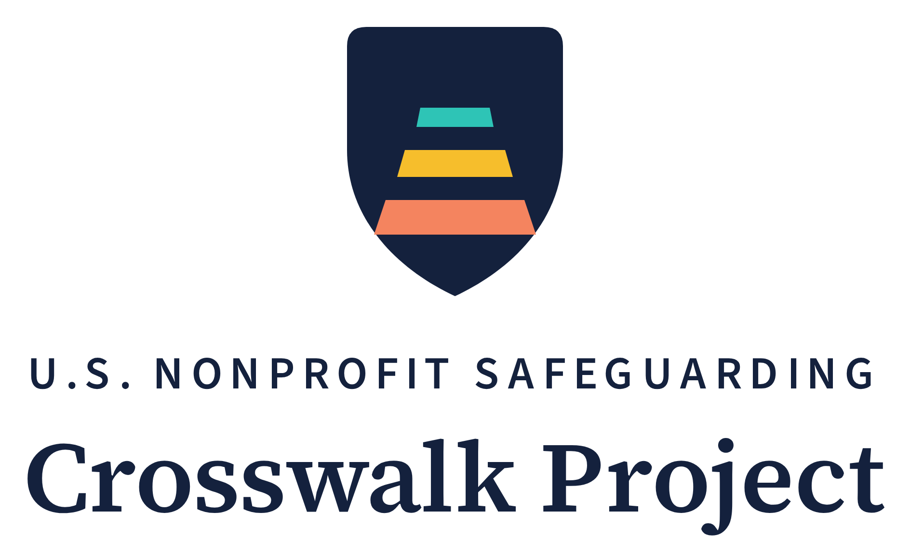
Safeguarding Self-Assessment
A 32-indicator readiness check your team completes on its own
Series | Crosswalk Project Implementation Toolkit — Tool 2
Author | Saba Gul, LL.M.
Updated | October 2026
License | Creative Commons Attribution 4.0 International (CC BY 4.0) — free to use, adapt, and share with attribution
Companion tools | Tool 1 — Organizational Safeguarding Policy Template; Tool 3 — Adopter Feedback Form; Tool 4 — Safeguarding Training Outlines
Companion research | Gul, S. (2026). Safeguarding Without a Baseline (Module 1 of the U.S. Nonprofit Safeguarding Crosswalk Project). Zenodo. DOI: https://doi.org/10.5281/zenodo.22022939
Latest version | https://pseacrosswalk.org/toolkit.html
Contact | info@pseacrosswalk.org

Scope note. This is an organizational self-assessment tool, not legal advice. It does not certify compliance with any law, funder condition, accreditation standard, or international framework, and it does not state the law of any state. It measures organizational readiness against the benchmark developed in the Project's open-access research. Organizations should have safeguarding measures reviewed by counsel licensed in their state. The author is not admitted to practice law in the United States.
How to Use This Self-Assessment
This tool converts the Crosswalk Project's open-access research into a practical readiness check. The research mapped the thirteen obligations of the international safeguarding standard — the IASC Six Core Principles Relating to Sexual Exploitation and Abuse — against United States law, and found no requirement of general application that both reaches nonprofits as a class and protects the people they serve. This self-assessment lets your organization see, in about an hour, how much of that protection you have already built and where the gaps are.
A benchmark, not a compliance check. No U.S. nonprofit is bound by the international standard, and completing this assessment does not make an organization "compliant" with it — nor does a low score mean any rule has been broken. Because no general U.S. requirement sets a safeguarding standard for nonprofits as a class, the assessment measures readiness against the most developed benchmark available, as decomposed and adapted for U.S. organizations in the Project's research. (The Project's Washington Safeguarding Baseline 2026 measures what organizations show publicly; it is not a readiness baseline against these indicators.) The score shows how much of a complete protection system is in place — nothing more, nothing less.
Who completes it. Your own team — no outside consultant, no facilitator, no cost. It works best when two or three people complete it together: someone who knows day-to-day program operations, someone who knows hiring and volunteer management, and a board member or executive.
How to score. For each of the 32 indicators, mark Yes (1 point) only if the statement is true now and you could show evidence of it — a document, a record, a dated log. Mark No (0 points) if it is partly true, planned, informal, or undocumented. Being strict is the point: a generous score hides exactly the gaps this tool exists to find.
The $0 mark. Indicators marked $0 require no spending to satisfy — only staff or volunteer time and an organizational decision. Thirty of the 32 indicators carry the mark; the exceptions are C3 and C5, where state or vendor fees for criminal-history checks may apply. The mark answers the sector's most common objection plainly: most of a basic safeguarding system costs nothing to buy. What it takes is time and a decision — and the time is real, so these tools are built to keep it small.
What the SCP column means — and what it does not. Each indicator is keyed to the element of the international standard it corresponds to (SCP-1.1 through SCP-6.3), so your results map directly onto the Policy Template and onto the open-access research. The indicators themselves are not the text of the international standard: the Six Core Principles state obligations in a few sentences and contain no operational detail — they never mention NSOPW.gov, reference checks, board minutes, retention periods, or state mandatory-reporter law. Each indicator is the Crosswalk Project's operationalization of an obligation — what fulfilling it looks like, and how you would evidence it, inside a U.S. nonprofit. The codes are there for traceability, so a board or funder can verify that all thirteen obligation elements are covered and none is missing. You can ignore the column when scoring.
Time required. About one hour. Add the six domain totals for a score out of 32, then read the band description in the Results section.
The 32 Indicators
Organization: [name] Date completed: [date] Completed by: [names and roles]
Domain A — Governance and Policy
Does safeguarding exist as a decision of the organization, owned at board level?
# | Indicator — mark Yes only if true now and evidenced | SCP | Yes (1) | No (0)
A1 | The organization has a written safeguarding policy covering sexual exploitation, abuse, and harassment of the people it serves. $0 | SCP-5.3 | ☐ | ☐
A2 | The policy was formally adopted by the board of directors, and the adoption is recorded in the minutes. $0 | SCP-6.3 | ☐ | ☐
A3 | The policy expressly protects program participants and beneficiaries — not only employees. $0 | SCP-6.1 | ☐ | ☐
A4 | A named person holds designated responsibility for safeguarding, and an alternate is named for reports involving that person or senior leadership. $0 | SCP-5.3 | ☐ | ☐
A5 | The board receives a safeguarding report at least annually (reports received, training completion, screening compliance). $0 | SCP-6.3 | ☐ | ☐
 | Domain subtotal (out of 5) |  | ______

Domain B — Code of Conduct
Are the prohibited behaviors written down as organizational rules that bind everyone?
# | Indicator — mark Yes only if true now and evidenced | SCP | Yes (1) | No (0)
B1 | Written rules state that sexual exploitation or abuse of a program participant is grounds for immediate dismissal or removal. $0 | SCP-1.1 / 1.2 | ☐ | ☐
B2 | Written rules prohibit sexual activity with anyone under 18, regardless of the state age of consent, and state that a mistaken belief about age is not a defense. $0 | SCP-2.1 / 2.2 | ☐ | ☐
B3 | Written rules prohibit exchanging money, goods, employment, or services for sex — including conditioning, delaying, or withholding assistance the participant is already entitled to. $0 | SCP-3.1 / 3.2 | ☐ | ☐
B4 | Written rules prohibit sexual relationships between personnel and adult program participants while the service relationship exists, and apply to all personnel — not only licensed professionals. $0 | SCP-4.1 | ☐ | ☐
B5 | Every employee, board member, volunteer, intern, and contractor has signed a written acknowledgment of these rules. $0 | SCP-6.2 | ☐ | ☐
 | Domain subtotal (out of 5) |  | ______

Domain C — Screening and Recruitment
Are the people who reach participants checked before they reach them?
# | Indicator — mark Yes only if true now and evidenced | SCP | Yes (1) | No (0)
C1 | Every position is classified at recruitment as a contact role or a non-contact role, and the classification is recorded. $0 | SCP-6.1 | ☐ | ☐
C2 | A check of the National Sex Offender Public Website (NSOPW.gov) is completed before anyone begins a contact role. $0 | SCP-6.1 | ☐ | ☐
C3 | A criminal history check meeting state-law and funder requirements is completed before anyone begins a contact role. (fees may apply) | SCP-6.1 | ☐ | ☐
C4 | At least two references are checked for each contact role, and each referee is asked directly whether they have any safeguarding concern. $0 | SCP-6.1 | ☐ | ☐
C5 | Screening is repeated on a defined cycle (for example every two or three years) for personnel in contact roles. (fees may apply) | SCP-6.1 | ☐ | ☐
 | Domain subtotal (out of 5) |  | ______

Domain D — Training and Awareness
Does everyone actually know the rules, and can you prove it?
# | Indicator — mark Yes only if true now and evidenced | SCP | Yes (1) | No (0)
D1 | All personnel complete safeguarding orientation before beginning work, covering what exploitation and abuse are, the conduct rules, warning signs, and how to report. $0 | SCP-6.2 | ☐ | ☐
D2 | Training expressly includes volunteers, board members, and contractors — not employees only. $0 | SCP-6.2 | ☐ | ☐
D3 | Personnel in contact roles complete a refresher at least once a year. $0 | SCP-6.2 | ☐ | ☐
D4 | Personnel who are mandatory reporters under state law are told so in writing at onboarding, with how, where, and by when to report. $0 | SCP-5.1 | ☐ | ☐
D5 | Training completion is documented — date, content, and attendance — and the records are retained. $0 | SCP-6.2 | ☐ | ☐
 | Domain subtotal (out of 5) |  | ______

Domain E — Reporting and Response
Can a participant raise a concern, and does something reliable happen when they do?
# | Indicator — mark Yes only if true now and evidenced | SCP | Yes (1) | No (0)
E1 | Program participants, family members, and the public — not just staff — can make a report, and they are told how, in plain language and in the languages they use. $0 | SCP-5.3 | ☐ | ☐
E2 | Reports can be made anonymously, and through more than one channel. $0 | SCP-5.3 | ☐ | ☐
E3 | All personnel are under a written duty to report concerns about a colleague, including personnel of partner or referral organizations, with a written no-retaliation guarantee. $0 | SCP-5.1 / 5.2 | ☐ | ☐
E4 | A written response procedure requires immediate protective steps for the person affected, before any inquiry concludes. $0 | SCP-6.1 | ☐ | ☐
E5 | A written procedure requires external reporting to the state agency or law enforcement where required by law, and states that internal inquiry never delays or replaces it. $0 | SCP-5.1 | ☐ | ☐
E6 | Participants have been asked how they would prefer to raise a concern, and channel awareness is checked at least once a year — for example, two questions in an existing feedback survey — with the results recorded. $0 | SCP-5.3 | ☐ | ☐
E7 | Each reporting channel has a named owner and a checking schedule, the checks are logged, and a period of twelve months with zero reports triggers a brief, recorded review of channel awareness and accessibility. $0 | SCP-5.3 | ☐ | ☐
 | Domain subtotal (out of 7) |  | ______

Domain F — Partners, Records, and Review
Does the protection hold when work is shared, and does the system improve?
# | Indicator — mark Yes only if true now and evidenced | SCP | Yes (1) | No (0)
F1 | Partners, subgrantees, and recurring referral organizations are informed of the conduct standards and give a written undertaking to apply equivalent standards. $0 | SCP-5.2 | ☐ | ☐
F2 | Safeguarding records — reports, inquiries, screening confirmations, training logs — are retained securely for a defined period with restricted access. $0 | SCP-6.3 | ☐ | ☐
F3 | Every report received is logged, with the date received, action taken, and outcome. $0 | SCP-5.3 | ☐ | ☐
F4 | The policy is reviewed at least every 12 months, and after any substantiated incident, with the review recorded. $0 | SCP-6.3 | ☐ | ☐
F5 | Where an engagement ended after a substantiated safeguarding violation, the organization will not give a reference concealing that fact. $0 | SCP-1.2 | ☐ | ☐
 | Domain subtotal (out of 5) |  | ______
Your Results
Domain | Subtotal | Out of
A — Governance and Policy | ______ | 5
B — Code of Conduct | ______ | 5
C — Screening and Recruitment | ______ | 5
D — Training and Awareness | ______ | 5
E — Reporting and Response | ______ | 7
F — Partners, Records, and Review | ______ | 5
TOTAL | ______ | 32

What Your Score Means
Score | Band | What it means and where to start
0–12 | Foundational | Your organization has few written safeguarding rules yet and relies mainly on the good judgment of individuals. This is where most small and mid-sized nonprofits begin — it reflects the absence of any general U.S. requirement, not a failure of care. Start with the companion Policy Template's starter policy (Sections 1–3 and 6): one board meeting and one staff orientation, using only the published guides.
13–21 | Developing | The rules largely exist, but the systems that make them real are uneven — typically screening or training is in place while reporting and records are not. Work through your two lowest domains using the matching sections of the Policy Template and the Training Outlines.
22–28 | Established | A working safeguarding system is in place. The remaining gaps are usually documentation, partner flow-down, or the annual review cycle — the things that prove the system works to a funder or a board. Close them item by item.
29–32 | Advanced | A comprehensive, documented safeguarding system is in place. Keep the review cycle running, and consider sharing what worked — sector-level practice improves when organizations that have solved this describe how.

Using Your Results
Record the date and the score. Give the board the domain subtotals rather than only the total — a score of 20 built from strong screening and no reporting mechanism is a different organization from one with 20 spread evenly, and the subtotals show which.
Re-run the self-assessment in 12 months, or after any substantiated incident, and compare. A dated pair of scores is among the most useful evidence of progress you can show a funder.
Organizations using these tools may contact the project with questions about the published materials; feedback informs sector-level research on safeguarding readiness. If you are willing to share what worked and what did not, the companion Adopter Feedback Form (Tool 3) takes 15–20 minutes and directly shapes the next published version.
Attribution. This self-assessment is released under CC BY 4.0. Organizations may adapt it freely. Suggested attribution: "Adapted from the U.S. Nonprofit Safeguarding Crosswalk Project, Safeguarding Self-Assessment (Gul, 2026), https://doi.org/10.5281/zenodo.22023885."

