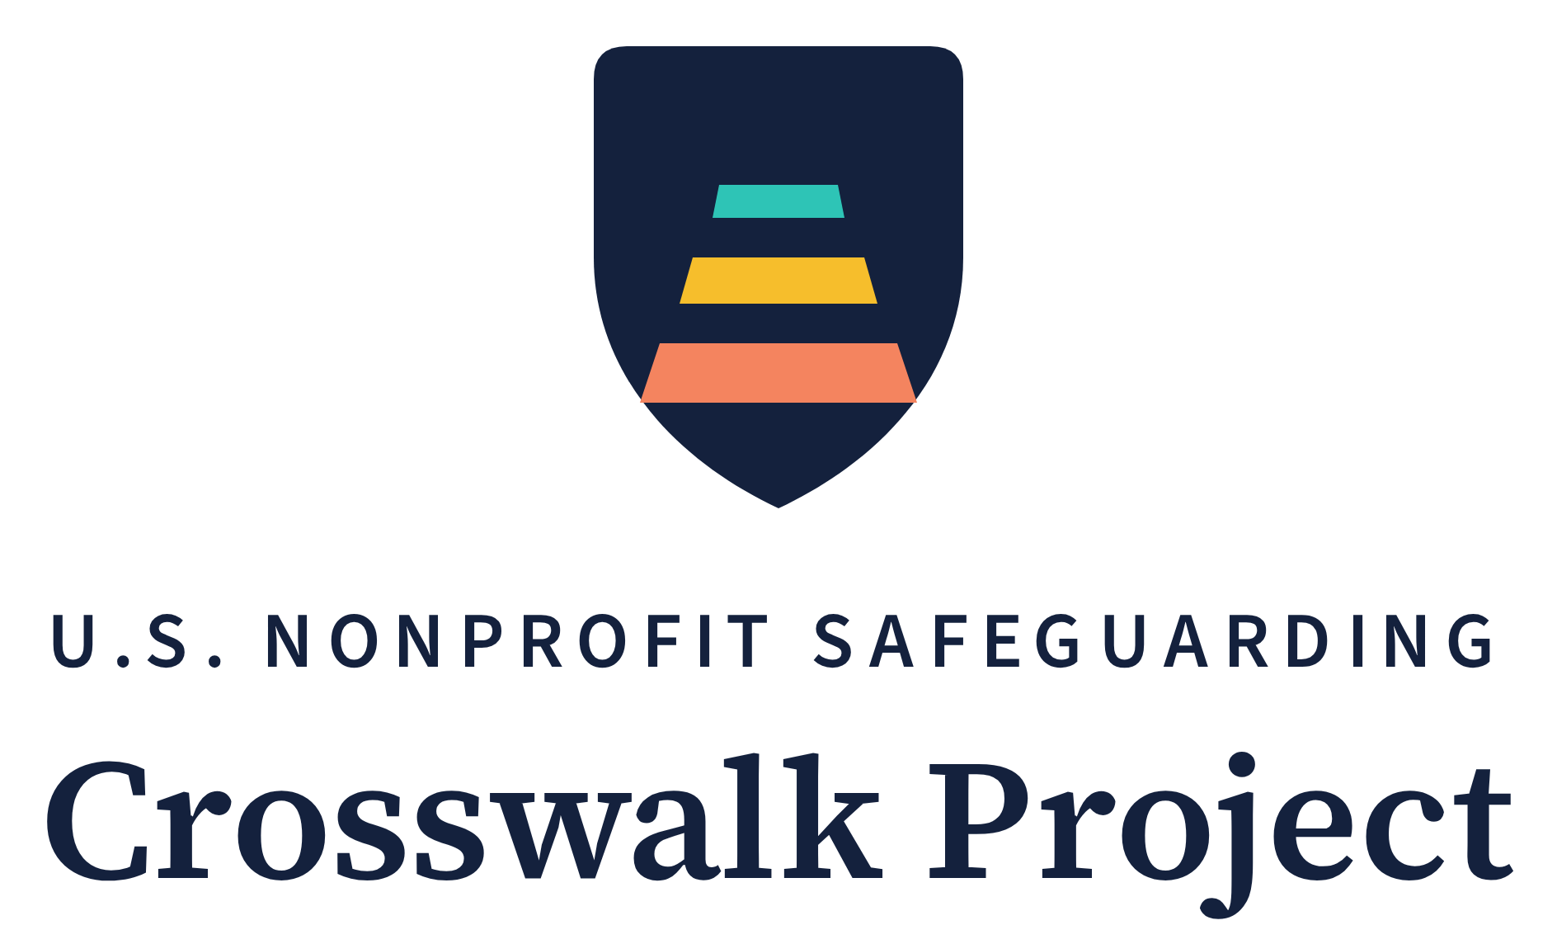
Adopter Feedback Form
15–20 minutes that directly shape the next published version
Series | Crosswalk Project Implementation Toolkit — Tool 3
Author | Saba Gul, LL.M.
Updated | October 2026
License | Creative Commons Attribution 4.0 International (CC BY 4.0) — free to use, adapt, and share with attribution
Companion tools | Tool 1 — Organizational Safeguarding Policy Template; Tool 2 — Safeguarding Self-Assessment; Tool 4 — Safeguarding Training Outlines
Companion research | Gul, S. (2026). Safeguarding Without a Baseline (Module 1 of the U.S. Nonprofit Safeguarding Crosswalk Project). Zenodo. DOI: https://doi.org/10.5281/zenodo.22022939
Latest version | https://pseacrosswalk.org/toolkit.html
Contact | info@pseacrosswalk.org

Scope note. This form collects an adopting organization's own account of using the Crosswalk Project's published, open-access materials. It is a research feedback instrument, not legal advice. Returning it creates no obligation on either side and no client, service, or employment relationship of any kind. Responses inform sector-level research on safeguarding readiness and the next published version of each tool. The author is not admitted to practice law in the United States.
How to Use This Form
Who completes it. Ideally the same two or three people who completed the Self-Assessment — someone who knows day-to-day program operations, someone who knows hiring and volunteer management, and a board member or executive. One person completing it alone is also fine.
When. Any time after your organization has used one or more of the tools. A useful moment is 60–90 days after board adoption of the policy, or after your first internally delivered training session — when the experience is fresh but real.
How long. About 15–20 minutes. Skip any question that does not apply; a partly completed form is still useful.
This form and the Notice of Adoption. The Notice of Adoption (Policy Template, Annex C) is a two-minute half page that simply records that your board adopted the policy. This form is the fuller, equally optional companion: it tells the Project what worked, what broke, and what changed. If you have already sent the Notice, there is no need to repeat it — send this form whenever you are ready.
How to return it. Type your answers directly into this document and email it back, or scan or photograph a completed printed copy, to info@pseacrosswalk.org. There is no cost and nothing to sign up for.
What happens to it. Responses inform the Project's open-access research on the safeguarding readiness of the U.S. nonprofit sector and shape the next version of each tool. Part E controls whether your organization is named or kept anonymous. Anonymity is the default.
Part A — About Your Organization
A1 Organization name (leave blank to respond anonymously): ________________________________________
A2 State(s) in which you operate: ________________________________________
A3 Who you serve, in one line: ________________________________________
A4 Annual budget band: ☐ Under $50,000 ☐ $50,000–$500,000 ☐ $500,000–$5 million ☐ Over $5 million
A5 People: ______ paid staff · ______ regular volunteers · ______ board members
A6 Contact for follow-up (optional — name and email): ________________________________________
A7 Date completed: ______________ Completed by (names and roles): ________________________________________
Part B — What You Used
B1 Which materials did your organization use? (Mark all that apply) ☐ Tool 1 — Policy Template ☐ Tool 2 — Self-Assessment ☐ Tool 4 — Training Outlines
B2 If you used the Policy Template — which sections did you adopt? ☐ Starter policy (Sections 1–3 and 6) ☐ Full policy (Sections 1–9) ☐ An adapted selection — which: ______________________
B3 Has the board formally adopted the policy? ☐ Yes — date: ____________ ☐ Scheduled — date: ____________ ☐ Not yet
B4 If you used the Self-Assessment — total score: ______ / 32, on (date) ____________. If you have re-run it: ______ / 32, on (date) ____________. Your two lowest domains the first time: ________________________
B5 If your team has delivered safeguarding training internally under Section 5 of the adopted policy — which sessions? ☐ Orientation ☐ Annual refresher ☐ Receiving and responding to reports ☐ Intake script · Roughly how many people attended in total: ______
Part C — What Worked and What Broke
This is the most valuable part of the form. Honest answers — especially about what did not work — are what improves the next version.
C1 How clear were the instructions in each tool you used? (1 = confusing, 5 = clear) Tool 1: ____ Tool 2: ____ Tool 4: ____
C2 How long did each tool actually take, compared with the time stated in it? ☐ About as stated ☐ Longer — which tool, and how long: ________________________________________
C3 Which single section, passage, or indicator needed the most adaptation for your organization — and why? ________________________________________________________________________________
C4 Was anything wrong for your state, size, or population — a requirement you could not meet, a reference that did not apply, wording that did not fit? ________________________________________________________________________________
C5 What one change would most improve the next version? ________________________________________________________________________________
Part D — What Changed
D1 As a result of using these materials, which of the following are now in place that were not before? (Mark all that apply)
☐ A written safeguarding policy covering the people we serve
☐ Board adoption recorded in the minutes
☐ A named Safeguarding Focal Point and alternate
☐ NSOPW.gov checks before contact roles begin
☐ Reference checks that ask the safeguarding question directly
☐ Signed code-of-conduct acknowledgments from all personnel
☐ Written rules for digital and remote contact with participants (Policy Section 3.7)
☐ Safeguarding orientation delivered internally
☐ Reporting channels posted and explained to program participants
☐ The Participant Charter handed to participants at intake (Policy Annex B)
☐ Each reporting channel checked on a schedule, with the checks logged
☐ A safeguarding log (date received, action taken, outcome)
☐ Written undertakings from partner or referral organizations
☐ Other: ____________________________
D2 The single most useful element of the toolkit for your organization was: ________________________________________________________________________________
D3 The biggest obstacle to putting the materials into practice was: ☐ Time ☐ Board buy-in ☐ Cost of background checks ☐ Uncertainty about state law ☐ Staff or volunteer turnover ☐ Other: ____________________
D4 What did putting these materials in place actually cost? This helps the Project test, with real data, whether a baseline safeguarding system can be built without a budget.
Money spent (not counting staff time): ☐ $0 ☐ Under $100 ☐ $100–$500 ☐ Over $500 — mainly on: ____________________
Approximate staff and volunteer hours, in total: ______ hours
Part E — Permissions and Follow-Up
Mark all that apply. If nothing is marked, only E1 applies.
☐ E1 Use our responses in open-access research and tool revisions in aggregate, without naming our organization. (Default.)
☐ E2 You may name our organization as an adopter of these materials in open-access research and project materials.
☐ E3 You may contact us with brief follow-up questions about the answers above.
☐ E4 Our organization is willing to provide a short written statement describing its use of these materials, for the Project's documentation.
Name: ____________________________ Role: ____________________________ Date: ______________
Return the completed form to info@pseacrosswalk.org. Thank you — every returned form makes the next version better for the organizations that come after yours.
Attribution. This form is released under CC BY 4.0. Organizations may adapt it freely. Suggested attribution: "Adapted from the U.S. Nonprofit Safeguarding Crosswalk Project, Adopter Feedback Form (Gul, 2026), https://doi.org/10.5281/zenodo.22023885."

