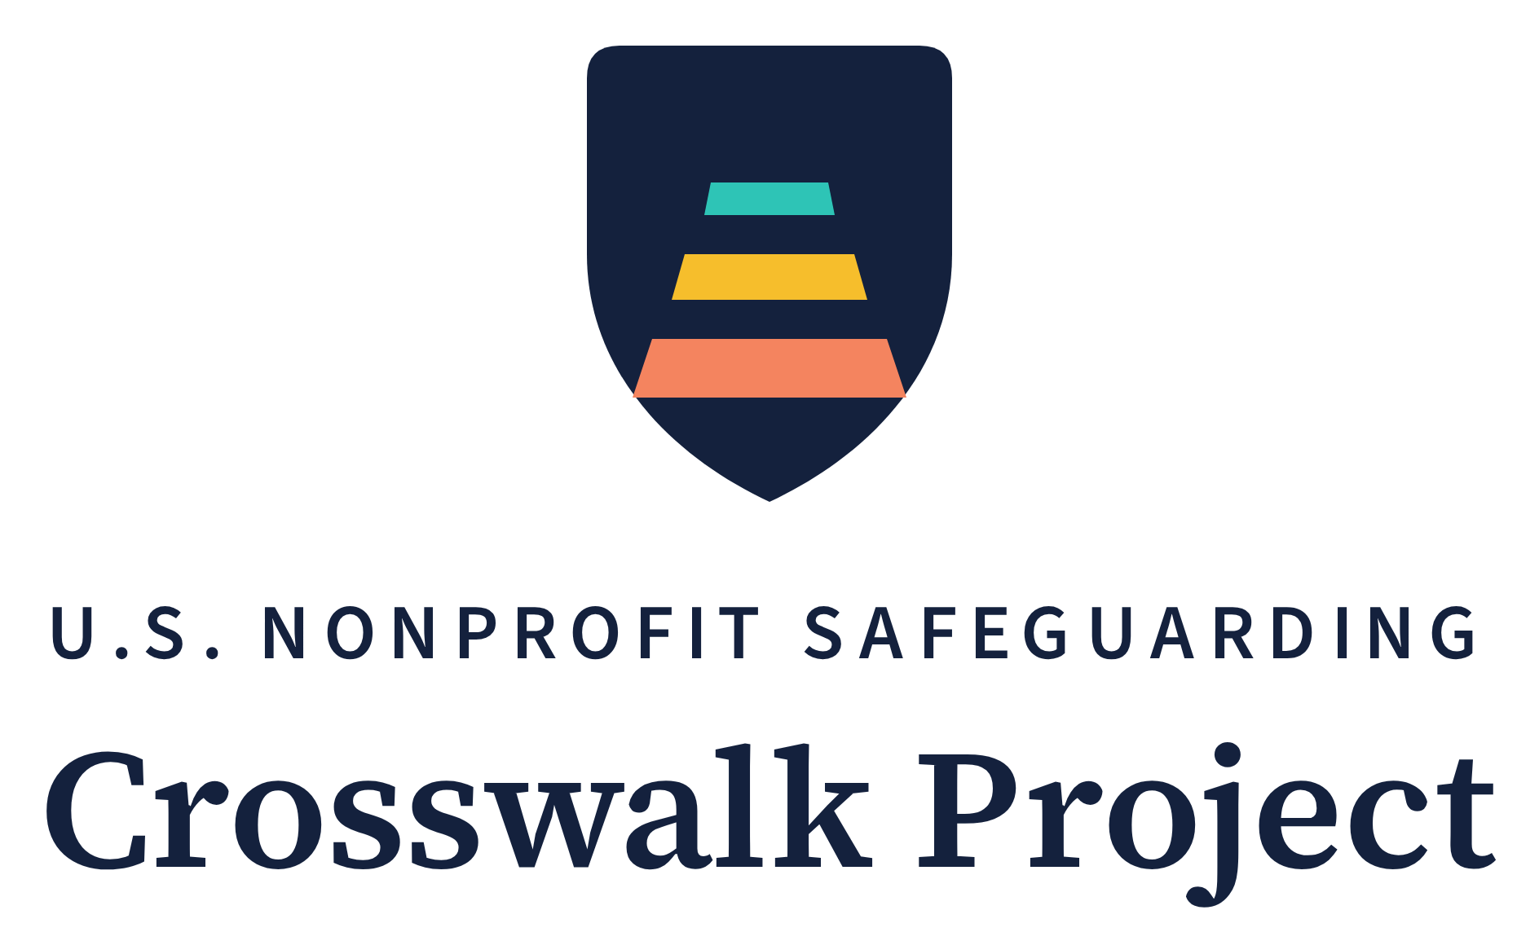
Safeguarding Training Outlines
Three sessions your own staff deliver — no external facilitator required
Series | Crosswalk Project Implementation Toolkit — Tool 4
Author | Saba Gul, LL.M.
Updated | October 2026
License | Creative Commons Attribution 4.0 International (CC BY 4.0) — free to use, adapt, and share with attribution
Companion tools | Tool 1 — Organizational Safeguarding Policy Template; Tool 2 — Safeguarding Self-Assessment; Tool 3 — Adopter Feedback Form
Companion research | Gul, S. (2026). Safeguarding Without a Baseline (Module 1 of the U.S. Nonprofit Safeguarding Crosswalk Project). Zenodo. DOI: https://doi.org/10.5281/zenodo.22022939
Latest version | https://pseacrosswalk.org/toolkit.html
Contact | info@pseacrosswalk.org

Scope note. These are training outlines for internal delivery, not legal advice and not a certified curriculum. They do not satisfy any specific state, funder, or accreditation training mandate on their own. Organizations should confirm their own legal training requirements with counsel licensed in their state. The author is not admitted to practice law in the United States.
How to Use These Outlines
These outlines exist because most small and mid-sized nonprofits cannot buy training. They are written so that someone already inside your organization — an executive director, a program manager, a volunteer coordinator, your Safeguarding Focal Point — can run each session using this document and your own completed policy. No external trainer, no license fee, no purchase.
What you need before you start: your organization's completed Safeguarding Policy (Tool 1), with the bracketed fields filled in. The training teaches your policy — these outlines supply the structure and the discussion, not the rules themselves.
Adapt freely. Shorten for a volunteer team, lengthen for a staff retreat, translate into the languages your people work in, split a session across two meetings. The CC BY 4.0 license permits all of this; only the attribution line stays.
When to bring in outside help. Internal delivery is enough to get a safeguarding system running, and for most organizations it is the right place to start. Bring in outside expertise — a local child advocacy center, a sexual assault program, your state coalition, or a safeguarding trainer — when a disclosure has already occurred and the people handling it need support; when your organization serves children in unsupervised or overnight settings, runs residential programs, or serves people with significant disabilities; when your only available facilitator is someone participants might one day need to report about; or when questions arise that your policy does not answer. Many state coalitions and advocacy centers offer training at low or no cost. Internal delivery builds the system; outside expertise deepens it.
Session | Length | Who attends, and when
1 — Safeguarding Orientation | 60 min | Everyone — staff, volunteers, board members, interns, contractors — before they begin work, then as new people join.
2 — Annual Refresher | 45 min | Everyone in a contact role, once a year.
3 — Receiving and Responding to Reports | 90 min | The Safeguarding Focal Point, the alternate, all managers, and interested board members — on appointment and annually.
Intake script | 3 min | Anyone who does intake — with every new participant, when the Participant Charter is handed over.

Record every session: date, session number, content covered, and an attendance list. Policy Section 5.4 requires it, and it is the evidence a funder or board will ask for.
Session 1 — Safeguarding Orientation
60 minutes · all personnel · before beginning work · delivered by [name of your facilitator]
Purpose. By the end, every person can say what sexual exploitation, abuse, and harassment are; name at least three rules from your code of conduct; describe one warning sign; and state exactly how to report a concern and to whom.
You will need: your completed Safeguarding Policy (one copy per person), the acknowledgment form for signature, a copy of your Participant Charter (Policy Annex B), a whiteboard or flip chart, and the name and contact details of your Safeguarding Focal Point written up where everyone can see them.
1. Why we are here — 10 minutes
- Open with the organization's own mission and the people it serves. Name them specifically.
- Explain the power difference: people who depend on us for assistance cannot refuse us freely. That dependence is what makes harm possible, and preventing its misuse is what safeguarding means.
- State plainly that this is not a suspicion of anyone in the room — it is how the organization protects both participants and personnel.
Say it in your own words: "The people we serve come to us because they need something they cannot easily get elsewhere. That gives everyone in this room a kind of power. Safeguarding is our system for preventing the misuse of that power: clear rules, a way for anyone to raise a concern, and a plan for what we do when someone does."
2. What we are preventing — 10 minutes
- Walk through the four definitions in Policy Section 2: sexual exploitation, sexual abuse, sexual harassment, and who counts as a program participant.
- Stress that exploitation does not require force — abuse of a position of vulnerability or trust is enough.
- Stress that a child means anyone under 18, whatever the state age of consent says.
Say it in your own words: "These are not abstract categories. Exploitation is what it looks like when someone uses what a participant needs as leverage. It rarely announces itself."
3. Our rules — 15 minutes
- Read Policy Section 3 aloud, standard by standard. Do not summarize — the wording matters.
- Pause on 3.3: withholding, delaying, or conditioning assistance a participant is already entitled to is prohibited. This is the rule people most often have not met before.
- Pause on 3.4: it applies to everyone — drivers, mentors, intake volunteers — not only licensed professionals.
- Pause on 3.7: every rule applies the same way by phone, text, video, and social media. Contact participants only through the organization's channels — never from a personal account — and never message a child one-to-one in private.
- Confirm that these are conditions of employment, board service, and volunteering, and that breaking them is grounds for immediate removal.
4. Recognizing warning signs — 10 minutes
Ask the group to consider three short situations. There are no trick answers; the aim is to make raising a concern feel normal and safe.
- A volunteer regularly drives one particular teenage participant home alone, and has begun texting them directly. What, if anything, would you do? (Policy Section 3.7 now answers the texting part directly.)
- A staff member tells a family their food assistance may be delayed unless they "co-operate." Which of our rules does this touch?
- A colleague asks you not to mention that they met a participant socially over the weekend. What does our policy require of you?
Say it in your own words: "Notice that in none of these do you have to be sure. You are not being asked to investigate or to accuse. You are being asked to pass a concern to one named person."
5. How to report — 10 minutes
- Name your Safeguarding Focal Point and the alternate. Say the names out loud and write them up.
- List every channel from Policy Section 6.2 — including how to report anonymously.
- Hand round the Participant Charter. This is exactly what every participant is promised at intake — so everyone in the room knows the promise they are now part of keeping.
- State the no-retaliation guarantee in Section 6.3, and the acknowledgment timeframe in 6.4.
- Explain mandatory reporting: who in the room is a mandatory reporter under state law, and that internal reporting never replaces an external legal duty.
6. Close — 5 minutes
- Take questions.
- Collect a signed acknowledgment from every attendee.
- Record the session: date, content, attendance.
Session 2 — Annual Refresher
45 minutes · all personnel in contact roles · once a year
Purpose. Not to repeat Session 1, but to keep the rules live, surface what has been unclear in practice over the past year, and capture what needs to change.
1. What changed this year — 5 minutes
- Note any change to the policy, the Focal Point, the reporting channels, or applicable state law.
- Share, in general terms, what the Focal Point's channel checks found this year — and, if the year was quiet, what the silence review (Policy Section 6.5) concluded. Frame it as information about the system, never as praise or suspicion of the team.
2. Rules refresh — 10 minutes
- Re-read Policy Section 3 aloud. Ask which rule has been hardest to apply in real work — and listen; the answer usually tells you where your next gap is.
3. Practice with real texture — 20 minutes
Use situations drawn from your own program setting rather than the generic ones. Ask the group, for each: is this a concern, who would you tell, and by when?
- A situation involving a boundary that blurred gradually rather than suddenly.
- A situation where the person raising the concern would be reporting someone senior to them.
- A situation involving a partner or referral organization's staff rather than your own.
- A situation that unfolded by text, video, or social media rather than in person.
Say it in your own words: "If anything you have seen this year felt uncomfortable and you did not report it, this is a good moment to say why. That tells us what to fix."
4. Reporting refresh and close — 10 minutes
- Re-state the Focal Point, the channels, the anonymous option, and the no-retaliation guarantee.
- Re-confirm mandatory-reporter status and timeframes for those to whom they apply.
- Record the session: date, content, attendance.
Session 3 — Receiving and Responding to Reports
90 minutes · Focal Point, alternate, managers, interested board members · on appointment and annually
Purpose. The people who receive reports need more than the rules. This session builds the response sequence into muscle memory, so that the first ten minutes after a disclosure are handled well.
1. The first ten minutes — 20 minutes
- Receive without interrogating: listen, thank the person, do not press for detail you do not need, do not promise secrecy you cannot keep.
- Record what was said as close to verbatim as possible, with the date and time.
- Consider immediate safety first — Policy Section 7.1 authorizes protective steps, including suspending contact, before any inquiry concludes. Interim measures are precautionary, not disciplinary.
Say it in your own words: "Your job in the first ten minutes is not to find out whether it is true. It is to make sure the person is safe and that what they told you is written down accurately."
2. External reporting — 20 minutes
- Work through Policy Section 7.2: which reports must go to a state agency or law enforcement, to whom, and within what timeframe under your state's law.
- Fix the principle firmly: internal inquiry never delays or substitutes for a legally required external report.
- Confirm that the organization does not investigate possible criminal conduct beyond what employment decisions require.
3. Survivor-centered handling — 20 minutes
- Keep the person affected informed of what happens next; offer referral to local advocacy, medical, and counseling services — have that list ready in advance, not after.
- Never require the person to confront the person complained about.
- Hold confidentiality on a strict need-to-know basis, and be honest at the outset about its limits.
4. Inquiry, outcome, partners, and keeping channels alive — 20 minutes
- Walk through Policy Section 7.4: who conducts a documented inquiry, when impartiality requires an external reviewer, and who receives the conclusions.
- Walk through Section 7.5: how a concern about a partner or referral organization's personnel is conveyed and recorded.
- Confirm the report-logging duty in Section 6.4 and the records-retention rules in Section 9.2.
- Walk through the channel duties in Sections 6.2 and 6.5: who owns each channel, how often it is checked, where each check is logged, and what the Focal Point does after twelve months without a report — review the channels, not suspect the staff.
5. Run one full scenario — 10 minutes
Take one plausible disclosure from start to finish out loud: who receives it, what is said, what is written, who is told, within what timeframe, and what the person affected is offered. Note every step the group hesitated on — those are the gaps to close before a real report arrives.
Intake Script — Explaining Our Commitment to a Participant
3 minutes · anyone who does intake · with every new participant
Purpose. A printed promise is easy to ignore; the same promise said by a person is believable. Use this when handing a new participant the Participant Charter (Policy Annex B). Say it in the participant's language — through an interpreter where needed — and say it even to participants who can read the page.
Say it in your own words: "Before we start, I want to give you this page and tell you what it says, because it is a promise we make to everyone who comes here. Our help is free. You never have to pay for it or do anything in return — no money, no favors, nothing. Nobody who works or volunteers here is allowed to ask you for a date, a relationship, or anything sexual — ever. Saying no to anyone here will never change the help you get. If anything here ever makes you or your child uncomfortable, you can tell [Focal Point name], or use any of the ways on this page — you do not have to give your name. One honest thing: if you tell us a child or a vulnerable adult is in danger, the law may require us to tell the authorities too, to protect them. Do you have any questions? This page is yours to keep."
- Pause for questions. Do not rush this part — a question here is the channel working.
- Note in the intake record that the Charter was given and explained, with the date. This is evidence for Self-Assessment indicators E1 and E6.
Attribution. These outlines are released under CC BY 4.0. Organizations may adapt them freely. Suggested attribution: "Adapted from the U.S. Nonprofit Safeguarding Crosswalk Project, Safeguarding Training Outlines (Gul, 2026), https://doi.org/10.5281/zenodo.22023885."

