**Answer of (1)**

**a)**

touch 23341094_1.txt 23341094_2.txt 23341094_3.txt 23341094_4.txt

mkdir Shaptarshi1 Shaptarshi2

mv 23341094_1.txt 23341094_2.txt /home/shaptarshi/Shaptarshi1

mv 23341094_3.txt /home/shaptarshi/Shaptarshi1

ls

cd Shaptarshi1

ls

cp 23341094_1.txt 23341094_2.txt /home/shaptarshi/Shaptarshi2

cd Shaptarshi3

ls -l

Chmod g=rx,o=rx Shaptarshi1

mkdir 321assignment1

mv Shaptarshi1 Shaptarshi2 Shaptarshi3 23341094_4.txt /home/shaptarshi/321assignment1

ls

cd 321assignment1

ls

cd Shaptarshi3

cd ..

ls -l

mv Shaptarshi3 /home/shaptarshi

ls

rm -r Shaptarshi1 Shaptarshi2 23341094_4.txt

ls

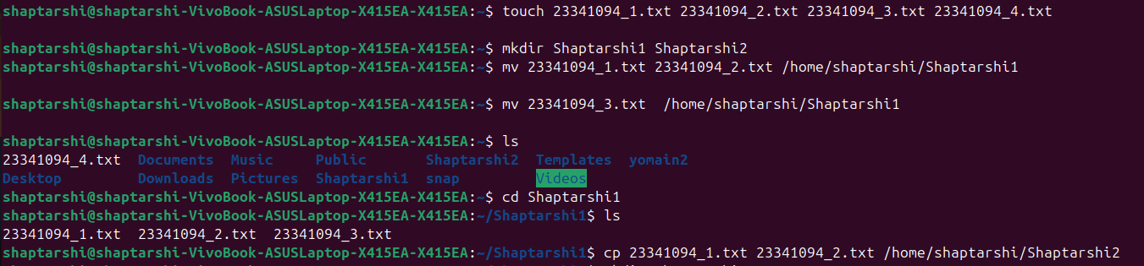





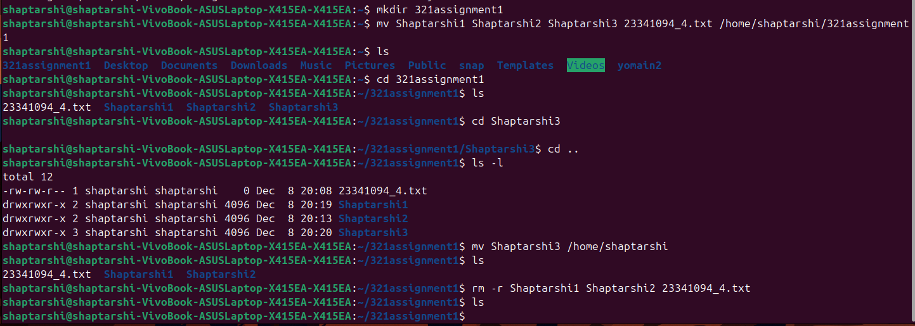

**b)**

gedit coursedetails.txt

grep -c "CSE" coursedetails.txt

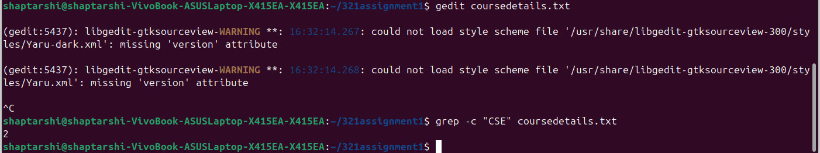

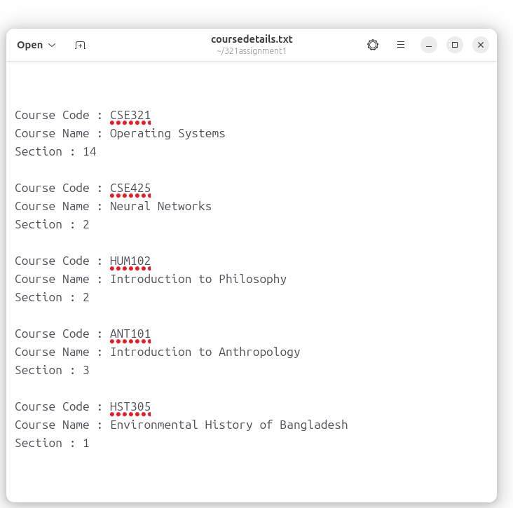

**c)**

ls -a

ls -la

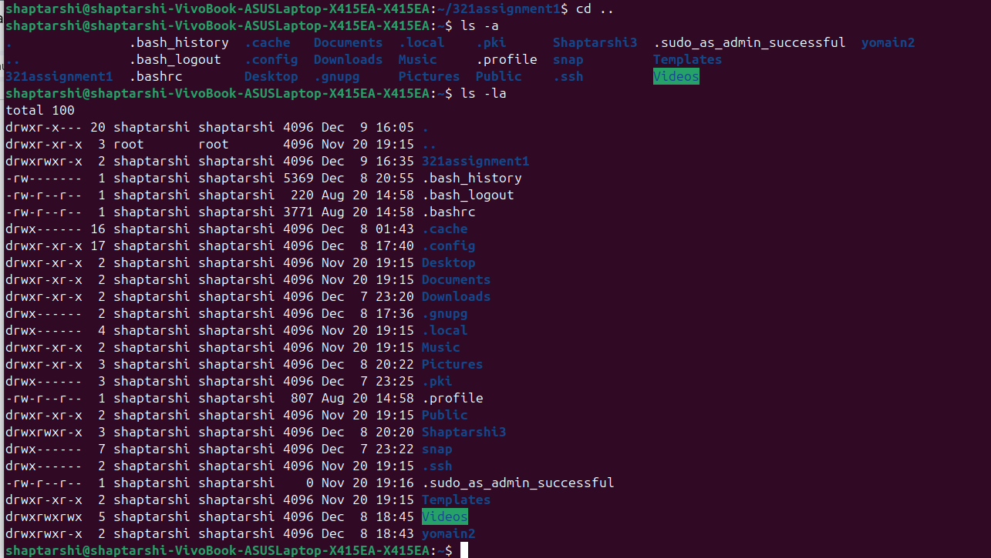

**d)**

cat >linefilee.txt

sed -n '5,17p' linefilee.txt

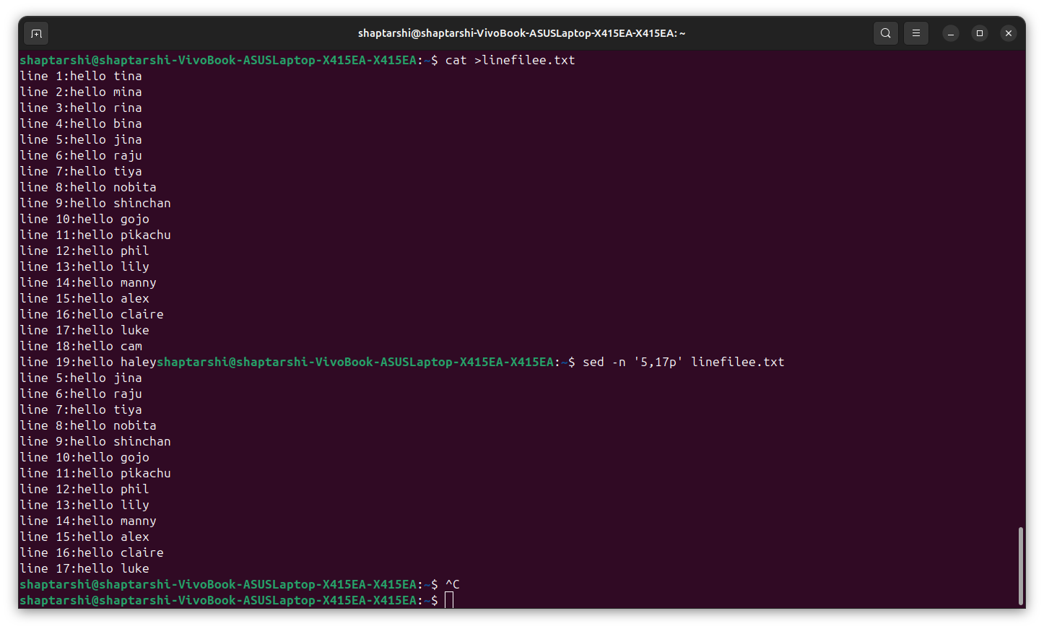

……………………

**Answer to (2)**

**a)**



**b)**

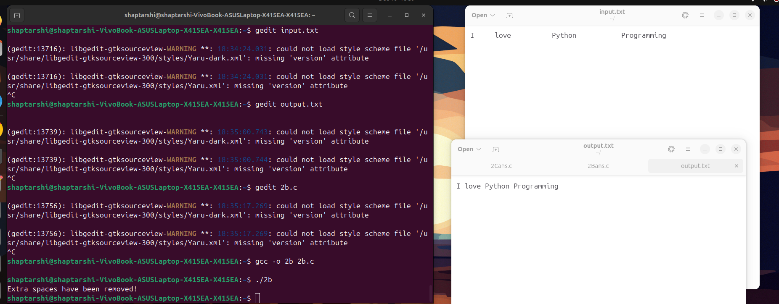

**c)**



**d)**

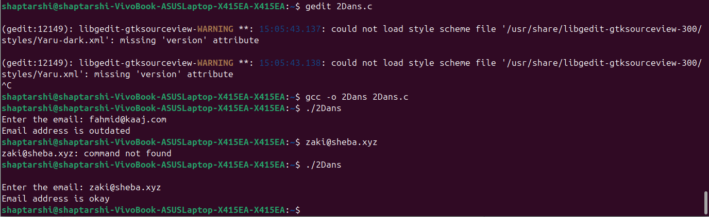

**e)**

