# Feature Catalogue 'Test application schema'

**Version:**

n/a

**Date:**

n/a

**Scope:**

This feature catalogue ...

**Responsible organisation:**

interactive instruments GmbH

## Application schema: MyApplicationSchema

**Version:**

1.0

**Sub-package:**

leaf1

leaf2

**Diagram(s):**

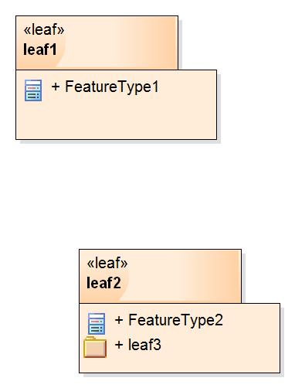

Figure - MyApplicationSchema Packages

## Package: leaf1

**Parent package:**

MyApplicationSchema

### FeatureType1

|  |  |  |
| --- | --- | --- |
| **FeatureType1**   |  |  | | --- | --- | | **Type:** | Feature type | |

## Package: leaf2

**Sub-package:**

leaf3

**Parent package:**

MyApplicationSchema

**Diagram(s):**

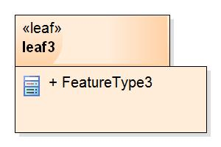

Figure - leaf2

### FeatureType2

|  |  |  |  |  |
| --- | --- | --- | --- | --- |
| **FeatureType2**   |  |  | | --- | --- | | **Supertype of:** | FeatureType3 | | **Type:** | Feature type | |
| **Attribute:**   |  |  | | --- | --- | | **Name:** | prop1 | | **Voidable:** | false | | **Multiplicity:** | 1 | | **Value type:** | CharacterString | |

**Diagram(s):**

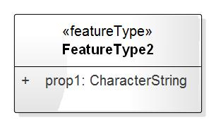

Figure - Context - FeatureType2

## Package: leaf3

**Parent package:**

leaf2

### FeatureType3

|  |  |  |  |  |
| --- | --- | --- | --- | --- |
| **FeatureType3**   |  |  | | --- | --- | | **Subtype of:** | FeatureType2 | | **Type:** | Feature type | |

**Diagram(s):**

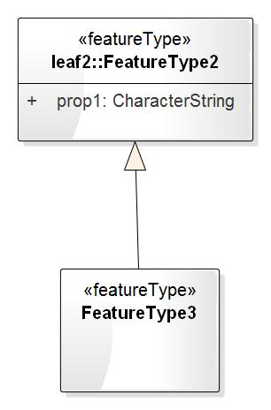

Figure - Context - FeatureType3

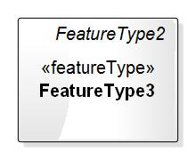

Figure - FeatureType3 (Standalone)