Book-Store

**PROJECT WRITE-UP SUBMITTED IN PARTIAL FULFILMENT OF THE REQUIREMENT FOR THE INTERNSHIP PURPOSE**

**OF MY 6TH SEMESTER IN MCA (MASTER IN COMPUTER APPLICATION)**

**DEPARTMENT OF COMPUTER APPLICATION**

**NORTH-EASTERN HILL UNIVERSITY**

BY

SHAPHRANG RYNGKSAI

*Master of Computer Application*

*Roll No : CA-M1611*

*Registration No : 14540 of 2013-2014*

**INTRODUCTION**

“Book-Store” or we can simply call a ‘Simple command-line Book-Store application’ is an application which helps to automate the existing manual system by the use of computerized systems and computer software, fulfilling their requirements.

Basically, Book-Store is an application which connects Buyers and Sellers together where Sellers are the source of resources and the Buyers can find or search for books and buy them. Book-Store works like a mini e-commerce application but in a command-line manner.

**OBJECTIVE**

The objective of the Book-Store application is to provide flexibility to the Buyers by providing the functionalities of both Book search and Buy Book in a single application. In addition, this application also provides an effective means for the Sellers to add as much Books for the purpose of selling.

The main objective of this application is to create an online bookstore that allow users to search and purchase a book online based on the id, name, etc.

**DESIGN PHASE**

The Book-Store is designed on the basis of Three Modules.

* ADMINISTRATOR(Currently not developed)
* SELLER
* BUYER

**SELLER :**

The Seller users will be able to perform functions such as registering themselves with the application. Sellers are responsible for adding books , Modify or edit the details of a book and view the whole list of books.

**FUNCTIONS :**

* User can Register
* Add books
* Edit book information including id, name, isbn, etc.
* View Books
* View ordered books

**Buyer :**

Buyer users will be able to perform functions such as registering themselves with the application. This module allows Buyer to view all the books which are available in this Book-Store. They can also searched for a particular book by either providing the id or the name and they can buy books as well.

**FUNCTIONS :**

* User can Register
* View books
* Buy books
* Search for books with specific id.

**ADMINISTRATOR (Currently not developed) :**

The Admin module provides various functionalities. The Admin users are responsible for managing the users .i.e. both seller and buyer and the books as well.

**FUNCTIONS :**

* Admin can log-in the application.
* Manage Seller
* Manage Buyer
* Manage Books

DATA FLOW DIAGRAM

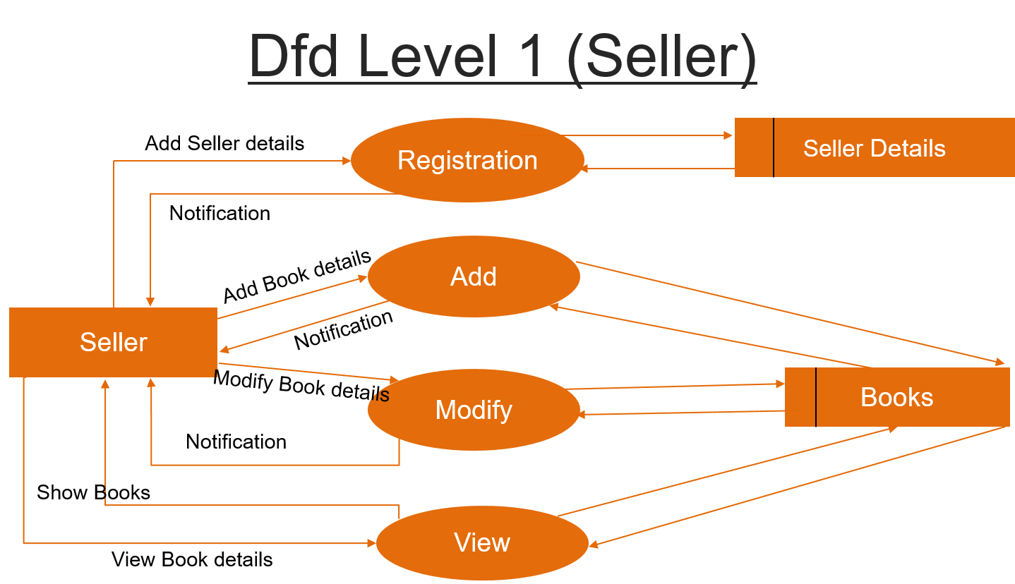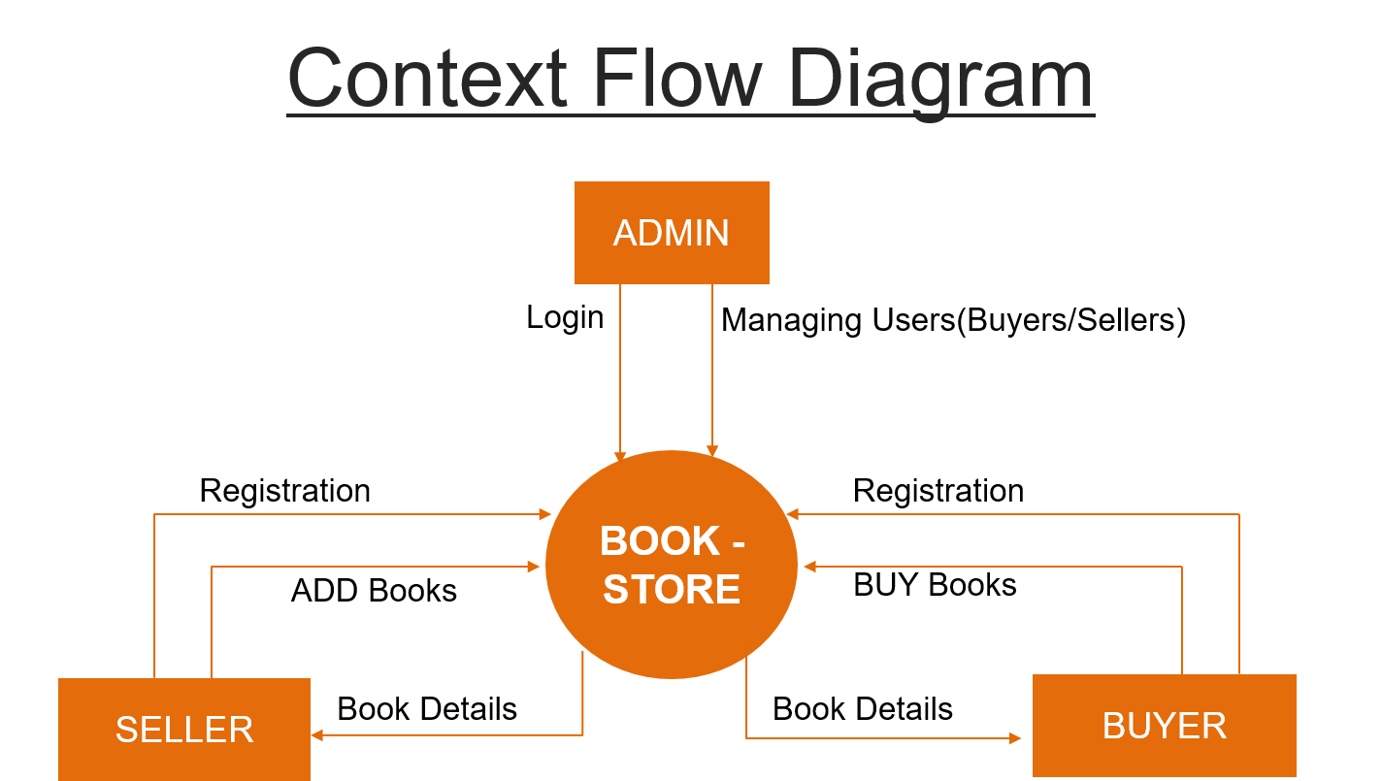

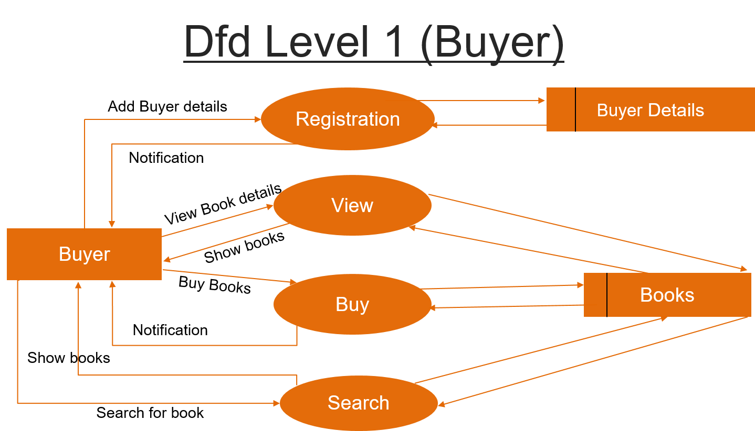

ER Diagram

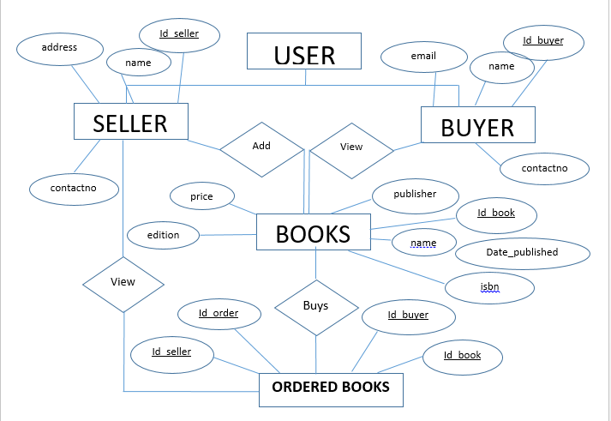

DATABASE DESIGN

DATABASE DESIGN

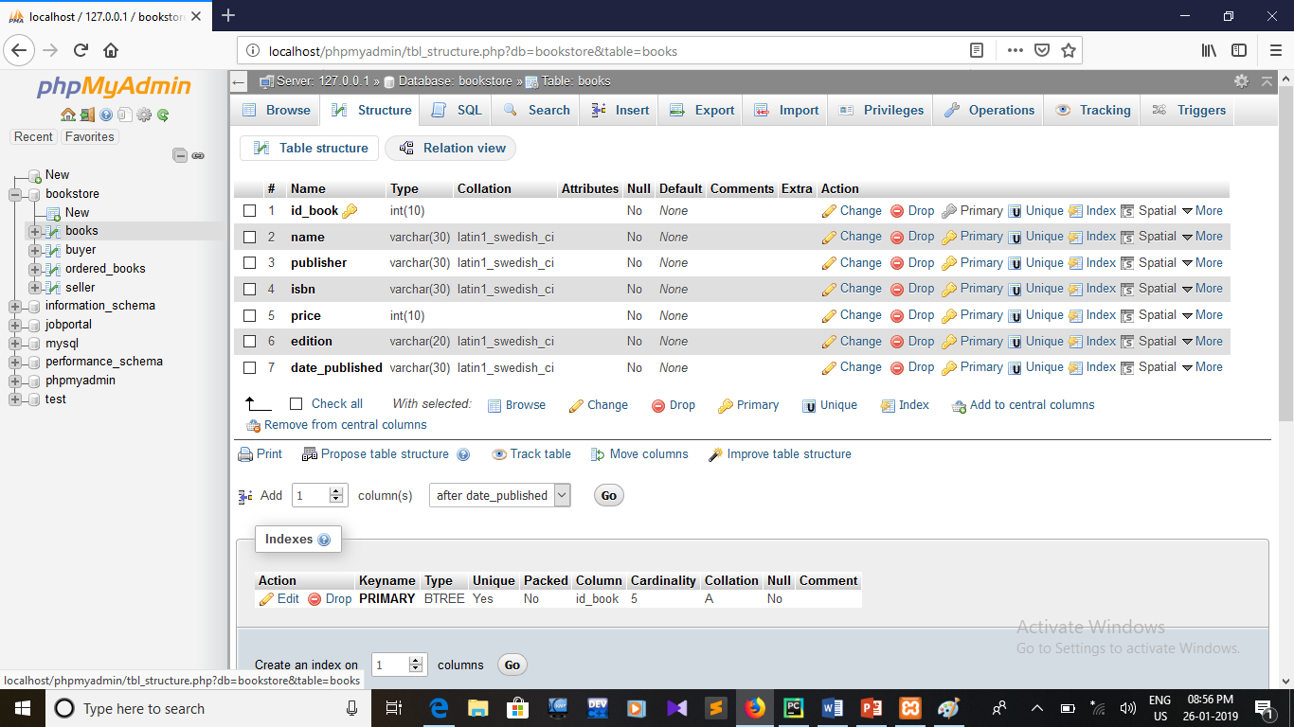**Bookstore database**

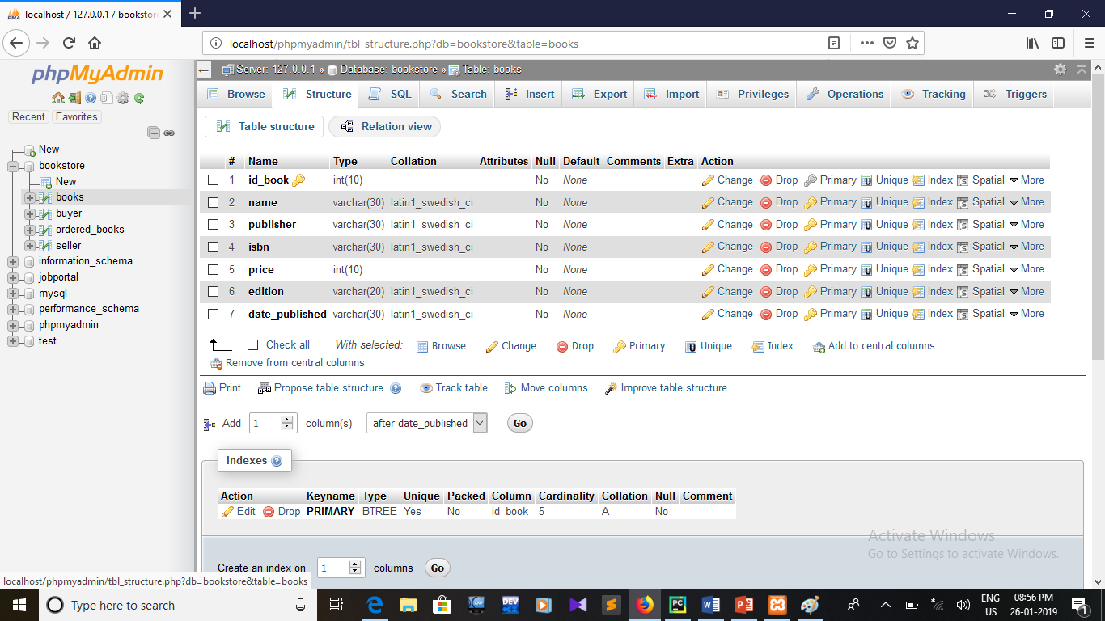**Books table**

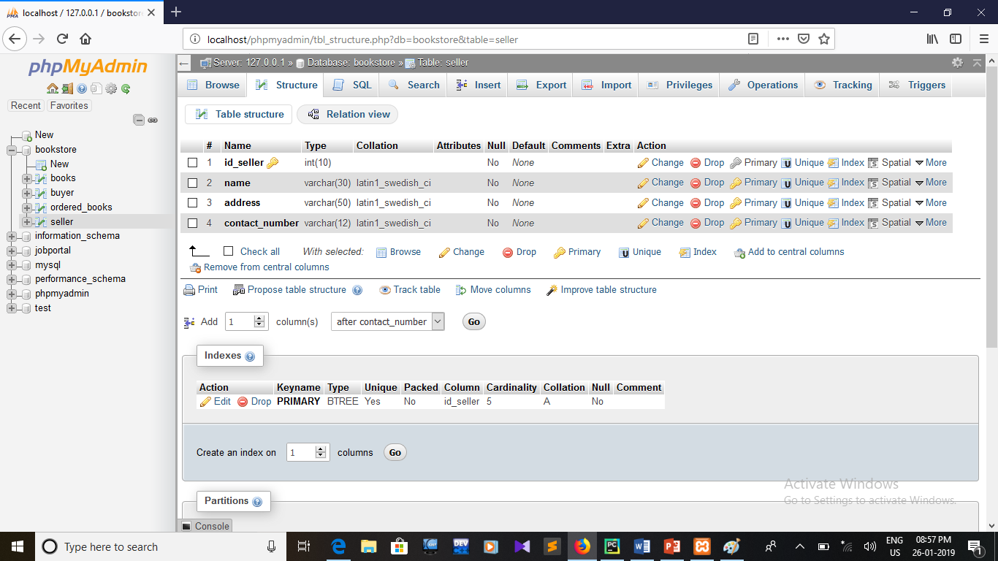**Seller table**

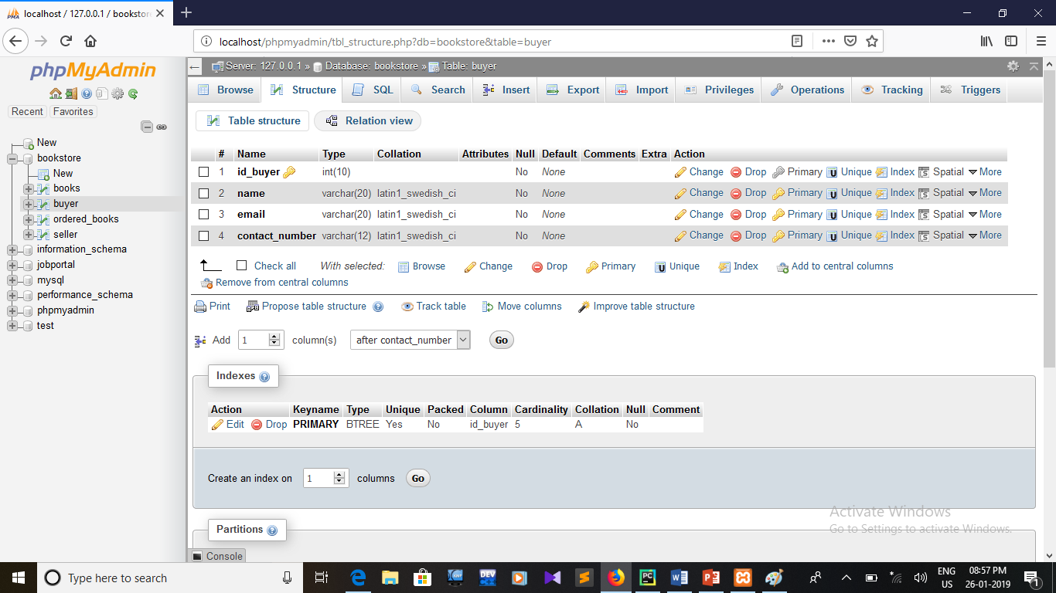**Buyer table**

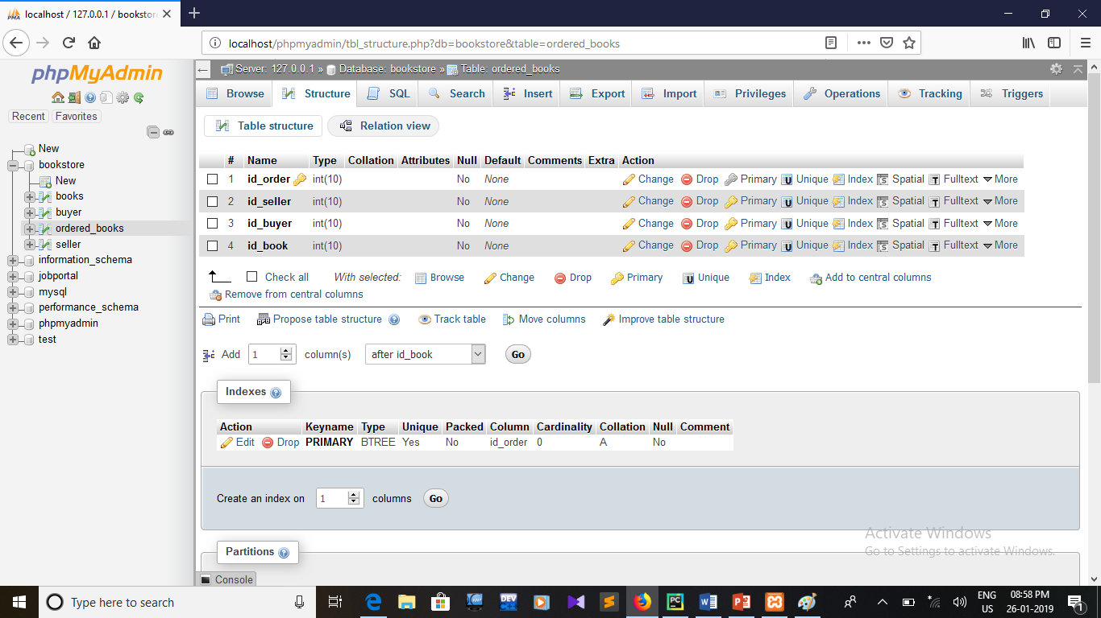**Ordered Books table**

**CONCLUSION**

This application would be a great contribution to the modern world as it would help the mass who is in love with books received on their doorsteps.

But, the application approach I used here is not fit for this idea (Web-Based is commonly used). This simple command-line bookstore application hes been built just to groom up my Python skills.

Although, some of the things mention here are not implimented as such but I hope I can improve it in future days.