Exercise 4: Modeling moisture content in a soil column
CE 394K.2 Hydrology

5 April 2007
Prepared by Ernest To and David R. Maidment
Center for Research in Water Resources
University of Texas at Austin
Table of Contents
Goals of the Exercise
Computer and Data Requirements
Software
MATLAB source code
Procedure
Downloading and opening the code in MATLAB.
Description of the Problem
Explanation of program
Publishing code and results to html format.
Modifying the program
To be turned in
Appendix – Source code of moisture_diffusion.m

Goals of the Exercise
The goals of this exercise are to 1) model the spatial and temporal profile of moisture content in a soil column using a simplified version of Richard’s equation, and 2) introduce students to MATLAB by using MATLAB to solve Richard’s equation and graph the results.

Computer and Data Requirements

Software
For this exercise you will need to use MATLAB version 7 or above which should be installed in the workstations at the Civil Engineering Learning Resources Center at the University of Texas at Austin.

MATLAB source code
The source code for this exercise is available at http://www.ce.utexas.edu/prof/maidment/GradHydro2007/Ex4/Ex4.zip.

Procedure

Download and open the code in MATLAB.
Download the zip file from http://www.ce.utexas.edu/prof/maidment/GradHydro2007/Ex4/Ex4.zip and unzip the contents to a location on your local computer (e.g. C:\temp). Next start MATLAB by going to Programs -> MATLAB -> R2006b -> MATLAB R2006b.
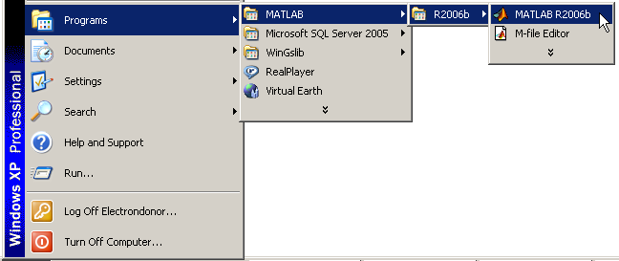

In the Current Directory box at the top of screen, type in the folder (C:\temp in this case) that contains the contents of the unzipped file and hit enter.

Next go to the top-left window and click on the Current Directory tab. You will see the moisture_diffusion.m file.

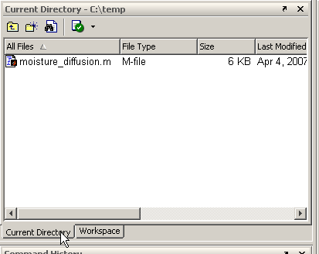

Double-click on the file to bring up the source code in the MATLAB editor window.

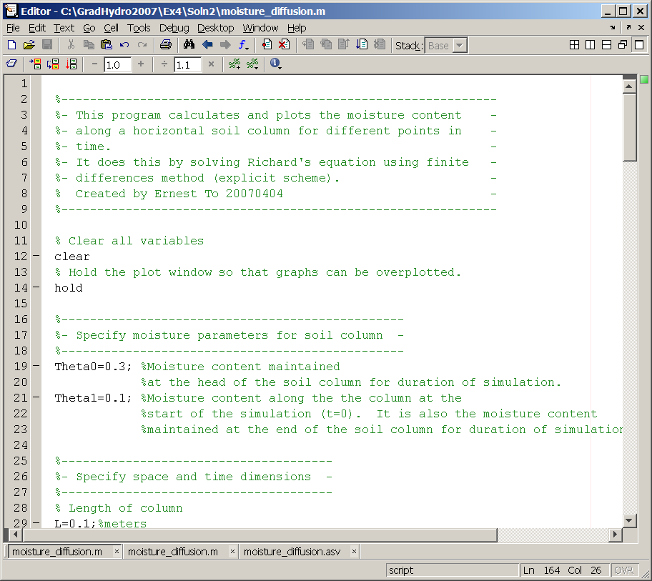

You can compile and run the code by clicking on the run button (see below). However, before doing this let’s go through what the code does.

Description of the Problem
The purpose of this exercise of the MATLAB program is to simulate the moisture content (θ) in a one-dimensional horizontal soil column (see figure below) at a given distance (x) and time (t). The soil characteristics are described by the soil water diffusivity, D, and the hydraulic conductivity, K. The soil column is characterized by its length, L.

Initially, the soil column is assumed to have a uniform moisture content of θ₁. At t=0, the head of the column (x=0) is exposed to a moisture content of θ₀. The moisture content is maintained at θ₀ at x=0 for the rest of the simulation. At the other end of the column (x=L), the moisture content is maintained at θ₁ for the entire duration of the simulation. The purpose of this exercise is to simulate how the moisture content in the soil column changes with time and distance.

x
0
Θ = Θ₁ for t = 0, 0<x <L
Θ = Θ_{o} for x = 0, t > 0
Boundary conditions
Θ = Θ₁ for x = L, t > 0
Figure 1. Illustration of a one-dimensional horizontal soil column.
(from http://www.ce.utexas.edu/prof/maidment/GradHydro2007/Visual/Infiltration.ppt)

The governing equation for unsaturated flow in a vertical soil column is Richard’s equation:

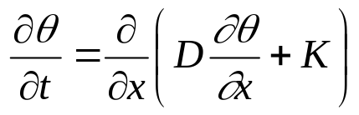
which simplifies in the case of a horizontal column, having no gravity force in the direction of motion, to:

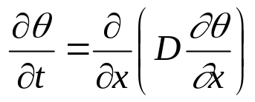

By assuming that soil diffusivity, D is constant throughout the soil column, the equation further simplifies to:

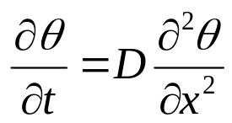

which is a 2nd-order ordinary partial differential equation.

The MATLAB program uses a numerical method known as finite differencing to solve the simplified Richard’s Equation. By discretizing the time and distance axes into intervals of 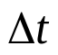and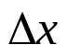 respectively (see Figure 2), the equation above can be linearized into the following form:

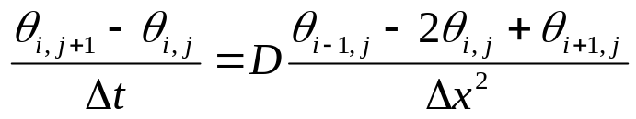

Where,
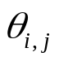= moisture content at the ith distance interval and jth time interval
= length of time interval
= length of the distance interval
D = soil water diffusivity

x
0
Θ(i,j+1)
t
j=1
j=2
j=3
j=JΔt
i=IΔx
i=1
Θ(i,j)
Θ(i+1,j)
Θ(i-1,j)
Figure 2. Discretization of the time and length axes.

By rearranging terms, the following form can be obtained:

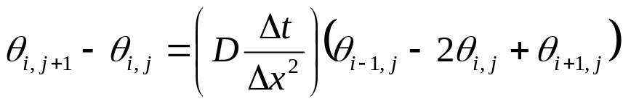
By substituting 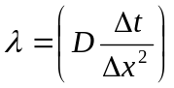 into the above equation, we get:
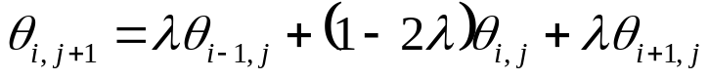

which can also be re-written as:

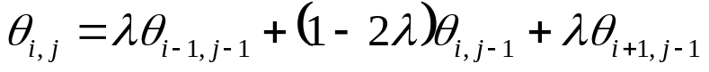

Thus, the moisture content for a given time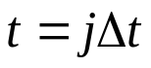 and location 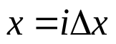is expressed as a function of the moisture content at the previous step (j-1) at the same (i) as well as adjacent (i-1 and i+1) locations. Because the initial boundary locations are known, can be computed directly (thus explicitly) at all time and locations by repeated application of the above equation starting from t = 0.
Please note, however, that the stability of the solution (i.e. the ability of the solution to converge as 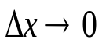 and 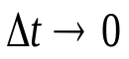) from the explicit scheme is dependent on the value of lambda. For 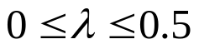 the solution remains stable. For values outside this range, stability is not guaranteed.

Explanation of program
The algorithm of moisture_diffusion.m is basically a straightforward implementation of the solution scheme described above. The steps are outlined as follows:
- First, the values of θ₀ and θ₁ are defined.
- Next, the length of the column, L, and the number of length intervals, I, along the column are defined.
- The duration of the simulation, T, and the number of time intervals, J, within the period are defined.
- The soil diffusivity, D, is defined.
- The value of lambda is checked to ensure stability. The program displays a warning message if lambda is greater than 0.5 or less than 0.
- A two-dimensional matrix for storing moisture content is declared.
- Known values of are inputted into the two-dimensional matrix based on the initial and boundary conditions.
- Remaining unknown locations are solved using the finite differencing scheme.
- The spatial profiles of are plotted for selected time intervals. See diagram below:
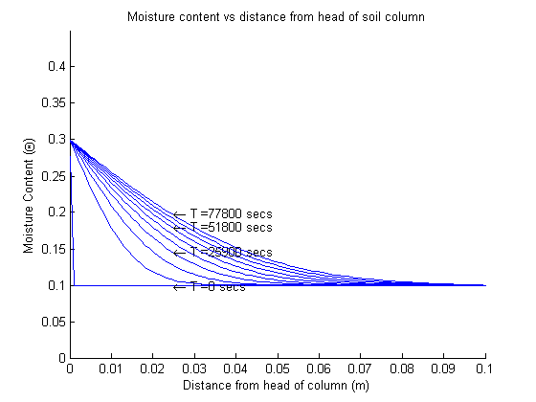
- The infiltration rate and the cumulative infiltration depth at the head of the column are calculated using the equations:

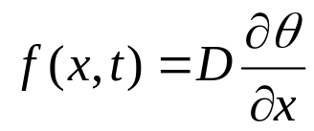 which can be approximated as 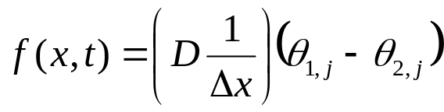
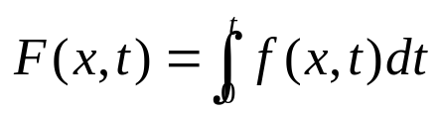 which can be approximated as 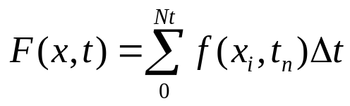

- Finally, the temporal profiles the infiltration rate and the cumulative infiltration depth at the head of the column are plotted (see below for examples).
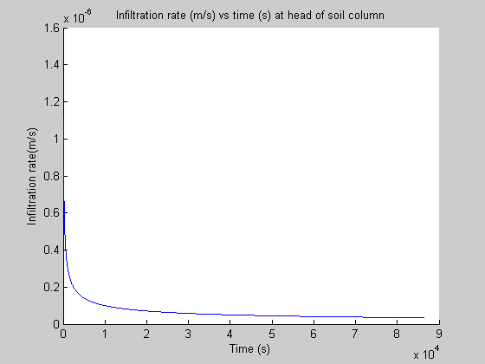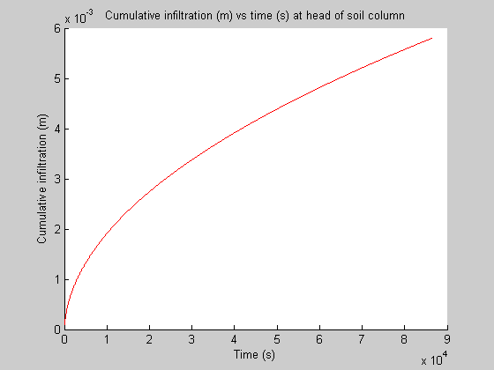

The above plots are in m/s vs seconds. To provide some summary statistics for each condition, the values of f and F are printed out at t = 0, 6, 12, 18, 24 hours:

Time Infiltration Rate (mm/hr) Cumulative Infiltration (mm)
0 5.688 0
6 0.2456 2.8486
12 0.1737 4.0695
18 0.1418 5.0064
24 0.1228 5.7963

For more information, please refer to the source code in the appendix.

Publishing code and results to html format.
MATLAB 7.1 or above provides a nice feature (Publish to HTML) that allows the user to – in a single click – run his code and publish both the code and the results together to HTML format. This feature is particularly useful when the user is modifying his code and needs to document the execution results after each modification. The user can execute this feature by going under File in the main toolbar and selecting Publish to HTML.

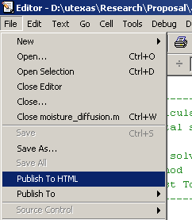

Publish to HTML creates a webpage that has the source code at the top and
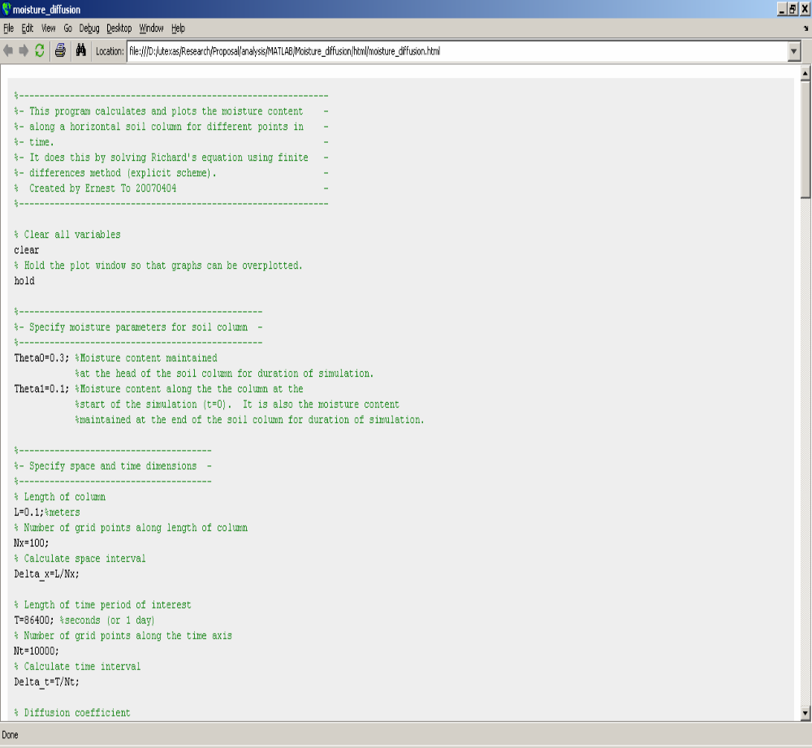

Graphs at the bottom of the page.
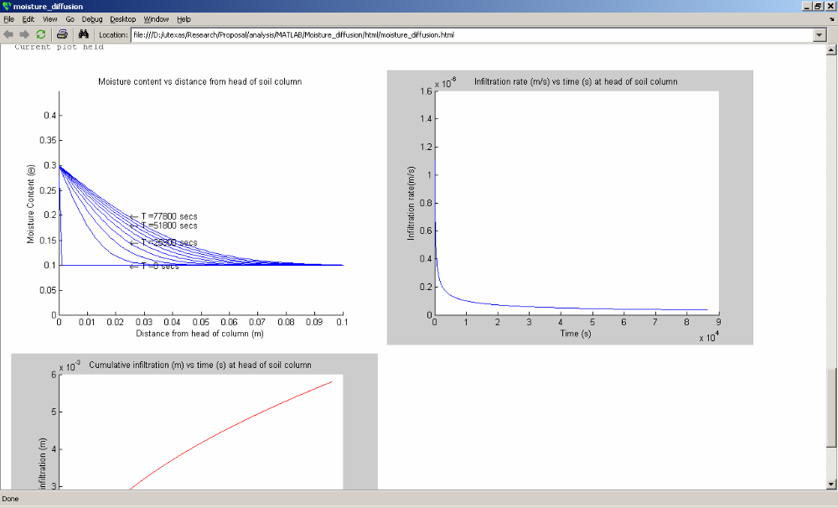

Modifying the program

Modify the program so that you can examine the effect of different options for the parameters

(1) Change the value of θ_{o} (the moisture content at the head of the column) from 0.2 to 0.5 in increments of 0.1 and examine the effect on f and F for t = 0 hours and t =1 day.

(2) Change the value of D from 7.9 x 10⁻⁹ m²/s to 7.9 x 10⁻⁸ m²/s and 7.9 x 10⁻¹⁰ m²/s and examine the effect on f and F for t = 0 hours and t =1 day.

(3) Do some creative! A part of the purpose of this exercise is to give you some exposure to the use of Matlab. Do something interesting with the program that it does not already do now and present the results of your modification.
To be turned in:

(1) A publication in html format of the results of the program for the initial conditions for which it
was set up, as shown in this exercise.

(2) The results of the prescribed modifications for θ_{o} and D as given above.

(3) The results of your creative program modifications.
OK, you're done!

Appendix – Source code of moisture_diffusion.m

%-------------------------------------------------------------
%- This program calculates and plots the moisture content -
%- along a horizontal soil column for different points in -
%- time. -
%- It does this by solving Richard's equation using finite -
%- differences method (explicit scheme). -
% Created by Ernest To 20070404 -
%-------------------------------------------------------------

% Clear all variables
clear
% Hold the plot window so that graphs can be overplotted.
hold

%------------------------------------------------
%- Specify moisture parameters for soil column -
%------------------------------------------------
Theta0=0.3; %Moisture content maintained
%at the head of the soil column for duration of simulation.
Theta1=0.1; %Moisture content along the the column at the
%start of the simulation (t=0). It is also the moisture content
%maintained at the end of the soil column for duration of simulation.

%--------------------------------------
%- Specify space and time dimensions -
%--------------------------------------
% Length of column
L=0.1;%meters
% Number of grid points along length of column
I=100;
% Calculate space interval
Delta_x=L/I;

% Length of time period of interest
T=86400; %seconds (or 1 day)
% Number of grid points along the time axis
J=10000;
% Calculate time interval
Delta_t=T/J;

% Diffusion coefficient
D=7.9e-9;%m^2/s

% Calculate Lambda, where Lambda = D*(Delta_t)/((Delta_x)^2)
Lambda=D*(Delta_t)/((Delta_x)^2);

% Check lambda for stability - make sure finite difference representation
% converges as delta_x ->0 and delta_t->0.
if Lambda<=0||Lambda>0.5
disp('Lambda needs to be between 0 and 0.5 for the solution scheme to be stable.')
disp('Please adjust your x and t intervals.');
message = strcat('Lambda = ',num2str(Lambda));
disp(message);
pause;
%pause if solution is unstable
end

%-------------------------------------------------------------------
%- Declare 2D matrix to store moisture content (theta) at -
%- different x and t. -
%-------------------------------------------------------------------

% Declare a 2D matrix with dimensions I, J that has all elements as zero
Theta=zeros(I,J);

%--------------------------------
%- Specify initial conditions -
%--------------------------------
%Set initial moisture content of the soil column
Theta(:,1)=Theta1; % Assume initial moisture content is Theta1 everywhere except
% at the head of the column
%--------------------------------
%- Specify boundary conditions -
%--------------------------------
%Set boundary conditions at the head and end of the soil column
Theta(1,:)=Theta0; % Assume that the moisture content at the head is maintained
% at Theta0 by infiltration for all t.
Theta(I,:)=Theta1; % Assume that the moisture content at the end is maintained
% at Theta1 for all t.

%----------------------------------------------
%- Calculate Theta(x,t) using explicit scheme -
%----------------------------------------------

for j=2:(J)
for i=2:(I-1)
Theta(i,j)=Lambda*Theta((i-1),(j-1))+(1-2*Lambda)*Theta(i,(j-1))+Lambda*Theta((i+1),(j-1));
end
end

%disp(Theta);
%----------------------------
%- Plot theta(x,t) -
%----------------------------
%Setup x values for plotting
x = linspace(0,L,I);

%Display graph every T_int time steps
T_int=1000;
%Set up the max and min values for the x and y axes of the graph
max_Theta=max(Theta)*1.5;
axis([0 L 0 max_Theta(1)])

%Setup graph and axis labels
title('Moisture content vs distance from head of soil column')
xlabel('Distance from head of column (m)')
ylabel('Moisture Content (\Theta)')

for j=1:T_int:J
%Plot moisture content along the column at time step j.
plot(x,Theta(:,j),'B-');

% Annotate the time step for every other two graphs
if round((j-1)/(3*T_int))== (j-1)/(3*T_int)
% Create label to show the time (in seconds) for the current graph
Time_step_label = strcat('\leftarrow T = ',num2str(round(j*Delta_t/100)*100),' secs');
text(L/4,Theta(I/4,j),Time_step_label,'HorizontalAlignment','left')
end
end

%-----------------------------------------------------------
%- Calculate infiltration rate at head of column -
%-----------------------------------------------------------
inf_rate=D*(Theta(1,:)-Theta(2,:))/(Delta_x);

%Create a new plot window
figure
hold

title('Infiltration rate (m/s) vs time (s) at head of soil column')
ylabel('Infiltration rate(m/s)')
xlabel('Time (s)')

%Setup t values for plotting
t = linspace(0,T,J);
plot(t,inf_rate,'B-');

%-----------------------------------------------------------
%- Calculate cumulative infiltration head of column -
%-----------------------------------------------------------
inf_accum=inf_rate; %declare an array that has same dimensions
inf_accum(:)=0; %as inf_rate but has all entries as 0.

%Calculate the cumulative infiltration
for j=2:J
inf_accum(j)=inf_accum(j-1)+Delta_t*inf_rate(j-1);
end

%Create a new plot window
figure
hold

title('Cumulative infiltration (m) vs time (s) at head of soil column')
ylabel('Cumulative infiltration (m)')
xlabel('Time (s)')

plot(t,inf_accum,'R-');

%- Display infitration rate in mm/hr and cumulative infiltration at t = 0 hour
hour = 0;
disp (hour);
disp (inf_rate(1)*1000*3600);
disp (inf_accum(1)*1000);

%- Display infitration rate in mm/hr and cumulative infiltration at t = 6,12,18,24 hour

for hour=6:6:24
j=int32(3600*hour/Delta_t);
disp (hour);
disp (inf_rate(j)*1000*3600);
disp (inf_accum(j)*1000);

end

