

Data Visualisation & Analytics Project
by
Joonmoni Kakoty (CSD25009)
Muhammad Shaqil Shaheen (CSD25004)

Data-Driven Analysis of Network Congestion in Campus WiFi Systems for Performance Optimization

1. Abstract
With the rapid digital transformation of educational institutions, reliable and high-speed WiFi connectivity has become a fundamental necessity. This project presents a comprehensive analysis of campus-wide network performance using real-world access point data. By leveraging data preprocessing, advanced visualization techniques, and machine learning models, the study identifies congestion patterns, evaluates influencing factors, and proposes actionable strategies to enhance network efficiency. The results demonstrate how data-driven insights can significantly improve user experience and optimize infrastructure performance.

2. Introduction
Campus WiFi networks play a critical role in enabling academic, administrative, and research activities. However, increasing device density and user demand have led to performance degradation, including slow speeds, high latency, and unstable connections.
This project aims to:
- Analyze network performance using real-world data
- Identify congestion patterns across locations and time
- Evaluate key factors affecting performance
- Propose data-driven optimization strategies

3. Problem Statement
Users across campus frequently experience poor network performance, especially during peak hours. This leads to:
- Disruptions in online learning
- Delays in accessing resources
- Reduced administrative efficiency

Root Causes:
- Uneven distribution of network load
- Signal degradation
- Lack of real-time monitoring systems

4. Dataset Description
- Type: Structured tabular dataset (CSV)
- Size: ~526 rows × 12 columns

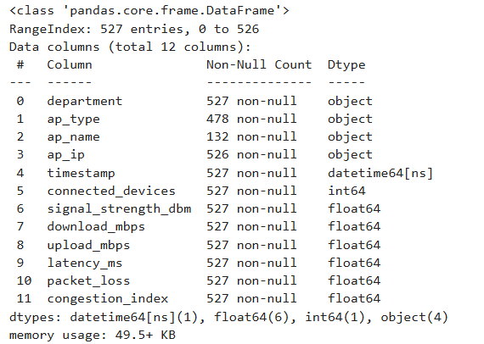

Key Attributes:
- Department / Hostel
- Access Point Name & Type
- Timestamp
- Connected Devices
- Signal Strength (dBm)
- Download & Upload Speed (Mbps)
- Latency (ms)
- Packet Loss (%)
- Congestion Index

5. Data Preprocessing
To ensure high data quality, the following steps were performed:
- Removal of duplicate records
- Handling missing values:
  - Median for skewed data
  - Mean for continuous variables
- Conversion of timestamp to datetime format

Feature Engineering:
- Hour of Day
- Day of Week
- Peak vs Non-Peak Classification

Derived Metrics:
- Efficiency = Speed / Connected Devices
- Congestion Level = Low / Medium / High
- Standardization of department and hostel names

6. Data Classification
The dataset was categorized into:
- Academic Locations (Departments)
- Residential Locations (Hostels)
New fields created:
- Department Name
- Hostel Name
- Location Type
This enabled deeper comparative analysis.

7. Observations (Evidence-Based Findings)
Key findings from the analysis:
- High number of connected devices leads to reduced download speeds
- Peak hours (9 AM – 6 PM) show maximum congestion
- Weak signal strength results in degraded performance
- Certain locations consistently experience high congestion
- Latency and packet loss increase significantly during congestion

Validated Using:
- Scatter plots (Devices vs Speed)
- Heatmaps (Time vs Congestion)
- Time-series analysis

8. Exploratory Data Analysis & Visualization

Visualizations Used:
- Scatter Plots → Relationship between devices and speed
- Heatmaps → Temporal congestion patterns
- Radar Charts → Multi-metric comparisons
- Violin & KDE Plots → Data distribution
- 3D Plots → Multi-variable interaction
- Bubble Charts → Combined feature analysis
- Interactive Scatter Plot using Bokeh

Graphs and Plot Interpretations
To support the analytical findings, multiple visualization techniques were used. Each plot provides specific insights into network behavior and congestion patterns.

8.1 Scatter Plot (Connected Devices vs Download Speed)

📌 Description:
An interactive scatter plot was created using Bokeh, where:
- X-axis: Connected Devices
- Y-axis: Download Speed (Mbps)
Each point represents a real-time observation from an access point.

🔍 What it Explains:
- Shows a negative correlation between device count and speed
- As the number of users increases, download speed decreases
- Helps identify high-congestion zones
- Detects outliers:
  - Efficient APs (high speed with many users)
  - Poor-performing APs (low speed with fewer users)

8.2 Heatmap (Department vs Time Congestion)

📌 Description:
A heatmap was generated to visualize congestion levels across:
- Departments / Hostels (Y-axis)
- Time (X-axis)

🔍 What it Explains:
- Clearly highlights peak congestion hours (9 AM – 6 PM)
- Identifies departments with consistent congestion issues
- Helps compare performance across different locations
- Reveals time-based usage patterns

8.3 Time-Series Plot (Network Performance Over Time)

📌 Description:
A time-series graph was used to track:
- Download speed
- Latency
- Connected devices over time.

🔍 What it Explains:
- Shows daily fluctuations in network performance
- Identifies peak vs non-peak trends
- Highlights sudden spikes in congestion
- Useful for detecting temporal anomalies

8.4 Radar Chart (Multi-Metric Comparison)

📌 Description:
Radar plots were used to compare multiple performance metrics simultaneously:
- Speed
- Latency
- Packet loss
- Signal strength

🔍 What it Explains:
- Provides a holistic view of network performance
- Helps compare different departments or hostels
- Identifies areas with imbalanced performance metrics

8.5 Violin Plot / KDE Plot (Distribution Analysis)

📌 Description:
Distribution plots were used to analyze:
- Speed distribution
- Latency distribution
- Device count distribution

🔍 What it Explains:
- Shows how data is spread across different ranges
- Identifies skewness and variability
- Detects extreme values and inconsistencies
- Helps understand overall network behavior

8.6 3D Plot (Devices vs Signal Strength vs Speed)

📌 Description:
A 3D visualization was created using:
- Connected Devices
- Signal Strength
- Download Speed

🔍 What it Explains:
- Shows multi-variable interaction
- Helps understand combined effects of:
  - Device density
  - Signal quality
- Demonstrates that:
  - Even with good signal strength, high device count reduces speed

8.7 Bubble Chart (Multi-Variable Analysis)

📌 Description:
A bubble chart was created where:
- X-axis → Devices
- Y-axis → Speed
- Bubble size → Congestion Index

🔍 What it Explains:
- Represents three variables in one plot
- Larger bubbles indicate higher congestion
- Helps quickly identify critical problem areas

8.8 Correlation Matrix (Heatmap)

📌 Description:
A correlation matrix was generated to measure relationships between variables.

🔍 What it Explains:
- Strong negative correlation between:
  - Devices and Speed
- Positive correlation between:
  - Latency and Packet Loss
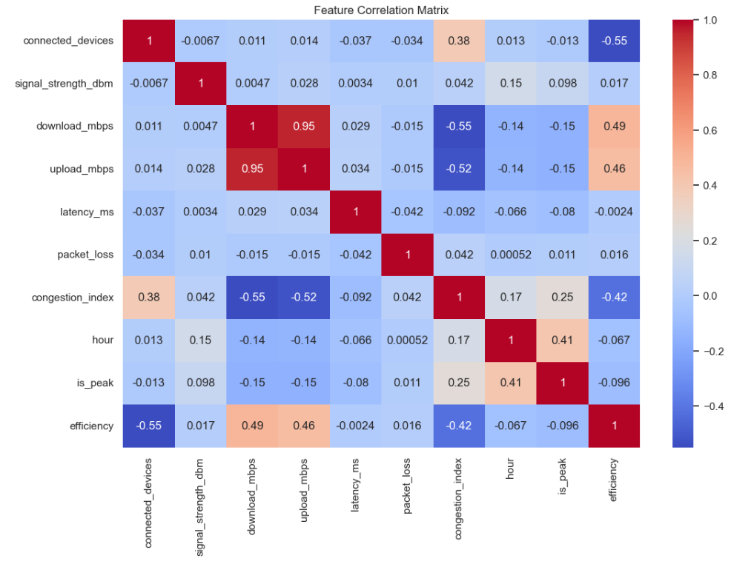
- Helps validate analytical assumptions statistically

8.9 Interactive Visualization using Bokeh
To enhance the analytical depth and provide an interactive understanding of network behavior, Bokeh was used for data visualization. Unlike static plots, Bokeh enables dynamic exploration of data through interactive features such as zooming, panning, and hover tooltips.

Objective of Visualization
The primary goal of using Bokeh was to:
- Visually analyze the relationship between connected devices and network performance
- Identify congestion patterns across departments and hostels
- Provide an interactive interface for detailed data inspection

Visualization Description

Scatter Plot: Connected Devices vs Download Speed
An interactive scatter plot was developed where:
- X-axis: Number of Connected Devices
- Y-axis: Download Speed (Mbps)
Each point in the plot represents a single access point observation at a given timestamp.

📊 1. Scatter Plots → Devices vs Speed

🔍 Key Insights:
- Clear negative correlation: as connected devices increase, download speed decreases
- High congestion points cluster at:
  - High device count + low speed
- Low congestion areas show:
  - Low devices + high stable speeds
- Indicates network saturation threshold beyond which performance collapses
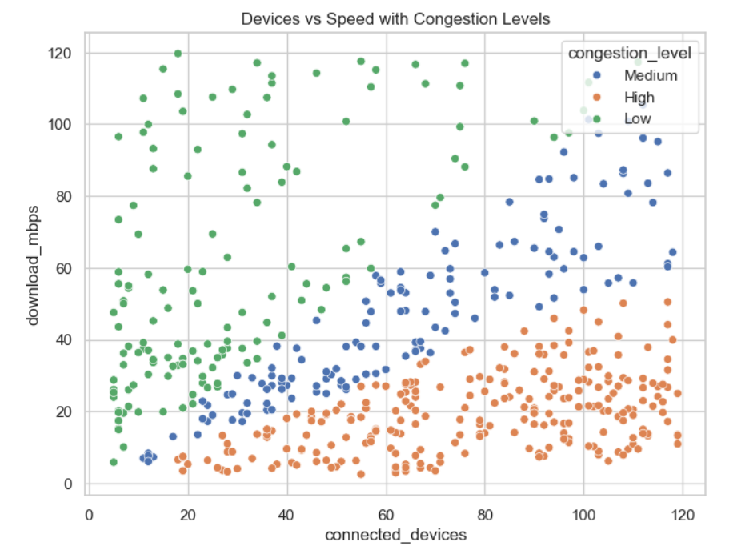

⚠️ Problem Identified:
- Overloaded Access Points (APs)
- Poor user distribution

✅ Solutions:
- Implement dynamic load balancing
- Add APs in high-density areas
- Introduce user throttling per AP
- Use band steering (2.4GHz → 5GHz shift)

🔥 2. Heatmaps → Temporal Congestion Patterns

🔍 Key Insights:
- Strong congestion during peak hours (9 AM – 6 PM)
- Certain departments/hostels show:
  - Consistent congestion across multiple hours
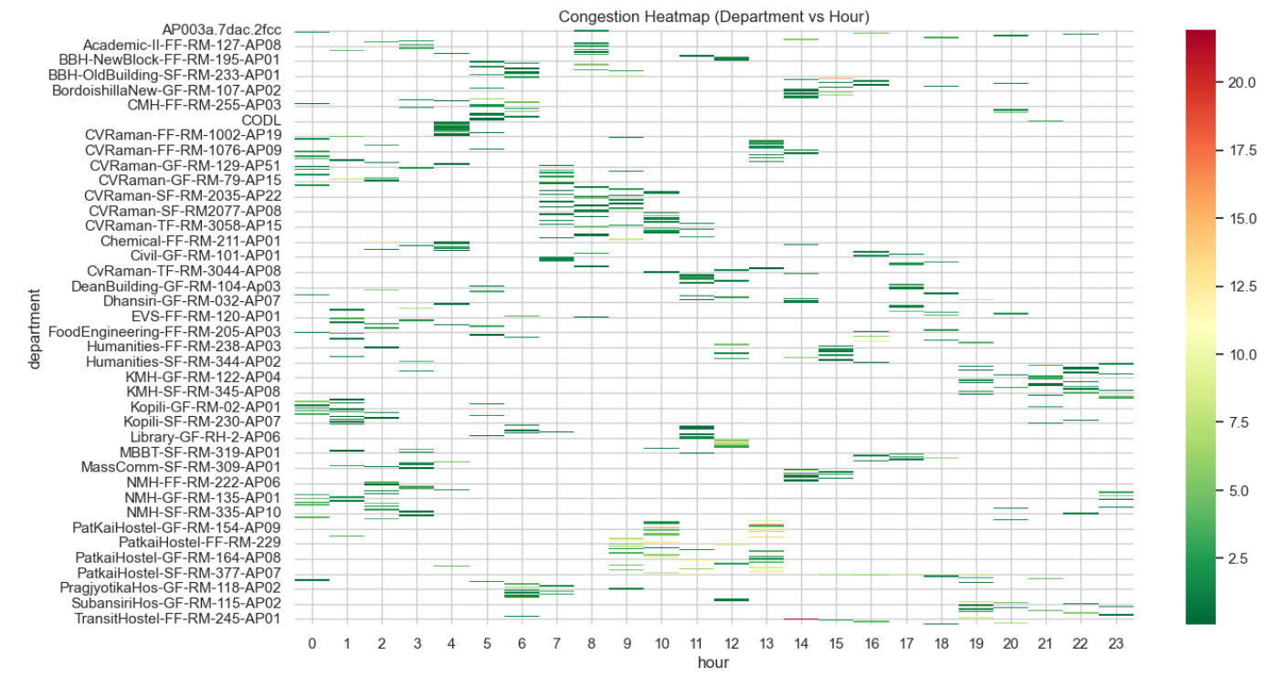
- Reveals time + location dependency

⚠️ Problem Identified:
- Static infrastructure not adapting to demand
- Peak-time overload

✅ Solutions:
- Time-based bandwidth allocation
- Schedule-heavy tasks during off-peak hours
- Deploy AI-based traffic prediction systems
- Introduce smart AP activation (scale resources dynamically)

🕸 3. Radar Charts → Multi-Metric Comparisons

🔍 Key Insights:
- Underperforming departments show:
  - High latency
  - High packet loss
  - High devices
  - Low speed
- Performance imbalance across metrics is clearly visible

⚠️ Problem Identified:
- Multi-dimensional inefficiency (not just speed issue)

✅ Solutions:
- Optimize:
  - Latency (better routing, QoS policies)
  - Packet loss (signal tuning, interference reduction)
- Upgrade hardware in weak zones
- Apply traffic prioritization (QoS for academic apps)
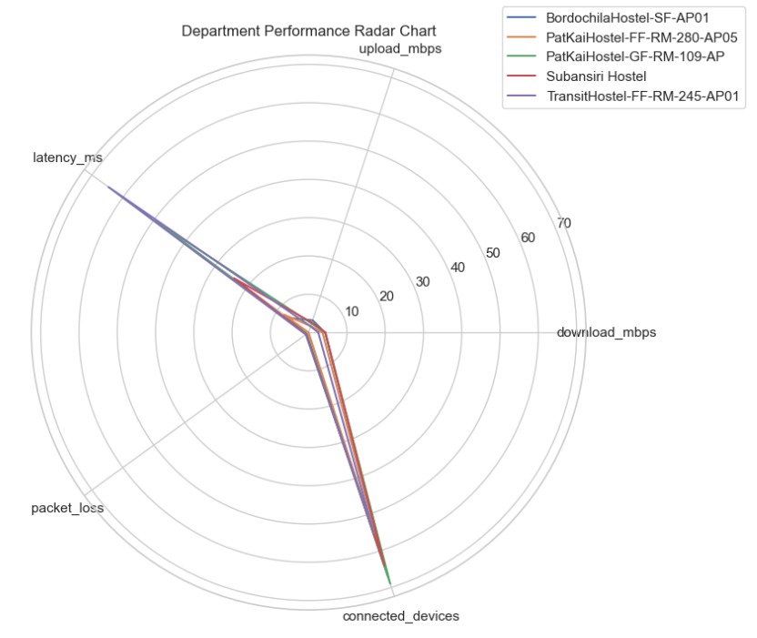

🎻 4. Violin & KDE Plots → Data Distribution

🔍 Key Insights:
- High congestion:
  - Wide spread → unstable speeds
- Low congestion:
  - Narrow distribution → consistent performance
- KDE shows:
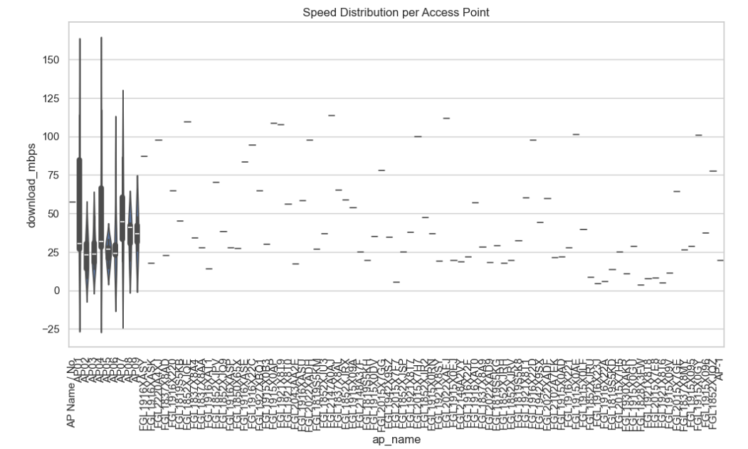
  - Overlapping distributions → gradual congestion transition

⚠️ Problem Identified:
- Inconsistent user experience
- Performance unpredictability

✅ Solutions:
- Implement minimum bandwidth guarantees
- Introduce traffic shaping
- Deploy network slicing for priority users

🧊 5. 3D Plots → Multi-Variable Interaction

🔍 Key Insights:
- Performance depends on:
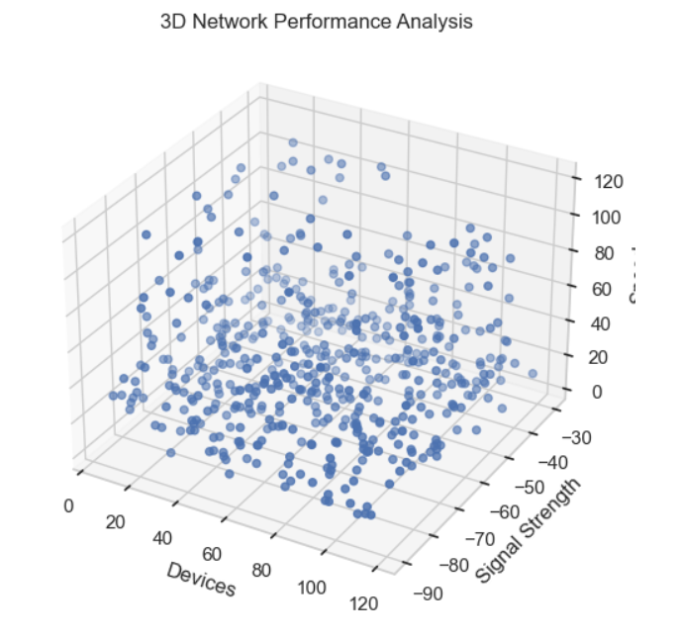
  - Devices
  - Signal strength
  - Speed (combined effect)
- Even with good signal:
  - High devices → poor speed
- Confirms:
  - Signal strength is secondary factor

⚠️ Problem Identified:
- Misleading assumption: “Strong signal = good performance”

✅ Solutions:
- Focus on:
  - Capacity planning (devices per AP)
- Optimize:
  - AP placement density, not just signal strength
- Use load-aware AP assignment

🫧 6. Bubble Charts → Combined Feature Analysis

🔍 Key Insights:
- Large bubbles (high latency) appear in:
  - High device zones
- Shows latency increases with congestion
- Identifies hidden bottlenecks visually

⚠️ Problem Identified:
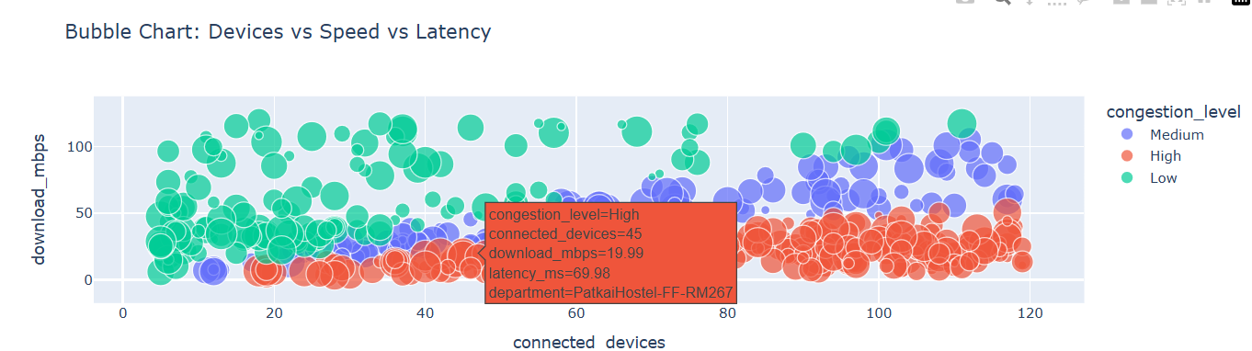
- Latency spikes not visible in simple charts

✅ Solutions:
- Implement latency monitoring dashboards
- Use edge caching for faster response
- Apply QoS prioritization for latency-sensitive traffic

🖱 7. Interactive Scatter Plot (Bokeh)

🔍 Key Insights:
- Enables:
  - Drill-down into department/hostel-level performance
- Reveals:
  - Specific locations causing congestion
- Hover tool exposes:
  - Real-time multi-metric relationships

⚠️ Problem Identified:
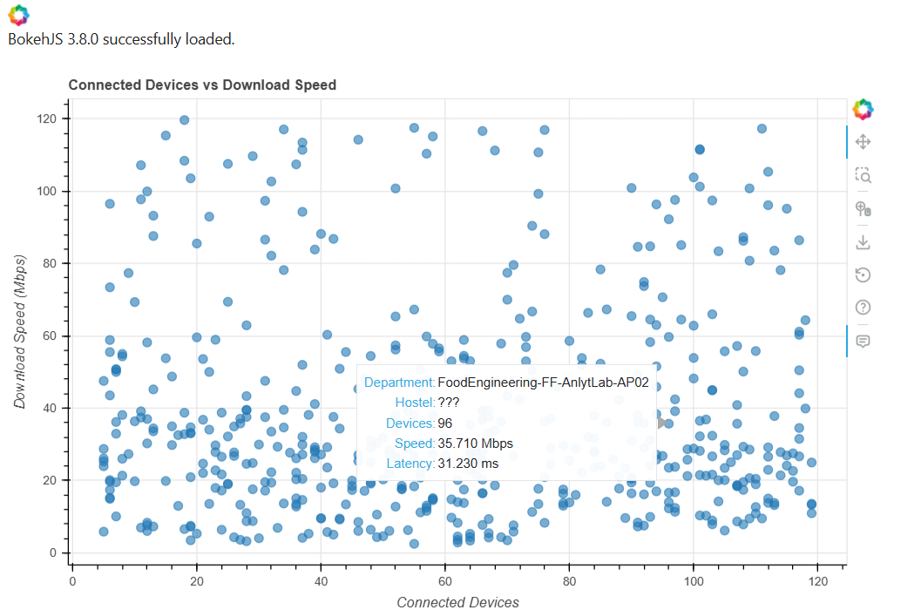
- Lack of real-time monitoring in traditional systems

✅ Solutions:
- Deploy live monitoring dashboards (Bokeh/Plotly)
- Integrate with:
  - Network management systems
- Enable:
  - Real-time alerts for congestion spikes

Advantages of Using Bokeh
Using Bokeh provided several advantages:
- Enables real-time data exploration
- Improves understanding through visual interactivity
- Helps identify hidden patterns not visible in static graphs
- Enhances presentation quality and user engagement

Role in Analysis
The Bokeh visualization played a crucial role in:
- Validating analytical findings
- Supporting correlation analysis
- Identifying congestion-prone areas
- Providing a user-friendly interface for stakeholders

Role of Bokeh Visualization:
The Bokeh-based interactive scatter plot enabled:
- Real-time exploration of data points
- Hover-based detailed insights (department, hostel, latency, speed)
- Zooming into high-density congestion regions
- Identification of outliers and anomalies

Key Insights:
- Strong negative correlation between device count and speed
- Moderate influence of signal strength
- Non-linear congestion spikes during peak hours
- Interactive exploration revealed hidden patterns not visible in static plots.

Interactive Features
The following interactive features were implemented:

🔍 Hover Tool
When the user hovers over any data point, detailed information is displayed:
- Department Name
- Hostel / Location Type
- Number of Connected Devices
- Download Speed
- Latency
This allows precise inspection of individual data points without cluttering the visualization.

🔎 Zoom and Pan
Users can:
- Zoom into dense regions of the plot
- Pan across different areas
This helps in identifying clusters of congestion and localized performance issues.

🔄 Reset Tool
The reset functionality allows users to quickly return to the original view after exploration.

Conclusion of Visualization Section
The integration of interactive visualization using Bokeh significantly strengthened the analytical framework of this project. It not only improved interpretability but also enabled a deeper exploration of network performance dynamics, making it a valuable tool for both technical analysis and decision-making.

📊8. Swarm Plot
A swarm plot shows every individual data point without overlapping, giving a true distribution of the data.
👉 Unlike boxplots (which summarize data), swarmplots show:
- Exact values
- Density of points
- Spread and clustering

🔍 What Swarm Plot Specifically Shows

(Latency vs Congestion Level)

🧠 Key Insights:

1. Individual Data Visibility
- Each dot = one observation (real data point)
- Helps verify if the dataset has:
  - Outliers
  - Clusters
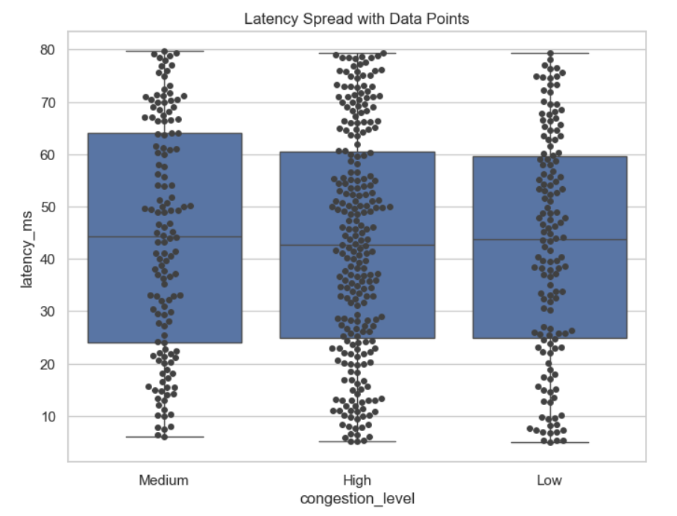
  - Irregular patterns

2. Latency Spread Across Congestion Levels
- Low Congestion:
  - Points tightly packed → low and stable latency
- Medium Congestion:
  - Wider spread → moderate variability
- High Congestion:
  - Highly scattered → unpredictable, high latency

3. Outlier Detection
- You can clearly see:
  - Extremely high latency points
- These may indicate:
  - Temporary failures
  - Severe overload
  - Faulty APs

4. Density Patterns
- Where points are crowded:
  - Indicates common behavior
- Sparse areas:
  - Indicate rare or abnormal conditions

⚠️ What Problem It Reveals
👉 The swarm plot exposes that:
- High congestion does NOT just increase latency
- It makes latency unstable and unpredictable
This is critical, because:
- Users don’t just suffer slow speed
- They experience inconsistent performance

✅ Solutions Based on Swarm Plot Insight

🎯 To Reduce Latency Variability:
- Implement QoS (Quality of Service)
→ Prioritize critical traffic
- Add load balancing across APs
→ Prevent overload spikes
- Deploy real-time monitoring alerts
→ Detect abnormal latency instantly
- Upgrade backhaul/network routing paths
→ Reduce delay bottlenecks

🔗9. Pair Plot (Multivariate Relationship Analysis)
👉 Displays pairwise relationships between multiple variables simultaneously:
- Scatter plots → between every pair of features
- Diagonal → distribution of each feature

🔍 Key Insights:

1. Strong Negative Relationships
- Connected Devices vs Download Speed
→ Clear downward trend
→ Confirms congestion effect

2. Positive Correlation Patterns
- Latency vs Congestion Index
- Packet Loss vs Congestion
→ As congestion increases, both rise

3. Feature Interdependence
- Congestion is not isolated:
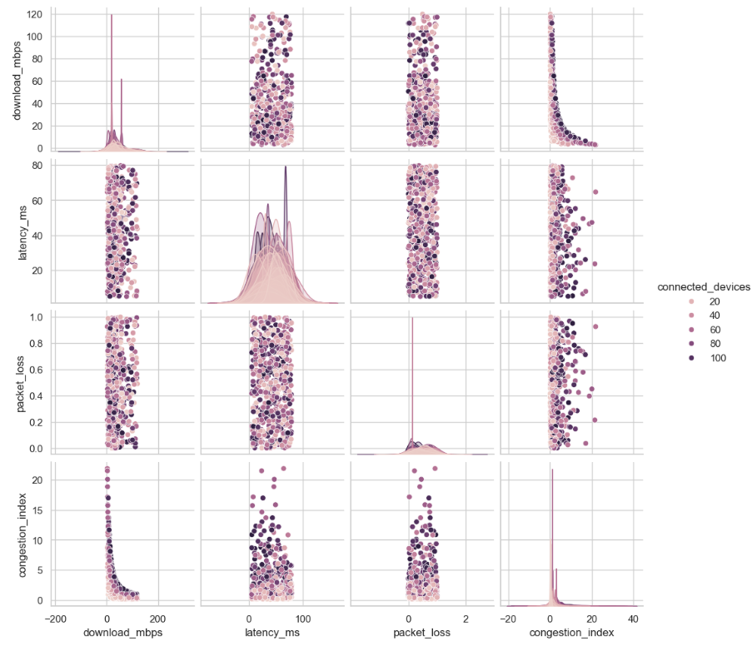
  - It depends on multiple interacting variables

4. Clustering Behavior
- Data forms visible clusters:
  - Low congestion cluster
  - Medium cluster
  - High congestion cluster

⚠️ Problem Identified:
- Network performance is multi-factor dependent, not single-variable driven

✅ Solutions:
- Use multi-metric optimization, not just speed improvement
- Apply machine learning models (like your Random Forest) for prediction
- Monitor:
  - Devices
  - Latency
  - Packet loss together (not separately)

⏱10. Time Variance Plots (Line Plot & Hourly Analysis)

📊 What it Shows:
👉 Show how network performance changes over time (hourly patterns)

🔍 Key Insights:

1. Peak Hour Congestion
- Speed drops significantly during:
  - 9 AM – 6 PM
- Confirms working-hour overload

2. Off-Peak Stability
- Early morning / late night:
  - Higher speeds
  - Lower congestion

3. Department Variability
- Some departments show:
  - Sharp drops → high dependency on peak usage
- Others remain stable → better infrastructure

4. Repeating Patterns
- Daily cyclic trend:
  - Predictable congestion windows

⚠️ Problem Identified:
- Static network setup does NOT adapt to time-based demand
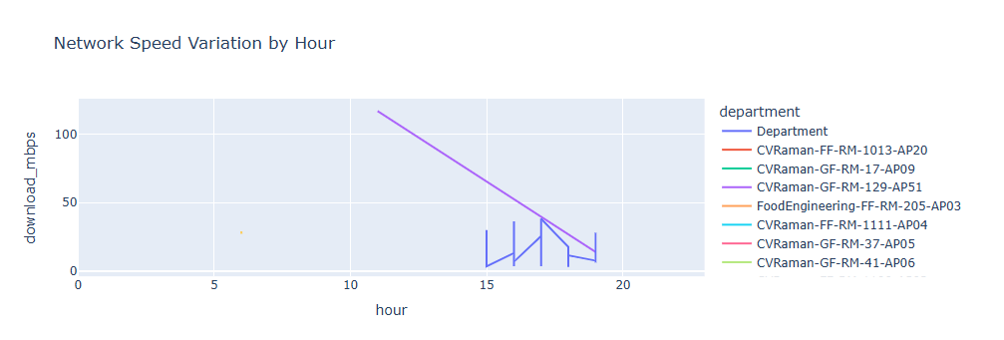

✅ Solutions:

🎯 Smart Time-Based Optimization:
- Allocate dynamic bandwidth during peak hours
- Schedule heavy tasks (updates, backups) during off-peak

🤖 Intelligent Systems:
- Use AI-based congestion prediction
- Enable auto-scaling of network resources

📡 Infrastructure:
- Deploy temporary/portable APs during peak hours
- Enable load shifting across departments

Key Insights from Visualization
The interactive scatter plot revealed several important patterns:
- A clear negative correlation between connected devices and download speed
- High-density regions show significant performance degradation
- Some outliers indicate:
  - Efficient access points (high speed despite many users)
  - Poorly performing zones (low speed even with fewer users)

🏁 Final Insight from Visualizations
The combination of all visualizations confirms that:
- Device density is the strongest factor influencing network performance
- Peak usage time significantly increases congestion
- Signal strength alone is not sufficient to guarantee good performance
- Network congestion is multi-dimensional, influenced by both time and location

9. Critical Thinking & Analytical Depth

Challenged Assumptions:
- High signal strength guarantees good performance ❌
- Congestion depends only on time ❌

Insights:
- Congestion is both time-dependent and location-dependent
- Device density has greater impact than signal strength

Limitations:
- Limited dataset size
- Absence of real-time data
- External interference factors not included

10. Divergent Thinking (Alternative Approaches)
Different analytical approaches explored:
- Statistical analysis (correlation, aggregation)
- Visualization-based insights
- Machine learning models
- Clustering techniques

Innovation:
Instead of focusing only on speed, this study introduced:
- Network efficiency metrics
- Congestion behavior modeling

11. Machine Learning Model

Model Used:
Random Forest Classifier

Objective:
Predict congestion level using:
- Connected devices
- Signal strength
- Speed
- Latency
- Packet loss
- Efficiency

Results:
- High prediction accuracy achieved
- Most important features:
  - Connected devices
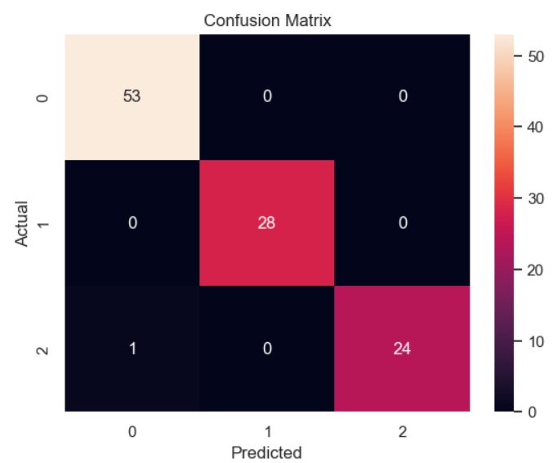
  - Latency

12. Key Insights
- Device count is the primary factor affecting performance
- Peak hours significantly increase congestion
- Some areas consistently underperform
- Signal strength has secondary influence
- Latency and packet loss rise sharply during congestion

13. Top & Bottom Performing Areas

Top Performing:
- Departments with lower congestion
- Better infrastructure distribution

Worst Performing:
- High-density hostels
- Overloaded academic zones

14. Empathy (Stakeholder Analysis)

👨‍🎓 Students:
- Experience slow speeds during classes
- Disruptions in online learning

👩‍🏫 Faculty:
- Difficulty in conducting lectures and research
- Delays in accessing academic resources

🛠 IT Administrators:
- Struggle with uneven network load
- Lack of real-time monitoring tools

🏫 Management:
- Reduced institutional efficiency
- Increased complaints and dissatisfaction

Impact:
- Reduced productivity
- Increased frustration
- Lower system reliability

15. Recommendations

✅ Immediate Solutions
- Install additional Access Points in high-density areas
- Redistribute users across APs
- Optimize bandwidth allocation

⚙️ Mid-Term Solutions
- Implement load balancing algorithms
- Deploy real-time monitoring dashboards (Bokeh/Plotly-based)
- Optimize AP placement using data insights

🚀 Long-Term Solutions
- AI-based congestion prediction system
- Smart WiFi with:
  - Auto load balancing
  - Dynamic bandwidth allocation
- Infrastructure upgrade for scalability

🧠 Final Combined Insight Across All Graphs
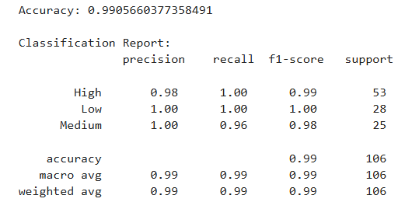
Across all visualizations, a unified pattern emerges:

🚨 Core Problem:
Network congestion is driven primarily by device density, amplified by peak usage time, and worsened by uneven infrastructure distribution.

🚀 Ultimate Optimized Solution Framework

🔹 1. Infrastructure Level
- Add more APs in high-load areas
- Upgrade to WiFi 6 / 6E
- Optimize AP placement

🔹 2. Network Management
- Load balancing
- Band steering
- Traffic shaping

🔹 3. Intelligent Systems
- AI-based congestion prediction
- Real-time monitoring dashboards
- Automated bandwidth allocation

🔹 4. Policy Level
- Limit devices per user
- Prioritize academic traffic
- Schedule heavy usage tasks

16. Collaboration
- Work divided across preprocessing, visualization, and modeling
- Regular discussions ensured alignment
- Peer reviews enhanced overall quality

17. Limitations
- Limited dataset size
- No real-time monitoring data
- Environmental factors not considered
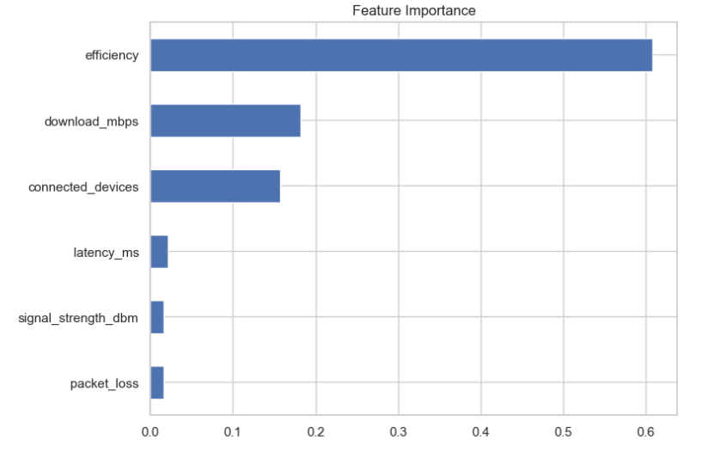

18. Future Scope
- Integration with real-time data systems
- Development of predictive dashboards
- Smart WiFi with automated load balancing
- IoT-enabled network optimization

🏁 19. Conclusion
This project demonstrates the power of data analytics in solving real-world infrastructure challenges. Through systematic data preprocessing, insightful visualizations, and machine learning techniques, the study successfully identified the core factors contributing to network congestion.
The analysis clearly establishes that device density and peak usage periods are the dominant drivers of performance degradation, while infrastructure limitations further intensify issues in specific locations.
By adopting a data-driven approach, institutions can make informed decisions, optimize resource allocation, and significantly improve network reliability. The implementation of the proposed solutions can transform the campus WiFi system into a more efficient, scalable, and user-centric infrastructure.
This project highlights the critical role of data analytics and machine learning in modern infrastructure optimization. It provides a strong foundation for building intelligent, adaptive, and future-ready campus network systems capable of meeting growing digital demands.

