ASSIGNMENT 4

Shaquiel Pashtunyar

2022-07-16

# Markdown Basics

## Favorite Foods

1.Pizza 2.Sushi 3.Burgers

## Images

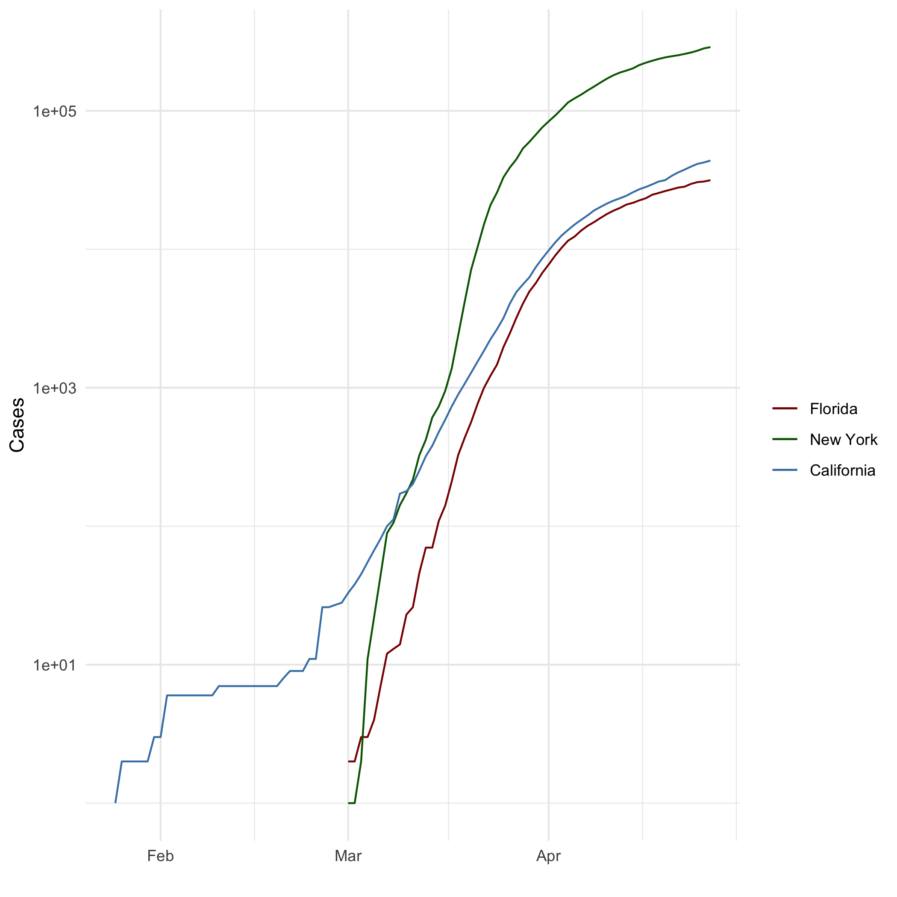

All Caese(Log Plot)

## Add a Quote

“There is nothing wrong with not knowing, but there is a problem to not ask.” - My Dad

## Add an Equation

$$E=mc^{2}$$

## Add a Footnote [1]

## Add Citations

* R for Everyone
* Discovering Statistics Using R

# Inline Code

## NY Times COVID-19 Data

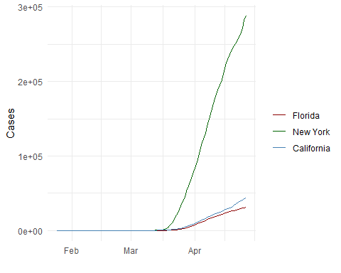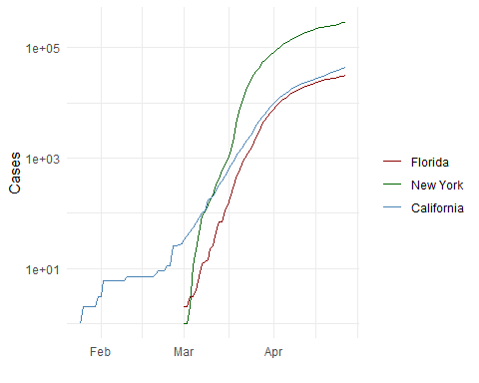

## R4DS Height vs Earnings

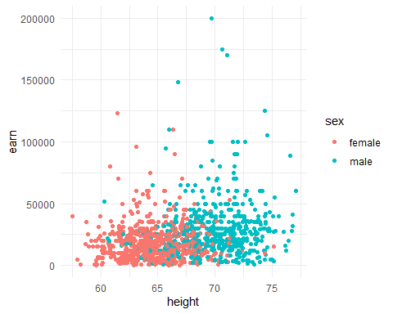

# Tables

## name race in_fellowship ring_bearer age  
## 1 Aragon Men TRUE FALSE 88  
## 2 Bilbo Hobbit FALSE TRUE 129  
## 3 Frodo Hobbit TRUE TRUE 51  
## 4 Galadriel Elf FALSE FALSE 7000  
## 5 Sam Hobbit TRUE TRUE 36  
## 6 Gandalf Maia TRUE TRUE 2019  
## 7 Legolas Elf TRUE FALSE 2931  
## 8 Sauron Maia FALSE TRUE 7052  
## 9 Gollum Hobbit FALSE TRUE 589

## Pandoc Table

## Warning: package 'knitr' was built under R version 4.2.1

One Ring to Rule Them All

| name | race | in_fellowship | ring_bearer | age |
| --- | --- | --- | --- | --- |
| Aragon | Men | TRUE | FALSE | 88 |
| Bilbo | Hobbit | FALSE | TRUE | 129 |
| Frodo | Hobbit | TRUE | TRUE | 51 |
| Galadriel | Elf | FALSE | FALSE | 7000 |
| Sam | Hobbit | TRUE | TRUE | 36 |
| Gandalf | Maia | TRUE | TRUE | 2019 |
| Legolas | Elf | TRUE | FALSE | 2931 |
| Sauron | Maia | FALSE | TRUE | 7052 |
| Gollum | Hobbit | FALSE | TRUE | 589 |

# References

@RforEveryone Second Edition

@https://www.rstudio.com/wp-content/uploads/2015/03/rmarkdown-reference.pdf

1. What is a footnote but just a note.