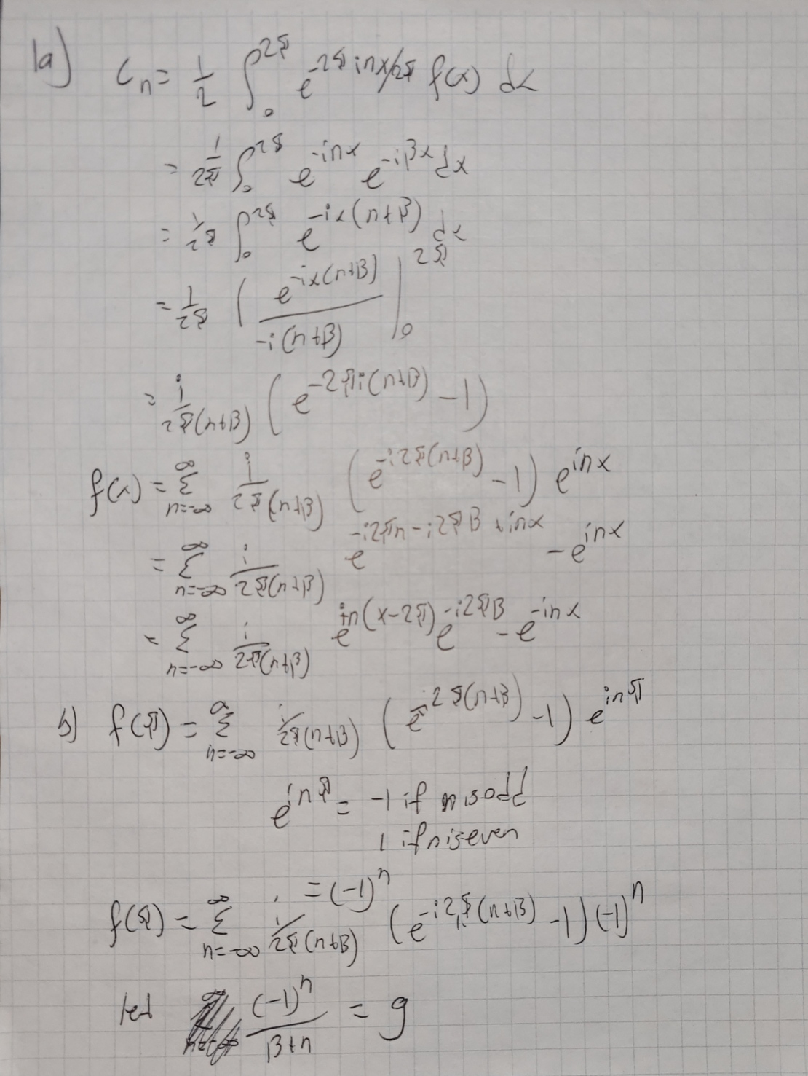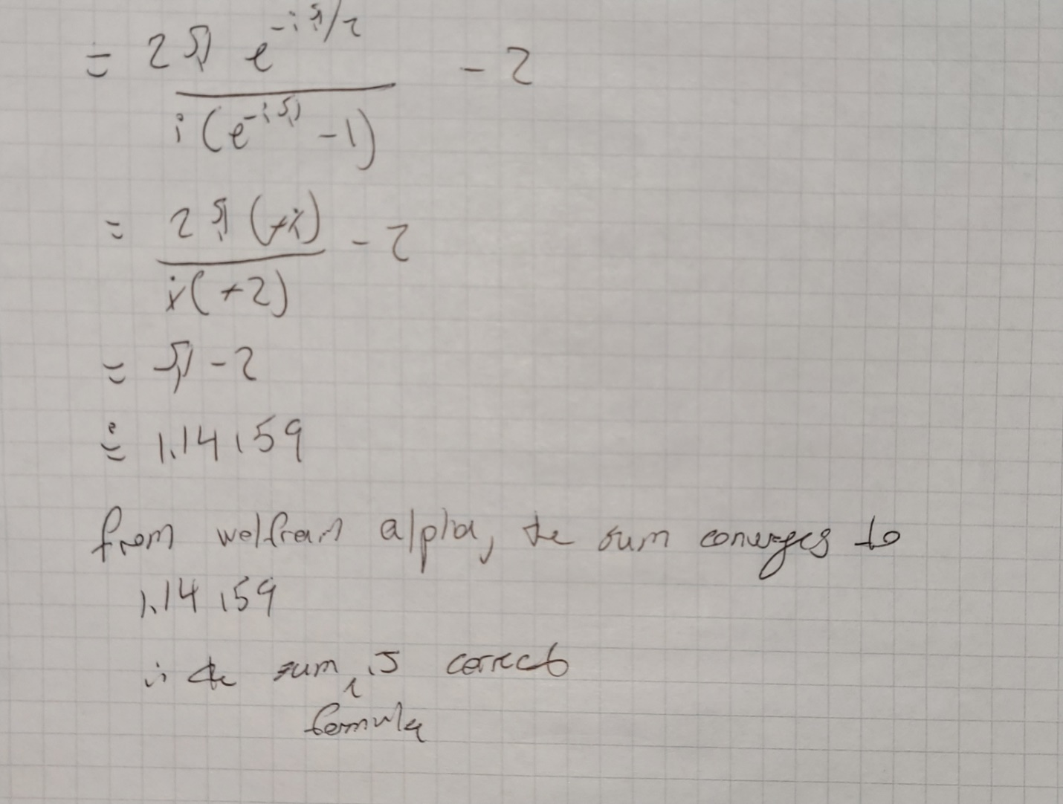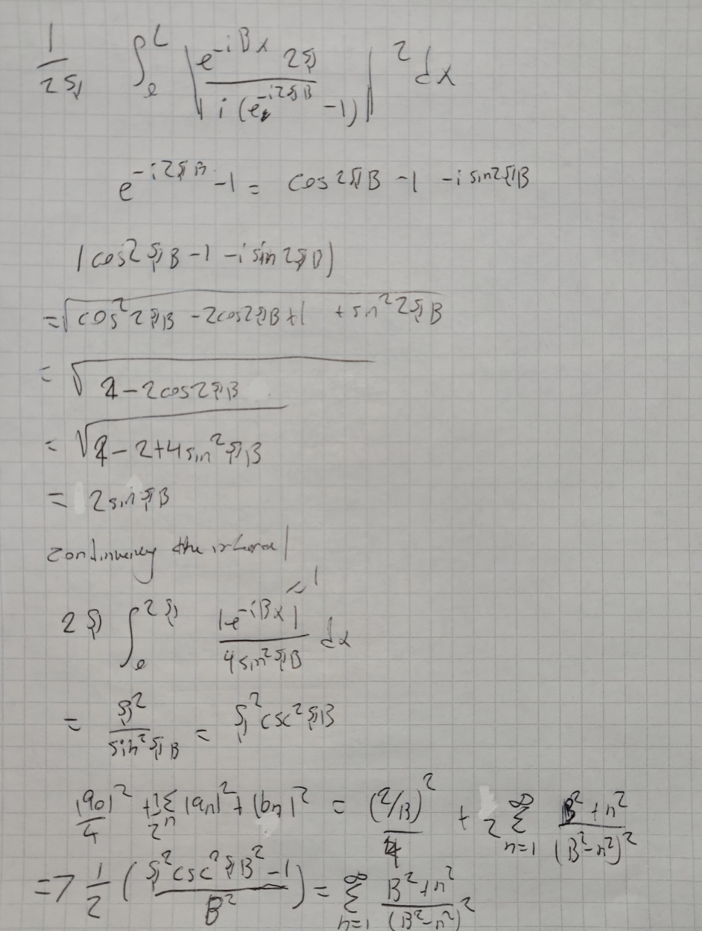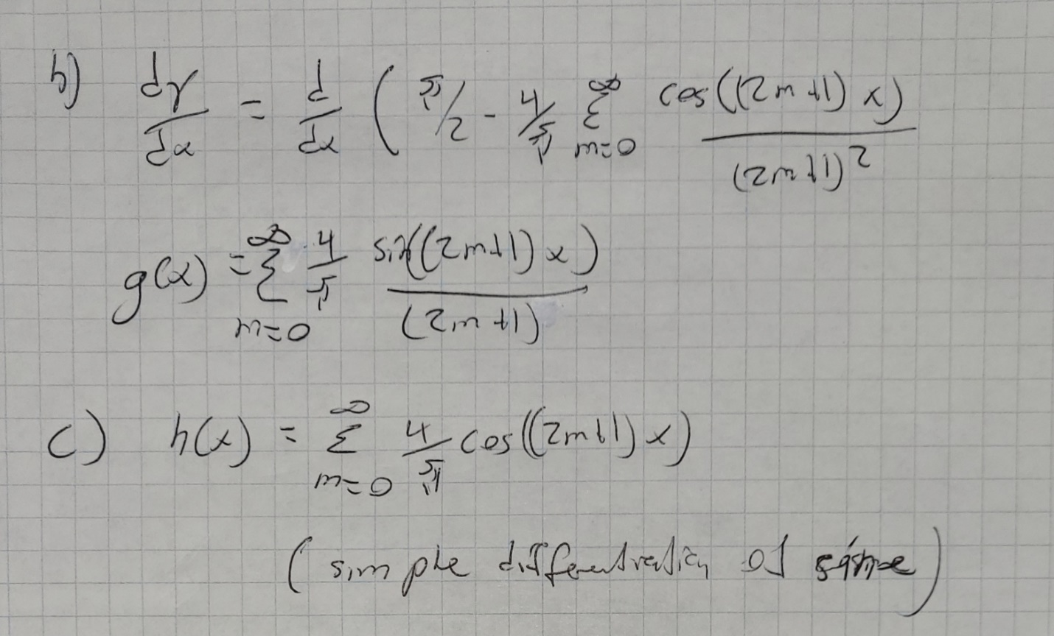

d)

All fourier series were plotted with different number of terms against the analytical solution

h(x), actual function not shown because it is not possible to show a real plot of a Dirac Delta. However, the function should be 2δ(X). At higher values for m, the peak was not visible as it got too narrow.