
Department of Computing

Phase 4 – Final Report & Implementation
Sharon Smith
Topic: Features of Social Media Posts That Drive Higher Engagement
CSCI 5010: Programming for Data Analytics
Instructor: Dr. Ahmad Al Doulat
Date: 5th December 2025

1. Introduction
Social media plays a major role in digital communication, advertising, and content creation, but understanding what drives engagement remains a challenge for creators and brands. Even though platforms provide analytics dashboards, they often show results after the content has already been posted, leaving users with little guidance on what features lead to stronger engagement. Studies have shown that content characteristics such as media type, vividness, and format influence engagement behavior (Cuevas-Molano et al., 2021). This project analyzes 5,000 viral posts from TikTok, Instagram, YouTube, and Twitter to identify which post characteristics, such as content type, hashtags, platform, and region, are associated with higher engagement. The purpose of this project is to provide clear, data-supported insights that help creators and marketers make better decisions about what to post and where to invest their time and resources.

2. Problem Statement
Although engagement is known to depend on factors like platform, content type, and format, creators and brands still lack consistent, data-driven guidance on which specific post features reliably increase engagement across platforms and regions. Prior research notes that engagement drivers vary across contexts, making it difficult to generalize patterns (Adepoju & Omar, 2023; Cuevas-Molano et al., 2021). This makes it difficult to plan effective content strategies and often leads to wasted time, effort, and resources.

3. Motivation
This topic matters because engagement is one of the main metrics that determines visibility, reach, and content success on social media. With so many creators and brands competing for attention, understanding what actually works can make a difference in performance. Engagement metrics like likes, comments, and shares are widely used in academic research to measure audience response (Adepoju & Omar, 2023) By identifying which post features consistently drive higher engagement, this project provides insights that can help people post smarter, target the right platforms, and increase the impact of their content. It will also help brands know where exactly to invest their social media marketing budget. The goal is to move beyond assumptions and give creators clear evidence they can rely on.

4. Research Questions
- Which types of content generate the highest engagement across platforms?
- How do hashtags affect engagement rate?
- Which content type produces the highest engagement across different regions?
- Which platforms achieve the highest engagement across regions?

5. Related Context
Most social media analytics research focuses on a single platform, making it difficult to compare engagement patterns across multiple sites. Research also shows that content performance varies depending on media format and audience preferences (Cuevas-Molano et al., 2021). Additional studies confirm that engagement behaviors differ across regions and content styles (Adepoju & Omar, 2023). The dataset used in this project is valuable because it combines viral posts from TikTok, Instagram, YouTube, and Twitter, allowing cross-platform comparisons. It includes views, likes, comments, shares, hashtags, regions, and content types, providing a rich foundation for understanding engagement behavior. This context helps frame the study as one that fills a gap by comparing multiple platforms and regions in a single analysis.

6. Dataset Description
The dataset comes from Kaggle and contains 5,000 viral posts across four major platforms: TikTok, Instagram, YouTube, and Twitter (Soundankar, 2024). It includes information such as post date, platform, content type, region, views, likes, comments, shares, and hashtags. One major limitation is that the dataset includes only viral posts, meaning engagement patterns may not represent average posts. Another issue was the mismatch between platforms and content type labels. For example, YouTube entries labeled as “tweets.” Since the dataset did not explain how the Engagement_Level field was calculated, that variable was removed from the analysis. Despite these issues, the dataset provides enough detail to compare engagement patterns across platforms, content types, and regions.

7. Approach / Methodology
For data cleaning, I started out in Excel. Because the dataset contained inconsistent content labels across platforms. I relied on Excel filters to manually inspect and correct the misaligned content types. After identifying that the labels were style-based formats rather than platform-specific features, I standardized them into five universal categories: short_form_video (reels, shorts, short clips, including TikTok “video”), long_form_video (standard long videos, except on TikTok, which does not support long-form video), image_post (static photos or graphic content), text_post (tweet-style or text-dominant posts), and live_stream (live broadcasting content).
The main analysis was carried out in Python using Pandas for data manipulation, NumPy for calculations, and Matplotlib and Seaborn for visualization. I began by loading the dataset and checking for missing or duplicated values. After converting the Post_Date field to a datetime format, I extracted the Month and Year to support time-based analysis.
Feature engineering included calculating Engagement as the sum of likes, comments, and shares, and creating Engagement Rate by dividing engagement by views (Liang et al., 2023; Adepoju & Omar, 2023). These features allowed for fair comparisons across posts with different exposure levels. Using Pandas groupby operations and Seaborn bar charts, I visualized differences in engagement across content types, hashtags, regions, and platforms to directly address the research questions.

8. Results & Insights
Research Question 1: Which content types generate the highest engagement?
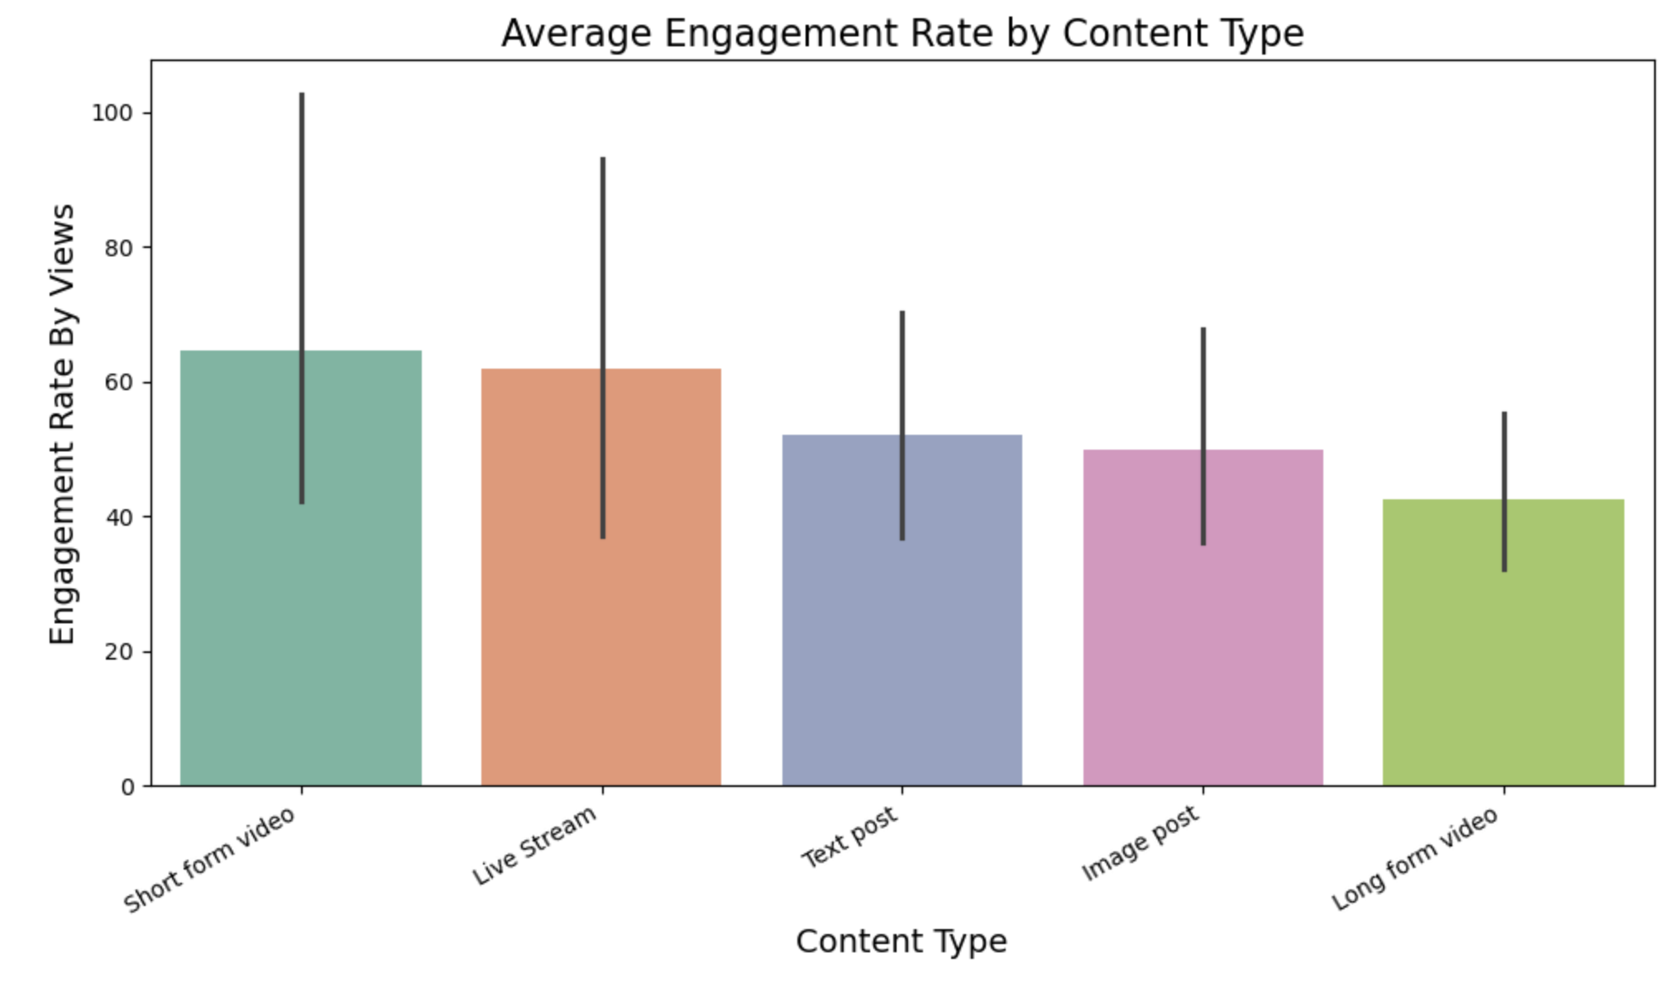

Results:
Short-form videos show the highest engagement rate across the dataset. Live streams follow as the second-highest, but their performance varies by platform. Long-form videos consistently show the lowest engagement, while image posts and text posts fall in the middle range.
Interpretation:
Short-form videos clearly generate the strongest interaction. They deliver quick, high-impact content that aligns with how users consume media today, making them the most effective format for maximizing engagement.
Research Question 2: How do hashtags impact engagement rate?

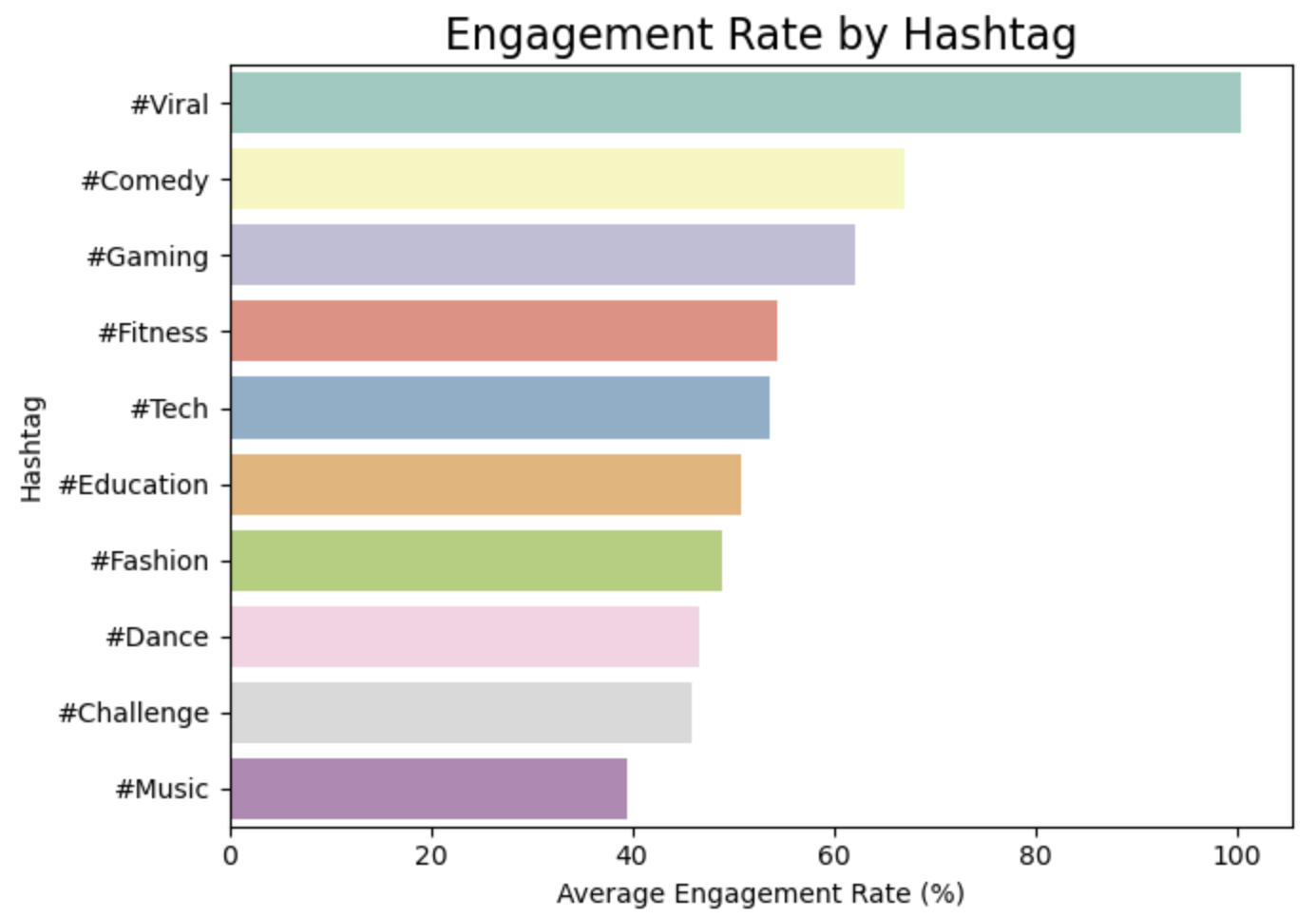
Results:
“#Viral” produces the highest engagement rate among the hashtags in the dataset, while “#Music” shows the lowest. Other hashtags such as #Education, #Comedy, and #Tech remain in the mid-range with no major influence on engagement.
Interpretation:
Hashtags only increase engagement when paired with already engaging content. #Viral performs well because it commonly appears on short-form videos that already generate high organic interaction. Not all trending hashtags guarantee engagement.
Research Question 3: Which content type has the highest engagement across different regions?
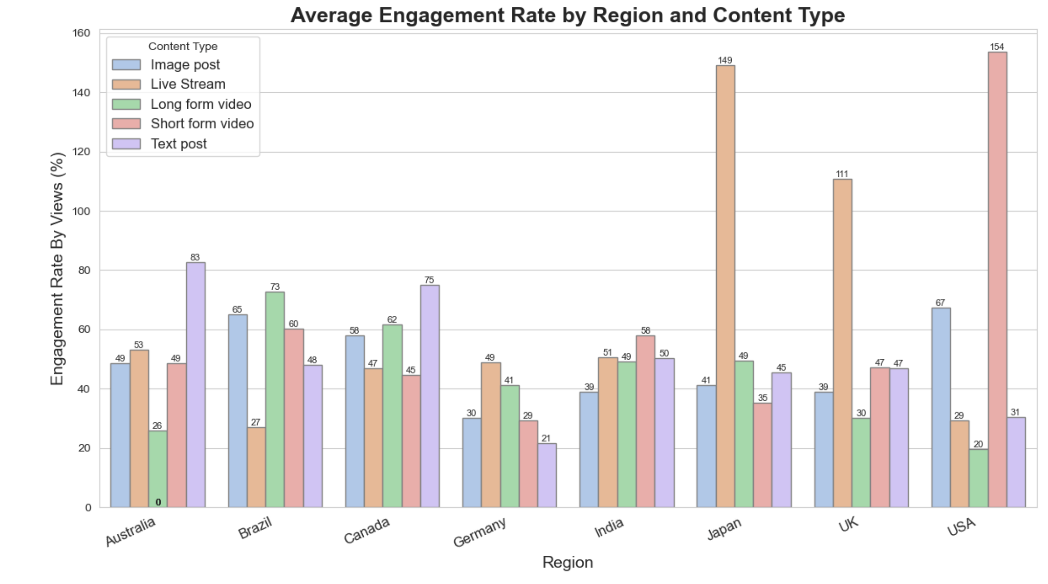
Results:
Short-form videos generate the highest engagement rate in most regions, especially the USA and Brazil. Live streams perform strongly in countries such as Japan, Australia, and the UK. Image posts show moderate engagement across multiple regions, while long-form videos and text posts remain low in most countries except for slight increases in Canada and Brazil.
Interpretation:
Across countries, users consistently favor quickly consumable content. Short-form videos are globally dominant, while live streams perform well in regions with strong real-time interaction cultures. These patterns show that content preferences are influenced by cultural media habits, not just platform design
Research Question 4: Which platform shows the highest engagement across regions?
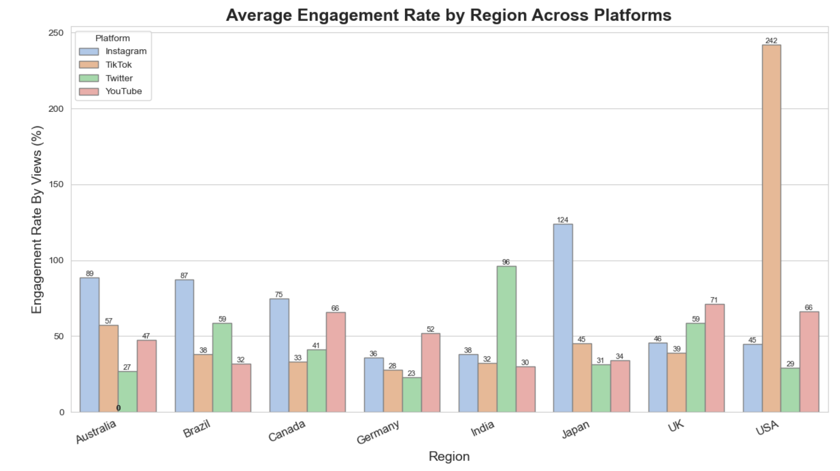
Results:
Instagram leads in several regions—Japan, Brazil, and Australia—driven by strong engagement with live streams. TikTok performs best in the USA and Japan, especially for short-form video content. Twitter performs highest in India due to strong engagement with long-form posts. YouTube is the most stable platform but rarely the top performer.
Interpretation:
There is no single “best” platform globally. Each platform performs strongest where its dominant content style aligns with regional user behavior—TikTok with short videos in the USA and Japan, Instagram with live content in Australia and Brazil, and Twitter with text-heavy posts in India. Engagement is shaped by the match between platform features and cultural preferences.

9. Answers to Research Questions
RQ1: Short-form videos generate the highest engagement overall.
RQ2: Hashtags influence engagement, with “#viral” performing best.
RQ3: Short-form videos dominate most regions; live streams rank high in specific countries.
RQ4: No single platform wins overall, each performs best with its strongest content type.

10. Conclusion
This project shows that engagement is strongly shaped by content type, platform, and region. Short-form videos consistently drive the highest engagement, making them the most reliable format across platforms. Live streams perform exceptionally well in certain regions, while long-form videos and text posts remain less engaging overall. Hashtags only significantly boost engagement when paired with already engaging content. These findings offer creators and brands clearer guidance on how to plan content and choose platforms based on what actually performs well.

11. Future Directions
Future work could expand this analysis by including caption text, sentiment, posting time, and non-viral posts to compare engagement patterns across all performance levels. Machine learning models could also be used to predict engagement based on content features, offering more personalized recommendations for creators.

12. Lessons Learned
Throughout this project, I learned the importance of thoroughly inspecting a dataset before analysis. The mismatch between content types and platforms showed how real-world data often requires careful cleaning and restructuring. I also gained experience using Pandas for data manipulation, creating new features, and generating visualizations that directly answer research questions. Most importantly, I learned how analytical decisions, such as recording formats or defining engagement metrics, shape the strength and clarity of the final insights.

References
- Cuevas‐Molano, E., Matosas‐López, L., & Bernal‐Bravo, C. (2021). Social media engagement: An analysis of the impact of content factors on Instagram. Technium Social Sciences Journal, 23, 198–215.
- Adepoju, O., & Omar, A. (2023). Analyzing tweeting patterns and public engagement during the recognition period of the COVID-19 pandemic: A study of two U.S. states. Journal of Information Technology Case and Application Research, 25(3), 181–197.
- Liang, H., Zhao, X., & Wang, H. (2023). Driving mechanisms of user engagement with AI-generated content on social media platforms: A multimethod analysis combining LDA and fsQCA. Frontiers in Psychology, 14, 1165941. https://doi.org/10.3389/fpsyg.2023.1165941
- Matosas-López, L., Cuevas-Molano, E., & Bernal-Bravo, C. (2021). Factors increasing consumer engagement of branded content in Instagram. IEEE Access, 9, 143531–143545. https://doi.org/10.1109/ACCESS.2021.3121186
- Soundankar, A. (2024). Viral social media trends and engagement analysis [Data set]. Kaggle. https://www.kaggle.com/datasets/atharvasoundankar/viral-social-media-trends-and-engagement-analysis

