Data

Stocking rate
In order to estimate cattle stocking rate, first we retrieve county level beef cow inventory data and pastureland data from USDA Census of Agriculture for the period 1982-2017 (USDA 2024). Figure 2 illustrates historical trends in pastureland use and beef inventory data (as of the end of December) across the United States. It can be seen that while beef cow inventory has shown some fluctuations over the years, with notable declines observed around 1983, 2012, and 2018, pastureland use has exhibited a steady decline.
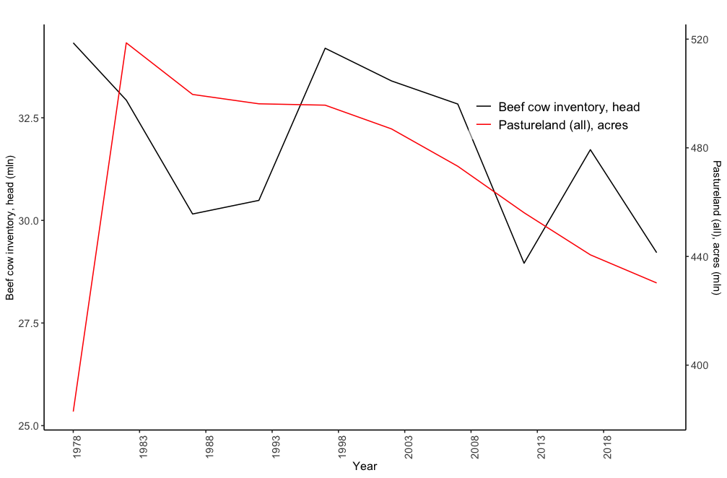
Figure 2. Annual US national beef cow inventory and pastureland data.
Source: USDA, NASS (2024).

The stocking rate is commonly expressed as the number of Animal Units (AU) or Animal Unit Months (AUM) per unit of land (Redfearn and Bidwell 2017). AU is defined as a mature cow weighing approximately 1,000 pounds, while AUM represents the amount of forage required to sustain one AU for one month. The total forage demand is calculated by multiplying the number of AUs by the grazing duration (in months), resulting in the total AUMs required for the grazing period. Using this methodology, the stocking rate (expressed in AUMs per acre) for a specific county $i$ and year $t$ can be derived using the following formula:
$${SR}_{it}= {inventory}_{it}*\frac{{live weight}_{t}}{AU}*\frac{months}{{pasture land}_{it}}=\frac{{Total AUM}_{it}}{{pasture land}_{it}}$$
The formula incorporates three key factors: the number of animals (inventory), their forage demand, and the land resources. The term $\frac{{live weight}_{t}}{AU}$ converts the forage requirements of animals with varying sizes into a standardized measure based on an AU. By adjusting for grazing duration (months) and dividing by the size of the available pastureland, the stocking rate reflects both the available forage quantity and the grazing duration.

Drought data
Drought mechanisms are driven by a complex interplay of climatic, hydrological, and ecological factors that influence water availability in ecosystems. A key aspect of drought is the imbalance between water supply, largely determined by precipitation, and water demand, influenced by temperature, vegetation, and atmospheric conditions. Understanding drought requires quantifying these components, particularly evapotranspiration, which represents the loss of water through evaporation and transpiration. To construct a drought indicator, potential evapotranspiration (PET) is estimated, representing the amount of water that could be evaporated under current weather conditions. Using the Thornthwaite method (Palmer and Havens 1958, 123):
$${PET}^{*}= \left\{\begin{aligned}16 {\left[\begin{matrix}\frac{10 T_{mean}}{I}\end{matrix}\right]}^{a}, { T}_{mean}>0 \\ 0, { T}_{mean} ≤0\end{aligned}\right.$$
$$I=\sum_{j=1}^{12}{i_{j}}$$
$$i={\left[\begin{matrix}\frac{T_{mean}}{5}\end{matrix}\right]}^{1.514}$$
$$a=675*{10}^{-9} I^{3}-771* {10}^{-7} I^{2}+1792*{10}^{-5} I+0.492$$
where ${PET}^{*}$ is a monthly normative potential evapotranspiration value (mm ${month}^{-1}$); $T_{mean}$ is the monthly average temperatures ($℃$); $I$ is an annual heat index; $i$ is a monthly heat index; $a$ is a constant. Afterwards, we calculate a measure of the water surplus or deficit for the analyzed month as follows:
$$D_{i}= P_{i}-{PET}_{i}$$
where $P_{i}$ is a monthly precipitation level (mm ${month}^{-1}$). Daily weather data, for the period of interest, is retrieved from Parameter-elevation Regressions on Independent Slopes Model (PRISM), which provides high-resolution, gridded climate data, including precipitation, temperature (minimum, maximum, and mean), and other weather-related variables across the US (PRISM Climate Group, Oregon State University 2024).

Weather data
Now, we turn to weather data, which plays a central role in understanding both drought dynamics and crop growth conditions. While precipitation drives water supply, temperature is a critical factor influencing plant development through thermal time accumulation and heat stress. Growing Degree Days (GDD) and Extreme Degree Days (EDD) are widely used metrics for quantifying these thermal effects on crops. GDD measures the accumulation of daily thermal time (DTT) above a base temperature, capturing the growth potential for plants, while EDD accounts for periods of extreme heat that may harm crop development. Using PRISM data, we calculate GDD and EDD following established methodologies (Zhou and Wang 2018):
$$DTT= \left\{\begin{aligned}0 { T}_{avg}< T_{b} \\ T_{avg}- T_{b}{ T}_{b}< T_{avg}<{ T}_{u} \\ T_{u}- T_{b }{ T}_{u}< T_{avg}\end{aligned}\right.$$
$$GDD=\sum{DTT}$$
$${EDD}_{d}= \left\{\begin{aligned}T_{max,d}-T_{u} T_{max,d}>T_{u} \\ 0 T_{max,d}≤T_{u}\end{aligned}\right.$$
where $T_{avg}=\frac{T_{min}+ T_{max}}{2}$, $T_{b}$ is base temperature and ${ T}_{u}$ is upper threshold temperature. The critical threshold temperatures of 10 and 31$℃$ are chosen for this analysis (Schlenker and Roberts 2009). These metrics allow us to assess both the beneficial and adverse effects of temperature on agricultural systems, offering valuable insights into the interaction between climate variability and ecosystem productivity.

Hay stocks
During drought conditions, pasture growth is significantly limited, reducing the availability of forage for grazing. This compels producers to rely on hay as supplemental feed to maintain livestock health and productivity. Incorporating hay stocks into the analysis captures the critical role of supplemental feeding in mitigating the adverse effects of drought, offering a more comprehensive perspective on the relationship between drought, forage availability, and stocking rates. For this study, we utilize annual nationwide hay stocks data from USDA NASS (2024) for the period of interest, providing a robust dataset to assess the role of supplemental feeding during periods of forage scarcity.

Summary statistics
Table 1 provides a detailed breakdown of stocking rates by region and decade across the continental United States, highlighting both national and regional trends. Nationally, the average stocking rate declined from 0.69 AUMs per acre in the 1980s to 0.77 in the 1990s, followed by a modest recovery to 0.88 in the 2010s. However, significant regional variations emerge. The Northern Plains experienced a sharp decline, dropping from 0.80 AUMs per acre in the 1980s to 0.39 in the 2020s. Similarly, the Mountain region exhibited persistently low rates likely reflecting limited grazing capacity. In contrast, the Lake States demonstrated remarkable growth, increasing from 0.58 AUMs per acre in the 1980s to 1.53 in the 2020s, with a notable 40.27% rise between the 2000s and 2010s. Periods of heavy drought, such as the early 1980s, late 1990s, and early 2010s, reveal potential links between drought conditions and stocking rates. While regions like the Pacific and Southern Plains maintained relatively stable but low rates during these times, other regions showed greater sensitivity, reflecting differences in resilience and management practices. These results suggest that, despite a gradual national recovery in stocking rates, regional disparities underscore the complex interplay between drought, forage availability, and grazing capacity, warranting further investigation into the relationship between drought and stocking rates.
Table 1. Stocking rate by US geographical region, 1990-2020.
Region | Year |  |  |  | Percent Change
 | 1980-1989 | 1990-1999 | 2000-2009 | 2010-2019 | 1990-1980 | 2000-1990 | 2010-2000
Appalachia | 1.1 | 1.4 | 1.37 | 1.43 | 27.43 | -2.01 | 3.83
Corn Belt | 1.1 | 1.18 | 1.34 | 1.53 | 7.69 | 13.15 | 14.68
Delta States | 1.02 | 1.12 | 1.08 | 1.22 | 9.49 | -3.22 | 13.21
Lake States | 0.58 | 0.71 | 0.95 | 1.33 | 23 | 33.33 | 40.27
Mountain | 0.17 | 0.2 | 0.15 | 0.16 | 12.64 | -22.6 | 2.87
Northeast | 0.58 | 0.74 | 0.75 | 1.02 | 28.15 | 1.36 | 34.74
Northern Plains | 0.8 | 0.7 | 0.42 | 0.43 | -12.04 | -40.48 | 1.82
Pacific | 0.27 | 0.3 | 0.28 | 0.29 | 9.39 | -4.86 | 1.18
Southeast | 0.97 | 1.05 | 0.93 | 1.09 | 7.93 | -11.5 | 17.29
Southern Plains | 0.32 | 0.34 | 0.34 | 0.3 | 7.32 | -1.47 | -11.52
National | 0.69 | 0.77 | 0.76 | 0.88 | 12.03 | -1.68 | 15.41
Source: USDA NASS (2024) and authors' calculations.

The Census of Agriculture reports come out every 5 years.
For example, suppose a pasture is used to graze 50 animals, each weighing 1,200 pounds, for six months. Assuming a standard AU represents 1,000 pounds, each animal equates to 1.2AUs. If the pastureland is 100 acres, the stocking rate is 3.6 AUMs per acre.
Robustness analysis section analyses different threshold values for pasturelands and their impacts on results.
Regions are grouped based on shared geography, climate, and agriculture. The Lake States (Michigan, Wisconsin, Minnesota) focus on dairy and forage, while the Corn Belt (Iowa, Illinois, Indiana, Ohio, Missouri) leads in grain and livestock feed. The Northern and Southern Plains emphasize beef cattle, with differences in grazing and irrigation. The Delta States and Southeast combine crop cultivation and cattle operations, while Appalachia supports small-scale farming. The Northeast features diversified farming and dairy, the Mountain region specializes in large-scale grazing, and the Pacific excels in diverse, high-value agriculture, with California pivotal for irrigated forage and beef cattle production. These regional adaptations highlight the diversity of U.S. agriculture.

