Introduction
Selecting an appropriate stocking rate is one of the most crucial decisions in grazing management (Smart et al. 2010). It plays a central role in determining both grazing efficiency and the long-term health of the land. Producers can optimize forage utilization, prevent overgrazing, and support the ecological resilience of pastures and rangelands. In contrast, improper stocking rates - whether too high or too low - can lead to significant land degradation, a reduction in biodiversity, and diminished livestock productivity.
There are several competing theories as to why the stocking rate might have been decreasing. First, cattle are harvested at heavier weights. Fewer feeder cattle are needed to produce the same amount of beef and thus leading to fewer cows (Figure 1). Larger animals demand significantly more forage resources (Uresk 2010). The increased size of cattle means that although fewer cows are being grazed, the forage demand per acre remains relatively high. Thus, the increase in cattle size does not fully explain the observed fluctuations in stocking rates.
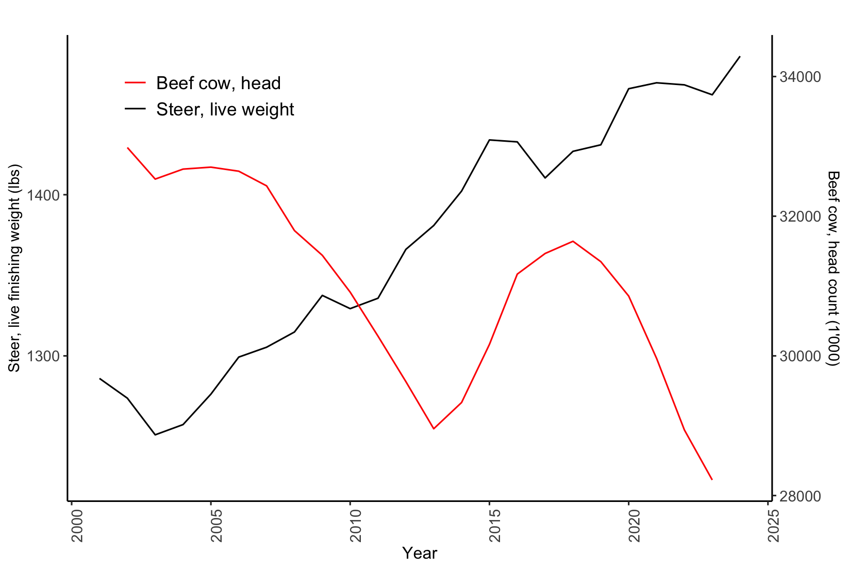
Figure 1. US historical steer finishing weights and beef cow head numbers (2000-2024).
Source: USDA, NASS (2024).

Second, the amount and quality of grazing land and pasture have changed. The quality of land could change particularly in the Northern Plains where good pasture that is tillable could be converted to grain production given high corn and soybean prices. This reduction in land suitable for grazing, compounded by climate change, poses additional challenges. However, advances in grazing management, such as rotational grazing systems, offer potential mitigation by increasing the land's carrying capacity, allowing producers to maintain or even enhance forage utilization on reduced acreage.
Furthermore, climate variability - marked by rising temperatures and shifting precipitation patterns - exacerbates the challenge of maintaining optimal stocking rates.
Insufficient precipitation reduces hay yields and crop residue, while excessive rainfall can lead to waterlogging, nutrient loss, and pest proliferation, all of which increase reliance on irrigated feed resources. Droughts, in particular, have intensified in both frequency and severity, posing significant risks to agricultural systems and rangeland ecosystems (Leeper et al., 2022; Iglesias, Travis, and Balch, 2022). These unpredictable climate conditions complicate the balance between stocking rates and available forage, further challenging sustainable grazing management.
While existing research has explored the broader relationships between climate variability and beef cows (Klemm and Briske, 2019; Rodziewicz, Dice, and Cowley 2023), agriculture (Kuwayama et al. 2019), change in farmland use and stocking rate (Mu, McCarl and Wein 2013), and rangeland beef cattle production (Briske et al. 2020), there is a notable gap in identifying whether temperature increases or the frequency and intensity of precipitation have a greater influence on stocking rates. This knowledge is essential for crafting more precise and effective adaptation strategies to address climate change. Understanding whether temperature increases or changes in precipitation have a greater impact on stocking rates will enable producers and policymakers to optimize management practices and allocate resources more strategically. The objective of this paper is to determine the extent to which climate variability, particularly changes in precipitation patterns such as droughts, influences stocking rates. We hypothesize that precipitation, particularly in the form of droughts, has more significant impact on forage availability and thus on stocking rates, as it leads to increased reliance on harvested feed resources like hay and irrigated crops. To test this, we employ USDA Census of Agriculture data combined with PRISM weather data, using a regression-based approach to assess the relationship between climate variables and stocking rates.
We also included hay stocks as another explanatory variable for this analysis. Hay stocks provide supplemental feed when forage availability is reduced due to adverse weather conditions, such as insufficient rainfall or extreme temperatures. The model aims to capture how producers adjust their stocking rates not only in response to climate factors, but also based on the availability of alternative feed sources.
We found that stocking rates are significantly influenced by both climatic factors and hay availability. Drought-related variables exhibited a delayed yet profound effect, reflecting their impact on forage availability over time. This highlights the need to incorporate lagged drought variables in predictive models to capture their long-term impact. Furthermore, we observed a nonlinear relationship between hay stocks and stocking rates, with initial increases in hay stock correlating with reductions in stocking rates but eventually becoming a stabilizing resource. Projections using the weather dataset under two climate scenarios provide insights into future stocking rate trends under varying climate trajectories, offering valuable guidance for long-term adaptive management.
This paper is organized as follows: this section is followed by literature review on the effects of climate variability on agriculture and beef production. Data and methods sections are further followed by results, discussion, including robustness analysis, and concludes with final remarks and policy implications.

Northern Great Plains region of the USA includes the states of Colorado, Montana, Nebraska, North Dakota, South Dakota, and Wyoming (USDA n.d.).

