Robustness check

Delayed effects of drought
Droughts can impact stocking rates in both immediate and long-term ways, with their effects often lagging behind the onset of drought conditions. Klemm and Briske (2019) highlight that the full impact of drought may not be immediately reflected in ranchers' decisions, as drought often causes a gradual depletion of forage resources. Initially, ranchers may rely on hay reserves or supplemental feed to sustain their herds, temporarily masking the effects of reduced forage availability. This reliance on reserves can delay the need to adjust stocking rates, particularly during the early stages of a drought when supplemental feed is still accessible and relatively affordable. However, as drought conditions persist, the gradual depletion of hay stocks and the increasing costs of replenishing them can force ranchers to reduce stocking rates to prevent overgrazing and long-term degradation of their pastureland. These reductions in stocking rates may be further exacerbated by the lingering impacts of drought on pasture recovery. Even after normal precipitation resumes, pastures often require time to regenerate, leading to prolonged periods of reduced forage productivity. Such delayed effects mean that the influence of a drought can extend well beyond its immediate duration, creating ongoing challenges for ranchers in balancing herd sizes with the long-term health of their pasture ecosystems.
To account for these potential lagged effects, this study will incorporate lagged variables of drought-related climate measures in the robustness check section. By doing so, we aim to capture the full extent of drought's influence on stocking rates over time, refining our analysis and providing a more comprehensive understanding of how drought impacts livestock management decisions. This approach recognizes that both immediate and belated drought effects play a critical role in shaping grazing strategies and herd management practices, emphasizing the importance of long-term planning for sustainable pasture use.
We first observe that lagged values of ($D_{it})$ exhibit significant correlations across multiple years. This suggests that the effects of drought in one year may persist and influence conditions in subsequent years. For instance, a water deficit in one year may reduce pasture quality and soil moisture, carrying over effects to the next grazing season. Conversely, a surplus might provide delayed benefits such as improved forage availability. To account for these interdependencies and cumulative effects, we use Principal Component Analysis (PCA). PCA allows us to summarize the information from the current drought variable and its lagged values ($D_{it-1}, D_{it-2}, D_{it-3},$ …) into a single uncorrelated index (the principal component​). This index captures the shared variance among the drought variables, representing their combined or cumulative effect. We intend to reduce multicollinearity and simplify interpretation, focusing on the overall drought intensity and persistence across multiple years rather than individual contributions from each lag.
We use the first principal component derived from the current drought variable and its lagged values. The first component is chosen as it explains most of the variance among drought variables. Considering that drought effects typically persist for several years, we include up to 5 lagged years in the analysis, consistent with observed drought durations in many regions. Table 3 summarizes the regression results for models incorporating 1 to 5 lagged drought years. Each model evaluates the cumulative impact of drought conditions (represented by PC1), alongside other key variables. Fixed effects are also included to account for time-invariant regional characteristics and broader trends.
Table 3. Regression results for delayed drought effects.
Variable | 1 Lag | 2 Lags | 3 Lags | 4 Lags | 5 Lags
PC1 | -0.0173 | -0.1147*** | -0.1478*** | -0.1748*** | -0.1801***
$GDD$ | 0.00045*** | 0.00029*** | 0.00020*** | 0.00012** | 0.000085*
$EDD$ | -0.00112*** | -0.00085*** | -0.00075*** | -0.00070*** | -0.00068***
$Hay stock$ | -0.00758*** | -0.00688*** | -0.00656*** | -0.00628*** | -0.00645***
${Hay stock}^{2}$ | 0.00000183*** | 0.00000167*** | 0.00000159*** | 0.00000151*** | 0.00000156***
County FE | Y | Y | Y | Y | Y
State FE | Y | Y | Y | Y | Y
Source: Authors’ calculations.
Note: *** p < 0.01, ** p < 0.05, and * p < 0.10.

The most notable finding is the strengthening impact of cumulative drought effects as more lagged years are included in the model. For the 1-lag model, the coefficient for PC1 is small (-0.0173) and statistically insignificant, suggesting that short-term drought alone does not strongly influence stocking rates. However, as additional lags are included, the coefficient for PC1 becomes increasingly negative and statistically significant, reaching -0.1801 in the 5-lag model. However, it is important to note that we cannot distinctly identify which specific year of drought contributes most to the observed effects, as our approach captures only the cumulative impact across multiple lagged years. Nevertheless, the findings strongly indicate that lagged drought effects exist and significantly influence grazing systems. However, to fully understand the role of individual years and their contributions to the cumulative impact, future studies must address these gaps. Collecting more granular annual data on stocking rates, as well as additional contextual variables, would help disentangle the effects of specific drought years.

Threshold effects
Pasture thresholds for temperature effects can be distinct from those observed in row crops like corn or soybeans due to differences in physiological responses and growth patterns. According to Schlenker and Roberts (2009), temperature has a nonlinear relationship with crop yields, with specific thresholds marking optimal and stress ranges. Authors identify these thresholds by modeling temperature's marginal effects on crop yields, using piecewise regressions with temperature bins and dummy variables to capture nonlinearities. The paper divides temperature into distinct segments (or "bins") and calculated how incremental temperature changes affected log-yields. The temperature ranges were derived from extensive yield and climate data, where thresholds were chosen based on empirical evidence of where temperature begins to hinder growth. The final analysis is conducted at the county level, allowing for the aggregation of yields and temperature effects while controlling for fixed effects to account for unobserved heterogeneity across locations.
To adapt this approach for hay, we will follow the exact methodology described in the paper and apply it specifically to Douglas County, Kansas, using hay data sourced from USDA NASS (2024). We will use the same temperature binning method to identify the thresholds for hay growth and stress. By leveraging the same regression framework with temperature dummies, we aim to assess whether hay exhibits similar temperature thresholds as row crops or if its growth patterns diverge significantly, as might be expected given the perennial and resilient nature of many forage species. The Figure 3 illustrates the marginal effects of temperature on hay yield (log-transformed, tons/acre) across a range of temperatures. At lower temperatures (below approximately 31°C), the marginal effects remain relatively flat, indicating stable hay yields within this range. Beyond 31°C, the marginal effects begin to decline sharply, showing a marked reduction in hay yields as temperatures approach and exceed 35°C. This drop signifies the onset of heat stress, where critical physiological processes like photosynthesis, water uptake, and cellular respiration are adversely affected.
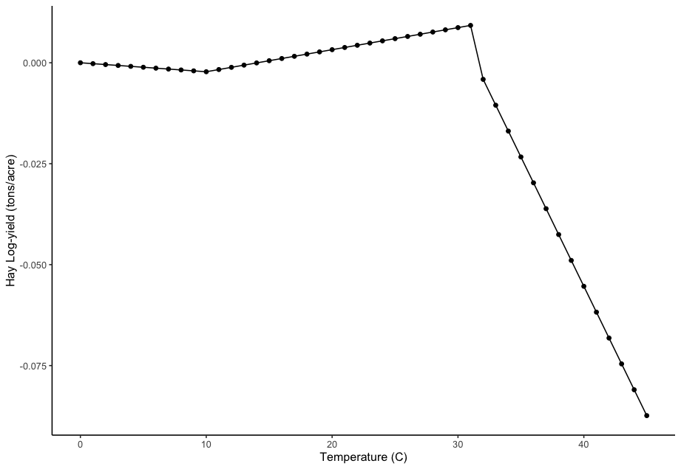
Figure 3. Marginal effects of temperature on hay yield (Douglas County, Kansas).
Source: USDA, NASS (2024). Authors’ calculations.

The analysis supports the validity of 31°C as the upper temperature threshold used in our regression model. By selecting 31°C as the threshold in our model, we are effectively capturing this critical transition point, ensuring that the piecewise regression accurately reflects the temperature-yield relationship for hay.

Stocking rate projections
This study utilizes climate projection data from the Multivariate Adaptive Constructed Analogs (MACA) datasets to project future stocking rates under Representative Concentration Pathways (RCP) 4.5 and RCP 8.5 scenarios, which are part of the Coupled Model Intercomparison Project Phase 5 (CMIP5). The MACA dataset provides high-resolution (4-km grid) downscaled climate data, which was extracted and aggregated at the county level across the United States. RCP 4.5 represents a stabilization scenario where radiative forcing is stabilized at 4.5 W/m² by the year 2100 through the implementation of mitigation measures, while RCP 8.5 reflects a high-emissions "business-as-usual" trajectory, leading to radiative forcing of 8.5 W/m² (Multivariate Adaptive Constructed 2024). The weather variables analyzed include monthly precipitation, minimum temperature, and maximum temperature, spanning the years 2006 to 2099. These variables were processed for both scenarios to calculate derived agroclimatic indices critical for understanding forage growth and livestock productivity. Incorporating CMIP5 scenarios allows this study to provide a robust comparative analysis of future stocking rate dynamics, capturing the implications of moderate (RCP 4.5) versus severe (RCP 8.5) climate change trajectories. The results aim to inform adaptive grazing management strategies and policy interventions to enhance livestock system resilience in a changing climate.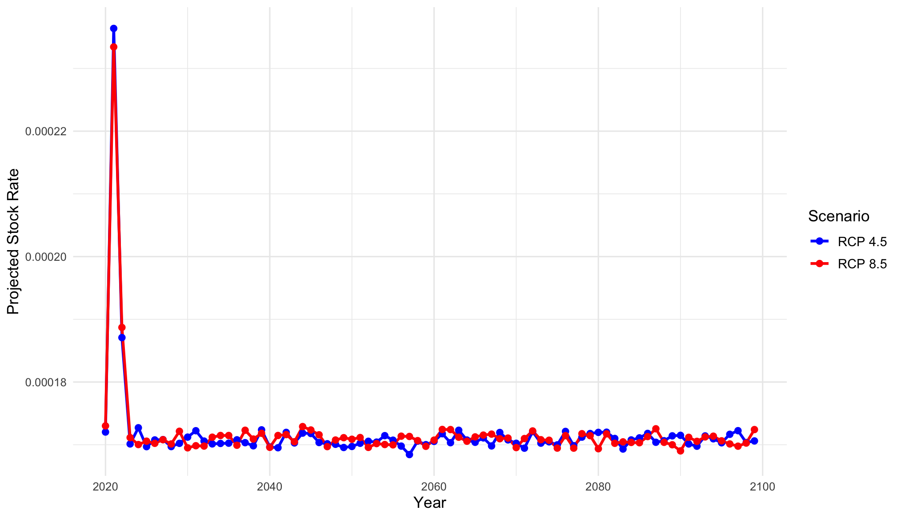
Figure 4. Projected stocking rates (2020-2099).
Source: MACA weather projections and Authors’ calculations.

Figure 4 illustrates the projected stocking rates across the United States from 2020 to 2099 under the RCP 4.5 and 8.5 climate scenarios. A comparative analysis of the two scenarios highlights subtle differences in the trends. Under RCP 4.5 (a mitigation scenario), the projected stocking rates remain slightly higher on average compared to RCP 8.5 (a high-emissions scenario). This difference may be attributed to the more favorable climatic conditions in RCP 4.5, with lower temperature extremes and less severe drought impacts. Conversely, the higher frequency and intensity of extreme weather events projected under RCP 8.5 lead to slightly reduced stocking rates, reflecting the cumulative effects of prolonged water deficits and forage stress on pastureland. Despite these variations, the results suggest a broadly consistent long-term trend across both scenarios, emphasizing the resilience of livestock systems when supported by adaptive management practices. However, the slight divergence in stocking rates between the scenarios underscores the potential benefits of mitigation efforts to stabilize climate impacts and maintain sustainable livestock operations. This analysis provides a critical foundation for understanding the interplay between climate change and livestock systems, offering insights into how different climate trajectories may influence grazing capacity. These findings are instrumental in informing policy decisions and adaptive strategies aimed at enhancing the resilience of livestock systems under changing climatic conditions.

