Assignment 5- JavaScript Shara Rizvi- 3313

1. Prompt for amount, interest rate and no. of years and calculate simple interest.

<html>
<head>
<title>
Simple Interest
</title>
<style type="text/css">
button{
width:20%;
}
</style>
<script>
var p, r, t;
function insertAmount(){
p = prompt("Please enter amount");
if(isNaN(p))
{
alert("Please only enter numeric characters only for amount! (Allowed input:0-9)");
insertAmount();
}
return;
}
function insertRate(){
r = prompt("Please enter rate");
if(isNaN(r))
{
alert("Please only enter numeric characters only for amount! (Allowed input:0-9)");
insertRate();
}
return;
}
function insertYear(){
t = prompt("Please enter years");
if(isNaN(t))
{
alert("Please only enter numeric characters only for amount! (Allowed input:0-9)");
insertRate();
}
return;
}
function CalculateSI(){
if(isNaN(p)||isNaN(r)||isNaN(t))
{
alert("Enter all the values first");
return;
}
si=p*r*t/100;
document.getElementById("result").innerHTML = "Rs. "+si+" is the SI and total amount is Rs. "+(p+si);
return;
}
</script>
</head>
<body>
<br/>
<br/>
<div>
<center>
<button onclick="insertAmount()">Insert Amount</button>&nbsp;&nbsp;&nbsp;
<button onclick="insertRate()">Insert Rate</button>&nbsp;&nbsp;&nbsp;
<button onclick="insertYear()">Insert Year</button>
</center>
</div>
<br/>
<center><button onclick="CalculateSI()" style="height: 50px">Calculate SI</button><center>
<br/>
<center><h2><label id="result" style="color: green"></label></h2></center>
</body>
</html>

Output:
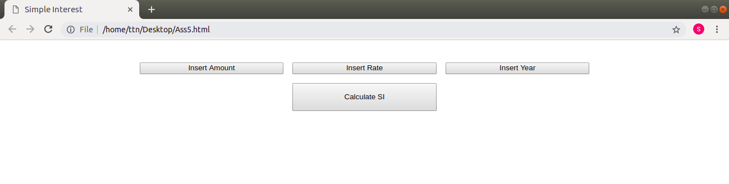
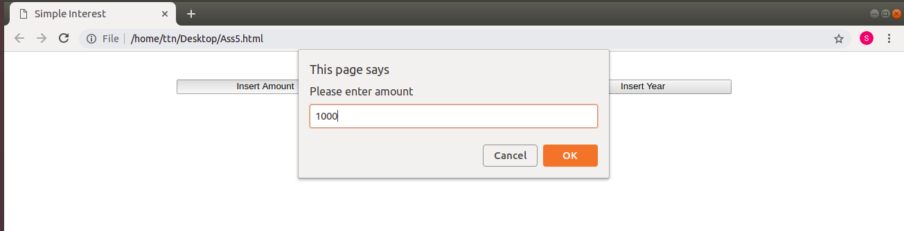
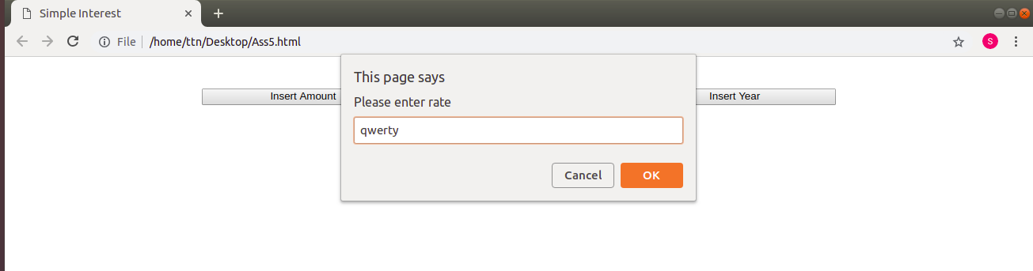

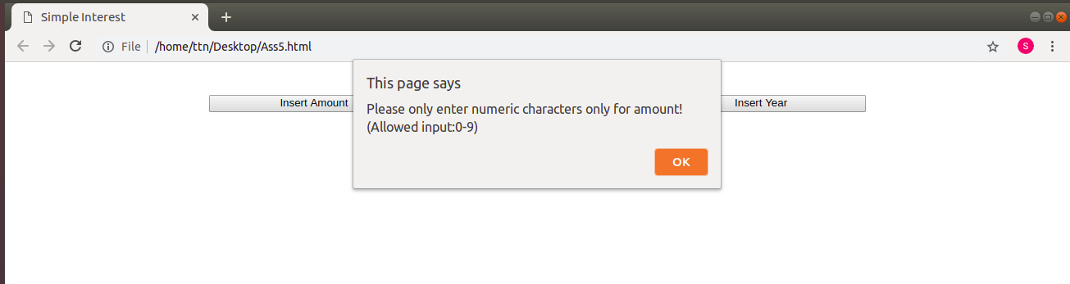
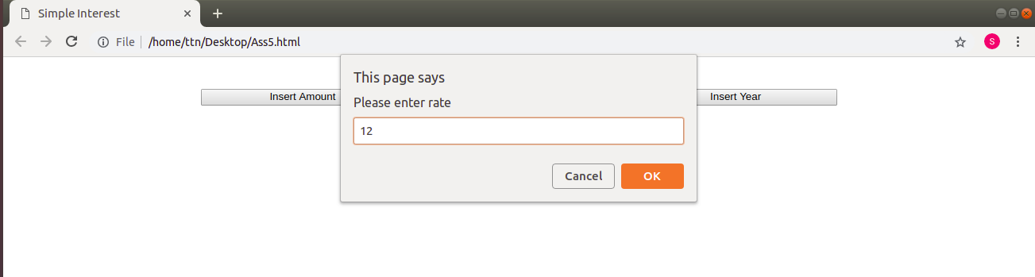
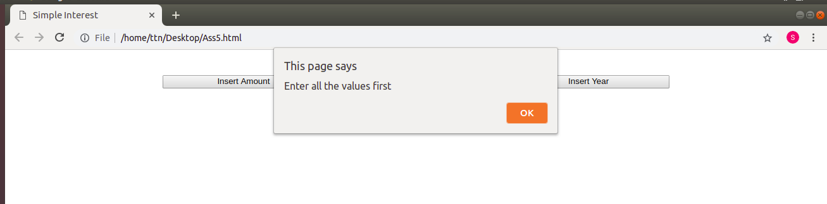

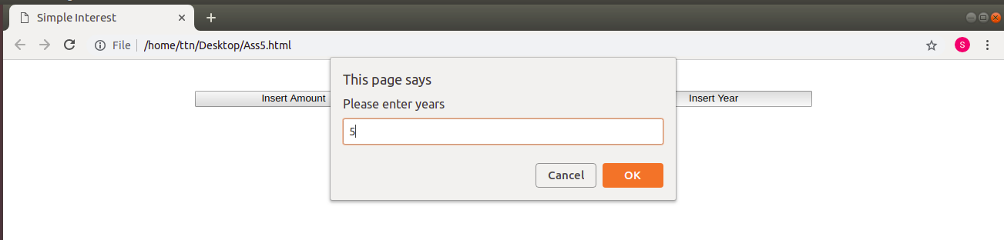

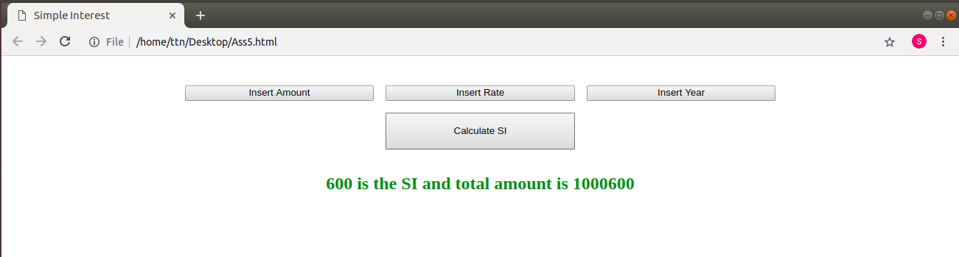

2. is palindrome string

<html>
<head>
<title>
Pallindrome
</title>
<style type="text/css">
button{
width:20%;
}
</style>
<script>
var p, r, t;
function pallindrome(){
str=prompt("Enter a String");
var j=str.length-1;
var ispallindrome=true;
for (var i = 0; i < str.length; i++) {
if(str.charAt(i)!=str.charAt(j))
ispallindrome=false;
j--;
}
if(ispallindrome)
document.getElementById("result").innerHTML = str+" is a pallindrome.";
else
document.getElementById("result").innerHTML = str+" is not a pallindrome.";
return;
}
</script>
</head>
<body onload="pallindrome()">
<br/>
<br/>
<br/>
<center><h2><label id="result" style="color: green"></label></h2></center>
</body>
</html>

Output:
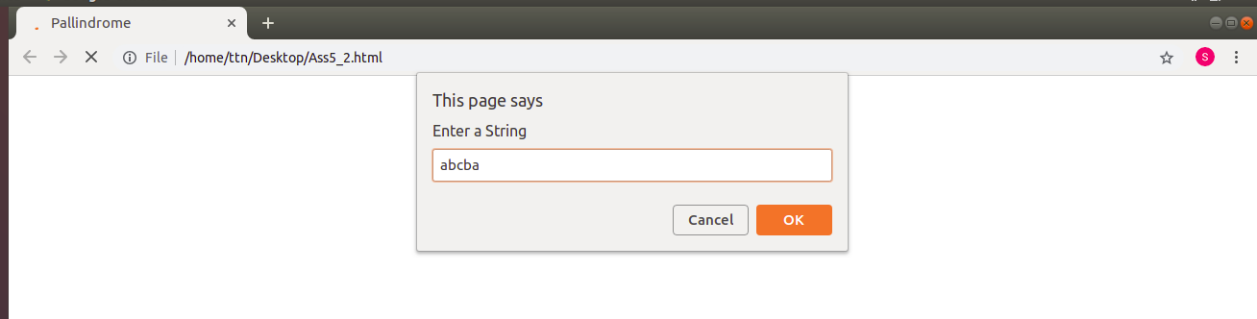
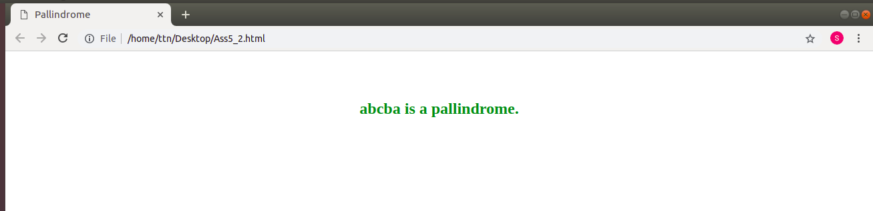
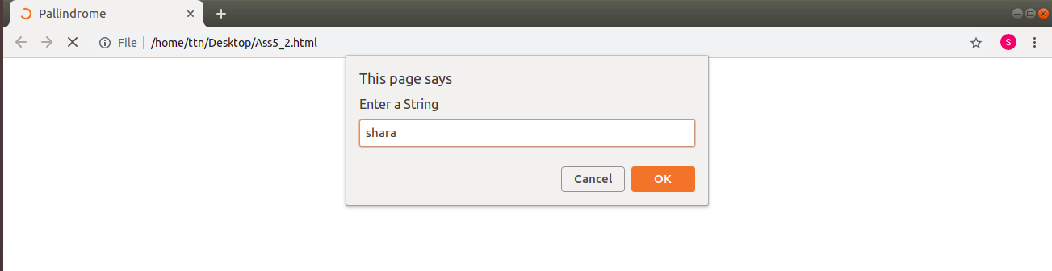

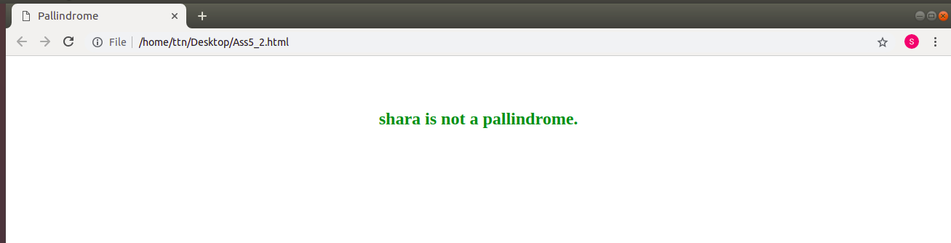
3. Area of circle

<html>
<head>
<title>
Area of a Circle
</title>
<script>
var p, r, t;
function areaOfCircle(){
r=prompt("Enter radius in cms");
if(isNaN(r)){
areaOfCircle();
}
aoc=3.14*r*r;
document.getElementById("result").innerHTML = "Area of circle is: "+aoc+"cm <sup>2</sup>";
return;
}
</script>
</head>
<body onload="areaOfCircle()">
<br/>
<br/>
<br/>
<center><h2><label id="result" style="color: green"></label></h2></center>
</body>
</html>

Output:

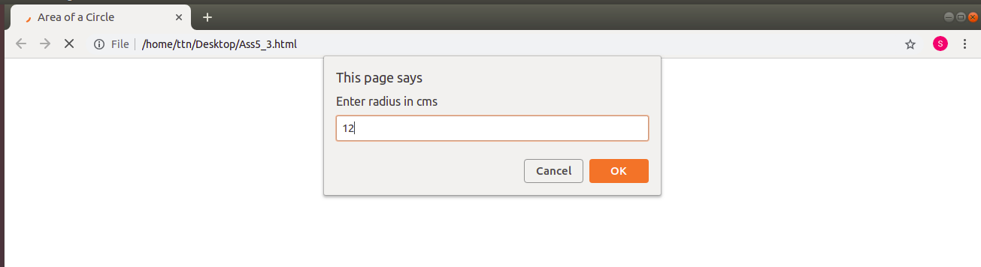
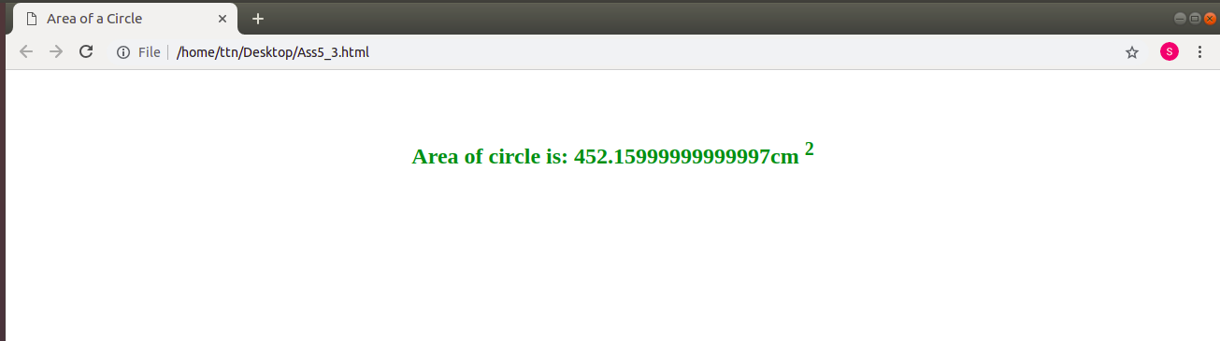

4. Copy information of one object to another and log it to console.

<html>
<head>
<title>
Copy Object
</title>
<style type="text/css">
</style>
<script>
var obj = { "name":"Shara", "competency": "AMC"};
var obj1={};
function printObj(){
str="";
for(var i in obj) str=str+i+": "+obj[i]+" ";
document.getElementById("result").innerHTML = str;
return;
}
function copyObj(){
for(var i in obj) obj1[i]=obj[i];
console.log(obj1);
return;
}
</script>
</head>
<body onload="printObj()">
<br/>
<br/>
<br/>
<center><h2>obj: <label id="result" style="color: green"></label></h2></center>
<center>Click <button onclick="copyObj()">here</button> to copy this object and print on console.</center>
</body>
</html>

Output:

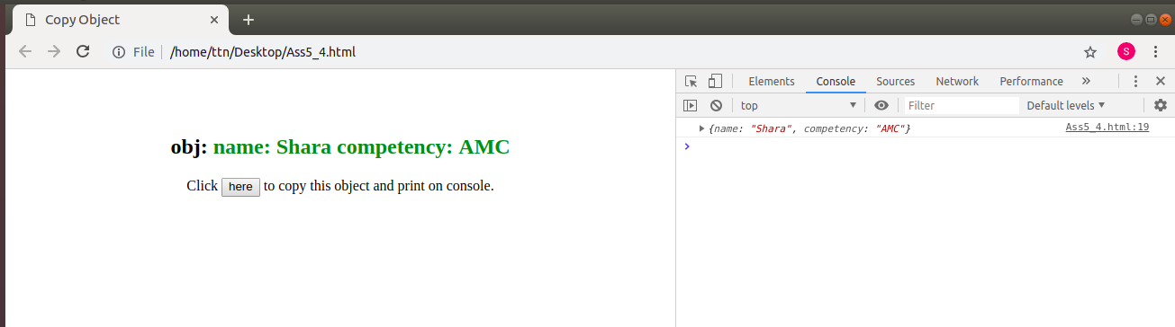

5. create a list of objects of Employee with info as follow :
- Name, age, salary ,DOB
- filter all employees with salary greater than 5000
- group employee on the basis of their age
- fetch employees with salary less than 1000 and age greater than 20. Then give them an increment 5 times their salary.

<html>
<head>
<title>
Employee
</title>
<style type="text/css">
</style>
<script>
arr=[{},{},{},{}];
arr[0] = { "name":"Shara", "age": "23", "salary":"30000", "DOB":new Date(1995,4,7)};
arr[1] = { "name":"Nargis", "age": "33", "salary":"30000", "DOB":new Date(1995,3,29)};
arr[2] = { "name":"Touseef", "age": "22", "salary":"3000", "DOB":new Date(1995,11,17)};
arr[3] = { "name":"Nouman", "age": "44", "salary":"500", "DOB":new Date(1993,2,5)};

function showemp(){
var str="";
arr.forEach(function(emp){
str=str+"Name: "+emp.name+", Age: "+emp.age+", Salary: "+emp.salary+", DOB:"+emp.salary+"<br/>";
});
document.getElementById("emp").innerHTML=str;
}

function filtersalary(event){
return event.salary> 5000;
}
var highsalary=arr.filter(filtersalary);
var str=[];
var i=0;
highsalary.forEach(function (arrayItem) {
str[i] = arrayItem.name;
i++;
});
str.join(", ");
function gethighsal(){
document.getElementById("result").innerHTML = " "+str;
}

function group18to25(event){
return event.age>=18 && event.age<=25;
}
function group26to35(event){
return event.age>=26 && event.age<=35;
}
function group36to50(event){
return event.age>=36 && event.age<=50;
}
function groupabove50(event){
return event.age>50;
}
var g18to25=arr.filter(group18to25);
var str1=[];
i=0;
g18to25.forEach(function (arrayItem) {
str1[i] = arrayItem.name;
i++;
});
str1.join(", ");
var g26to35=arr.filter(group26to35);
var str2=[];
i=0;
g26to35.forEach(function (arrayItem) {
str2[i] = arrayItem.name;
i++;
});
str2.join(", ");
var g36to50=arr.filter(group36to50);
var str3=[];
i=0;
g36to50.forEach(function (arrayItem) {
str3[i]= arrayItem.name;
i++;
});
str3.join(", ");
var gabove50=arr.filter(groupabove50);
var str4=[];
i++;
gabove50.forEach(function (arrayItem) {
str4[i] = arrayItem.name;
i++;
});
str4.join(", ");
function getagegroups(){
if(str1.length==0)
str1="No employee in this age group";
if(str2.length==0)
str2="No employee in this age group";
if(str3.length==0)
str3="No employee in this age group";
if(str4.length==0)
str4="No employee in this age group";
document.getElementById("g1").innerHTML = "Group1: 18-25-> "+str1;
document.getElementById("g2").innerHTML = "Group2: 26-35-> "+str2;
document.getElementById("g3").innerHTML = "Group3: 36-50-> "+str3;
document.getElementById("g4").innerHTML = "Group4: Above 50-> "+str4;
}

function fetche(event){
return event.age>20 && event.salary<1000;
}
var femployee=arr.filter(fetche);
str5="";
femployee.forEach(function (arrayItem) {
str5 = "Name: "+arrayItem.name+", Initial Salary: "+arrayItem.salary;
i++;
});
str5.join(", ");
function fetchemployee(){
arr.forEach(function (arrayItem) {
if(arrayItem.salary<1000&&arrayItem.age>20){
var out=arrayItem.salary*5;
arrayItem.salary=out;
}
});
document.getElementById("g5").innerHTML = " "+str5;
console.log(arr);
}
</script>
</head>
<body onload="showemp()">
<br/>
<h2>Employee details are:</h2>
<label id="emp" style="color: green"></label>
<br/>
<br/>
<I>Click <button onclick="gethighsal()">here</button> for all employees with salary greater than 5000. </I><br/>
<label id="result" style="color: green"></label><br/><br/>
<I>Click <button onclick="getagegroups()">here</button> to group employee on the basis of their age. </I><br/>
<label id="g1" style="color: green"></label><br/>
<label id="g2" style="color: green"></label><br/>
<label id="g3" style="color: green"></label><br/>
<label id="g4" style="color: green"></label><br/> </br/>
<I>Click <button onclick="fetchemployee(), showemp() ">here</button> to fetch employees with salary less than 1000 and age greater than 20. Then give them an increment 5 times their salary. Check updated value in the table above.</I><br/>
<label id="g5" style="color: green"></label>
</body>
</html>

Output:
