Assignment 4- HTML & CSS Shara Rizvi- 3313

1. How are inline and block elements different from each other?

Inline elements | Block elements
An inline element does not cause a line break i.e. it doesn’t start from a new line. | A block element cause a line break i.e. that it starts from a new line.
An inline element does not take up the full width of the page. | A block element takes up the full width of the page, from left to right.
It only takes the space of the bounded by the opening and closing tags. | It takes one or multiple lines and a line break before and after the element.
E.g: <span>, <a>, <img>, etc. | E.g: <div>, <h1>-<h6>, <ul>, <li>, etc.

2. Explain the difference between visibility:hidden and display:none.

Visibility:hidden | Display:none
If this property is added to the tag’s css, the element will not be visible on the page but it will be allocated the space it requires on the page. | If this property is added to the tag’s css, the element will not appear on the page at all. Also, no space for it will be allocated on screen.

3. Explain the clear and float properties.

Clear: The clear property for a element specifies whether other elements can float around it and where can and where cannot.
The clear property has following values:
a. none- allows floating from both the sides. Default.
b. left- no floating allowed on left of the element.
c. right- no floating allowed on right of the element.
d. both- no floating on either side.
e. inherit- element has the same clear property as it’s parent.
E.g:
div{
clear:left;
}

Float: The float property of an element allows it to float around it’s adjacent elements. It is used for setting positions and applying formatting on the page.
The float property has following values:
a. left: the element flows to the left of it’s container.
b. right: the element flows to the right of it’s container.
c. none: the element does not float. Default.
d. inherit: element has the same floating property as it’s parent.
E.g:
img{
float:right;
}

4. Explain difference between absolute, relative, fixed, and static.

Static Position: Default positioning type. Elements are stacked in one-after-another manner. The position is with respect to the page, not with respect to the browser. The only reason one would ever set an element to position: static; is to forcefully remove some positioning that got applied to an element outside of control.

Relative Position: This means the element is relative to itself. If position: relative; is set on an element but no other positioning attributes (top, left, bottom or right), it will have no effect on it's positioning just like with position: static; But if provided with other positioning attributes, (like top: 10px;), it will shift its position 10 pixels down from where it would normally be. This property introduces the ability to use z-index on that element (E.g: .yellow-box{position: relative; z-index: 1;} .blue-box{position: relative; z-index: 2;}).

Absolute Position: An element with property position:absolute; will be relative to its’s parent element with relative (or absolute) positioning. <html> is the default if there is no such parent. Elements with this property are removed from the normal flow of elements on the page and these elements are not affected by other elements and alo, they don’t affect other elements’ positioning.

Fixed Position: An element with property position:fixed; is positioned relative to the viewport i.e. the browser window. A fixed positioned element will stay fixed where it is on the browser even when the page is scrolled as viewport doesn't change when the window is scrolled.

5. Write the HTML code to create a table in which there are 4 columns( ID , Employee Name, Designation, Department) and at least 6 rows. Also do some styling to it.

Html page:
<!doctype html>
<html>
<head>
<title>
Ass4 Q5
</title>
<style type="text/css">
table{
border: 1px solid black;
width:100%;
text-align: center;
height: 30px;
background-color: gray;
}
tr{
background-color: pink;
}
</style>
</head>
<body>
<h1>Q5</h1>
<table >
<tr style="height: 50px; background-color: gray">
<th>ID</th>
<th>Employee Name</th>
<th>Designation</th>
<th>Department</th>
</tr>
<tr>
<td>101</td>
<td>Shara Rizvi</td>
<td>Trainee</td>
<td>AMC</td>
</tr>
<tr>
<td>102</td>
<td>Nargis Tarannum</td>
<td>Software Developer</td>
<td>PHP</td>
</tr>
<tr>
<td>103</td>
<td>Nouman Khan</td>
<td>Senior Developer</td>
<td>Ionic</td>
</tr>
<tr>
<td>104</td>
<td>Touseef Raza</td>
<td>Team Leader</td>
<td>AMC</td>
</tr>
<tr>
<td>105</td>
<td>Nargis Anjum</td>
<td>Product Ananlyst</td>
<td>Drupal</td>
</tr>
<tr>
<td>106</td>
<td>Nabeela Rizvi</td>
<td>Team Leader</td>
<td>JVM</td>
</tr>
</table>
</body>
</html>

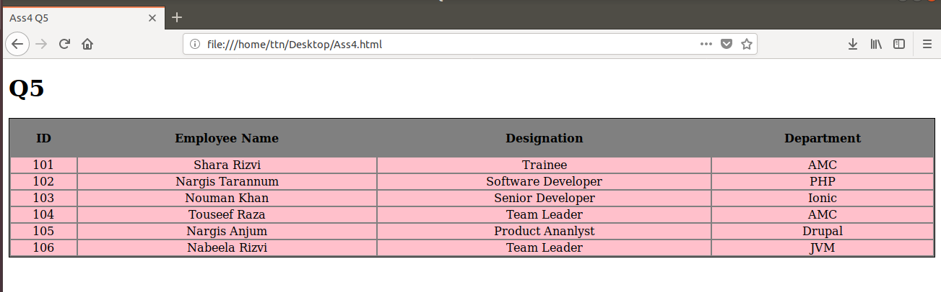
Output:

6. Why do we use meta tags?

The <meta> tag provides metadata (information about data) about the HTML document. Metadata is not displayed on the page but is machine parsable. They specify page description, keywords, author of the document, last modified, and other metadata. This metadata is used by browsers (how to display content or reload page), search engines (for keywords), etc. HTML5 introduced a method to let web designers take control over the viewport (the user's visible area of a web page), through the <meta> tag .
E.g:
<meta name="viewport" content="width=device-width, initial-scale=1.0">
<meta name="keywords" content="HTML, CSS, XML, XHTML, JavaScript">
<meta name="description" content="Meta contents">
<meta name="author" content="Shara Rizvi">
<meta http-equiv="refresh" content="60">

7. Explain box model.
All HTML elements are like boxes on the page. In CSS, "box model" is the term for design and layout. In CSS box model, a box wraps around every HTML element. It consists of: margins, borders, padding, and the actual content. The box model allows us to add borders around the element, and to define space between elements.
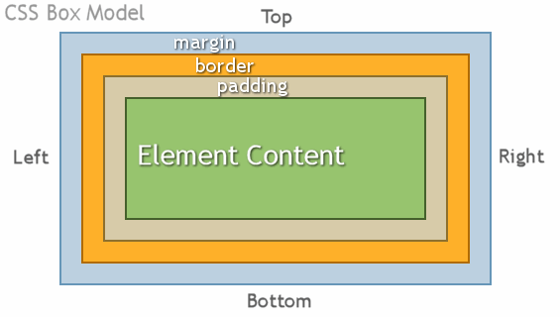

Eg:
div {
width: 300px;
border: 25px solid green;
padding: 25px;
margin: 25px;
}

8. What are the different types of CSS Selectors?

Universal Selector:
* {
color: green;
font-size: 20px;
}

Element Type Selector:
div{
border: solid 1px #ccc;
}

ID Selector:
#container {
width: 960px;
margin: 0 auto;
}
<div id="container"></div>
No two tags can have the same id.

Class Selector:
.rectangle{
padding: 20px;
margin: 10px;
width: 240px;
}
<div class="rectangle"></div>
Multiple tags can have the same class.

Descendant Combinator:
The descendant selector lets us combine two or more selectors so we can be more specific in our selection method.
#container .box {
float: left;
padding-bottom: 15px;
}

Child Combinator:
#container > .box {
float: left;
padding-bottom: 15px;
}
Elements of class box that are immediate children of element with id container.

General Sibling Combinator:
h2 ~ p {
margin-bottom: 20px;
}
styling will be applied to all <p> only if they are siblings of <h2>.

Adjacent Sibling Combinator:
p + p {
margin-top: 10px;
margin-bottom: 0;
}
The targeted element must be an immediate sibling, not just a general sibling.
Attribute Selector:
input[type="text"] {
background-color: #444;
width: 200px;
}
This targets elements based on the presence and/or value of HTML attributes.There should not be a space before the opening square bracket unless you intend to use it along with a descendant combinator.

Pseudo-class:
a:hover {
color: red;
}
A pseudo-state is that in which an element might be in for a while- e.g, the state of being hovered, or the state of being activated.

Pseudo-element:
.container:before {
content: "";
display: block;
width: 50px;
height: 50px;
background-color: #141414;
}
This selector inserts an imaginary element (e.g. :before above) into the page, inside the targeted element (e.g. tags with class container in above example), before its contents.

9. Define Doctype.
The <!DOCTYPE> declaration must be the very first thing in HTML document, before the <html> tag. The <!DOCTYPE> declaration is an instrution to the web browser about what version of HTML the page is written in. In HTML 4.01, the <!DOCTYPE> declaration refers to a DTD, because HTML 4.01 was based on SGML. The DTD specifies the rules for the markup language, so that the browsers render the content correctly. HTML5 is not based on SGML, and therefore does not require a reference to a DTD. W should add the <!DOCTYPE> declaration to HTML documents, so that the browser knows what type of document to expect.
HTML 5: <!DOCTYPE html>

HTML 4.01 Strict: <!DOCTYPE HTML PUBLIC "-//W3C//DTD HTML 4.01//EN" "http://www.w3.org/TR/html4/strict.dtd">

10. Explain 5 HTML5 semantic tags.
HTML5 semantic tags are no different than regular tags, their syntax remains the same. However, the content inside them gives the browser indications on what to do and how to do it.
<article>It is used to define the article content on your website. It is usually used for big parts of the text.
<aside>The <aside> semantic element defines the content which will be set to the side. It is occasionally used for creating sidebars but can also be used for less important content sharing.
<details>This is one of the HTML5 semantic tags that defines the details on your website. The details can either be visible to the audience or hidden.
<figcaption>The <figcaption> tag generates a title for <figure> element. It always goes together with<figure>element.
<figure>
<figcaption>Dog</figcaption>
<img src="image.png" width="300" height="300">
</figure>

<footer>The HTML5 element <footer> describes the footnote for your website or part of the content.

11. Create HTML for web-page.jpg.
Html:
<!DOCTYPE HTML>

<HTML>
<HEAD>
<STYLE>
body{
background-color:#2C2A2A;
margin-left: 50px;
margin-right: 50px;
}
#tab{

margin:8px;
padding:8px;
}
.whiteContainer
{
background-color:white;
color:black;
width:100%;
height:1000px;
}
.BlackInnerContainer
{
background-color:black;
width:90%;
height:300px;
margin:30px 0px 0px 55px;
padding-top:10px;
}
.GrayInnerContainer
{
background-color:gray;
width:88%;
height:auto;
margin:400px 0px 0px 55px;
padding:10px;
}
.Gallery
{
background-color:rgb(34,57,100);
width:87%;
height:auto;
margin:500px 0px 0px 60px;
padding:10px;
position: absolute;
}

.box1,.box2,.box3,.box4{
width:20%;
height:300px;
background-color: black;
color: white;
padding:10px;
display:inline-block;
margin-left:20px;
}

</STYLE>
</HEAD>

<BODY>
<DIV class="container" style="position:relatve">
<DIV style="position:absolute; margin-left:100px 0px 100px 0px;background-color:#101010;width:90%;height:auto" >
<DIV style="">
<H2 style="color:white;padding-left:60px;">ToTheNew</H2>
</DIV>
<DIV style="background-color:black;width:auto;color:white;margin:20px 60px 20px 60px; padding:10px;">
<span id="tab">Text Line</span>
<span id="tab">Text Line</span>
<span id="tab">Text Line</span>
<span id="tab">Text Line</span>
<span id="tab">Text Line</span>
</DIV>
<Div class="whiteContainer">
<Div class="BlackInnerContainer" style="position:absolute;">

</Div>
<Div class="GrayInnerContainer" style="position:absolute">
<p>this is created by <del><b>Shara Rizvi</b></del> this is created by <del><b>Shara Rizvi</b></del> this is created by <del><b>Shara Rizvi</b> </del></p>
</Div>

<Div class="Gallery">
<p id="Latest">Latest from the Gallery</p>
<hr style="width:auto">

<img src="" class="box1">

<img src=""class="box2">

<img src=" " class="box3">

<img src="" class="box4">

</Div>
</Div>
<footer>
<p style="margin-left:100px;color:white;">copyright &copy;2017-2018 All right reserved</p>
<p style="margin-right:100px;display:inline-flex;margin-top:-34px;float:right;color:white;"> Design by To The New</p>
</footer>
</DIV>
</DIV>
</BODY>

</HTML>
Output:
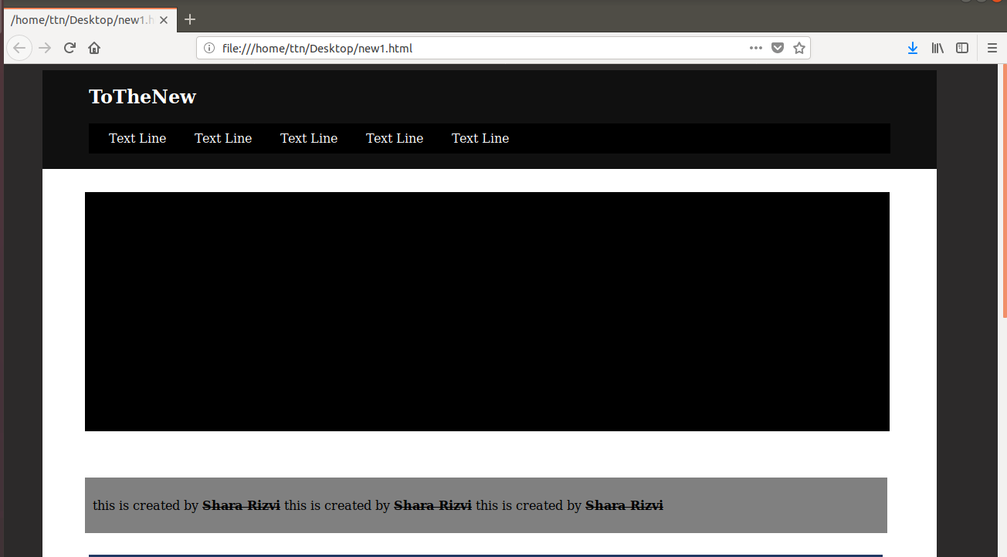

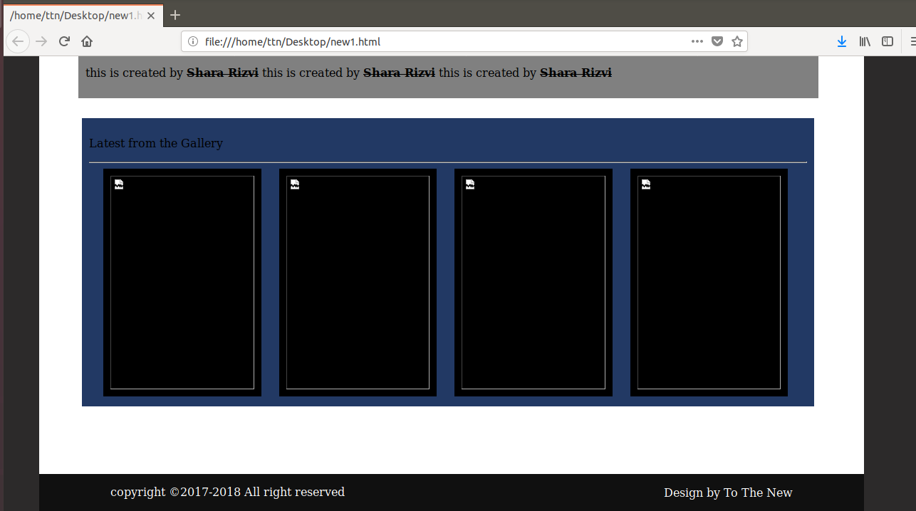

12. Create HTML for form.png
<!DOCTYPE html>
<html lang="en">
<head>
<title>Search Study Companion</title>
<meta charset="utf-8">
<meta name="viewport" content="width=device-width, initial-scale=1">

</head>
<style>
#companyLogo
{
color:#00b386;
margin-left: 100px;
}
.tabs
{
display: inline-flex;
list-style-type:none;
padding: 10px;
float: right;
margin-top:-50px;
margin-right:90px;
font:10px "Open Sans",sans-serif;
}
li
{
padding-left: 20px;
color:#00b386;
font: 18px "Open Sans",sans-serif;
}
.formCotainer
{
width:50%;
height:57.7vw;
margin-left:26.5vw;
border:2px solid #C8C8C8;
border-radius:10px;
}
.navOfFrom
{
width:49.49%;
position: absolute;
color: black;
background-color:#C8C8C8;
height: 5vw;
border-radius: 6px 6px 0px 0px;
}
#BugReport
{
margin-left:30px;
color:white;
font-weight: bold;
}
.formGroup
{

width:86%;
color:gray;
font: 16px "Open Sans",sans-serif;
padding:20px 30px 20px 40px;
}
input[type="text"],select
{
width:100%;
border: 2px solid gray;
border-radius: 5px;
display: inline-block;
padding: 10px;
}

select{
padding-left:20px;
background-color: #00b386;
border-color:#00b386;
width: 103.89%;
}
textarea
{
width:100%;
border: 2px solid gray;
border-radius: 5px;
display: inline-block;
padding: 10px;
}
label{
display: inline-block;
font-weight:500;
margin-top:10px;
}
#free{

padding: 30px 0px 10px 0px;
}
#Business
{
margin-left:240px;
}
.footerOfForm
{
width: 116%;
height: 5vw;
background-color:#C8C8C8;
border:2px solid #C8C8C8;
border-radius: 0px 0px 5px 5px;
margin-top:20px;
margin-left: -40px;}
input[type="button"] {
width:13%;
border: 2px solid #C8C8C8;
border-radius:10px;
display: inline-block;
color: white;
font-weight: bold;
margin:20px 35px 0px 0px;
font-size:16px;
background-color: #00b386;
padding: 10px;
display:inline;
float:right;
}
select{
font-weight: bold;
color:white;
}

.inputfile
{
width:100%;
border: 2px solid #00b386;
border-radius: 5px;
display: inline-block;
padding: 10px;
background-color: #00b386;
color:white;
font-weight: bold;

}

}
</style>
<body>
<div class="container">
<nav class="nav1">
<h1 id="companyLogo">TO THE NEW<h1>
<UL class="tabs"><li>Home</li>
<li><a link="">Quick</a></li>
<li><a link="">Help</a></li>
</UL>
</nav>
<hr style="width:87%;color:gray;margin-left:100px;">
<div class="formCotainer">
<div class="navOfFrom">
<h1 id="BugReport">Bug report</h1>
<form class="formGroup" action="#">

<label>Title:*</label><input type="text" name="title">
<label style="margin-top:10px;">Description:*</label>
<textarea cols="100" rows="10"></textarea>
<label>Operating System:</label>
<select>
<option value="Windows">Microsoft Windows</option>
<option value="Ubuntu">Ubuntu</option>
<option value="Kali linux">Kali linux</option>
<option value="Mac Os">Apple macOS</option>
<option value="Mac Os">Mac OS</option>
</select>
<label>Product:*</label>
<select>
<option value="Windows">Paramoid</option>
<option value="Ubuntu">Ubuntu</option>
<option value="Kali linux">Kali linux</option>
<option value="Mac Os">Apple macOS</option>
<option value="Mac Os">Mac OS</option>
</select>
<label>Version:*</label><br>
<input type="text" name="Version" style="width:20%"><br>
<label>License:</label><br>
<input id="free" type="radio" name="Free" value="Free">Free
<input id="Business" type="radio" name="Business" value="Business">Business<br>
<label>Severitry</label>
<select>
<option value="Windows">Paramoid</option>
<option value="Ubuntu">Ubuntu</option>
<option value="Kali linux">Kali linux</option>
<option value="Mac Os">Apple macOS</option>
<option value="Mac Os">Mac OS</option>
</select>
<label>Attachments:</label><br>
<input type="file" name="file" id="file" class="inputfile" />
<div class="footerOfForm">
<input type="button" name="send" value="send">
</div>
</form>
</div>
</div>
</body>
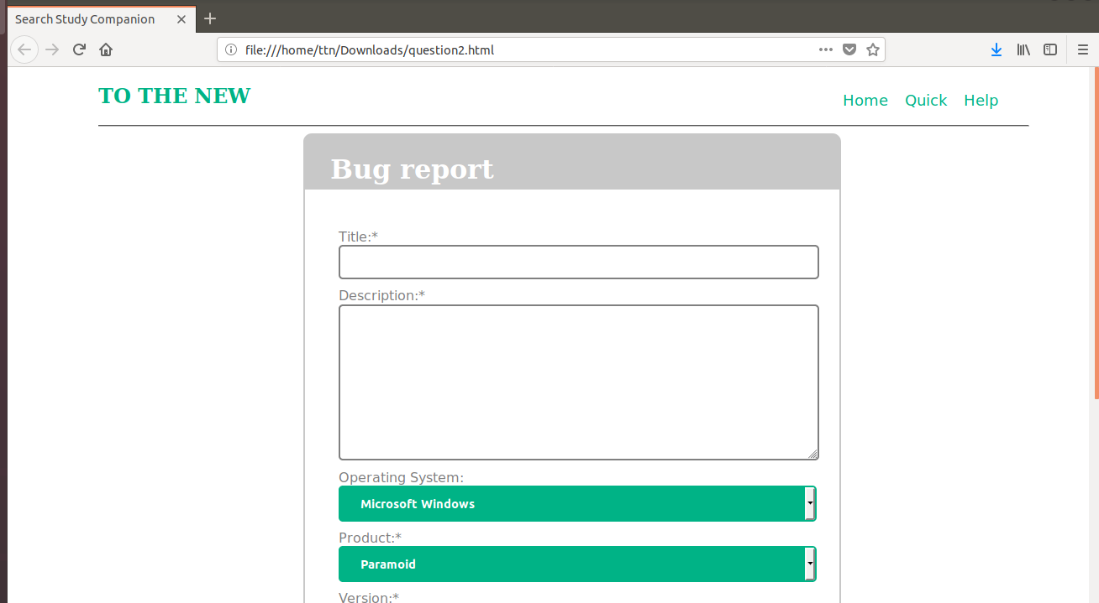
Output:

