Assignment 3 – Database Shara Rizvi- 3313

1. Create Database
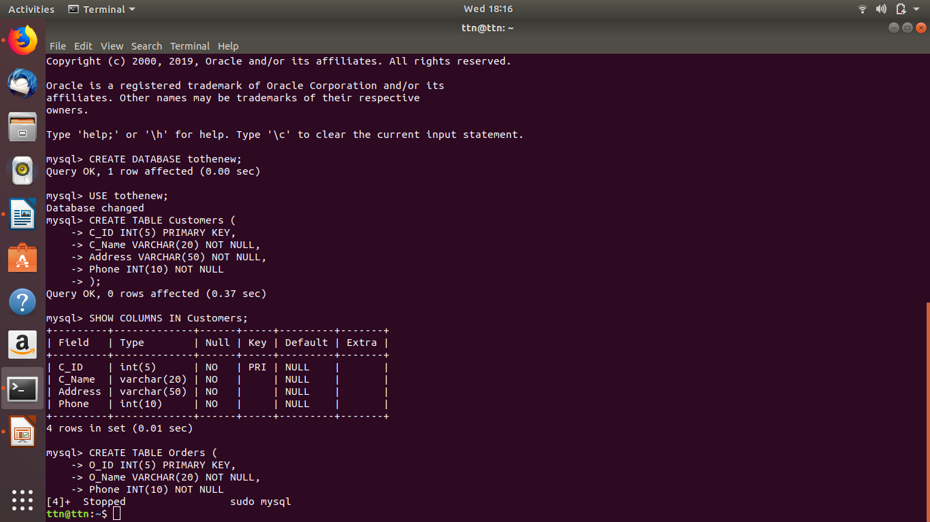

2. Design Schema

Customers

C_IDPK
C_Name
Address
Phone

Orders

O_IDPK
O_Name
C_IDFK
S_IDFK
Price
O_Date
Salesperson

S_IDPK
S_Name
Address
Phone

1 : M
M : 1

3. Create tables
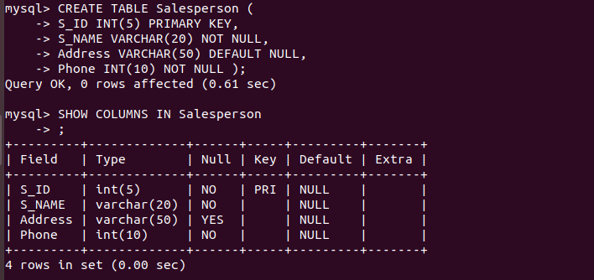
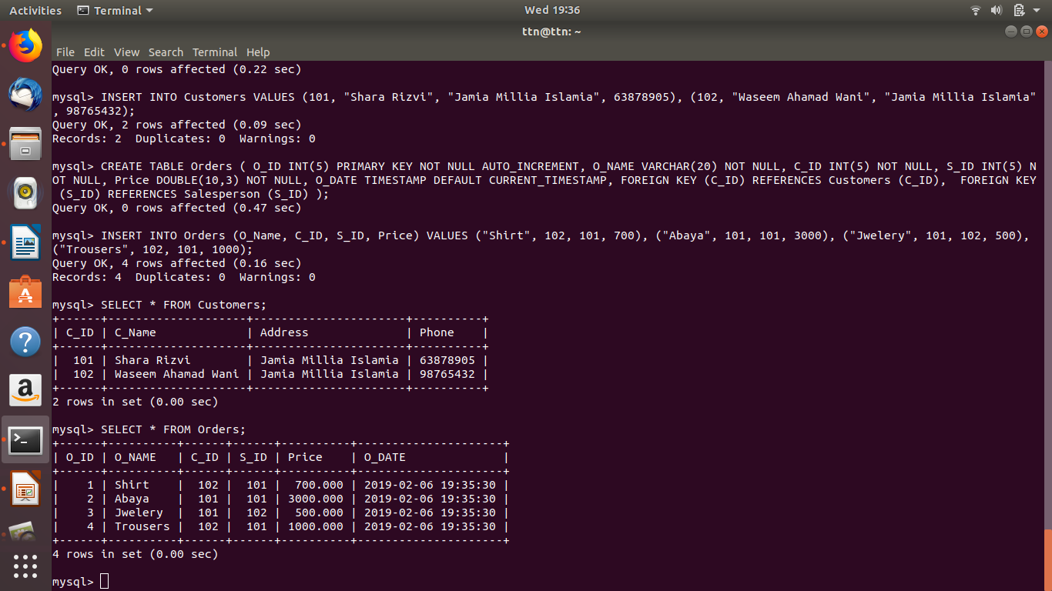
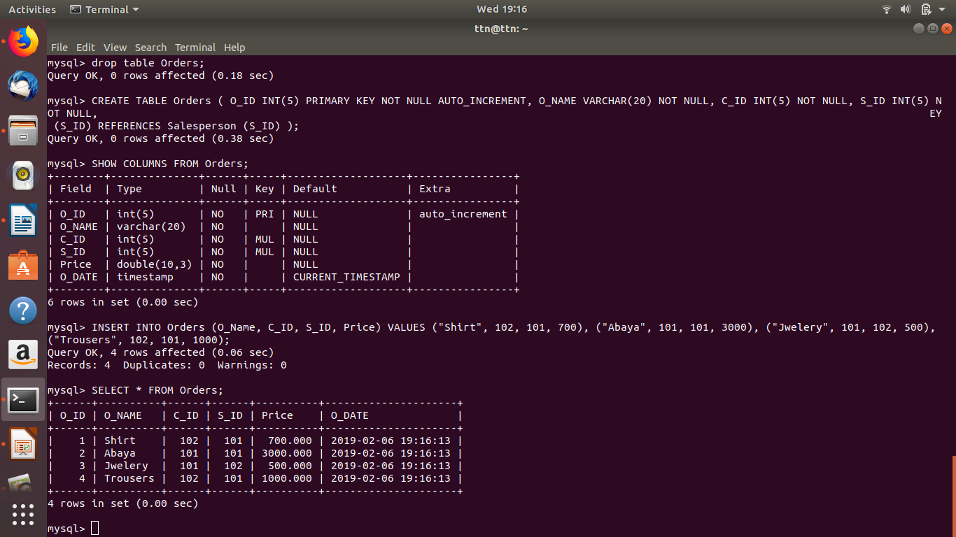

4. Insert sample data

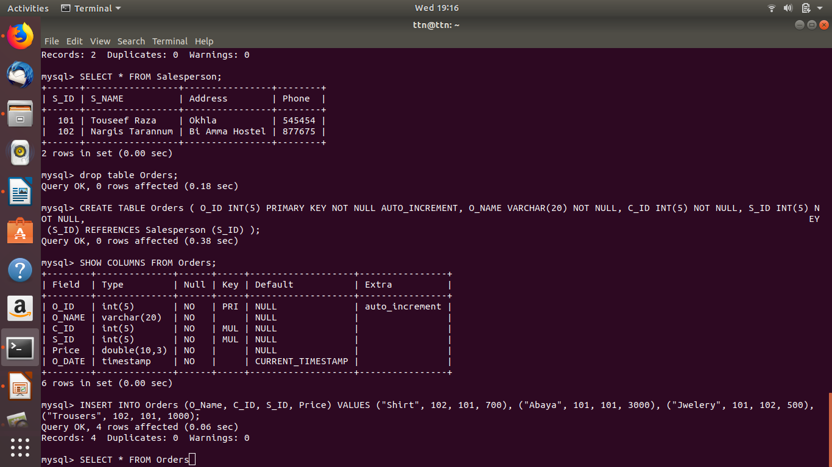
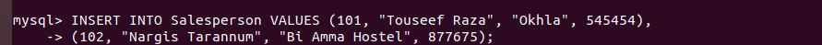

5. Find the sales person have multiple orders

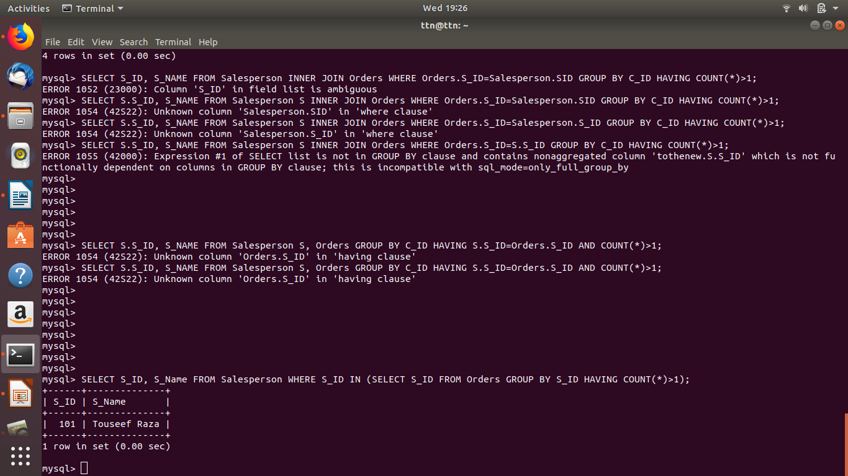

6. Find the all sales person details along with order details

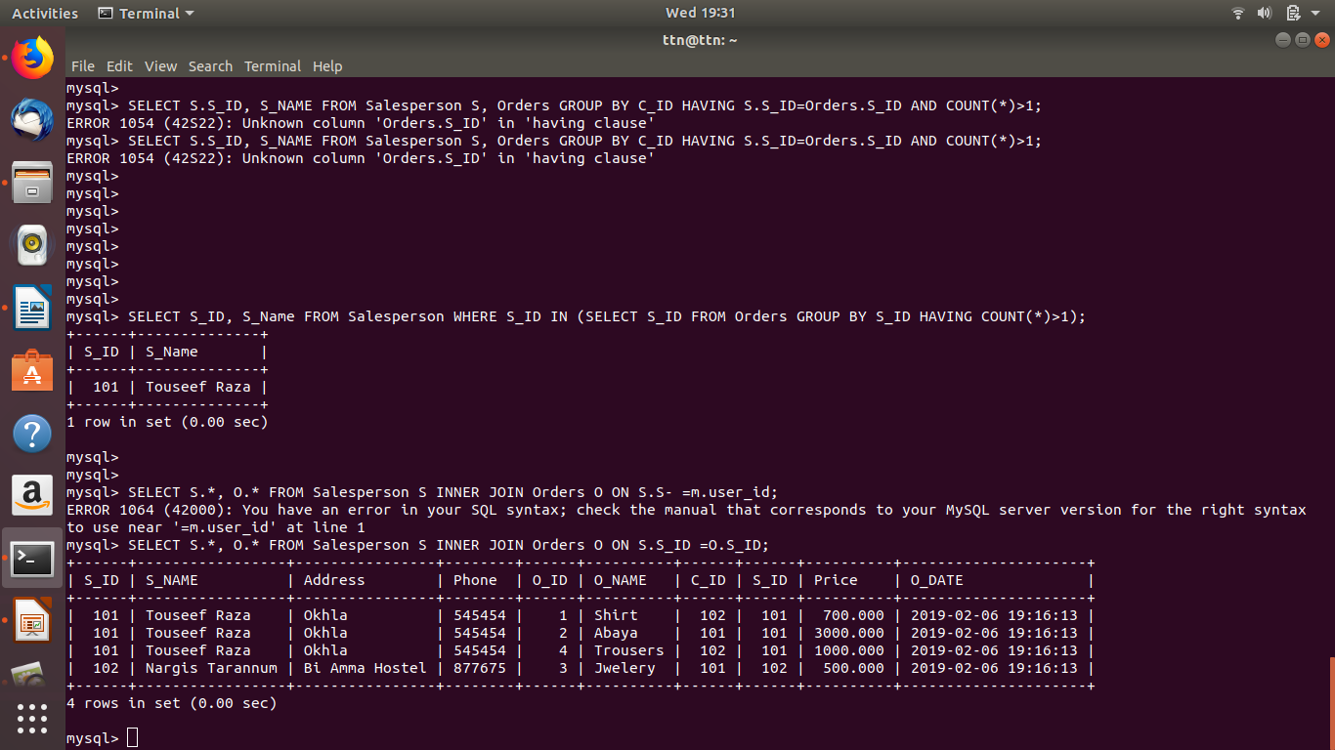

7. Create index
8. How to show index on a table

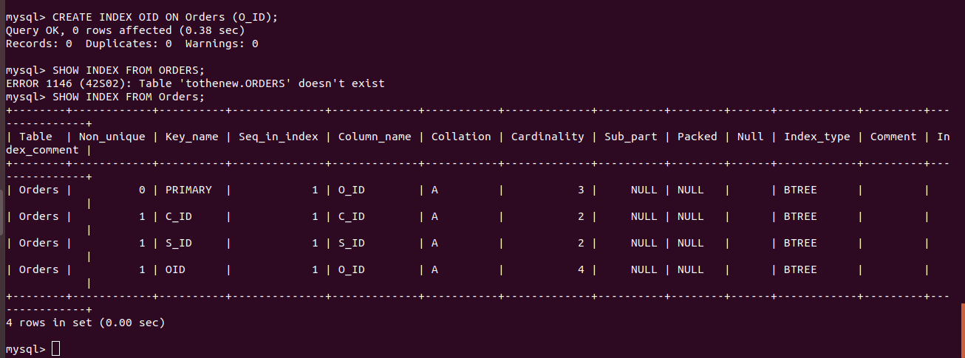
9. Find the order number, sales person name, along with the customer to whom that order belongs to

