Assignment 2 – Version Control Shara Rizvi- 3313

1. Git Setup https://confluence.atlassian.
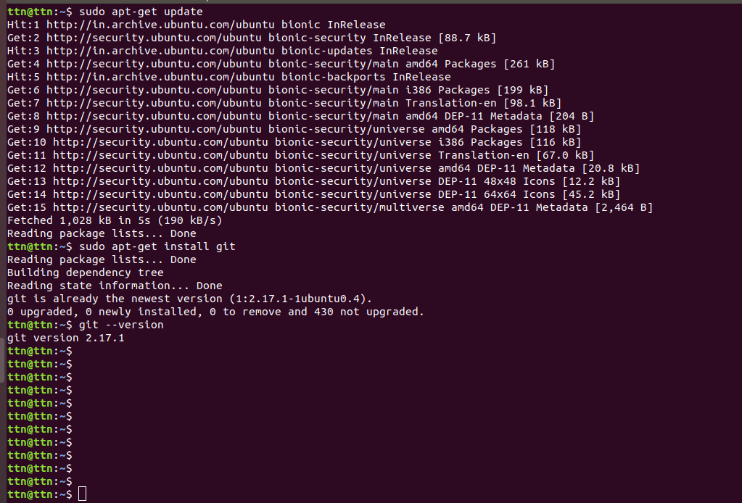
2. Initialize a Git Repository
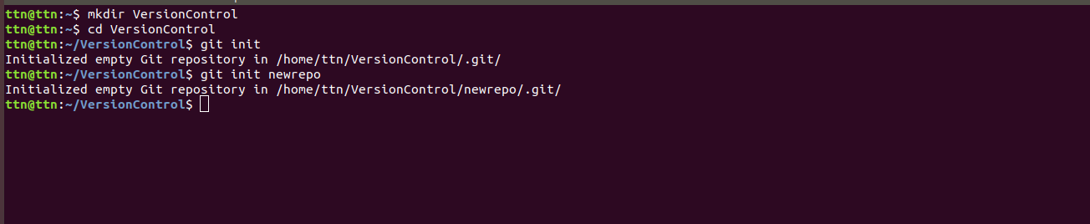
3. Add files to the repository
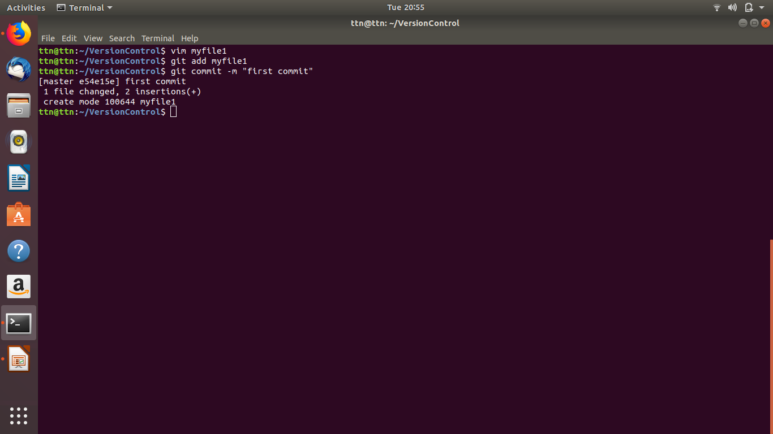

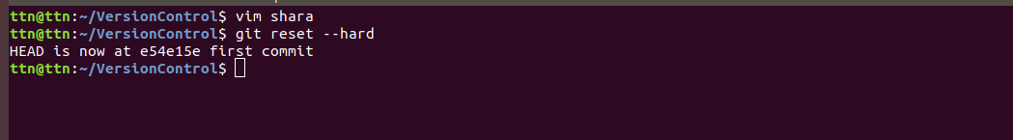
4. Unstage 1 file

5. Commit the file
6. Add a remote
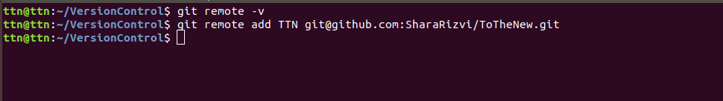
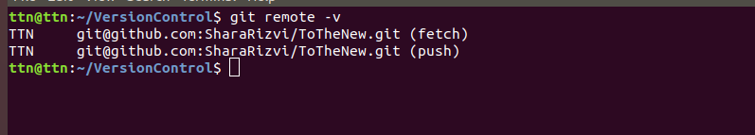
7. Undo changes to a particular file
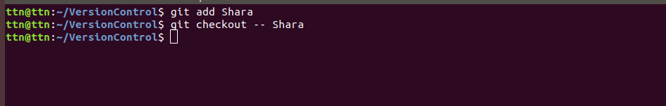
8. Push changes to Github
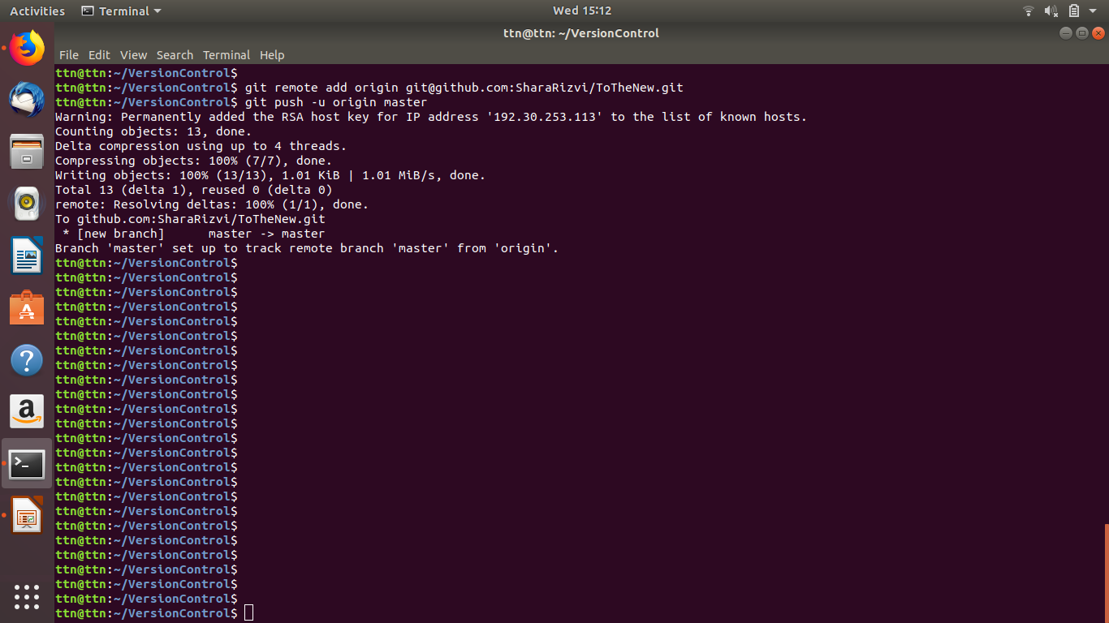

9. Clone the repository
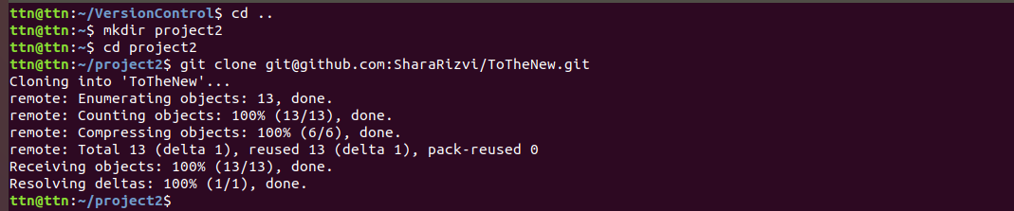
10. Add changes to one of the copies and pull the changes in the other

11. Check differences between a file and its staged version
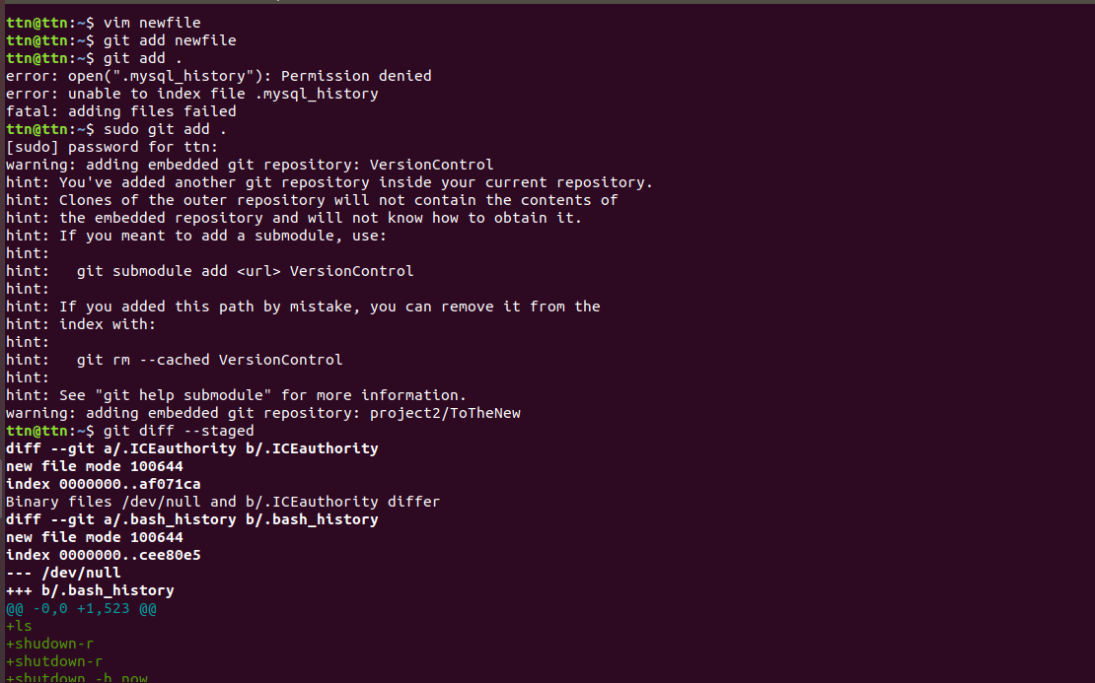

12. Ignore a few files to be checked in
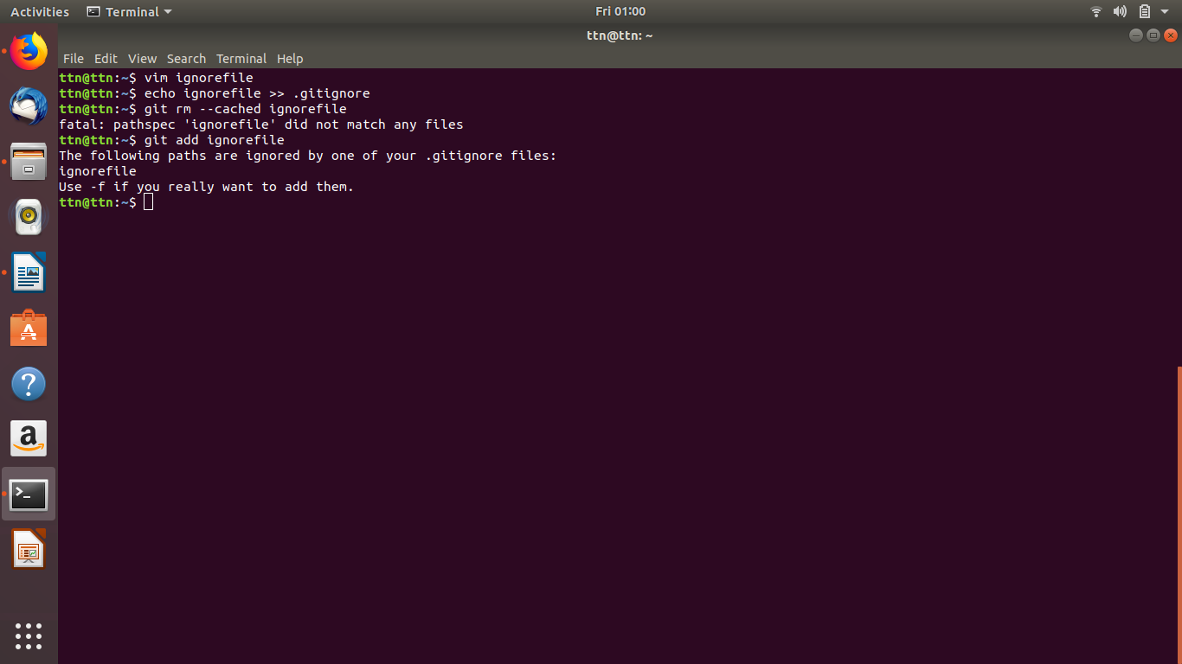

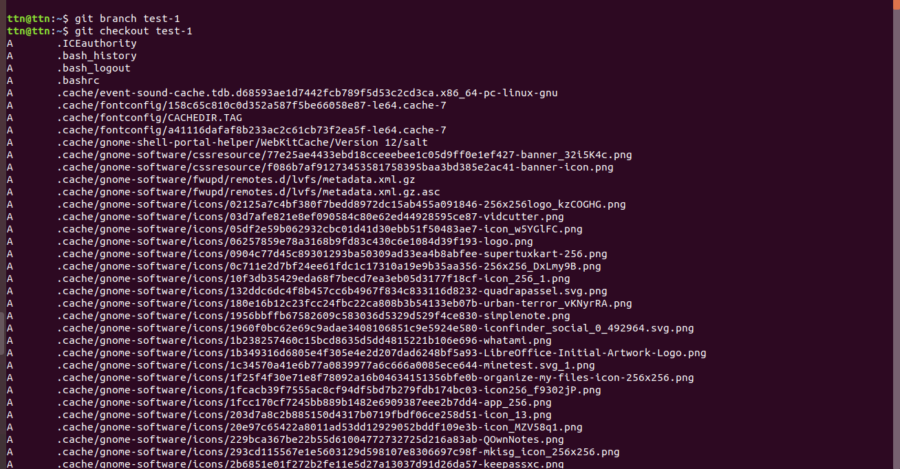
13. Create a new branch
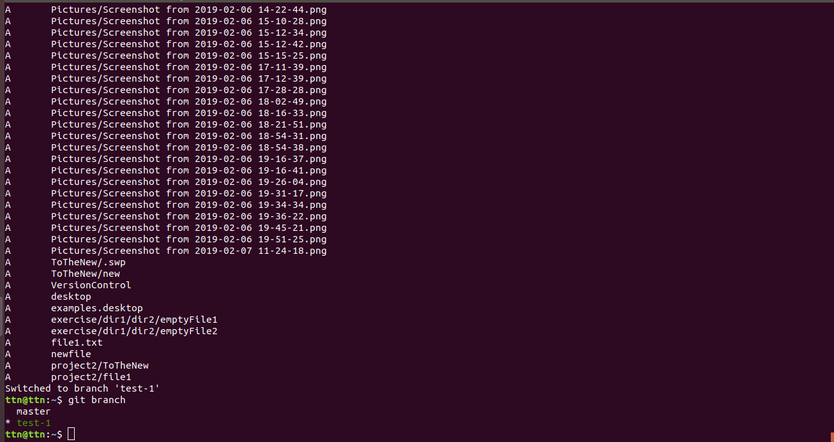

14. Diverge them with commits

