Task №1. Access settings

**CREATE** **TABLE** plan_status (

quarterid **varchar**(6) **NOT** **NULL**,

status **varchar**(10) **NOT** **NULL**,

modifieddatetime **timestamp** **NOT** **NULL** **DEFAULT** **CURRENT_TIMESTAMP**,

author **varchar**(20) **NOT** **NULL** **DEFAULT** **CURRENT_USER**,

country **varchar**(5) **NOT** **NULL**,

**CONSTRAINT** plan_status_pk **PRIMARY** **KEY** (quarterid, country)

);

**CREATE** **TABLE** plan_data (

versionid **varchar**(1) **NOT** **NULL**,

country **varchar**(5) **NOT** **NULL**,

quarterid **varchar**(6) **NOT** **NULL**,

pcid **int4** **NOT** **NULL**,

salesamt **numeric**(18,2) **NULL**,

**CONSTRAINT** planapp_data_pkey **PRIMARY** **KEY** (quarterid, country, pcid, versionid)

);

**CREATE** **TABLE** country_managers (

username **varchar**(30) **NOT** **NULL**,

country **varchar**(5) **NOT** **NULL**,

**CONSTRAINT** country_managers_pk **PRIMARY** **KEY** (username, country)

);

**CREATE** **TABLE** company (

id **int4** **NOT** **NULL** **GENERATED** **ALWAYS** **AS** **IDENTITY**,

cname **varchar**(200) **NOT** **NULL**,

countrycode **varchar**(10) **NULL**,

city **varchar**(30) **NULL**,

**CONSTRAINT** d_company_pk **PRIMARY** **KEY** (id)

);

**CREATE** **TABLE** company_sales (

cid **int4** **NOT** **NULL**,

salesamt **numeric**(18,2) **NULL**,

**year** **int4** **NULL**,

quarter_yr **int4** **NULL**,

qr **varchar**(6) **NOT** **NULL**,

categoryid **int4** **NOT** **NULL**,

ccls **varchar**(1) **NULL**,

**CONSTRAINT** company_sales_pk **PRIMARY** **KEY** (qr, cid, categoryid)

);

**CREATE** **TABLE** company_abc (

cid **int4** **NOT** **NULL**,

salestotal **numeric** **NULL**,

cls **varchar**(1) **NULL**,

**year** **int4** **NOT** **NULL**,

**CONSTRAINT** company_abc_pk **PRIMARY** **KEY** (cid, **year**)

);

**create** **view** v_plan_edit **as**

**select** pd.country, pd.quarterid, pd.pcid, pd.salesamt, pd.versionid

**from** plan_data pd

**where**

pd.versionid = 'P'

**and**

pd.country **in** (**select** country

**from** country_managers cm

**where** cm.username = **current_user**)

**and**

pd.quarterid **in** (**select** ps.quarterid

**from** plan_status ps

**where** ps.author = **current_user** **and** ps.status = 'L');

**create** **view** v_plan **as**

**select** pd.country,

pd.pcid,

pd.quarterid,

pd.salesamt

**FROM** plan_data pd

**WHERE** pd.versionid = 'A'

**AND** (pd.country **IN** (**SELECT** cm.country **FROM** country_managers cm

**WHERE** cm.username = **CURRENT_USER**)

**or**

pg_has_role(**current_user**, 'planadmin', 'member'))

**AND** (pd.quarterid **IN** ( **SELECT** ps.quarterid

**FROM** plan_status ps

**WHERE** ps.status = 'A'));

**create** **role** planadmin;

**create** **role** planmanager;

**grant** **select** **on** **all** **tables** **in** **schema** public **to** planadmin, planmanager;

**grant** **select**, **update**, **insert**, **delete** **on** plan_data **to** planadmin, planmanager;

**grant** **select**, **update**, **insert**, **delete** **on** plan_status **to** planadmin;

**grant** **select**, **update** **on** plan_status **to** planmanager;

**grant** **select**, **update**, **insert**, **delete** **on** country_managers **to** planadmin;

**grant** **select** **on** country_managers **to** planmanager;

**grant** **select** **on** v_plan **to** planmanager;

**grant** **select**, **update** **on** v_plan_edit **to** planmanager;

**create** **user** kirill **with** **password** 'sql';

**create** **user** sophie **with** **password** 'sql2';

**create** **user** ivan **with** **password** 'sql3'

**grant** planadmin **to** ivan;

**grant** planmanager **to** kirill, sophie;

**INSERT** **INTO** country_managers (username, country)

**VALUES** ('kirill', 'DE'), ('kirill', 'FR'), ('kirill', 'GB'), ('kirill', 'AU'), ('sophie', 'US'), ('sophie', 'CA');

Task №2. product2 & country 2 materialized views

**CREATE** **VIEW** product2 (pcid, productid, pcname, pname) **AS**

**SELECT** productcategory.productcategoryid, product.productid, productcategory.**name**, product.**name**

**from** product **inner** **join** productsubcategory **on** product.productsubcategoryid = productsubcategory.productsubcategoryid

**inner** **join** productcategory **on** productsubcategory.productcategoryid =productcategory.productcategoryid;

--**choose distinct countries where is Main Office:**

**CREATE** **VIEW** country2 (countrycode) **AS**

**SELECT** **distinct** address.countryregioncode

**FROM**

address

**inner** **join** customeraddress **on** address.addressid = customeraddress.addressid

**where** addresstype = 'Main Office'

**grant** **select** **on** product2, country2 **to** planadmin, planmanager

Task №3. Loading data into the company table

--delete from customeraddress

--where

--addressid in (825, 1098)

**ALTER** **TABLE** company **DROP** **COLUMN** id **RESTRICT**;

**ALTER** **TABLE** company **ADD** **COLUMN** id **SERIAL** **PRIMARY** **KEY**;

**insert** **into** company

**select** **distinct** **on** (customer.companyname) customer.companyname, address.countryregioncode, address.city

**from** customer

**inner** **join** customeraddress **on** customer.customerid = customeraddress.customerid

**inner** **join** address **on** customeraddress.addressid = address.addressid

**where** customeraddress .addresstype = 'Main Office'

Task №4. Company classification

**insert** **into** company_abc (cid, salestotal, **year**)

**select** **CAST** (company.id **AS** **INTEGER**), **sum** (salesorderheader.subtotal), **extract** (**year** **from** salesorderheader.orderdate)::**int**

**from** company

**inner** **join** customer **on** company.cname = customer.companyname

**inner** **join** salesorderheader **on** customer.customerid = salesorderheader.customerid

**where** **extract**(**year** **from** salesorderheader.orderdate) = 2012

**or** **extract**(**year** **from** salesorderheader.orderdate) = 2013

**group** **by** 1, 3

**order** **by** 2 **desc**

**ALTER** **TABLE** company_abc **ADD** **COLUMN** SRTi **numeric**;

**update** company_abc c

**set** srti = c1.srti

**from** (

**select** cid, **year**,

**sum**(salestotal) **over**(**partition** **by** **year** **order** **by** salestotal **desc**) srti

**from** company_abc

) c1

**where** c1.**year** = c.**year** **and** c1.cid = c.cid

**CREATE** **TABLE** total_srti_by_year (

maxsrti **numeric** **NOT** **NULL**,

**year** **int** **NOT** **NULL**,

**PRIMARY** **KEY** (**year**)

);

**insert** **into** total_srti_by_year

**select** **max**(company_abc.srti), company_abc.**year**

**from** company_abc

**group** **by** **year**

**update** company_abc **as** cm

**set** cls = **case**

**WHEN** cm.**year** = 2012 **and** cm.srti <= 27133701.3787*0.8 **THEN** 'A'

**WHEN** cm.**year** = 2012 **and** cm.srti <= 27133701.3787*0.95 **THEN** 'B'

**when** cm.**year** = 2012 **and** cm.srti <= 27133701.3787 **then** 'C'

**WHEN** cm.**year** = 2013 **and** cm.srti <= 32890351.7237*0.8 **THEN** 'A'

**WHEN** cm.**year** = 2013 **and** cm.srti <= 32890351.7237*0.95 **THEN** 'B'

**when** cm.**year** = 2013 **and** cm.srti <= 32890351.7237 **then** 'C'

**end**

**FROM** company_abc;

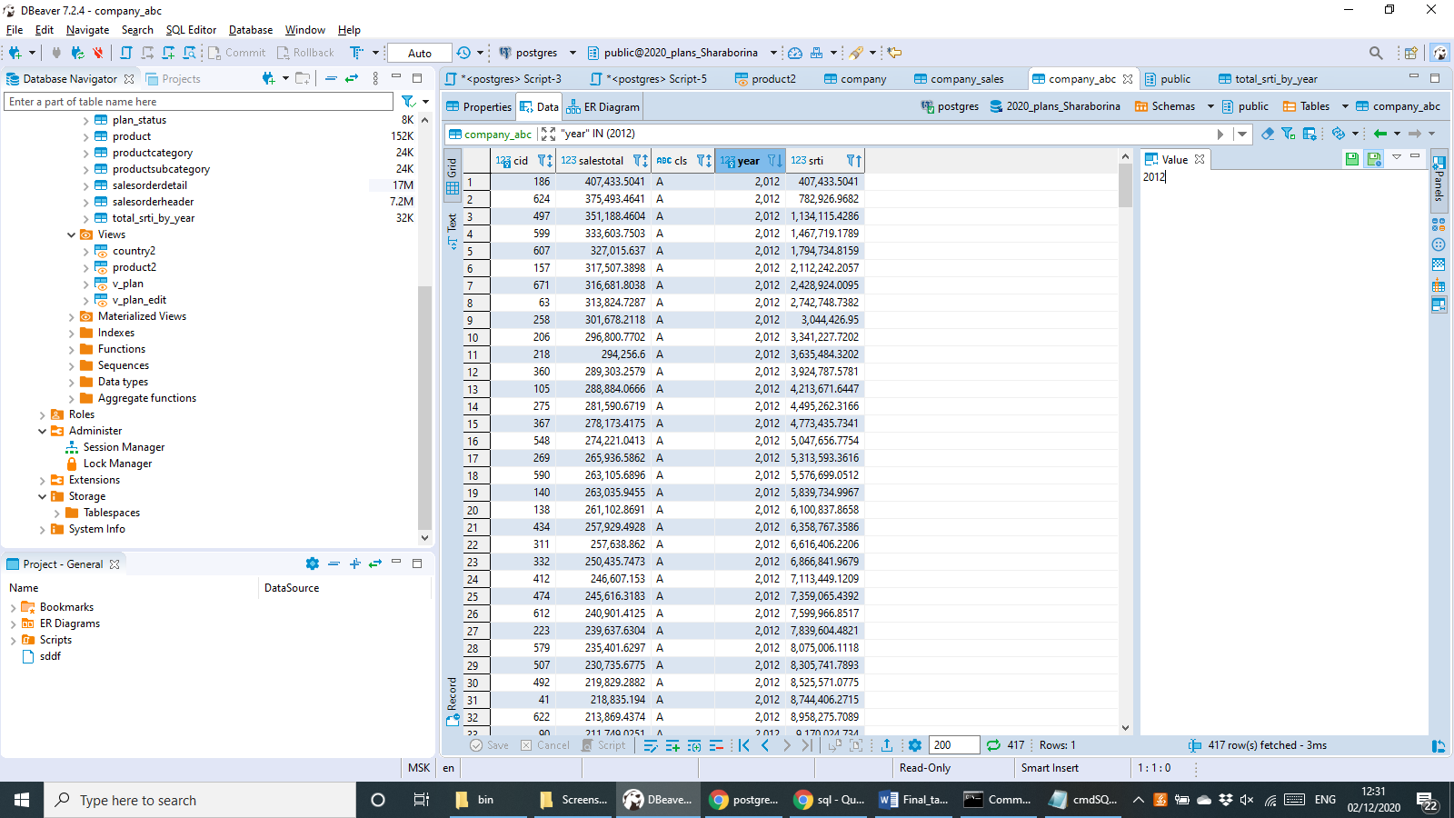

Task №5. Finding quarterly sales amount by company, product category and country

**insert** **into** company_sales (cid, salesamt, **year**, quarter_yr, qr, categoryid, ccls )

**select** company.id::**int**, **sum** (salesorderdetail.linetotal), **extract** (**year** **from** salesorderheader.orderdate)::**int** **as** myyear, **extract** (**quarter** **from** salesorderheader.orderdate)::**int** **as** myqr,

**extract** (**year** **from** salesorderheader.orderdate)::**text** || '.' || **extract** (**quarter** **from** salesorderheader.orderdate)::**text**, product2.pcid, company_abc.cls

**from** company

**inner** **join** customer **on** company.cname = customer.companyname

**inner** **join** salesorderheader **on** customer.customerid = salesorderheader.customerid

**inner** **join** salesorderdetail **on** salesorderheader.salesorderid = salesorderdetail.salesorderid

**inner** **join** product2 **on** salesorderdetail.productid = product2.productid

**inner** **join** company_abc **on** company.id = company_abc.cid **and** **extract** (**year** **from** salesorderheader.orderdate)::**int** = company_abc.**year**

**where** **extract**(**year** **from** salesorderheader.orderdate) = 2012

**or** **extract**(**year** **from** salesorderheader.orderdate) = 2013

**group** **by** 1,5,3,4,7, 6

Task №6. Initial data preparation

import psycopg2

from datetime import date

from typing import List

def start_planning(year, quarter, user, pwd):

con = psycopg2.connect(database='2020_plan_LSharaborina', user=user, port='5433', password=pwd, host='localhost')

cur = con.cursor()

cur.execute(""" DELETE

FROM plan_data p

WHERE p.quarterid = '%s.%s'

""", [year, quarter])

cur.execute(""" DELETE

FROM plan_status p

WHERE p.quarterid = '%s.%s'

""", [year, quarter])

cur.execute(""" INSERT into plan_status (quarterid, country, status, modifieddatetime, author)

SELECT '%s.%s', country2.countrycode, 'R', current_timestamp, %s

FROM country2

""", [year, quarter, user])

for status in ['N', 'P']:

cur.execute(""" INSERT into plan_data (versionid, country, quarterid, pcid, salesamt)

SELECT %s, country2.countrycode, '%s.%s', company_sales.categoryid, avg(COALESCE(company_sales.salesamt, 0))

FROM country2

INNER JOIN company on country2.countrycode = company.countrycode

INNER JOIN company_sales on company.id = company_sales.cid

where company_sales.qr = '%s.%s'

GROUP BY 2, 4

""", [status, year, quarter, year, quarter])

con.commit()

con.close()

start_planning(2014, 1, 'ivan', 'sql3')

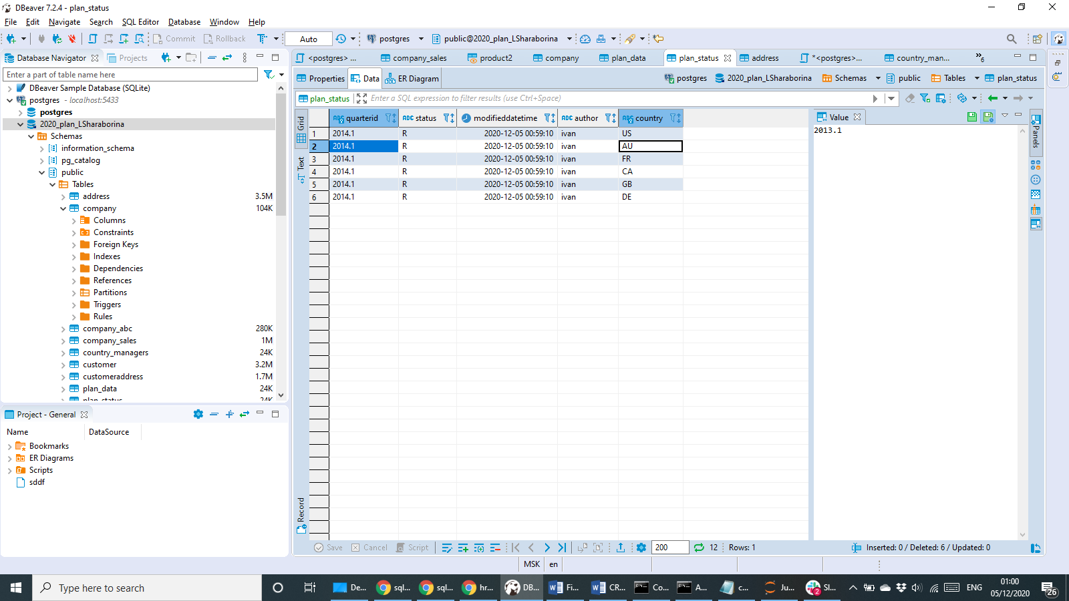

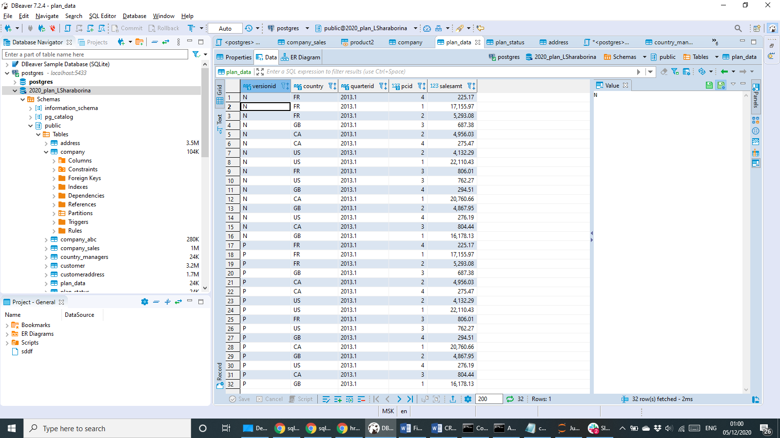

Task №7. Changing the plan data

def set_lock(year, quarter, user, pwd):

con = psycopg2.connect(database='2020_plan_LSharaborina', user=user, port='5433', password=pwd, host='localhost')

cur = con.cursor()

cur.execute("""WITH auc AS (

SELECT * FROM country_managers

WHERE country_managers.username = '%s'

)

UPDATE plan_status

SET status = 'L', modifieddatetime = current_timestamp, author = '%s'

FROM plan_status ps

inner join auc on auc.country = ps.country

where ps.quarterid = '%s.%s'

""", [user, user, year, quarter])

con.commit()

con.close()

def remove_lock(year, quarter, user, pwd):

con = psycopg2.connect(database='2020_plan_LSharaborina', user=user, port='5433', password=pwd, host='localhost')

cur = con.cursor()

cur.execute("""WITH auc AS (

SELECT * FROM country_managers

WHERE country_managers.username = '%s'

)

UPDATE plan_status

SET status = 'L', modifieddatetime = current_timestamp, author = '%s'

FROM plan_status ps

inner join auc on auc.country = ps.country

where ps.quarterid = '%s.%s'

""", [user, user, year, quarter])

con.commit()

con.close()

set_lock(2014, 1, 'sophie', 'sql2')