Written Report

# Analysis Summary

We have used a data of 15 schools in the district comprising of Government and Independent operations with a total student strength of 39,170. The total budget for the district is $24,649,428.00.

* The average math and reading scores amongst all schools are 70.34 and 69.98 respectively.
* 86.08% of students in the district passed math by obtaining a score of 50 or higher.
* 84.43% of students in the district passed reading by obtaining a score of 50 or higher.
* 72.81% of students in the district passed both math and reading by obtaining a score of 50 or higher in both the subjects.
* Spending range $585-$630 per student has the best overall passing record in percentage compared to higher or lower spending ranges. 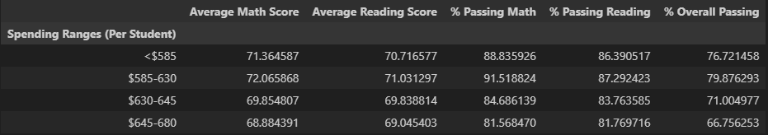

# Draws two correct conclusions or comparisons from the calculations.

1. Schools with less than a thousand students; has better overall passing percentage compared to medium and large schools. In other words, lesser the head count better the results.

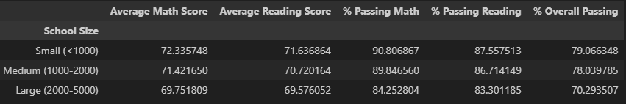

1. Independent Schools performance on overall passing is better than Government Schools.

