Written Report

Analysis Summary

We have used a data of 15 schools in the district comprising of Government and Independent operations with a total student strength of 39,170. The total budget for the district is $24,649,428.00.
- The average math and reading scores amongst all schools are 70.34 and 69.98 respectively.
- 86.08% of students in the district passed math by obtaining a score of 50 or higher.
- 84.43% of students in the district passed reading by obtaining a score of 50 or higher.
- 72.81% of students in the district passed both math and reading by obtaining a score of 50 or higher in both the subjects.
- Spending range $585-$630 per student has the best overall passing record in percentage compared to higher or lower spending ranges. 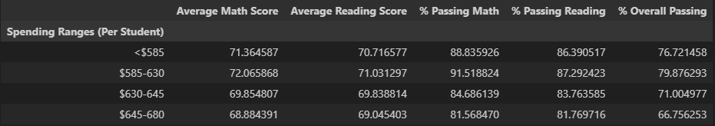

Draws two correct conclusions or comparisons from the calculations.

- Schools with less than a thousand students; has better overall passing percentage compared to medium and large schools. In other words, lesser the head count better the results.
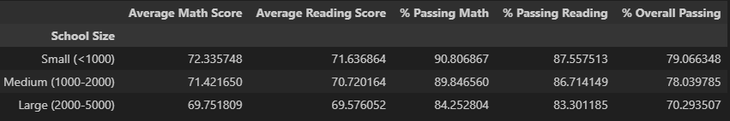

- Independent Schools performance on overall passing is better than Government Schools.
