AI Driven Full Stack Development (AI308B)
Moodle MSE2 Submission Format

Name | Sharad Krishna Singh
Branch | CSE AIML
Roll Number | 202401100400170
Section | C
Shift | EVENING
Case Study Name | Student Grievance Management System using MERN Stack

- GitHub Repository Link

- Render Deployment Links for all Routes
Backend Deployment Link | https://student-grievance-management-system-sqa1.onrender.com/
 | https://student-grievance-management-system-sqa1.onrender.com/
Auth Routes | POST https://student-grievance-management-system-sqa1.onrender.com/api/auth/register  POST https://student-grievance-management-system-sqa1.onrender.com/api/auth/login  GET https://student-grievance-management-system-sqa1.onrender.com/api/auth/me
Grievance Routes | POST https://student-grievance-management-system-sqa1.onrender.com/api/grievances  GET https://student-grievance-management-system-sqa1.onrender.com/api/grievances  GET https://student-grievance-management-system-sqa1.onrender.com/api/grievances?search=library  GET https://student-grievance-management-system-sqa1.onrender.com/api/grievances/GRIEVANCE_ID  PUT https://student-grievance-management-system-sqa1.onrender.com/api/grievances/GRIEVANCE_ID  DELETE https://student-grievance-management-system-sqa1.onrender.com/api/grievances/GRIEVANCE_ID
Frontend Deployment Link | https://student-grievance-management-system-xi.vercel.app/login
Register Page | https://student-grievance-management-system-xi.vercel.app/register
Dashboard Page | https://student-grievance-management-system-xi.vercel.app/dashboard
GitHub Repository | https://github.com/Sharad64e/student-grievance-management-system

- Project code
Backend Code(index.js, .git, .env,model.js etc..) which is used in the project development.
- Index.js

- .git

Frontend Code (App.jsx, main.jsx, Dashboard.jsx, Login.jsx, Register.jsx etc..) which are used in the project development.
- App.jsx

- Dashboard.jsx

- Login.jsx

- Screenshots of Login, Register, Dashboard and All Functional Modules

- Screenshot of VS Code Project Structure.

Filled Project Details
Name: Sharad Krishna Singh
Branch: CSE AIML
Roll Number: 202401100400170
Section: C
Case Study Name: Student Grievance Management System using MERN Stack
GitHub Repository Link: https://github.com/Sharad64e/student-grievance-management-system
Backend Render Deployment Link: https://student-grievance-management-system-sqa1.onrender.com/
Frontend Vercel Deployment Link: https://student-grievance-management-system-xi.vercel.app/login
Backend Routes for Live Testing
GET https://student-grievance-management-system-sqa1.onrender.com/
POST https://student-grievance-management-system-sqa1.onrender.com/api/auth/register
POST https://student-grievance-management-system-sqa1.onrender.com/api/auth/login
GET https://student-grievance-management-system-sqa1.onrender.com/api/auth/me
POST https://student-grievance-management-system-sqa1.onrender.com/api/grievances
GET https://student-grievance-management-system-sqa1.onrender.com/api/grievances
GET https://student-grievance-management-system-sqa1.onrender.com/api/grievances?search=library
GET https://student-grievance-management-system-sqa1.onrender.com/api/grievances/GRIEVANCE_ID
PUT https://student-grievance-management-system-sqa1.onrender.com/api/grievances/GRIEVANCE_ID
DELETE https://student-grievance-management-system-sqa1.onrender.com/api/grievances/GRIEVANCE_ID
Protected routes require header:
Authorization: Bearer YOUR_TOKEN
Project Features
? Student registration and login
? JWT based authentication
? Protected dashboard route
? Submit grievance form
? Display all grievances of logged-in student
? Search grievances
? Update and delete grievance
? Logout functionality
? Error handling for invalid login, duplicate email, and unauthorized access
? MongoDB Atlas storage for users and grievances
Project Code
Backend: server/src/server.js
import dotenv from 'dotenv';
import app from './app.js';
import connectDB from './config/db.js';
dotenv.config();
const PORT = process.env.PORT || 5000;
connectDB()
.then(() => {
app.listen(PORT, () => {
console.log(`Server running on port ${PORT}`);
});
})
.catch((error) => {
console.error('Failed to connect to MongoDB:', error.message);
process.exit(1);
});
Backend: server/src/app.js
import express from 'express';
import cors from 'cors';
import authRoutes from './routes/authRoutes.js';
import grievanceRoutes from './routes/grievanceRoutes.js';
import { errorHandler, notFound } from './middleware/errorMiddleware.js';
const app = express();
const allowedOrigins = [
process.env.CLIENT_URL,
'http://localhost:5173',
'http://127.0.0.1:5173'
].filter(Boolean);
app.use(cors({
origin(origin, callback) {
if (!origin || allowedOrigins.includes(origin)) {
callback(null, true);
return;
}
callback(new Error('Not allowed by CORS'));
},
credentials: true
}));
app.use(express.json());
app.get('/', (req, res) => {
res.json({ message: 'Student Grievance Management API is running' });
});
app.use('/api/auth', authRoutes);
app.use('/api/grievances', grievanceRoutes);
app.use(notFound);
app.use(errorHandler);
export default app;
Backend: server/src/config/db.js
import mongoose from 'mongoose';
const connectDB = async () => {
const mongoUri = process.env.MONGO_URI;
if (!mongoUri) {
throw new Error('MONGO_URI is missing in environment variables');
}
await mongoose.connect(mongoUri);
console.log('MongoDB connected');
};
export default connectDB;
Backend: server/src/models/User.js
import mongoose from 'mongoose';
import bcrypt from 'bcryptjs';
const userSchema = new mongoose.Schema(
{
name: {
type: String,
required: [true, 'Name is required'],
trim: true
},
email: {
type: String,
required: [true, 'Email is required'],
unique: true,
trim: true,
lowercase: true
},
password: {
type: String,
required: [true, 'Password is required'],
minlength: 6
}
},
{ timestamps: true }
);
userSchema.pre('save', async function hashPassword(next) {
if (!this.isModified('password')) {
next();
return;
}
const salt = await bcrypt.genSalt(10);
this.password = await bcrypt.hash(this.password, salt);
next();
});
userSchema.methods.matchPassword = function matchPassword(enteredPassword) {
return bcrypt.compare(enteredPassword, this.password);
};
const User = mongoose.model('User', userSchema);
export default User;
Backend: server/src/models/Grievance.js
import mongoose from 'mongoose';
const grievanceSchema = new mongoose.Schema(
{
student: {
type: mongoose.Schema.Types.ObjectId,
ref: 'User',
required: true
},
title: {
type: String,
required: [true, 'Title is required'],
trim: true
},
category: {
type: String,
required: [true, 'Category is required'],
enum: ['Academics', 'Facilities', 'Administration', 'Other']
},
description: {
type: String,
required: [true, 'Description is required'],
trim: true
},
status: {
type: String,
enum: ['Pending', 'In Review', 'Resolved'],
default: 'Pending'
}
},
{ timestamps: true }
);
const Grievance = mongoose.model('Grievance', grievanceSchema);
export default Grievance;
Backend: server/src/controllers/authController.js
import User from '../models/User.js';
import generateToken from '../utils/generateToken.js';
export const registerUser = async (req, res, next) => {
try {
const { name, email, password } = req.body;
if (!name || !email || !password) {
res.status(400);
throw new Error('Name, email, and password are required.');
}
const existingUser = await User.findOne({ email });
if (existingUser) {
res.status(409);
throw new Error('Email already registered. Please use another email.');
}
const user = await User.create({ name, email, password });
res.status(201).json({
token: generateToken(user._id),
user: {
id: user._id,
name: user.name,
email: user.email
}
});
} catch (error) {
next(error);
}
};
export const loginUser = async (req, res, next) => {
try {
const { email, password } = req.body;
if (!email || !password) {
res.status(400);
throw new Error('Email and password are required.');
}
const user = await User.findOne({ email });
const passwordMatches = user ? await user.matchPassword(password) : false;
if (!user || !passwordMatches) {
res.status(401);
throw new Error('Invalid login. Please check your email and password.');
}
res.json({
token: generateToken(user._id),
user: {
id: user._id,
name: user.name,
email: user.email
}
});
} catch (error) {
next(error);
}
};
export const getMe = (req, res) => {
res.json({ user: req.user });
};
Backend: server/src/controllers/grievanceController.js
import Grievance from '../models/Grievance.js';
export const createGrievance = async (req, res, next) => {
try {
const { title, category, description } = req.body;
if (!title || !category || !description) {
res.status(400);
throw new Error('Title, category, and description are required.');
}
const grievance = await Grievance.create({
student: req.user._id,
title,
category,
description
});
res.status(201).json(grievance);
} catch (error) {
next(error);
}
};
export const getGrievances = async (req, res, next) => {
try {
const search = req.query.search?.trim();
const query = { student: req.user._id };
if (search) {
query.$or = [
{ title: { $regex: search, $options: 'i' } },
{ category: { $regex: search, $options: 'i' } },
{ description: { $regex: search, $options: 'i' } },
{ status: { $regex: search, $options: 'i' } }
];
}
const grievances = await Grievance.find(query).sort({ createdAt: -1 });
res.json(grievances);
} catch (error) {
next(error);
}
};
export const getGrievanceById = async (req, res, next) => {
try {
const grievance = await Grievance.findOne({
_id: req.params.id,
student: req.user._id
});
if (!grievance) {
res.status(404);
throw new Error('Grievance not found.');
}
res.json(grievance);
} catch (error) {
next(error);
}
};
export const updateGrievance = async (req, res, next) => {
try {
const grievance = await Grievance.findOne({
_id: req.params.id,
student: req.user._id
});
if (!grievance) {
res.status(404);
throw new Error('Grievance not found or unauthorized access.');
}
grievance.title = req.body.title ?? grievance.title;
grievance.category = req.body.category ?? grievance.category;
grievance.description = req.body.description ?? grievance.description;
grievance.status = req.body.status ?? grievance.status;
const updatedGrievance = await grievance.save();
res.json(updatedGrievance);
} catch (error) {
next(error);
}
};
export const deleteGrievance = async (req, res, next) => {
try {
const grievance = await Grievance.findOne({
_id: req.params.id,
student: req.user._id
});
if (!grievance) {
res.status(404);
throw new Error('Grievance not found or unauthorized access.');
}
await grievance.deleteOne();
res.json({ message: 'Grievance deleted successfully.' });
} catch (error) {
next(error);
}
};
Backend: server/src/middleware/authMiddleware.js
import jwt from 'jsonwebtoken';
import User from '../models/User.js';
export const protect = async (req, res, next) => {
const authHeader = req.headers.authorization;
if (!authHeader || !authHeader.startsWith('Bearer ')) {
res.status(401);
next(new Error('Unauthorized access. Please login first.'));
return;
}
try {
const token = authHeader.split(' ')[1];
const decoded = jwt.verify(token, process.env.JWT_SECRET);
req.user = await User.findById(decoded.id).select('-password');
if (!req.user) {
res.status(401);
next(new Error('Unauthorized access. User no longer exists.'));
return;
}
next();
} catch {
res.status(401);
next(new Error('Unauthorized access. Invalid or expired token.'));
}
};
Backend: server/src/middleware/errorMiddleware.js
export const notFound = (req, res, next) => {
res.status(404);
next(new Error(`Route not found: ${req.originalUrl}`));
};
export const errorHandler = (err, req, res, next) => {
let statusCode = res.statusCode === 200 ? 500 : res.statusCode;
let message = err.message || 'Server error';
if (err.name === 'ValidationError') {
statusCode = 400;
message = Object.values(err.errors).map((item) => item.message).join(', ');
}
if (err.code === 11000) {
statusCode = 409;
message = 'Email already registered. Please use another email.';
}
res.status(statusCode).json({
message,
stack: process.env.NODE_ENV === 'production' ? undefined : err.stack
});
};
Backend: server/src/routes/authRoutes.js
import express from 'express';
import { getMe, loginUser, registerUser } from '../controllers/authController.js';
import { protect } from '../middleware/authMiddleware.js';
const router = express.Router();
router.post('/register', registerUser);
router.post('/login', loginUser);
router.get('/me', protect, getMe);
export default router;
Backend: server/src/routes/grievanceRoutes.js
import express from 'express';
import {
createGrievance,
deleteGrievance,
getGrievanceById,
getGrievances,
updateGrievance
} from '../controllers/grievanceController.js';
import { protect } from '../middleware/authMiddleware.js';
const router = express.Router();
router.use(protect);
router.route('/')
.post(createGrievance)
.get(getGrievances);
router.route('/:id')
.get(getGrievanceById)
.put(updateGrievance)
.delete(deleteGrievance);
export default router;
Frontend: client/src/App.jsx
import React from 'react';
import { Navigate, Route, Routes } from 'react-router-dom';
import ProtectedRoute from './components/ProtectedRoute.jsx';
import Dashboard from './pages/Dashboard.jsx';
import Login from './pages/Login.jsx';
import Register from './pages/Register.jsx';
import { useAuth } from './context/AuthContext.jsx';
const App = () => {
const { isAuthenticated } = useAuth();
return (
<Routes>
<Route path="/" element={<Navigate to={isAuthenticated ? '/dashboard' : '/login'} replace />} />
<Route path="/register" element={<Register />} />
<Route path="/login" element={<Login />} />
<Route element={<ProtectedRoute />}>
<Route path="/dashboard" element={<Dashboard />} />
</Route>
<Route path="*" element={<Navigate to="/dashboard" replace />} />
</Routes>
);
};
export default App;
Frontend: client/src/main.jsx
import React from 'react';
import { createRoot } from 'react-dom/client';
import { BrowserRouter } from 'react-router-dom';
import App from './App.jsx';
import { AuthProvider } from './context/AuthContext.jsx';
import './styles.css';
createRoot(document.getElementById('root')).render(
<React.StrictMode>
<BrowserRouter>
<AuthProvider>
<App />
</AuthProvider>
</BrowserRouter>
</React.StrictMode>
);
Frontend: client/src/api/axios.js
import axios from 'axios';
const api = axios.create({
baseURL: import.meta.env.VITE_API_URL || 'http://localhost:5000/api'
});
api.interceptors.request.use((config) => {
const token = localStorage.getItem('token');
if (token) {
config.headers.Authorization = `Bearer ${token}`;
}
return config;
});
export default api;
Frontend: client/src/context/AuthContext.jsx
import React, { createContext, useContext, useMemo, useState } from 'react';
import api from '../api/axios.js';
const AuthContext = createContext(null);
const storedUser = () => {
const value = localStorage.getItem('user');
if (!value) return null;
try {
return JSON.parse(value);
} catch {
localStorage.removeItem('user');
localStorage.removeItem('token');
return null;
}
};
export const AuthProvider = ({ children }) => {
const [user, setUser] = useState(storedUser);
const [token, setToken] = useState(localStorage.getItem('token'));
const saveSession = (data) => {
localStorage.setItem('token', data.token);
localStorage.setItem('user', JSON.stringify(data.user));
setToken(data.token);
setUser(data.user);
};
const register = async (formData) => {
const { data } = await api.post('/auth/register', formData);
saveSession(data);
};
const login = async (formData) => {
const { data } = await api.post('/auth/login', formData);
saveSession(data);
};
const logout = () => {
localStorage.removeItem('token');
localStorage.removeItem('user');
setToken(null);
setUser(null);
};
const value = useMemo(
() => ({
user,
token,
isAuthenticated: Boolean(token),
register,
login,
logout
}),
[user, token]
);
return <AuthContext.Provider value={value}>{children}</AuthContext.Provider>;
};
export const useAuth = () => useContext(AuthContext);
Frontend: client/src/components/ProtectedRoute.jsx
import React from 'react';
import { Navigate, Outlet } from 'react-router-dom';
import { useAuth } from '../context/AuthContext.jsx';
const ProtectedRoute = () => {
const { isAuthenticated } = useAuth();
return isAuthenticated ? <Outlet /> : <Navigate to="/login" replace />;
};
export default ProtectedRoute;
Frontend: client/src/pages/Register.jsx
import React, { useState } from 'react';
import { Link, useNavigate } from 'react-router-dom';
import { useAuth } from '../context/AuthContext.jsx';
const Register = () => {
const navigate = useNavigate();
const { register } = useAuth();
const [form, setForm] = useState({ name: '', email: '', password: '' });
const [error, setError] = useState('');
const [loading, setLoading] = useState(false);
const handleChange = (event) => {
setForm({ ...form, [event.target.name]: event.target.value });
};
const handleSubmit = async (event) => {
event.preventDefault();
setError('');
setLoading(true);
try {
await register(form);
navigate('/dashboard');
} catch (err) {
setError(err.response?.data?.message || 'Registration failed.');
} finally {
setLoading(false);
}
};
return (
<main className="auth-page">
<section className="auth-panel">
<div className="brand-mark">
SG
</div>
<h1>Create Student Account</h1>
<p>Register to submit and track your college grievances.</p>
<form onSubmit={handleSubmit} className="auth-form">
{error && <div className="alert error">{error}</div>}
<label>
Full name
<input name="name" value={form.name} onChange={handleChange} required />
</label>
<label>
Email
<input name="email" type="email" value={form.email} onChange={handleChange} required />
</label>
<label>
Password
<input
name="password"
type="password"
minLength="6"
value={form.password}
onChange={handleChange}
required
/>
</label>
<button type="submit" disabled={loading}>
{loading ? 'Creating...' : 'Register'}
</button>
</form>
<p className="switch-link">
Already have an account? <Link to="/login">Login</Link>
</p>
</section>
</main>
);
};
export default Register;
Frontend: client/src/pages/Login.jsx
import React, { useState } from 'react';
import { Link, useNavigate } from 'react-router-dom';
import { useAuth } from '../context/AuthContext.jsx';
const Login = () => {
const navigate = useNavigate();
const { login } = useAuth();
const [form, setForm] = useState({ email: '', password: '' });
const [error, setError] = useState('');
const [loading, setLoading] = useState(false);
const handleChange = (event) => {
setForm({ ...form, [event.target.name]: event.target.value });
};
const handleSubmit = async (event) => {
event.preventDefault();
setError('');
setLoading(true);
try {
await login(form);
navigate('/dashboard');
} catch (err) {
setError(err.response?.data?.message || 'Invalid login.');
} finally {
setLoading(false);
}
};
return (
<main className="auth-page">
<section className="auth-panel">
<div className="brand-mark">
SG
</div>
<h1>Student Login</h1>
<p>Login to manage your submitted grievances.</p>
<form onSubmit={handleSubmit} className="auth-form">
{error && <div className="alert error">{error}</div>}
<label>
Email
<input name="email" type="email" value={form.email} onChange={handleChange} required />
</label>
<label>
Password
<input name="password" type="password" value={form.password} onChange={handleChange} required />
</label>
<button type="submit" disabled={loading}>
{loading ? 'Checking...' : 'Login'}
</button>
</form>
<p className="switch-link">
New student? <Link to="/register">Create account</Link>
</p>
</section>
</main>
);
};
export default Login;
Frontend: client/src/pages/Dashboard.jsx
import React, { useEffect, useMemo, useState } from 'react';
import { LogOut, Pencil, Search, Send, Trash2, X } from 'lucide-react';
import api from '../api/axios.js';
import { useAuth } from '../context/AuthContext.jsx';
const emptyForm = {
title: '',
category: 'Academics',
description: '',
status: 'Pending'
};
const categories = ['Academics', 'Facilities', 'Administration', 'Other'];
const statuses = ['Pending', 'In Review', 'Resolved'];
const Dashboard = () => {
const { user, logout } = useAuth();
const [form, setForm] = useState(emptyForm);
const [grievances, setGrievances] = useState([]);
const [search, setSearch] = useState('');
const [editingId, setEditingId] = useState(null);
const [message, setMessage] = useState('');
const [error, setError] = useState('');
const [loading, setLoading] = useState(true);
const [saving, setSaving] = useState(false);
const stats = useMemo(() => {
return statuses.map((status) => ({
status,
count: grievances.filter((item) => item.status === status).length
}));
}, [grievances]);
const fetchGrievances = async (keyword = '') => {
setLoading(true);
setError('');
try {
const { data } = await api.get('/grievances', {
params: keyword ? { search: keyword } : {}
});
setGrievances(data);
} catch (err) {
setError(err.response?.data?.message || 'Unable to load grievances.');
} finally {
setLoading(false);
}
};
useEffect(() => {
fetchGrievances();
}, []);
const handleChange = (event) => {
setForm({ ...form, [event.target.name]: event.target.value });
};
const resetForm = () => {
setForm(emptyForm);
setEditingId(null);
};
const handleSubmit = async (event) => {
event.preventDefault();
setSaving(true);
setError('');
setMessage('');
try {
if (editingId) {
await api.put(`/grievances/${editingId}`, form);
setMessage('Grievance updated successfully.');
} else {
await api.post('/grievances', {
title: form.title,
category: form.category,
description: form.description
});
setMessage('Grievance submitted successfully.');
}
resetForm();
await fetchGrievances(search);
} catch (err) {
setError(err.response?.data?.message || 'Unable to save grievance.');
} finally {
setSaving(false);
}
};
const startEdit = (grievance) => {
setEditingId(grievance._id);
setForm({
title: grievance.title,
category: grievance.category,
description: grievance.description,
status: grievance.status
});
window.scrollTo({ top: 0, behavior: 'smooth' });
};
const deleteGrievance = async (id) => {
const confirmed = window.confirm('Delete this grievance?');
if (!confirmed) return;
setError('');
setMessage('');
try {
await api.delete(`/grievances/${id}`);
setMessage('Grievance deleted successfully.');
await fetchGrievances(search);
} catch (err) {
setError(err.response?.data?.message || 'Unable to delete grievance.');
}
};
const submitSearch = (event) => {
event.preventDefault();
fetchGrievances(search);
};
return (
<main className="dashboard-page">
<header className="topbar">
<div>
<p className="eyebrow">Student Grievance Management System</p>
<h1>Welcome, {user?.name}</h1>
</div>
<button className="ghost-button" onClick={logout} type="button">
<LogOut size={18} />
Logout
</button>
</header>
<section className="stats-row">
{stats.map((item) => (
<div className="stat-box" key={item.status}>
<span>{item.status}</span>
<strong>{item.count}</strong>
</div>
))}
</section>
<section className="dashboard-grid">
<form className="grievance-form" onSubmit={handleSubmit}>
<div className="section-heading">
<h2>{editingId ? 'Update Grievance' : 'Submit Grievance'}</h2>
{editingId && (
<button className="icon-button" onClick={resetForm} type="button" title="Cancel edit">
<X size={18} />
</button>
)}
</div>
{message && <div className="alert success">{message}</div>}
{error && <div className="alert error">{error}</div>}
<label>
Title
<input name="title" value={form.title} onChange={handleChange} required />
</label>
<label>
Category
<select name="category" value={form.category} onChange={handleChange} required>
{categories.map((category) => (
<option key={category}>{category}</option>
))}
</select>
</label>
{editingId && (
<label>
Status
<select name="status" value={form.status} onChange={handleChange} required>
{statuses.map((status) => (
<option key={status}>{status}</option>
))}
</select>
</label>
)}
<label>
Description
<textarea name="description" rows="7" value={form.description} onChange={handleChange} required />
</label>
<button type="submit" disabled={saving}>
<Send size={18} />
{saving ? 'Saving...' : editingId ? 'Update' : 'Submit'}
</button>
</form>
<section className="list-panel">
<div className="section-heading">
<h2>My Grievances</h2>
</div>
<form className="search-box" onSubmit={submitSearch}>
<Search size={18} />
<input
value={search}
onChange={(event) => setSearch(event.target.value)}
placeholder="Search by title, category, status..."
/>
<button type="submit">Search</button>
</form>
<div className="grievance-list">
{loading && <p className="muted">Loading grievances...</p>}
{!loading && grievances.length === 0 && <p className="muted">No grievances found.</p>}
{grievances.map((grievance) => (
<article className="grievance-card" key={grievance._id}>
<div>
<div className="card-top">
<h3>{grievance.title}</h3>
<span className={`status status-${grievance.status.toLowerCase().replaceAll(' ', '-')}`}>
{grievance.status}
</span>
</div>
<p>{grievance.description}</p>
<div className="meta">
<span>{grievance.category}</span>
<span>{new Date(grievance.createdAt).toLocaleDateString()}</span>
</div>
</div>
<div className="card-actions">
<button className="icon-button" onClick={() => startEdit(grievance)} type="button" title="Edit">
<Pencil size={17} />
</button>
<button
className="icon-button danger"
onClick={() => deleteGrievance(grievance._id)}
type="button"
title="Delete"
>
<Trash2 size={17} />
</button>
</div>
</article>
))}
</div>
</section>
</section>
</main>
);
};
export default Dashboard;
Screenshots To Upload/Paste
Registration Page
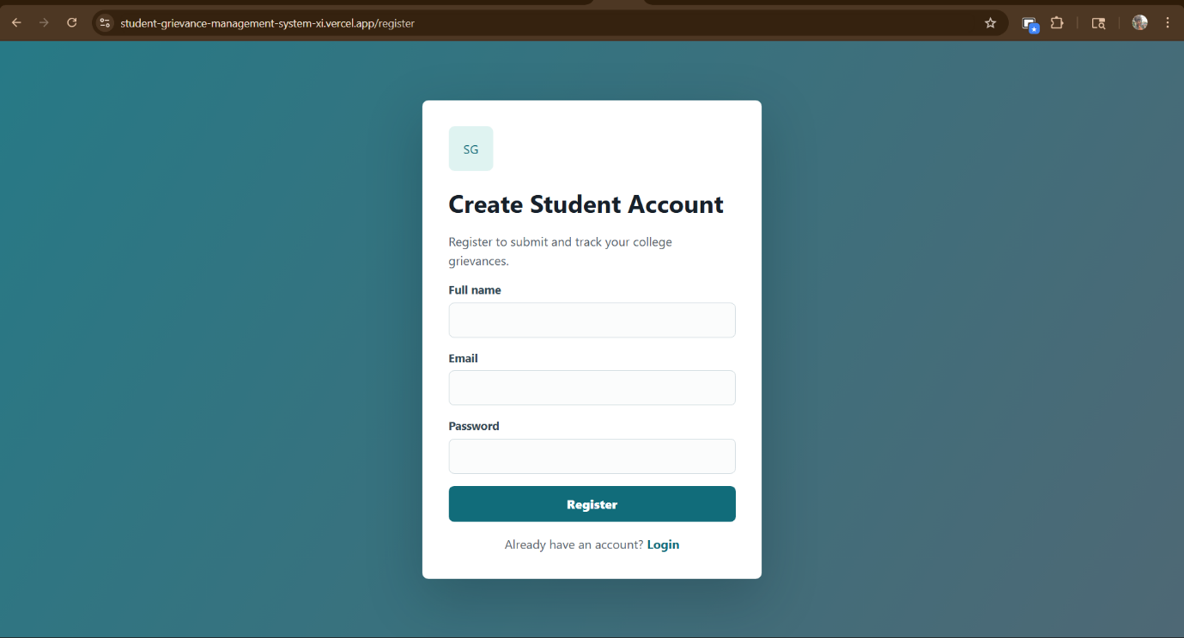
Login Page
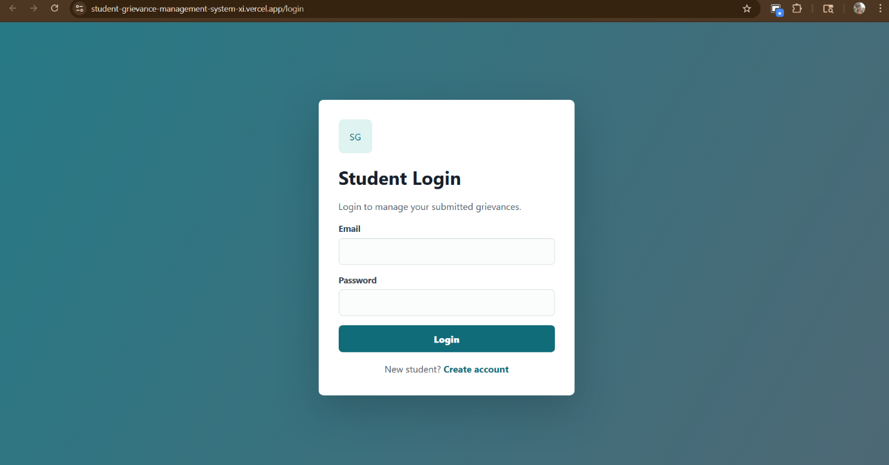
Dashboard
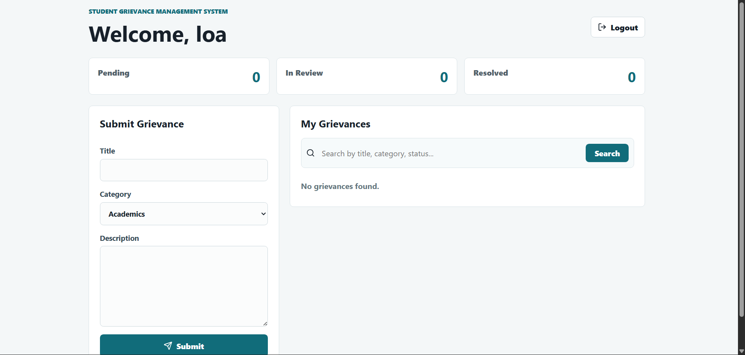
Submit Grievance
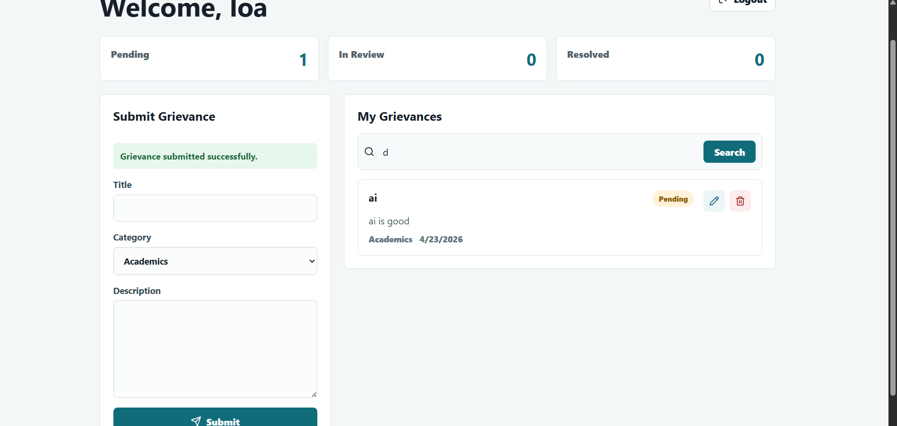
Display All Grievances
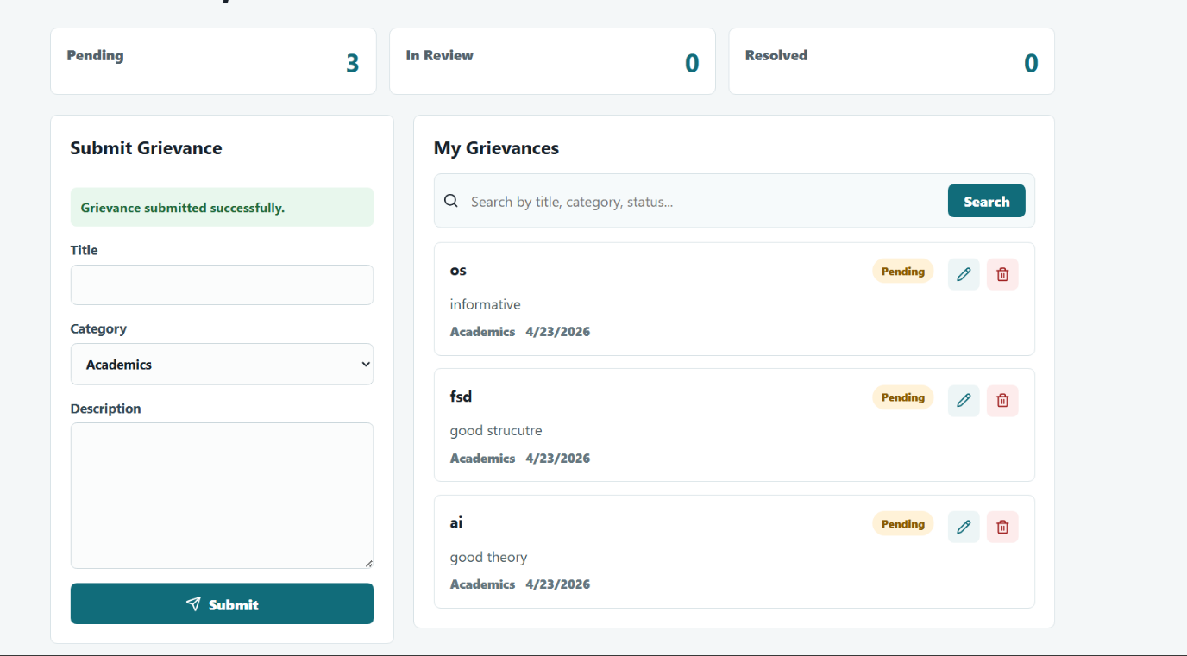
Search Grievance
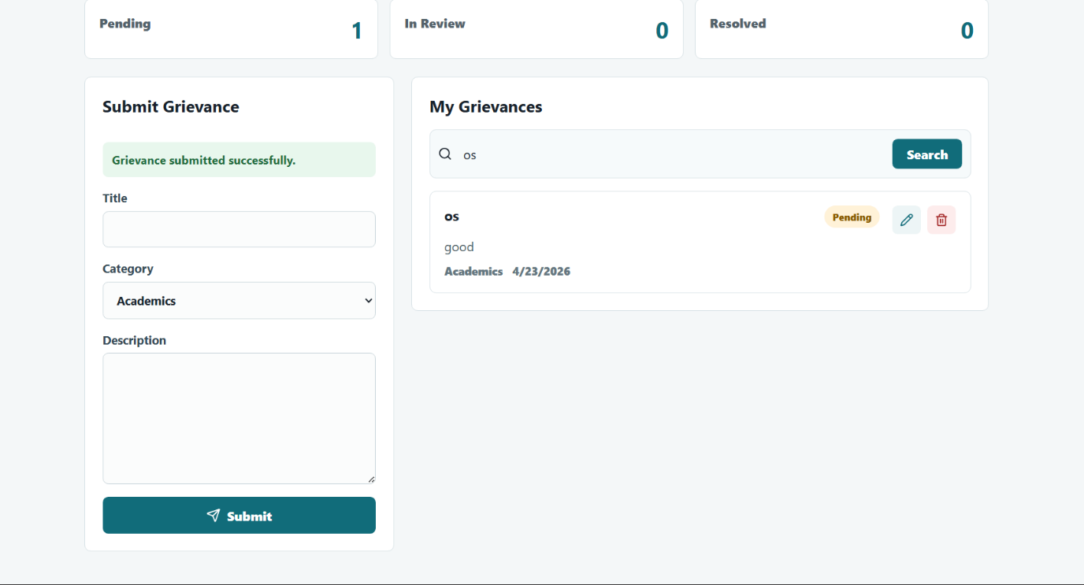
Update Grievance
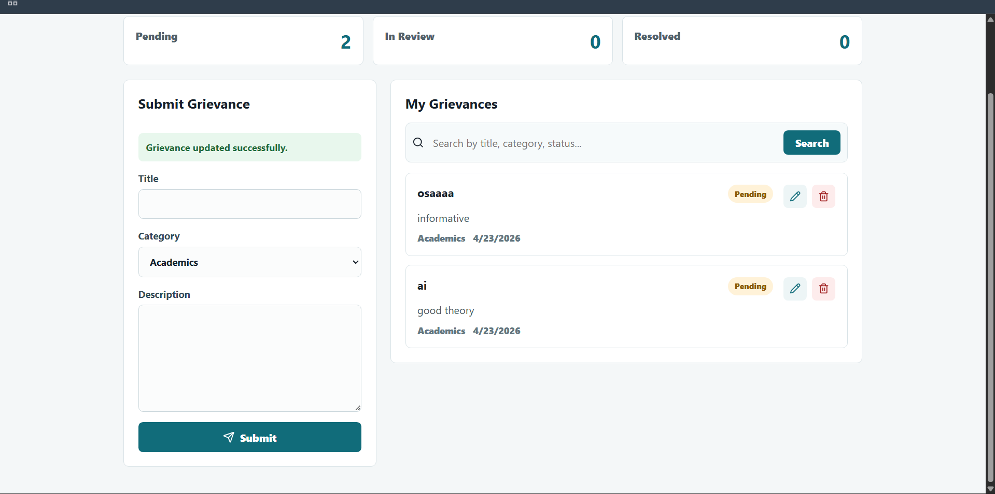
Delete Grievance
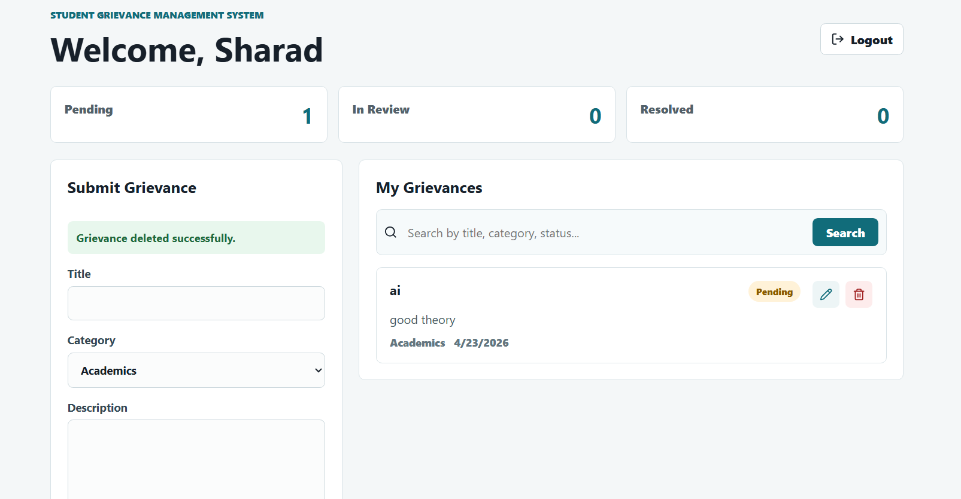
Invalid Login Error
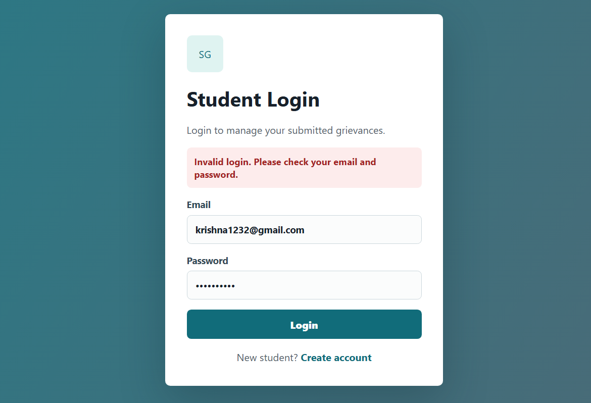
Duplicate Email Error
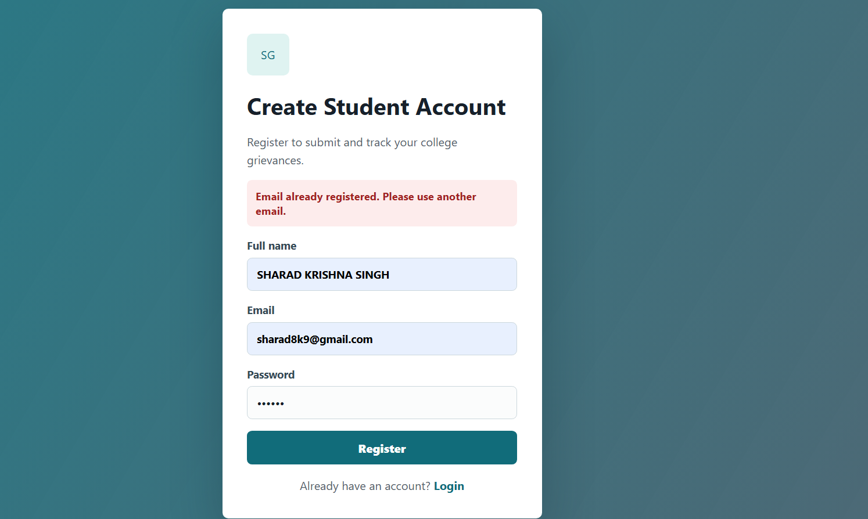
Postman/Thunder Client Register API Request
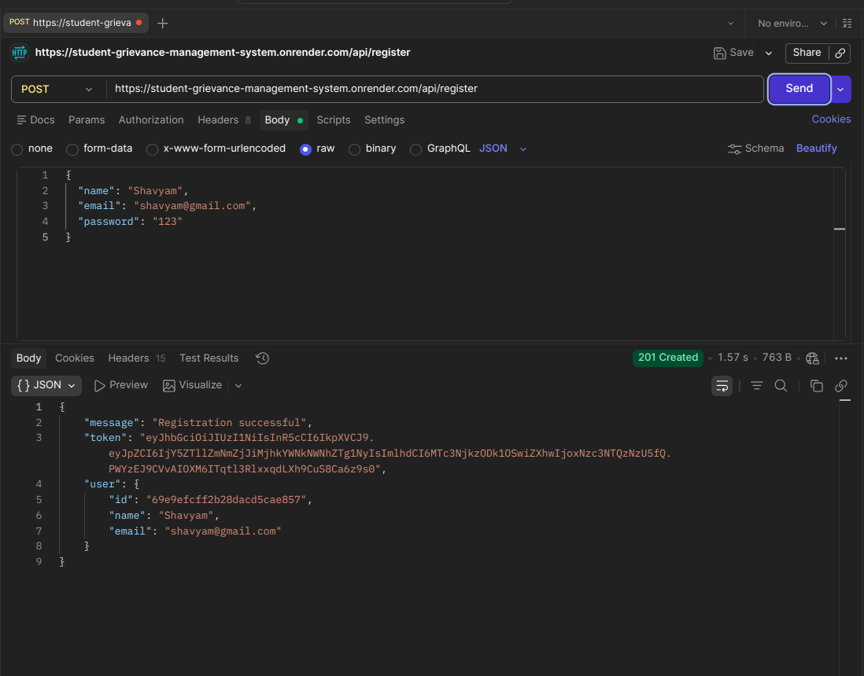
Postman/Thunder Client Login API Request
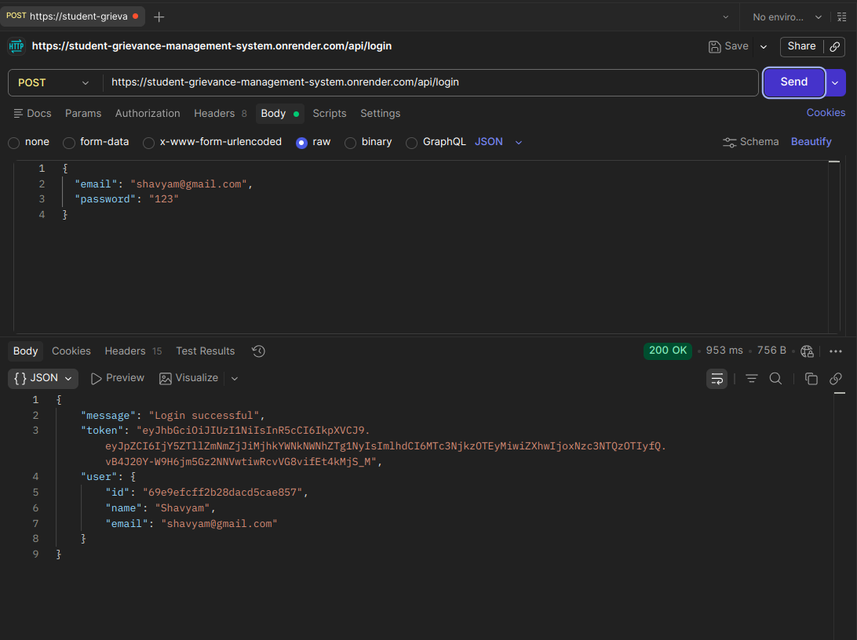
Postman/Thunder Client Create Grievance Request
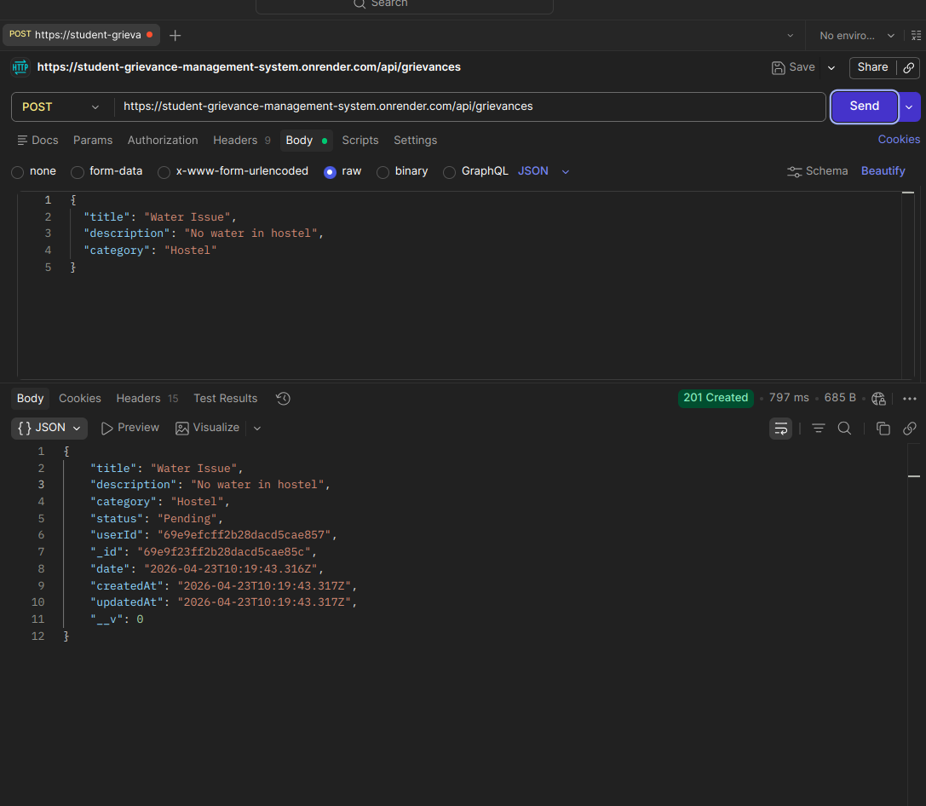
Postman/Thunder Client Get Grievances Request

Postman/Thunder Client Update Grievance Request
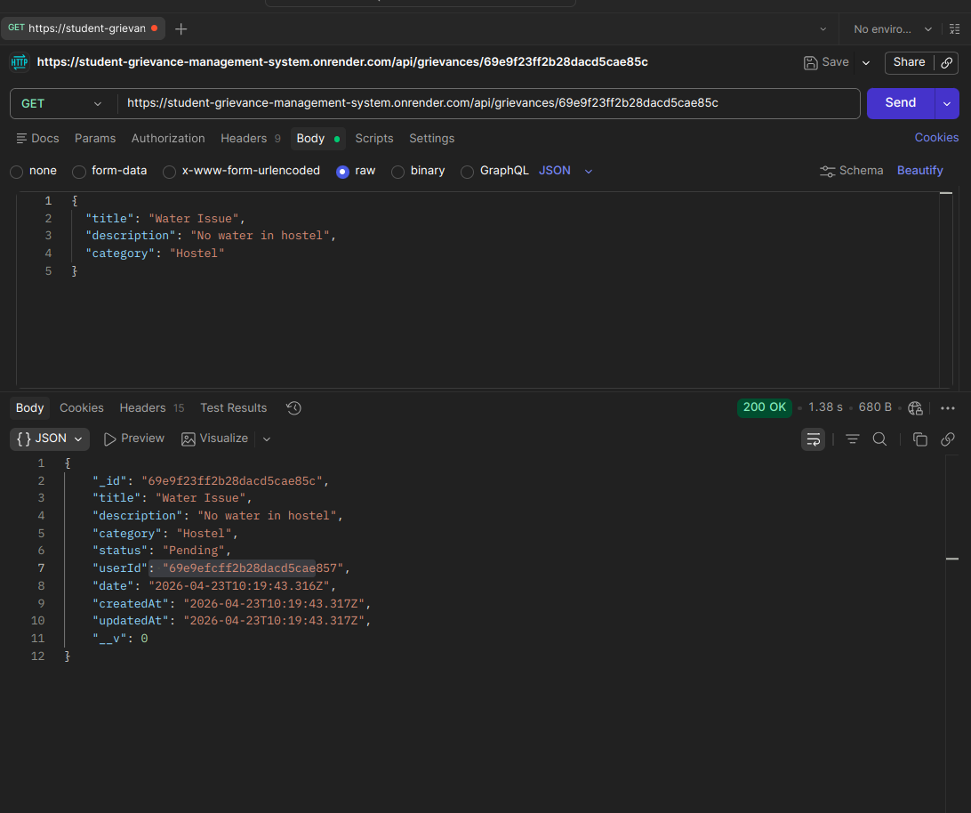
Postman/Thunder Client Delete Grievance Request

Unauthorized Access API Test

MongoDB Users Collection
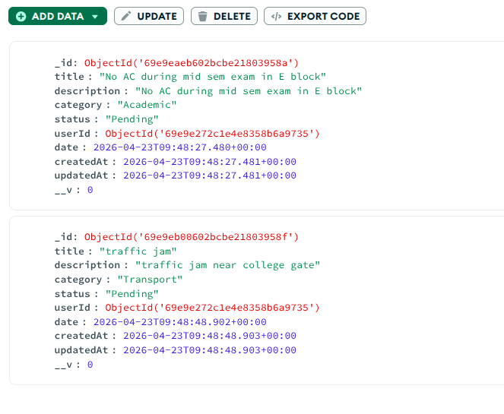
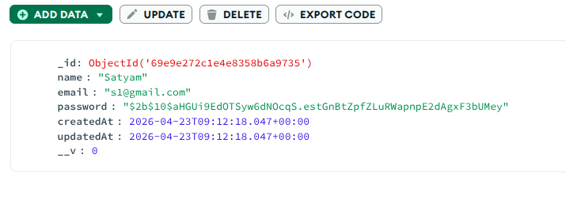
MongoDB Grievances Collection
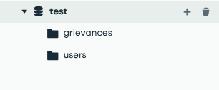
Render Backend Deployment Successful
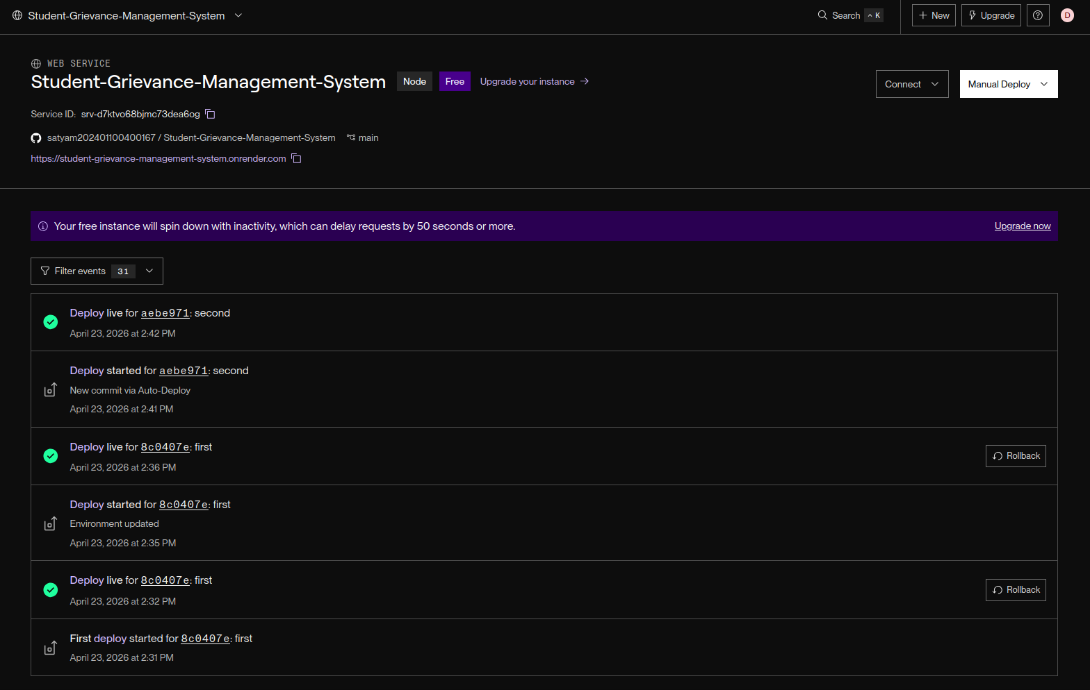
Vercel Frontend Deployment Successful
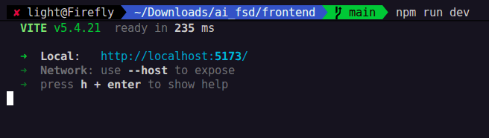
Render Live Backend Route Testing
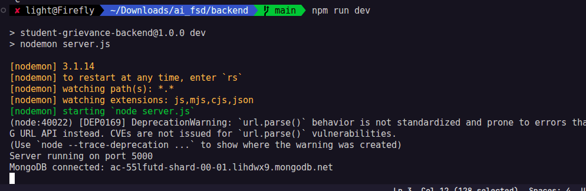
Vercel Live Frontend Testing

VS Code Project Structure
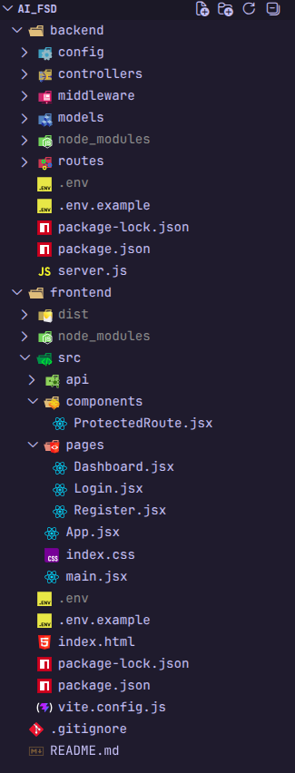
Conclusion
The Student Grievance Management System was developed using the MERN stack. It allows students to register, login, submit grievances, search their complaints, update or delete grievances, and logout. The backend was deployed on Render and the frontend was deployed on Vercel. MongoDB Atlas was used for database storage.

