SonarQube Setup

- Go to https://binaries.sonarsource.com/Distribution/sonarqube/sonarqube-7.8.zip to download the zip file and extract to the specified folder(Preferrable C:// drive).
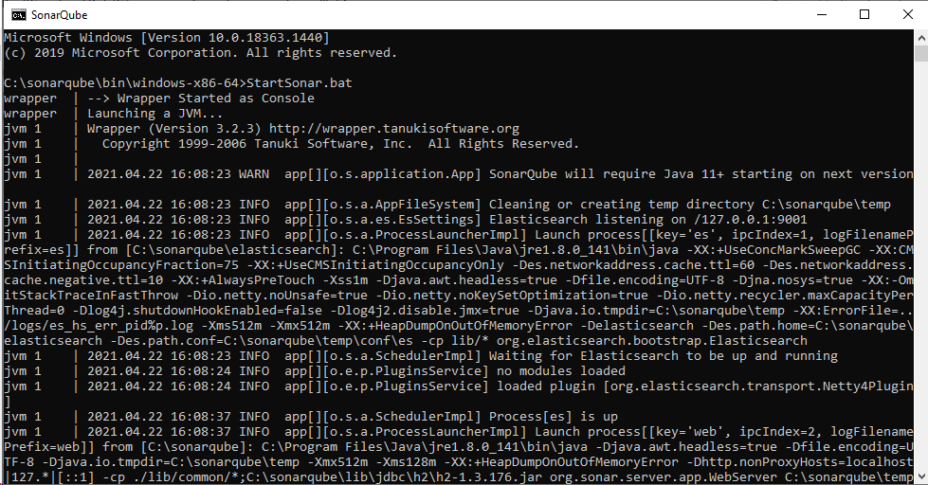
- Open Command Prompt in \bin\windows-x86-64 and run StartSonar.bat to start the SonarQube Server.

- If the server starts successfully, then proceed to next step. If the server is not started, this means that the default port 9000 is already in use. Change the port by changing the configuration in sonar.properties file in \conf path. Add the “sonar.web.port=9300” at end of the file.

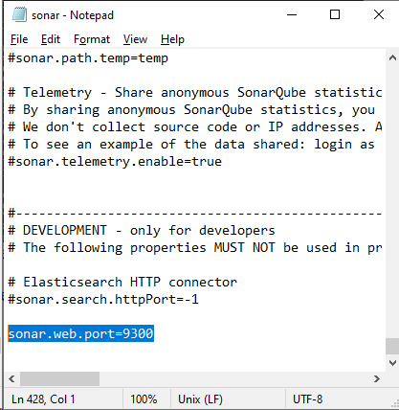
- Go to Eclipse IDE and open an Existing Maven Project and add the following configuration to the pom.xml

<profiles>
<profile>
<id>sonar</id>
<activation>
<activeByDefault>true</activeByDefault>
</activation>
<properties>
<!-- Optional URL to server. Default value is http://localhost:9000 -->
<sonar.host.url>
http://localhost:9300
</sonar.host.url>
</properties>
</profile>
</profiles>
<build>
<plugins>
<plugin>
<groupId>org.sonarsource.scanner.maven</groupId>
<artifactId>sonar-maven-plugin</artifactId>
<version>3.7.0.1746</version>
</plugin>
<!-- JaCoCo configuration -->
<plugin>
<groupId>org.jacoco</groupId>
<artifactId>jacoco-maven-plugin</artifactId>
<version>0.7.9</version>
<configuration>
<skip>${maven.test.skip}</skip>
<output>file</output>
<append>true</append>
</configuration>
<executions>
<execution>
<id>jacoco-initialize</id>
<goals>
<goal>prepare-agent</goal>
</goals>
</execution>
<execution>
<id>jacoco-site</id>
<phase>verify</phase>
<goals>
<goal>report</goal>
</goals>
</execution>
</executions>
</plugin>
</plugins>
</build>

Note: Make Sure the port in <sonar.host.url> is same as defined in sonar.properties.
- Right Click on the project and Go to Run As and Click Maven Build. Type “clean install” under goal and click Run.
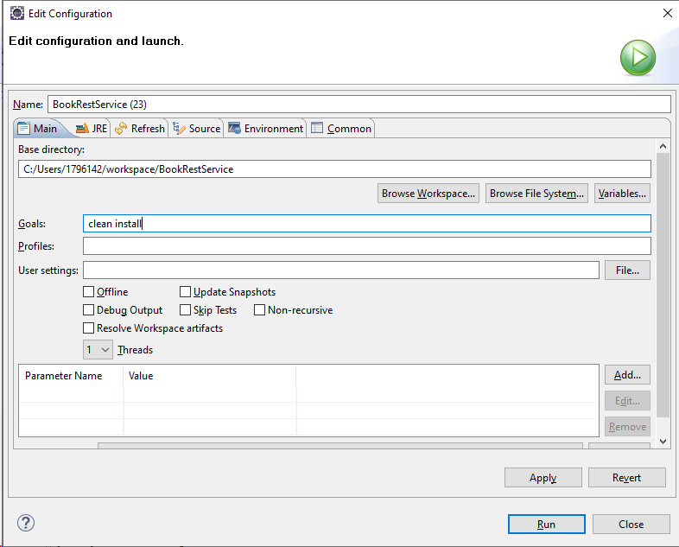
This will install all the dependencies used by the project.
- Right Click on Project and Go to Maven and Click Update Project.
- Right Click on the project and Go to Run As and Click Maven Build. Type “test” under goal and click Run. This would create “jacoco.exec” file under target folder of the project. This file would used for code coverage in SonarQube.
Note: Make Sure the jacoco.exec should be created. If not, check the steps performed and repeat the steps.
- Right Click on the project and Go to Run As and Click Maven Build. Type “sonar:sonar” under goal and click Run. This will deploy the project report to the SonarQube and the project would be available under projects tab. Now, all the details along with code coverage would be accessible.
