

PROJECT REPORT
ON

“ArtCraft – Art and Craft Supplies E-Commerce Platform”

IN

“Department of Computer Science and Engineering”

SUBMITTED IN PARTIAL FULFILLMENT OF THE DEGREE
OF
BE(CSE)

Under the Guidance of: Submitted By:

Mr. Sandeep and Mrs. Rakhi Sharad Chandel 2211981360
Department of CSE Rudar Attri 2211981320
Rudar Partap Singh 2211981321
Shaiv Sud 2211981358

Acknowledgements

This project, “ArtCraft: An E-Commerce Platform for Art and Craft Supplies,” completed as part of CS183 – Lab Oriented Project (LOP) under the Department of Computer Science and Engineering, Chitkara University, would not have been possible without the support, guidance, and encouragement of numerous individuals.
I express my sincere gratitude to Mr. Sandeep Sir, Faculty, CSE Department, Chitkara University, for providing consistent guidance and for teaching the foundational and advanced concepts of Frontend Development and Cloud Computing throughout the semesters. His expertise, timely feedback, and mentorship played a significant role in shaping the technical direction of this project.
I also extend heartfelt thanks to Ms. Rakhi Ma’am, Faculty, CSE Department, Chitkara University, for her valuable instruction and support in Backend Development. Her teaching helped strengthen core understanding of server-side development, APIs, and database integration, all of which were crucial while building this platform.
I am grateful to the Department of Computer Science and Engineering for offering the academic environment, laboratory resources, and structured curriculum that helped in the practical implementation of full-stack technologies.
My sincere appreciation goes to my family and friends for their continuous encouragement, motivation, and emotional support during the development of this project. Their belief in my abilities helped me stay focused and driven throughout the process.
Finally, I acknowledge the open-source community and development tools—including VS Code, Git, GitHub, and the Fedora Linux ecosystem—whose documentation and collaborative nature significantly eased the learning and development experience.
This project stands as a culmination of all the support and knowledge shared by the above individuals and resources, and I extend my deepest gratitude to all of them.

Preface

This report presents the development of ArtCraft, an e-commerce platform designed to support the online sale and management of art and craft supplies. The project was completed as part of CS183 – Lab Oriented Project (LOP) in the 7th Semester (December 2025) at Chitkara University.

Purpose and Motivation:
The primary objective of ArtCraft is to provide a simple, user-friendly, and efficient e-commerce system that can be used not only by professional sellers but also by general store owners who may lack technical expertise. Additionally, this project aims to serve as an open-source learning resource, enabling other students and developers to study, reuse, or extend its implementation.

1. Scope and Features:
The platform includes essential functionalities such as product management, user authentication, an admin dashboard, order handling, and a clean, accessible user interface. The goal was to integrate core concepts of full-stack application development into a cohesive, practical system.

2. Technologies Used:
The project was built using the MERN Stack (MongoDB, Express.js, React.js, Node.js) along with JWT-based authentication for secure access management. The development workflow utilized VS Code, Git, GitHub, and the Fedora Linux environment.

3. Challenges and Learning Outcomes:
Key challenges included learning the complete flow of full-stack development, understanding component-based architecture, implementing authentication, managing state across the system, and coordinating backend–frontend interactions. Overcoming these challenges strengthened understanding of modern web technologies and reinforced practical skills essential for real-world development.
This document provides a comprehensive overview of the system’s design, architecture, functional components, and implementation details, reflecting a formal and technical academic presentation aligned with university standards.

Table of Contents

Table of Contents
Acknowledgements 2
Preface 3
Table of Contents 4
Introduction to the Project 7
Introduction 7
Problem Statement 7
Objectives 7
Scope of the Project 8
Target User 9
Unique Value Proposition 9
Feasibility Study 10
Technical Feasibility 10
Operational Feasibility 10
Economic Feasibility 11
Schedule Feasibility 11
System Analysis 12
Current System Overview 12
Proposed System Overview 12
System Requirement 12
Functional Requirements 13
Non-Functional Requirements 13
Technologies Used 14
MongoDB 14
Express.js 14
React.js 14
Node.js 15
Additional Tools 15
System Architecture 16
MERN Architecture 16
Client–Server Interaction Flow 16
API Architecture 17
Deployment Architecture 18
Database Design 19
ER Diagram 19
Collection Schema Design 19
Relationships between Collections 20
Sample Documents (JSON) 21
Modules of the Project 23
User Module 23
Product Module 23
Cart & Checkout Module 24
Orders Module 24
Admin Module 24
Payment Integration Module 25
System Design 25
Context Diagram (Level 0) 25
Data Flow Diagram (DFD) 26
Flowchart 27
Sequence Diagram 29
UI/UX Design 30
Wireframes 30
Color Palette and Typography 30
Responsiveness Strategy 31
Implementation/Coding 33
Folder Structure 33
Key Backend Files (API, Models, Controllers) 34
Key Frontend Files (Components, Pages, Context) 37
Screenshots/Application Walkthrough 41
Home Page 41
Product Detail Page 42
Cart Page 44
Checkout Page 45
Admin Dashboard 47
Security Measures 48
Authentication & Authorization (JWT) 48
Password Hashing 48
Input Validation 48
API Protection 49
Role-Based Access 49
Deployment 50
Deployment Environment 50
Build & Department Steps 50
Environment Variables 51
CI/CD 51
Challenges and Solutions 52
Understanding MERN Workflow 52
State Management in React 52
API Errors & Debugging 53
Mobile Responsiveness 53
Floating AI Chatbot Integration 53
Backend Debugging & Data Handling 53
Time & Motivation Challenges During Placement Season 54
Learning Curve with React 54
Future Enchancements 55
UPI & Online Payment Integration 55
Advanced Search and Filtering 55
Improved User Profile & Address Management 55
Enhanced Admin Analytics 55
Dedicated Mobile Application 55
Separate Frontend and Backend Deployment 56
Email Verification & Password Reset 56
Full Inventory Management Enhancements 56
AI Chatbot Enhancement 56
Migration to AWS Infrastructure 57
Conclusion 57
Bibliography & References 58

Introduction to the Project

Introduction

This project, ArtCraft: An E-Commerce Platform for Art and Craft Supplies, is developed as a full-stack implementation of modern web development concepts learned throughout the semester. The inspiration behind building this platform comes from the desire to apply practical knowledge of frontend, backend, and database technologies, while simultaneously creating an open-source solution licensed under GPL v3.
The introduction also aligns with current digital adoption trends in India, where small businesses and local store owners are rapidly transitioning to online platforms. By combining motivation with technical depth, this project demonstrates how full-stack development skills can be used to create scalable and user-friendly systems accessible to a wide range of users.

Problem Statement
Many small art and craft sellers in India face significant challenges in establishing an online presence. Existing e-commerce solutions often come with high fees, complex dashboards, or paid software packages, making them unaffordable for small general stores. At the same time, customers frequently struggle to find affordable and reliable online platforms for art and craft supplies, resulting in dependency on larger marketplaces that charge higher commissions.
There is a need for a simple, affordable, and customizable platform that supports essential features such as easy product management, inventory control, and order handling, while reducing the barriers for sellers entering the digital marketplace.

Objectives
Technical Objectives:
- Implement a full-stack platform using the MERN Stack with JWT Authentication.
- Provide inventory features including add product, delete product, and order management.
- Ensure responsive design and scalable architecture for future enhancements.

- Integrate an AI-based floating chatbot assistant to guide users through the platform.

User-Focused Objectives:
- Build an easy-to-use admin dashboard for managing products and orders.
- Simplify seller onboarding for store owners with minimal technical knowledge.
- Offer an open-source learning resource for students and developers.
- Deliver a clean, easy-to-navigate UI with toast notifications and simple design elements.

Scope of the Project

The current scope includes features on both the admin and customer sides:

Admin Side:
- Add, update, and delete products.
- Manage orders and track order status.
- Access an integrated AI floating chatbot assistant for support.

Customer Side:
- Browse art and craft products.
- Place orders using the Cash on Delivery (COD) option.
- Interact with a clean, minimal UI and receive real-time feedback via toast notifications.

Future Enhancements:
- Integration of UPI online payment systems.
- Additional analytics features for sellers.
- Expansion of chatbot functionalities.

Target User

- Art and craft store owners looking for a simple and affordable online selling platform.
- General store owners who want a lightweight dashboard without purchasing expensive software.
- Students and learners exploring full-stack development concepts.
- Customers purchasing art and craft supplies online.

Unique Value Proposition

ArtCraft differentiates itself from traditional e-commerce systems through:

- An integrated AI floating chatbot offering intelligent assistance.
- A fully open-source codebase available on GitHub under GPL v3, encouraging learning and customization.
- A simplified, intuitive UI/UX designed for effortless navigation with toast-based notifications.
- A strong focus on affordability, simplicity, and customizability, making it ideal for small businesses and independent sellers.

Feasibility Study

Technical Feasibility

The project is technically feasible due to its use of reliable, modern, and open-source technologies. The platform is built using the MERN Stack (MongoDB, Express.js, React.js, Node.js) with JWT authentication to manage secure access. Development was performed using VS Code, Git, GitHub, and a Linux environment, ensuring compatibility, flexibility, and efficient workflow management.
Deployment was done on Render.com using a traditional server setup. Although Render provides a free tier, the backend experiences delays of 30–60 seconds during cold starts and goes to sleep after 15 minutes of inactivity. Despite this, the system runs reliably once active. Alternatives such as Vercel Serverless Functions or future deployment on AWS can eliminate such delays and support greater scalability.
The entire system is lightweight and compatible with low-end hardware, making it accessible to students, learners, and small businesses. The chosen tech stack provides significant room for future upgrades, including custom domains, cloud hosting, and performance enhancements.

Operational Feasibility

The platform is designed for store owners, students, and admin users, all of whom can operate the system with minimal training. The admin dashboard has a clean, simple layout with straightforward controls such as add product, delete product, and manage orders, ensuring a low learning curve.
A short 5–10 minute training session is sufficient for new users to understand the core functionalities. Operational ease is further enhanced through the integrated AI floating chatbot, implemented using the free Gemini API, which provides system guidance and answers user queries.

Because the system is browser-based, requires no installation, and uses intuitive UI components, overall operational feasibility is high.

Economic Feasibility

The project is economically viable due to its complete reliance on open-source and free resources. Development tools such as VS Code, GitHub, MongoDB Atlas (free tier), and Render.com were used without any monetary cost.
For sellers, this platform eliminates the need to purchase expensive e-commerce software or pay high commissions to major online marketplaces, offering significant cost savings. For students, it serves as a zero-cost learning tool, enabling hands-on experience in full-stack development.
Deployment was achieved using free hosting plans, ensuring negligible operational expenses during development. In the long term, the system remains cost-effective because maintenance and customization can be performed without licensing fees.

Schedule Feasibility

Development of the project took approximately three months, overlapping with active placement drives and academic commitments. These factors introduced delays; however, the team managed the schedule efficiently and maintained steady progress throughout the semester.
The work was completed within the academic timeline for the Lab Oriented Project (LOP) course. Tasks such as frontend design, backend development, authentication, chatbot integration, and deployment were carried out in phases, allowing the project to stay aligned with submission requirements despite external constraints.

System Analysis

Current System Overview

Most small art and craft sellers still rely on fully offline processes, where inventory is tracked manually and orders are handled on paper or through simple phone communication. Even where digital tools exist, sellers often use overpriced software solutions or outdated dashboards with poor UI/UX, which reduces efficiency and discourages adoption.
From the seller’s perspective, the major issues are high subscription costs, outdated interfaces, and the lack of a simple, modern system tailored for small businesses. From the customer’s perspective, limited online availability and inconsistent digital presence make it difficult to find affordable art and craft supplies through local stores.

Proposed System Overview

The proposed system introduces a web-based, easy-to-use, and modern e-commerce platform providing digital presence and simplified management tools for sellers. It includes an admin dashboard, product management, order management, an AI chatbot assistant, and JWT-based authentication to ensure secure access.
The system aims to reduce operational effort, modernize seller workflows, and offer a clean interface for both administrators and customers. It focuses on ease of use, automation, and enabling small businesses to establish an online identity with minimal technical overhead.

System Requirement

Hardware Requirements:
- A device with at least 2GB RAM and a modern web browser.
- Compatible with both laptops and mobile devices for sellers and customers.

Software Requirements:
- A web browser (Chrome, Firefox, or equivalent).
- Internet access to use the platform.
- Deployment supported through Render.com for backend hosting and live API access.

Functional Requirements

- Add new products from the admin dashboard.
- Delete or update existing products.
- Manage and update order status.
- Secure login and authentication for admins.
- Customer-facing product browsing.
- Integrated AI chatbot for assistance.
- Toast notifications for real-time feedback.
- Admin login system for protected access.

Non-Functional Requirements

- Usability: Simple, intuitive interface suitable for non-technical store owners.
- Scalability: Ability to expand features and migrate to improved hosting in the future.
- Performance: Smooth browsing and fast UI response, with optimization planned beyond free-tier hosting limitations.
- Security: Protected routes, JWT authentication, secure data handling, and controlled admin access.
- Future Enhancements: Improved hosting (e.g., AWS), online payment integration, and expanded features.

Technologies Used

MongoDB

MongoDB Atlas (free tier) is used as the cloud database for the project. Its document-oriented model, horizontal scalability, and flexible schema make it suitable for dynamic e-commerce data.
The project uses one database (artcraft) containing three core collections:
- users
- products
- orders
Cloud hosting ensures reliability and ease of remote access during development and deployment.

Express.js

Express.js is used as the backend framework responsible for handling routing, middleware, and REST API endpoints. It provides a lightweight structure for request handling, validation, authentication, and API responses.
The framework enables clean separation of concerns and supports modular API development for authentication, product handling, and order management.

React.js

React.js powers the frontend through a component-based architecture, enabling efficient UI rendering and code reusability.
The interface is styled using Tailwind CSS, providing a clean, responsive, and modern layout.
State management is handled using React Context API, ensuring simple, predictable state flow without adding unnecessary complexity.

Node.js

Node.js serves as the runtime environment for executing backend JavaScript, supporting asynchronous operations, database communication, and HTTP request handling.
It manages the backend server, environment configurations, and npm scripts such as:

- npm run build
- npm run dev
- node server.js
Environment variables include:
- MONGODB_URI=<mongodb_uri>
- JWT_SECRET=<jwt_secret>
- GEMINI_API_KEY=<api_key>
- PORT=5000
- NODE_ENV=production

Additional Tools

Postman: Used for testing, validating, and debugging API endpoints.
Git & GitHub: Provide version control, backup, collaboration, and open-source hosting of the complete project.
JWT (JSON Web Token): Enables secure authentication, protecting admin routes and sensitive operations.
npm: Manages all project dependencies, scripts, and development workflows.
Linux OS & VS Code: Used as the main development environment and editor for writing, debugging, and managing project code.
Render.com: Hosts and deploys the backend, offering a free-tier environment for running the server.

System Architecture

MERN Architecture

The system follows the standard MERN layered architecture with an added AI assistant component:

- Client (React + Tailwind CSS) — Single Page Application (SPA) built from reusable components (product listing, admin dashboard, forms, toast notifications). Responsible for rendering UI, capturing user actions, and calling backend APIs.
- Server (Node.js + Express.js) — Single backend application that exposes REST APIs, handles authentication (JWT), business logic (product/order management), and serves the built frontend (index.html) in a monolithic deployment.
- Database (MongoDB Atlas) — Cloud-hosted document store containing three collections (users, products, orders) for persistent storage.
- AI Chatbot (Gemini API integration) — External conversational assistant called from the frontend; backend mediates any required server-side calls or tokens.
- Authentication (JWT) — Token-based authentication issued by the server on successful login. The client stores the JWT in localStorage and attaches it to authenticated API requests.

Client–Server Interaction Flow

1. User / Admin Login:
- User submits credentials via the login form (frontend).
- Frontend sends POST /api/auth/login with credentials.
- Server validates credentials, generates a JWT, and returns it in the response.
- Frontend stores the JWT in localStorage and sets an authorization header (Authorization: Bearer <token>) for subsequent requests.
- Protected API endpoints verify JWT in incoming requests; if valid, the server authorizes the action.

2. Admin — Product Management (Add / Delete / Update):
- Admin uses the dashboard UI to add/update/delete a product.
- Frontend sends the corresponding authenticated request (POST/PUT/DELETE /api/products) with the JWT header.
- Server validates JWT, runs input validation and business logic, then updates MongoDB (products collection).
- Server responds with operation status; frontend displays toast notifications and updates UI state via React Context API.

3. Customer — Browse & Place Order
- Customer browses products; frontend fetches product data via GET /api/products.
- Customer places an order through the UI (checkout with COD). Frontend sends POST /api/orders with order details and optional user token.
- Server validates the order, stores it in the orders collection, returns confirmation.
- Admin views and updates order status through the dashboard; frontend polls or fetches order updates as needed.

4. AI Chatbot Interaction:
- User clicks the floating chatbot; frontend sends user query to the chatbot endpoint.
- Depending on implementation, the request may go directly to the external Gemini API (client-side) or via the backend which injects/guards API keys.
- Chatbot returns contextual responses; frontend renders replies in the floating UI. Chatbot also assists with system usage (how to add products, check orders).

API Architecture
APIs are grouped modularly by function. Each module follows REST principles and enforces authentication where required.
- Auth Module
  - POST /api/auth/register — create user/admin (if applicable)
  - POST /api/auth/login — validate credentials, return JWT
  - JWT issued with short-to-medium lifetime; server-side middleware validates token on protected routes.

- Products Module
  - GET /api/products — public product listing
  - POST /api/products — add product (admin, authenticated)
  - PUT /api/products/:id — update product (admin)
  - DELETE /api/products/:id — delete product (admin)
- Orders Module
  - POST /api/orders — create new order (customers)
  - GET /api/orders — admin view of orders (authenticated)
  - PUT /api/orders/:id — update order status (admin)
- Chatbot / Support Module
  - POST /api/chat — relay user messages to AI assistant (backend may mediate API key usage)
  - Designed to be stateless or minimally stateful depending on required context persistence.

Security notes: Protected endpoints require the Authorization header with a valid JWT. Sensitive keys and URIs are provided via environment variables on the server; the client never stores raw secret values.

Deployment Architecture

The system is deployed as a monolithic application, where the React frontend is built using npm run build and served directly by the Express backend. The backend and static frontend files run together on Render.com, using environment variables for all sensitive configurations.
Data is stored on MongoDB Atlas, connected through secure environment variables. Source code and deployment updates are managed through GitHub, allowing quick redeploys.
Although optimized for simplicity, the architecture can scale further by migrating to AWS or separating the frontend and backend into independent services for improved performance and availability.

Database Design

ER Diagram
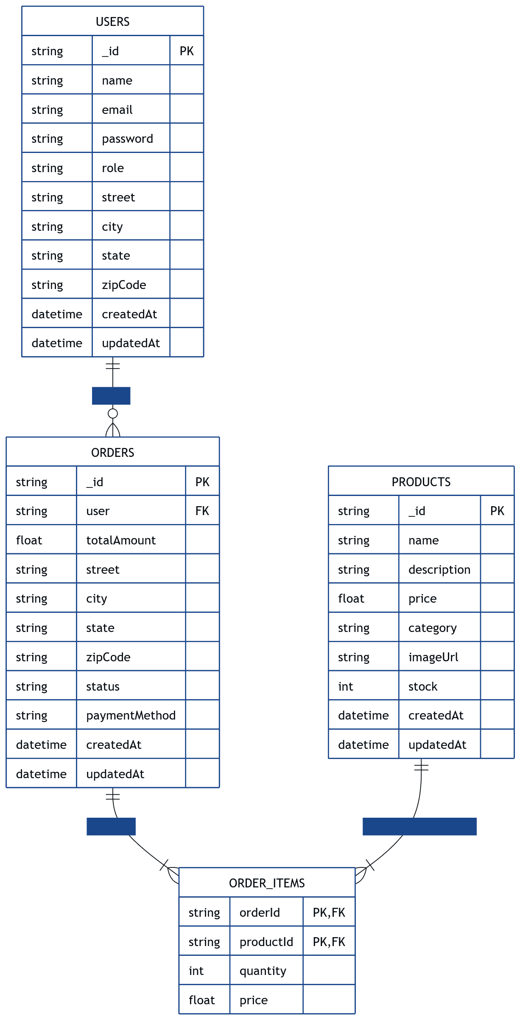

Collection Schema Design

1. Users Collection:
Fields include:
- name: String
- email: unique identifier
- password: hashed password (securely stored in real implementation)
- role: user/admin
- address: optional embedded object
- timestamps: createdAt, updatedAt

2. Products Collection:
Fields include:
- name, description, price, category
- imageUrl: static asset or link
- stock: numerical quantity available
- timestamps

3. Orders Collection:
Fields include:
- user: ObjectId referencing Users
- items: Array of product, quantity, price
- totalAmount
- shippingAddress (embedded)
- status (pending → delivered)
- paymentMethod
- timestamps

Relationships between Collections

- Users → Orders: Each order links to one user via user: ObjectId.
- Orders → Products: Each order contains an array of items, where each item references a product: ObjectId.
- Products are independent documents but frequently appear inside Orders as references.
- No direct relationship is stored between Products and Users; Orders serve as the join link between them.

This structure ensures:
- Flexible growth of product catalog
- Efficient querying for admin dashboards
- Clean separation of user, product, and transactional data

Sample Documents (JSON)
Sample order document:
{
"_id": "682a311859646c445b965fcb",
"user": "682a301da0f4b93bcf68df28",
"items": [
{
"product": "682a301da0f4b93bcf68df2b",
"quantity": 1,
"price": 9.99
},
{
"product": "682a301da0f4b93bcf68df2a",
"quantity": 1,
"price": 24.99
}
],
"totalAmount": 34.98,
"shippingAddress": {
"street": "L.I.G BLOCK-6, A-3",
"city": "Parwanoo",
"state": "HP",
"zipCode": "173220"
},
"status": "delivered",
"paymentMethod": "Cash on Delivery",
"createdAt": "2025-05-18T10:12:24.375Z",
"updatedAt": "2025-08-14T12:45:27.333Z"
}
Sample product document:
{ "_id": "6902dabcf91a87c9c5fe1985",
"name": "Acrylic Paint Set",
"description": "Professional 12-color acrylic paint set, perfect for canvas painting",
"price": 99.99,
"category": "Painting",
"imageUrl": "/uploads/acrylic-paint.jpg",
"stock": 100,
"createdAt": "2025-10-29T08:45:48.733Z",
"updatedAt": "2025-10-29T17:47:21.111Z" }

Sample user document:
{
"_id": "6902dabcf91a87c9c5fe1983",
"name": "Sharad",
"email": "sharad@gmail.com",
"password": "123",
"role": "user",
"createdAt": "2025-10-29T08:45:48.622Z",
"updatedAt": "2025-10-29T08:45:48.622Z"
}

Modules of the Project

User Module

The User Module manages all functionalities related to customer authentication and basic account operations. Users can register and log in to access protected features such as the cart, checkout, and order history. After login, users can view their profile, but profile updates are not yet supported; during checkout, users manually enter address information each time.
Role-based access control allows standard users to access shopping features, while an admin role gains additional privileges such as dashboard visibility and management options. Email verification is not required in the current version but is planned for future implementation.

Product Module

This module handles all product-related operations in the system. Customers can browse available items and open a product details page for additional information. The platform currently does not support search or filtering features, and all products are treated as simple single-item entries without variations.

Admins can perform full product management through the dashboard, including adding new products, editing existing products, and deleting products as needed.

Cart & Checkout Module

The Cart Module enables users to manage selected items before placing an order. Customers can add products to the cart, remove items, and update quantities directly from the cart interface.
During checkout, users provide their street address, city, state, and zip code, along with selecting a payment method. Currently, the system supports Cash on Delivery (COD), with UPI-based online payments planned for future versions. An order summary is shown before final confirmation, ensuring clarity and transparency.

Orders Module

This module manages all order lifecycle operations. Customers can view a list of their past orders, check order details, and track order status as it progresses from pending to delivered.
Admins have advanced capabilities, including viewing all orders, changing order status, and managing cancellations. A cancellation option exists, but it is currently restricted to the admin. Refund handling is also managed manually by the admin or store owner, depending on the situation.

Admin Module

The Admin Module provides system-wide management tools accessible only to authenticated users with the admin role. Admins can access a dedicated dashboard, which includes options for managing products, viewing all orders, updating order statuses, and controlling cancellations.
The module focuses on simplicity and functionality, offering clean, straightforward interfaces without additional analytics or visual reporting at this stage. All admin actions are protected through role-based authentication to ensure system security and data integrity.

Payment Integration Module

The current system supports only Cash on Delivery, which simplifies deployment and avoids the complexities of integrating payment gateways. Future enhancements include full UPI integration, with plans to implement Razorpay as the primary payment provider.
The main limitation is that modern payment platforms now require extensive business verification and documentation before enabling UPI or online payments, making integration more difficult for student or early-stage academic projects. Once verification requirements can be met, the platform will expand to support secure online payments.

System Design

This section presents the key system design diagrams created for the ArtCraft E-Commerce Platform. These visuals illustrate how the system components interact, how data flows between modules, and how users engage with the platform. The diagrams included are:

1. Context Diagram (Level 0)
2. Data Flow Diagram (DFD)
3. Flowchart
4. Sequence Diagram

Context Diagram (Level 0)

This diagram provides a high-level overview of the entire system, showing all external entities interacting with the ArtCraft System.
It highlights the primary inputs and outputs between:
- Customer User
- Admin
- Payment Gateway (future)
- MongoDB Database

It establishes the system boundary and clarifies the responsibilities handled by the platform.

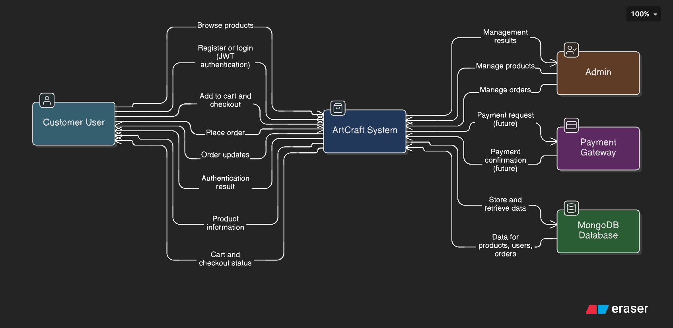
Figure: Context Diagram

Data Flow Diagram (DFD)

This diagram breaks the system into logical subprocesses and shows how data moves across:

- User Management
- Product Management
- Order Processing
- Cart & Checkout
- Admin Operations
- Database Operations
- Future Payment Flow

It outlines the transformation of data between components and helps explain system workflow at a structured level.

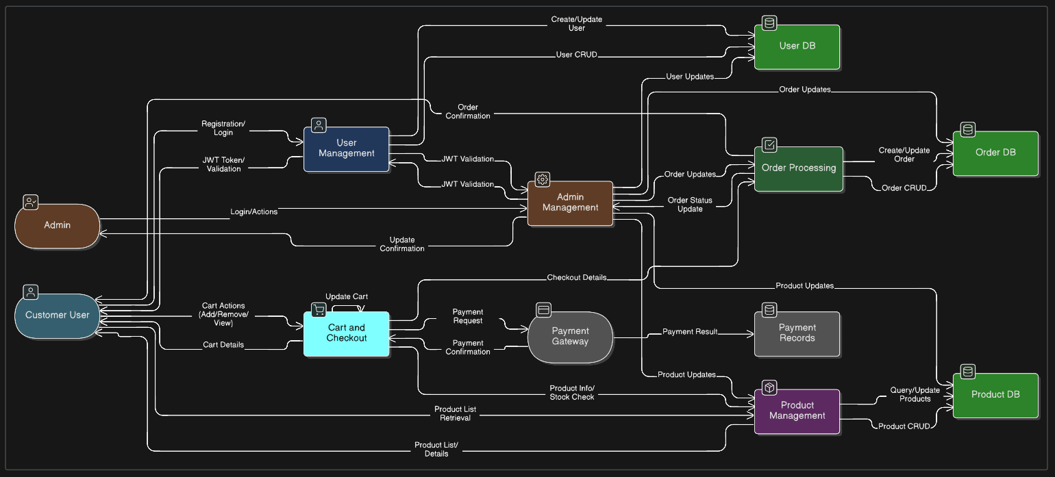
Figure: Data Flow Diagram

Flowchart
The flowchart represents two major journeys:

Customer Interaction Flow:
- Register/Login
- Browse products
- View details
- Add to cart
- Checkout
- Payment selection
- Order completion
Admin Interaction Flow:
- Admin login
- Add/Edit/Delete products
- View orders
- Update or cancel orders
It visually maps step-by-step decision flows for both users.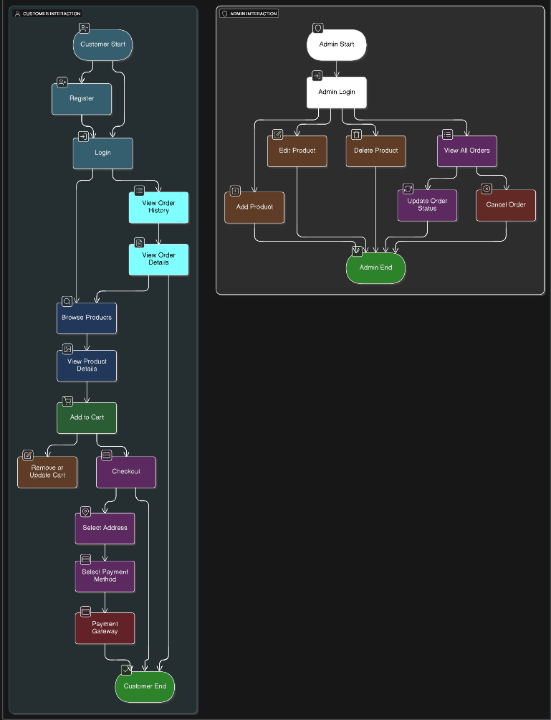
Figure: Flowchart

Sequence Diagram
This diagram captures the chronological interaction between:
- Customer
- Web App
- Payment Service
- Inventory System

Operations illustrated include:
- Browsing products
- Adding items to cart
- Checkout and conditional payment flow
- Inventory update sequence
- Order and stock confirmation

The diagram helps clarify real-time request/response behavior in the system.
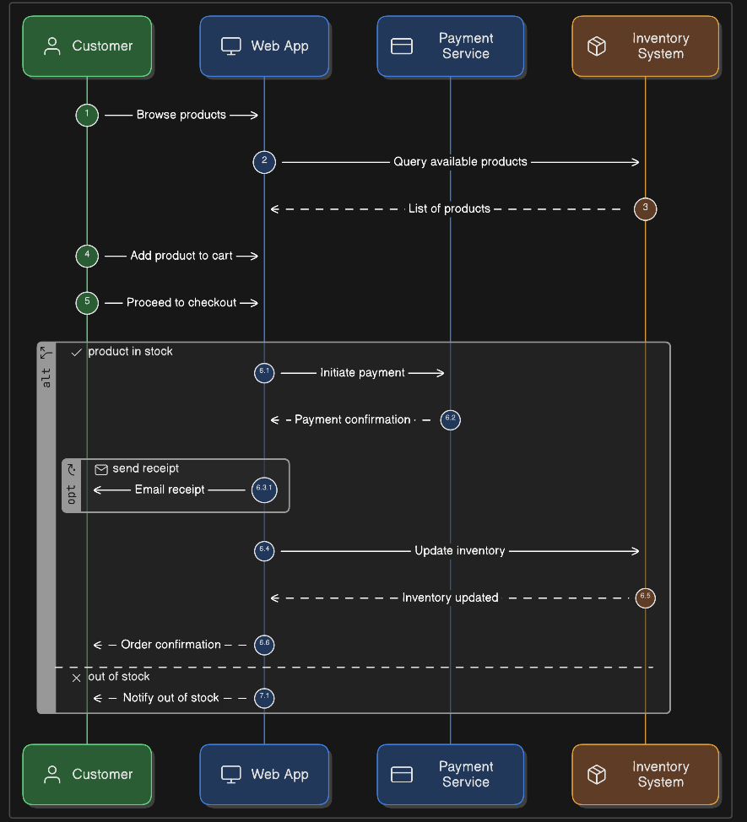
Figure: Sequence Diagram

UI/UX Design

Wireframes
Although initial wireframes were created, they are intentionally excluded from this documentation. The final UI closely follows standard e-commerce patterns: a clean homepage hero section, product grid listing, product details layout with image + information split, simplified cart and checkout forms, and a clearly structured admin dashboard for product and order management.

Color Palette and Typography

Color Palette:
The interface primarily follows TailwindCSS’s built-in palette, resulting in a modern, clean, and accessible UI. Key colors extracted from the implemented components include:

- Primary Colors
  - Blue-500 (#3B82F6) – Buttons, CTAs, accents
  - Indigo-600 (#4F46E5) – Gradient hero background
- Secondary / Utility Colors
  - Gray-50 / Gray-100 / Gray-600 / Gray-800 – Backgrounds, borders, text
  - Green-100 / Green-800 – Stock availability badge
  - Red-100 / Red-800 – Out-of-stock badge
- UI Feedback Colors
  - Blue-700 – Hover effect for primary buttons
  - White (#FFFFFF) – Hero text, button foregrounds
  - Custom Fallback Image Handling Color Logic – Used via utility classes
These colors help maintain a balanced visual hierarchy and ensure readability across screens.

Typography:
The application uses a system-optimized, performance-friendly font stack:
-apple-system, BlinkMacSystemFont, 'Segoe UI', Roboto, 'Helvetica Neue', Arial, sans-serif
Characteristics:
- Highly legible on both desktop and mobile.
- Automatically uses platform-native UI typography (e.g., San Francisco on macOS/iOS, Segoe UI on Windows).
- No external font loading improves performance and Core Web Vitals.
Tailwind’s consistent spacing utilities (p-4, mb-6, gap-4, rounded-lg) and shadows (shadow-md, shadow-sm) create a uniform, clean aesthetic across components.

Responsiveness Strategy

Mobile-First Structure:
The UI follows Tailwind’s mobile-first philosophy:
- Base styles target small screens.
- Layout expands using responsive classes (sm:, md:, lg:).
Examples:
- Product grid transitions from 1 → 2 → 3 → 4 columns across breakpoints.
- Flex layouts convert automatically with flex-col sm:flex-row (used in the hero buttons).
- Buttons and spacing adjust proportionally without custom CSS.

Practical Responsive Adjustments:
Key responsive behaviors include:
- Navbar and Navigation
  - Clean top navigation layout adapts for mobile stacking.
  - Login/Register buttons remain accessible even on small screens.
- Product Cards
  - Height-limited product images (max-h-44) ensure visual consistency.
  - Text truncation (line-clamp) maintains clean layout on narrow screens.

- Checkout Workflow
  - Form components stack vertically on mobile.
  - Spacing and padding adapt automatically via Tailwind utility classes.
- Admin Dashboard
  - Tables and management panels scroll horizontally on small devices.
  - Cards for metrics remain responsive using flex/grid utilities.

Device Testing:
Testing was performed on:
- Desktop (primary)
- Mobile devices
Adjustments were made using Tailwind’s responsive utilities to fix spacing, overflow, and layout issues. Tablet optimization is not explicitly implemented but inherits responsive behavior from existing breakpoints.

Implementation/Coding

This section provides a structured and technical overview of the project implementation. It highlights the core folder structure, essential backend and frontend files, and the most relevant code snippets. All samples are intentionally short and focused on key logic.

Folder Structure
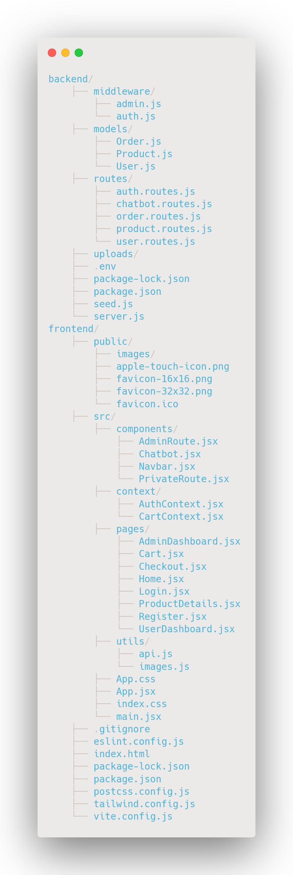

Key Backend Files (API, Models, Controllers)

Authentication (auth.routes.js): Handles register, login, and fetching authenticated user.

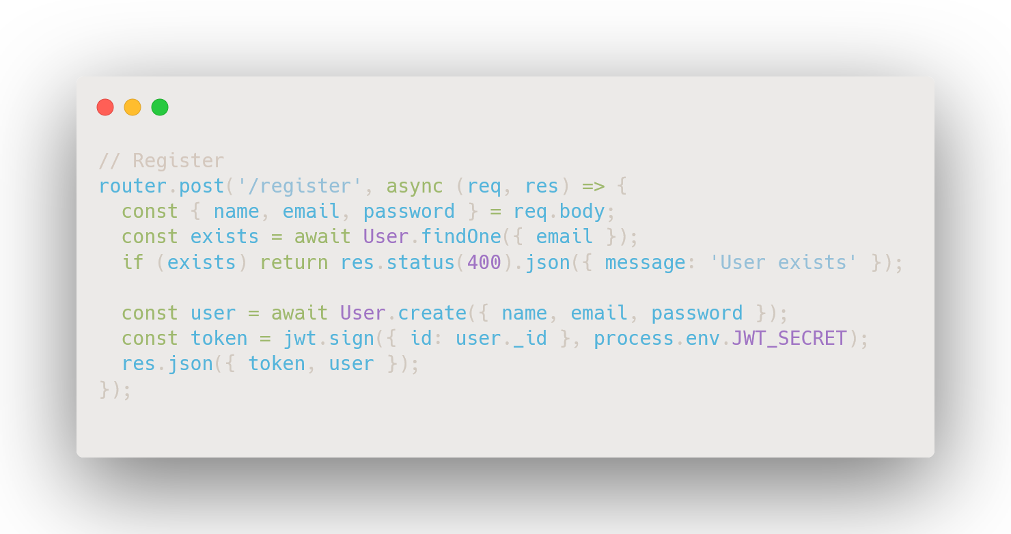
Figure: Register Endpoint Snippet

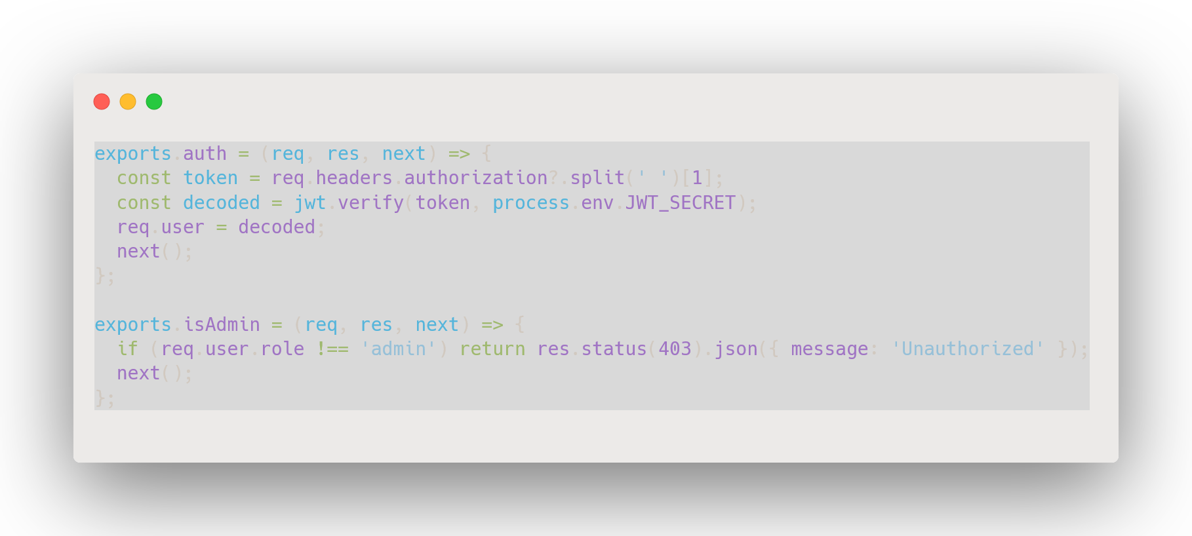
Figure: Middleware Snippet (auth.js)

Product API (product.routes.js): Handles product creation, listing, update, delete.
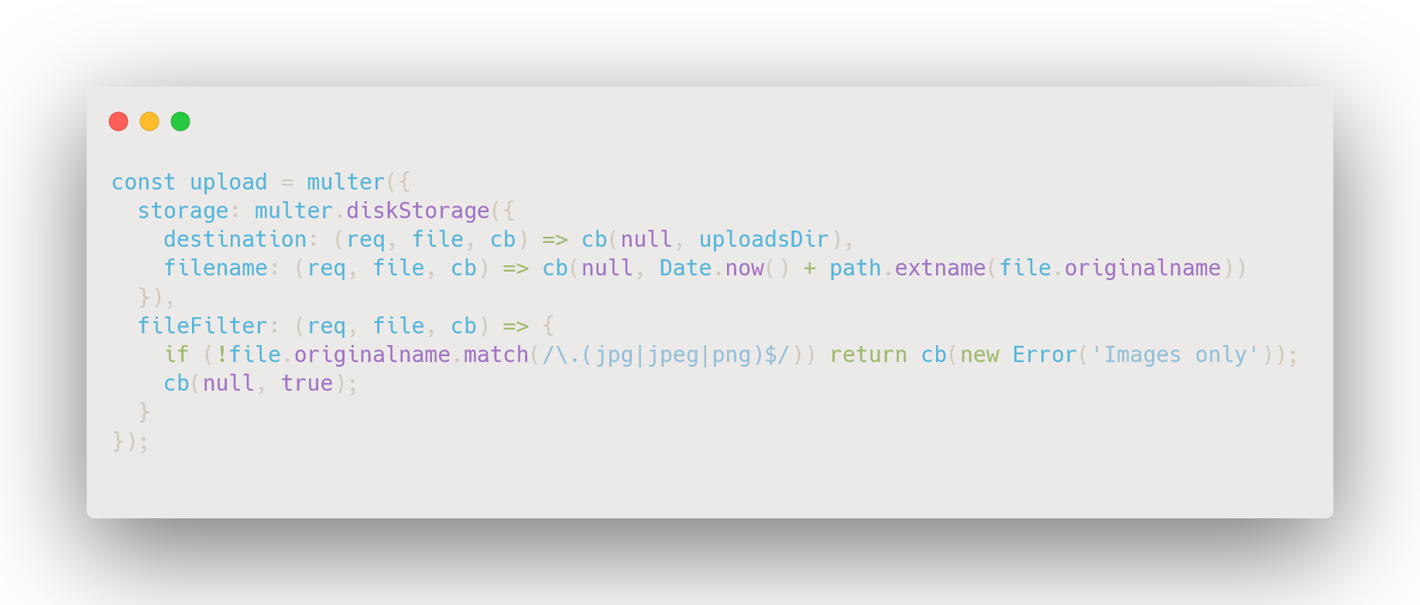
Figure: Multer Snippet

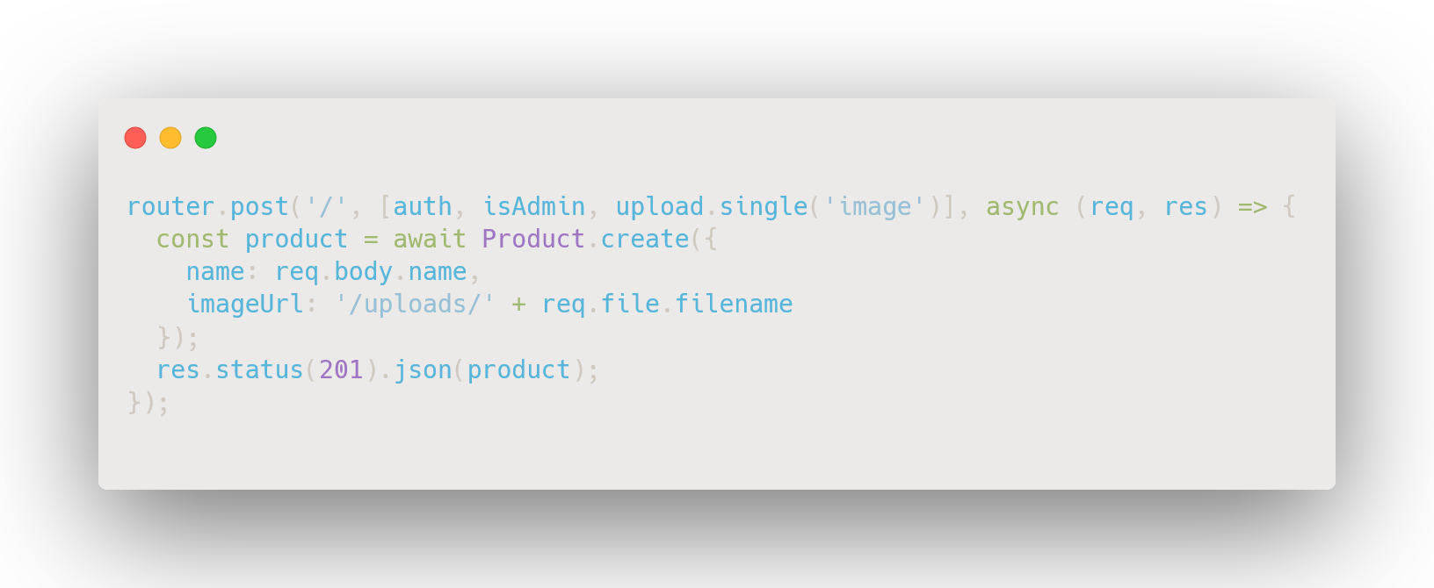
Figure: Create Product Snippet

Orders API (order.routes.js): Handles order creation and admin order access.
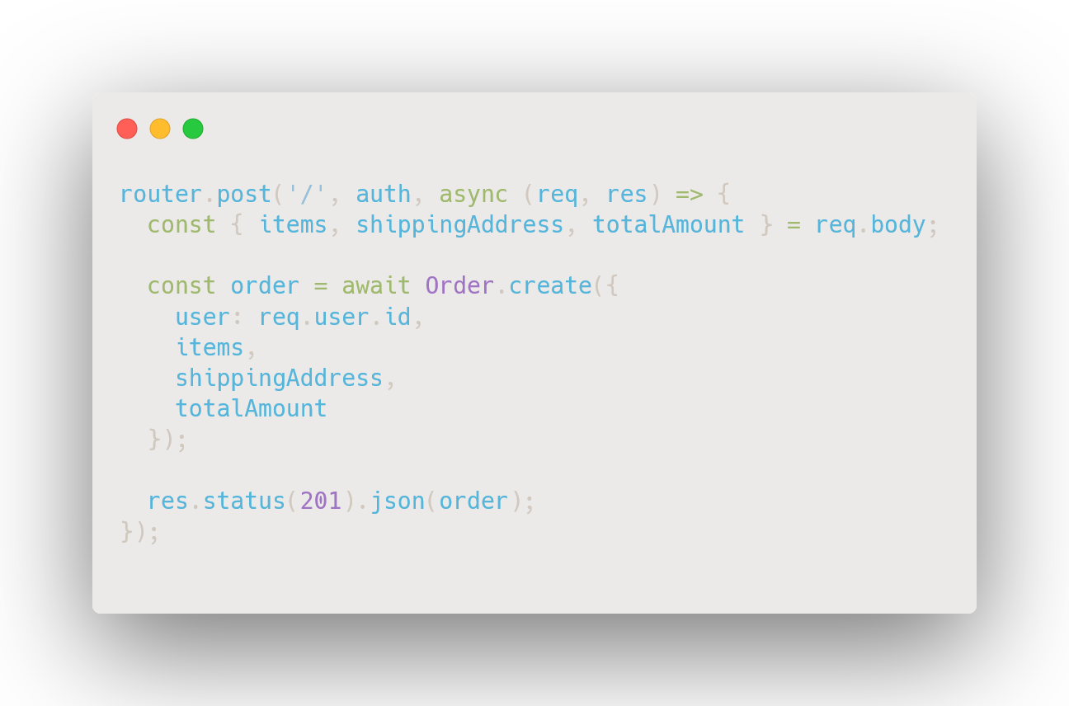
Figure: Order Creation Snippet

server.js:
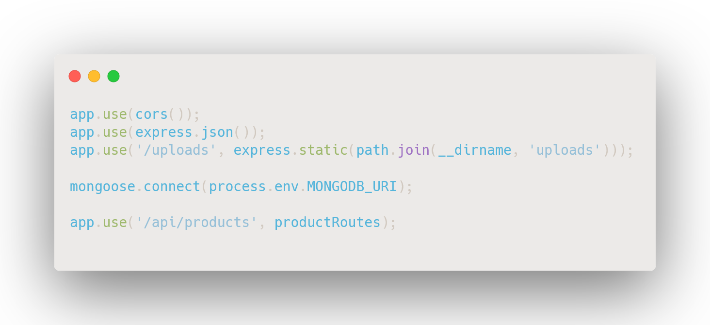
Figure: Core Setup Snippet

Key Frontend Files (Components, Pages, Context)

Context API:

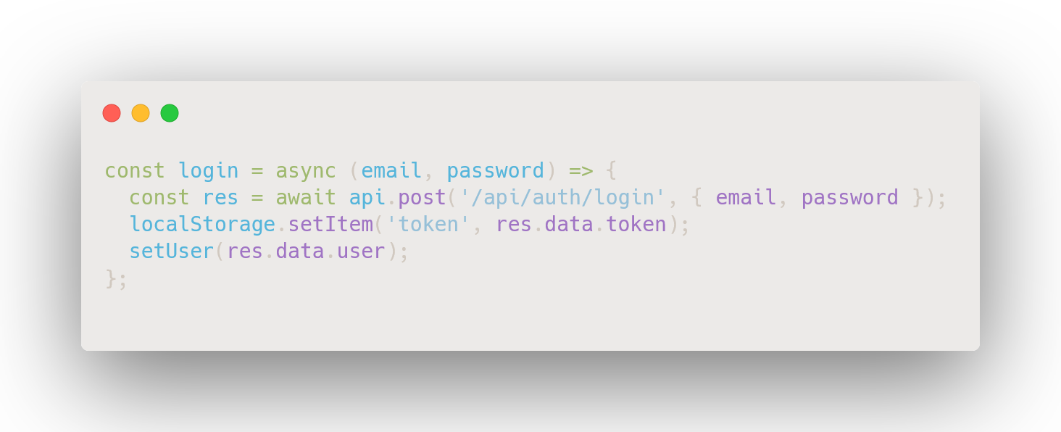
Figure: AuthContext.jsx – Login Snippet

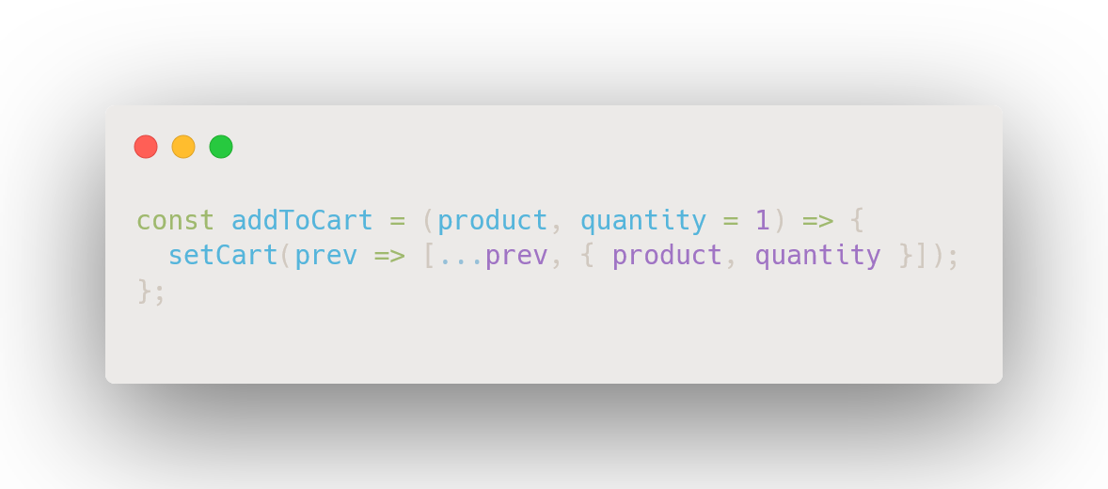
Figure: CartContext.jsx – Add to Cart Snippet

Utility Layer:

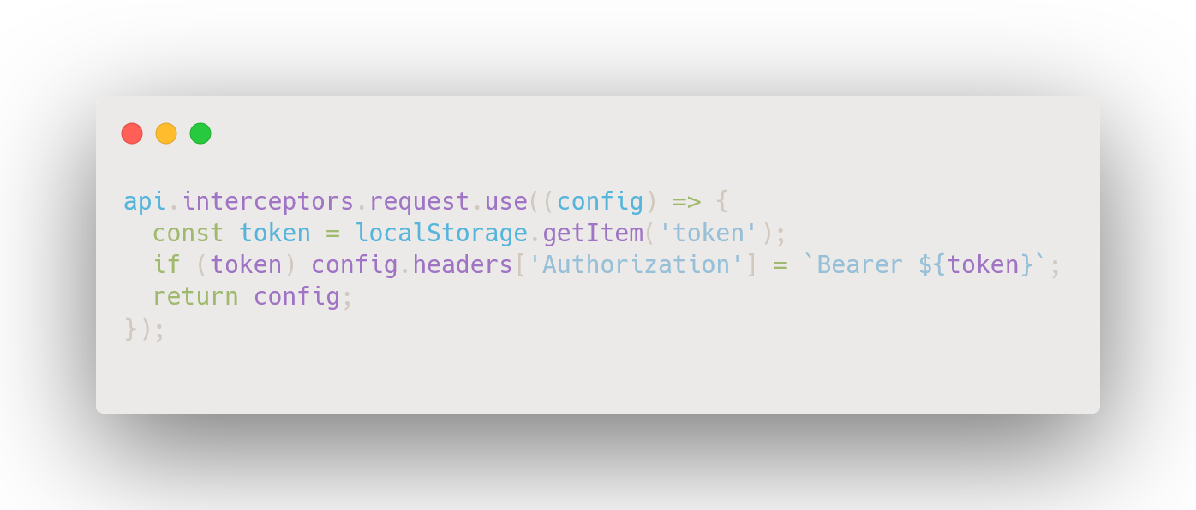
Figure: api.js – Token Interceptor
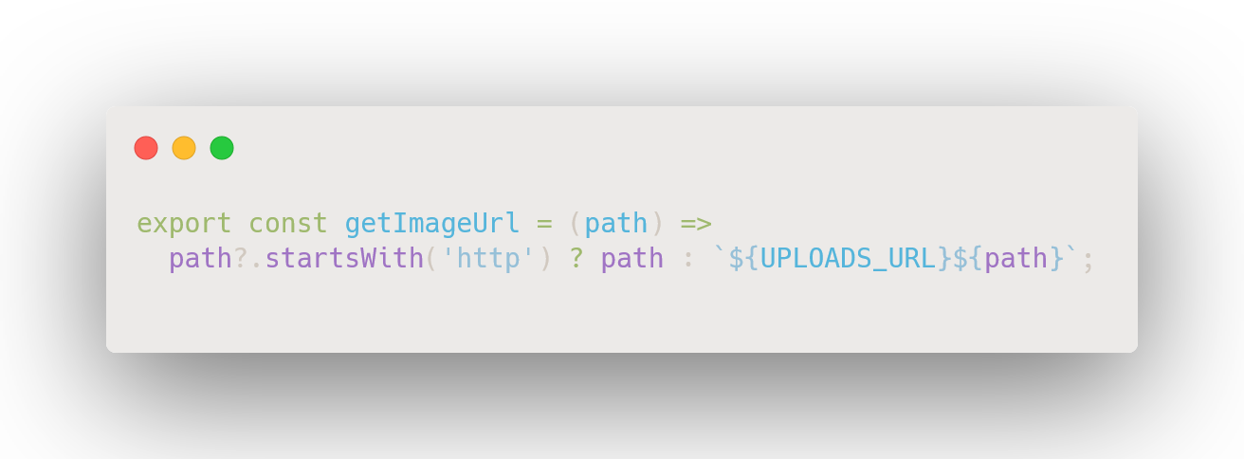
Figure: Image URL Helper

Core Components:

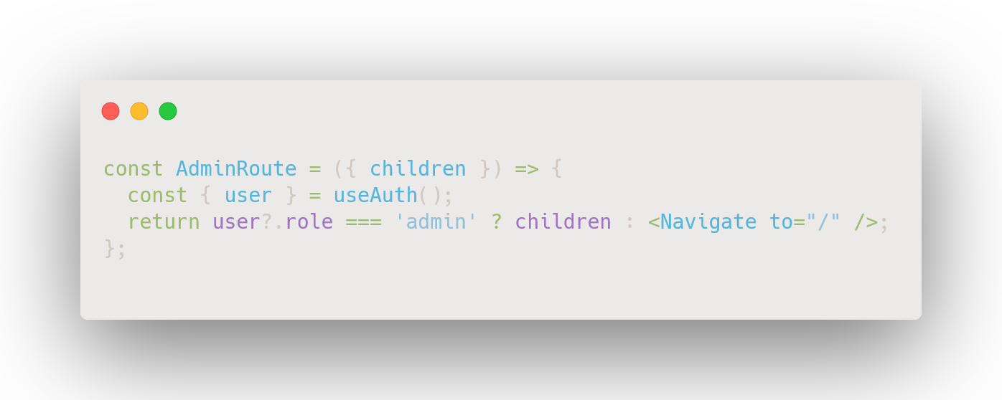
Figure: AdminRoute.jsx 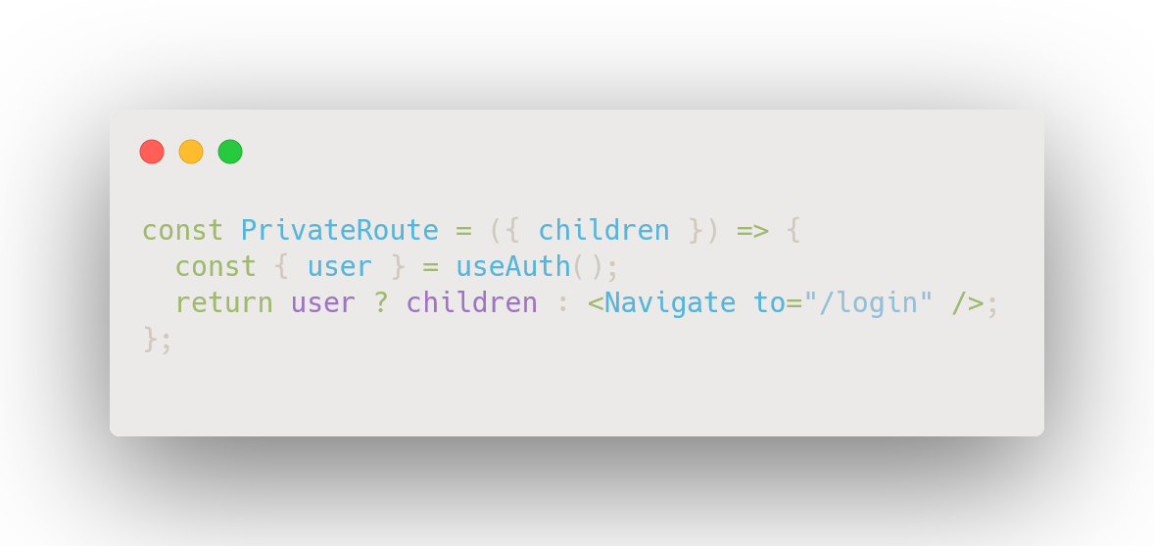
Figure: PrivateRoute.jsx

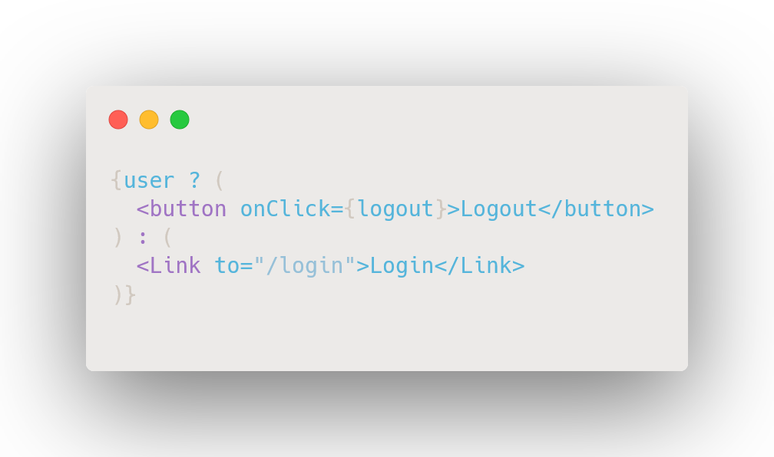
Figure: Navbar Logout Snippet

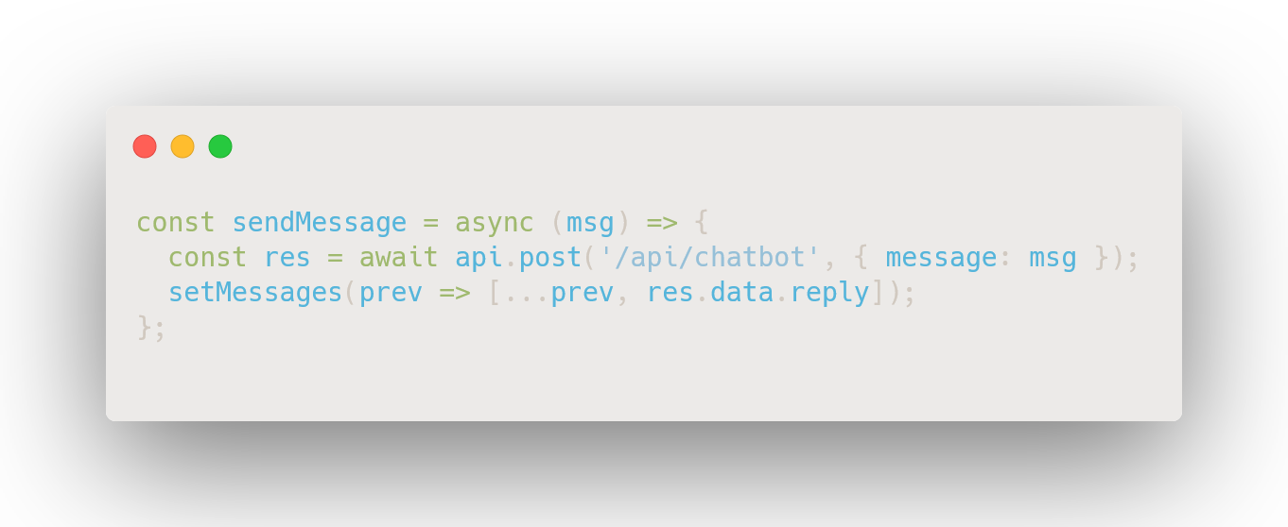
Figure: Chatbot.jsx (API Call)

Screenshots/Application Walkthrough

This section provides a visual overview of the ArtCraft E-commerce Platform, covering both desktop and mobile interfaces. Each subsection briefly explains the purpose of the page followed by the corresponding screenshots. All screenshots should be centered, labeled, and sized uniformly for clarity.

Home Page

Description:
The Home Page displays featured products, simple navigation, and a clean UI designed for quick browsing. It serves as the entry point for both new and returning users.

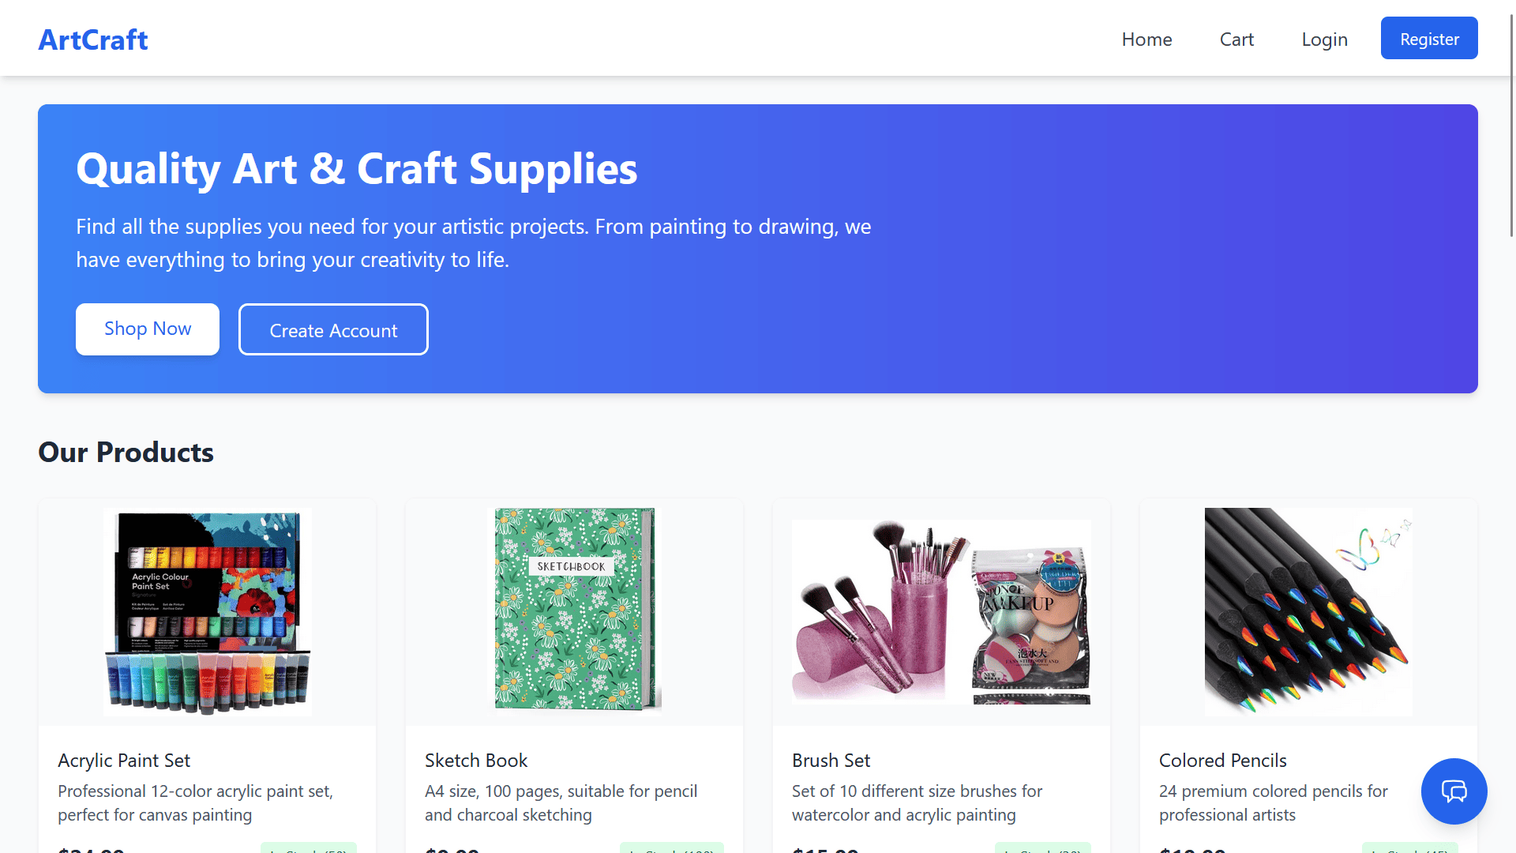
Figure 1.1: Desktop View – Home Page

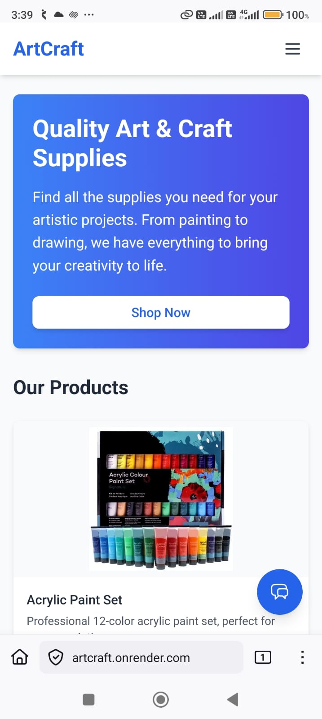
Figure 1.2: Mobile View – Home Page

Product Detail Page

Description:
Shows detailed information about a selected product, including price, description, category, stock status, and an option to add the item to the cart.

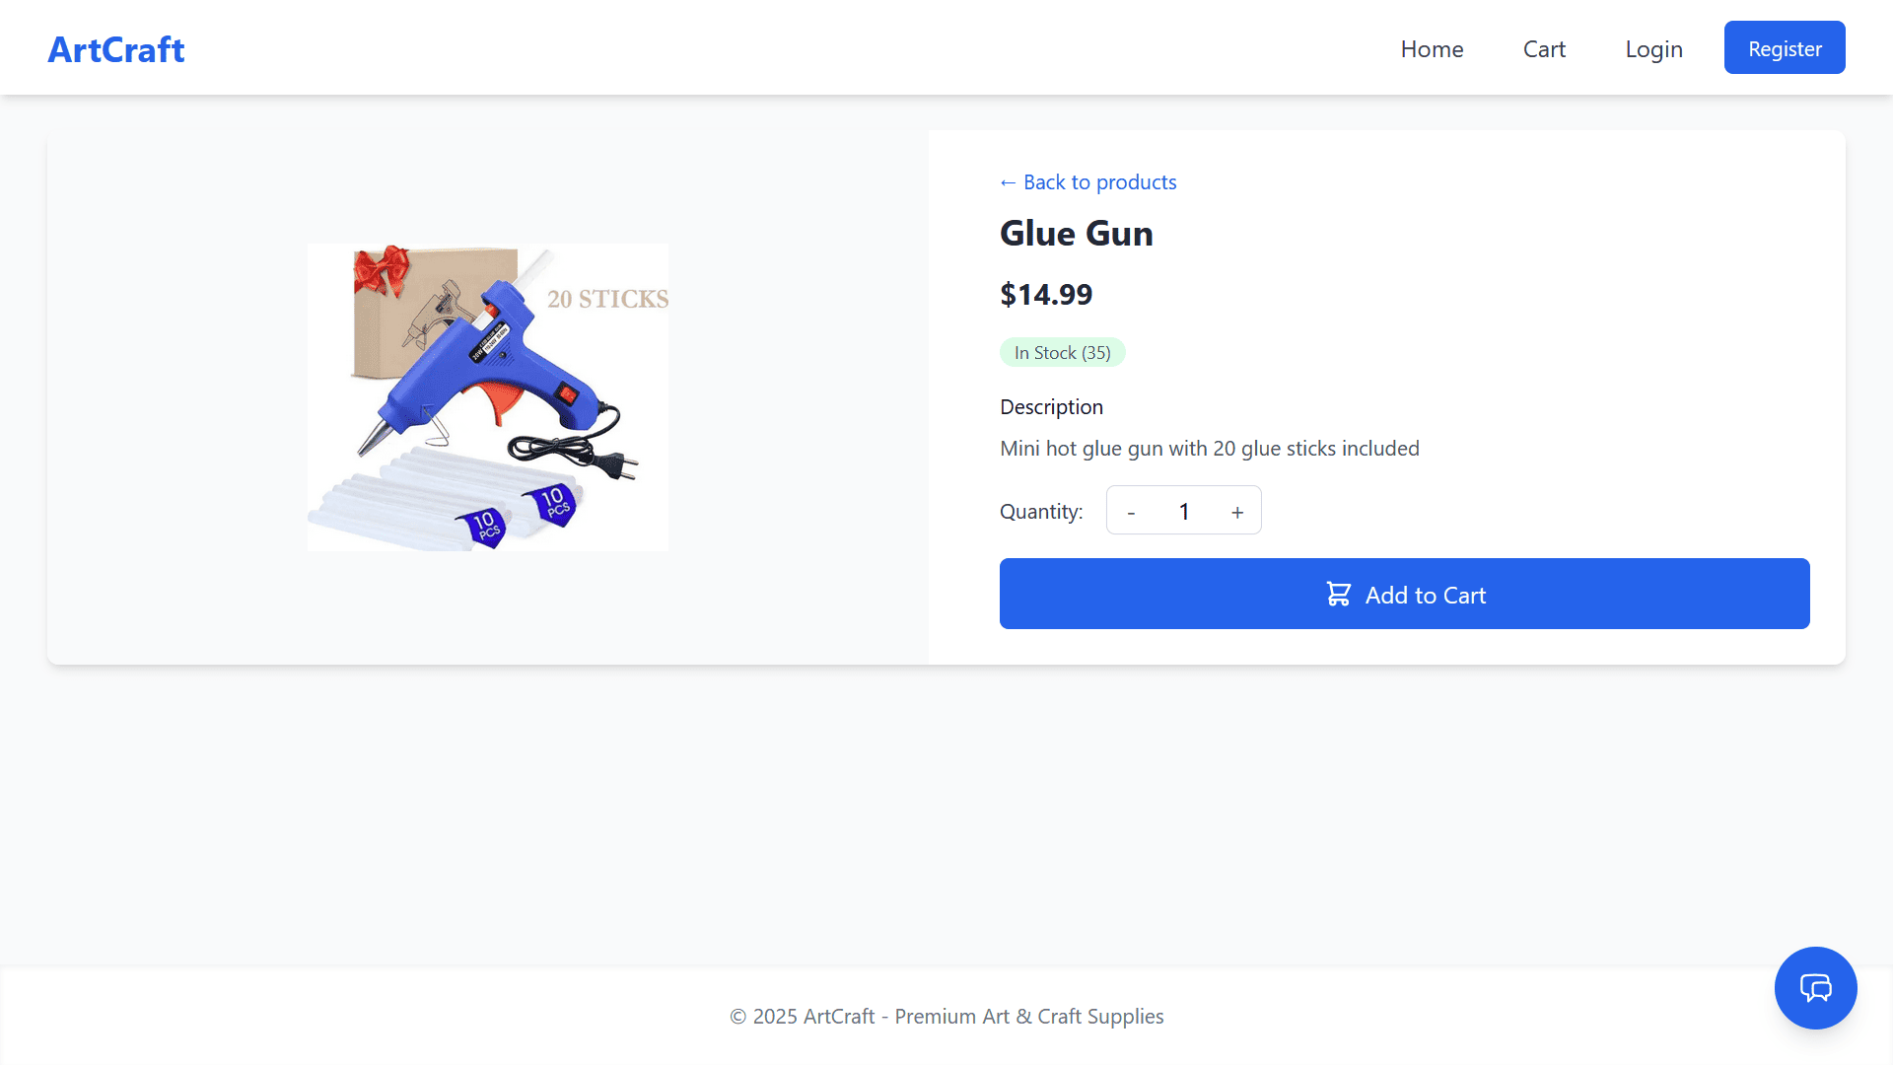Figure 2.1: Desktop View – Product Details

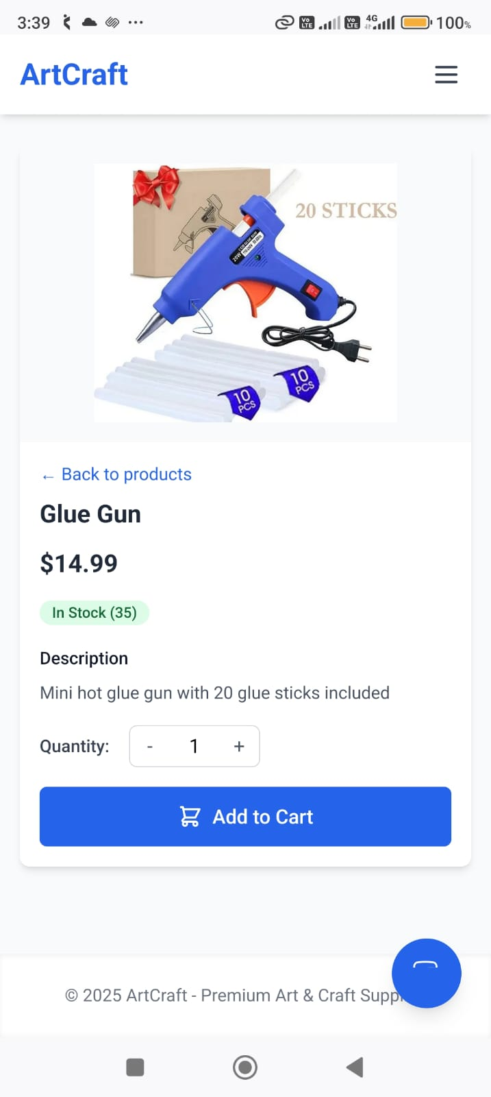
Figure 2.2: Mobile View – Product Details

Cart Page

Description:
Displays all items added by the user, allowing quantity updates, item removal, and total amount calculation.
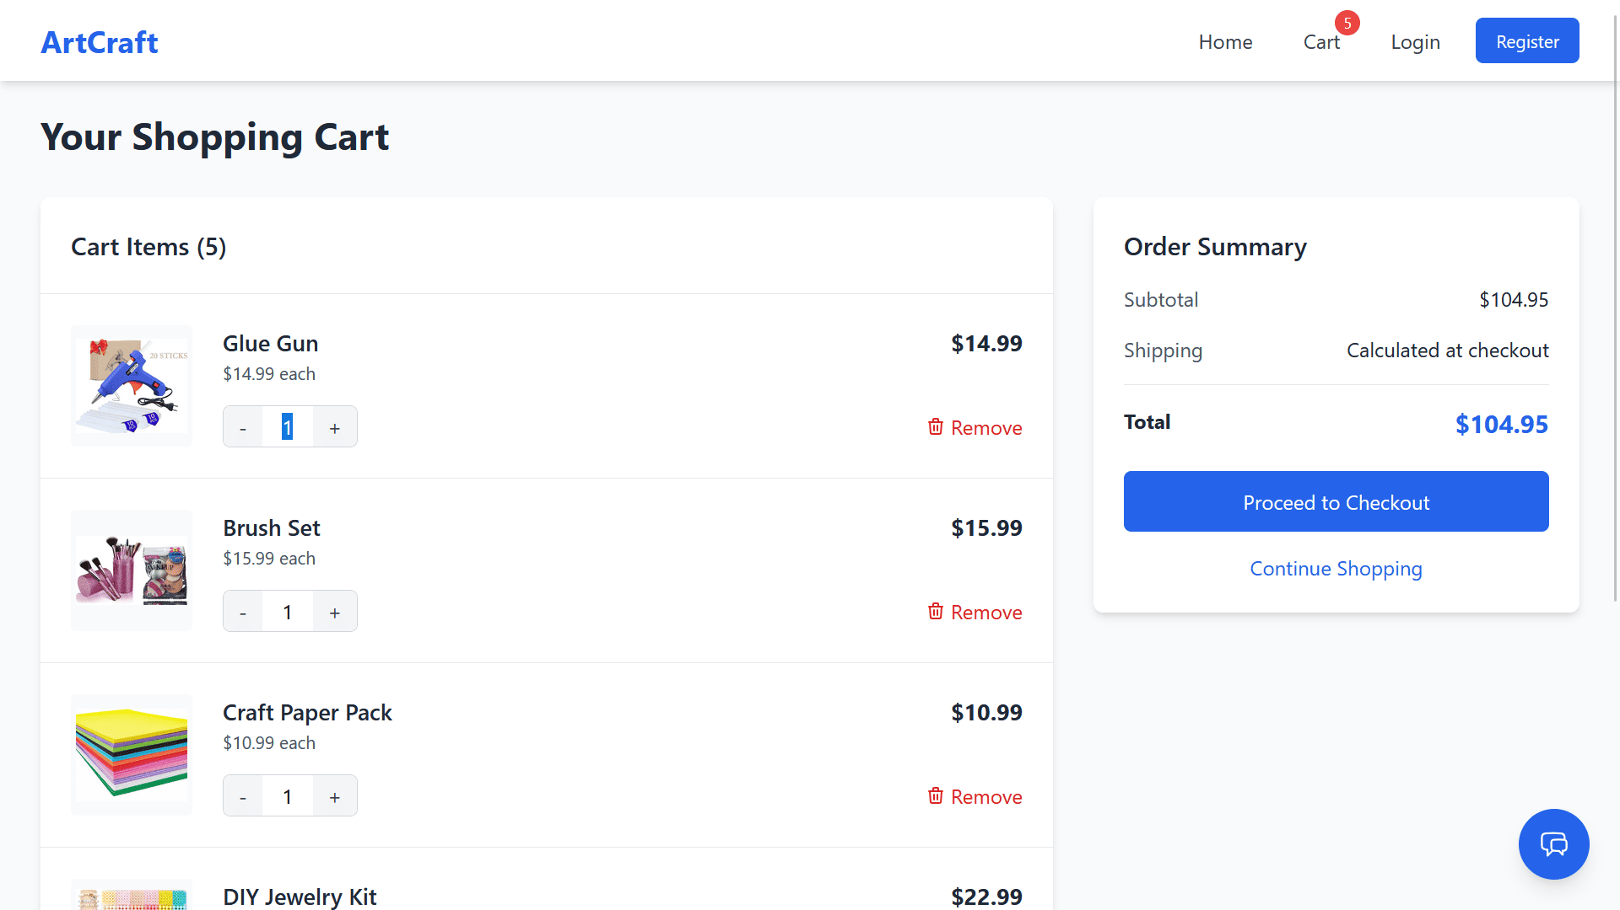Figure 3.1: Desktop View – Cart Page

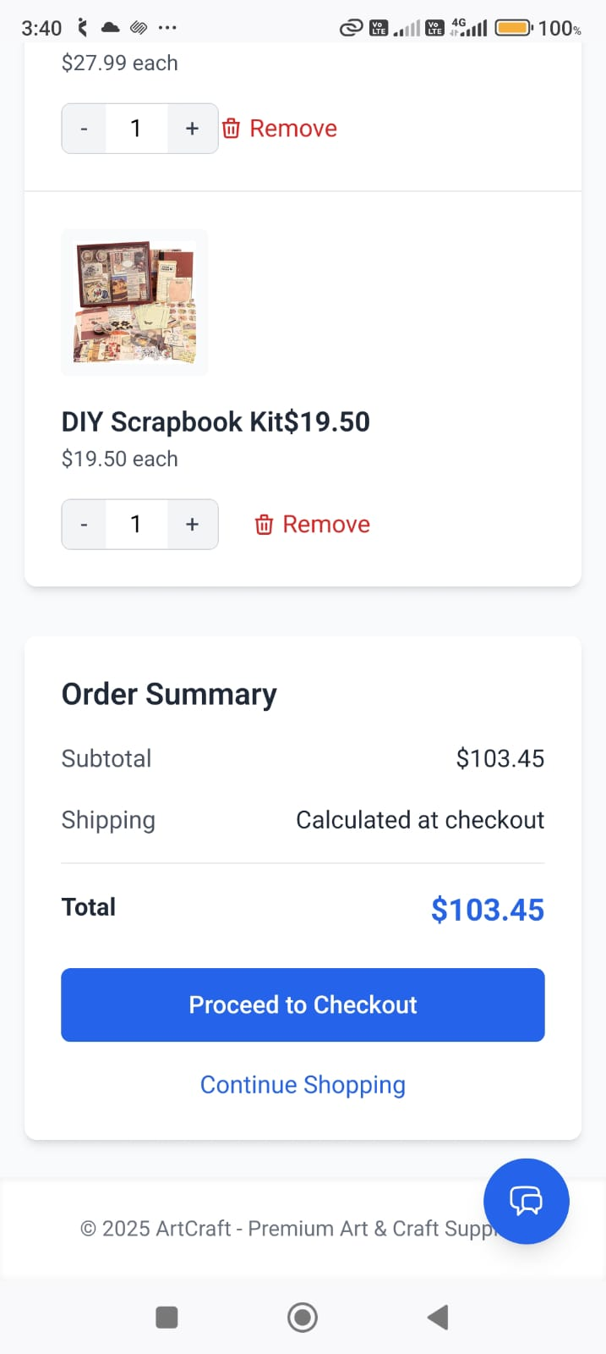
Figure 3.2: Mobile View – Cart Page

Checkout Page

Description:
Supports address input (street, city, state, zip code) and payment method selection (COD currently, UPI planned). The final summary is shown before order placement.

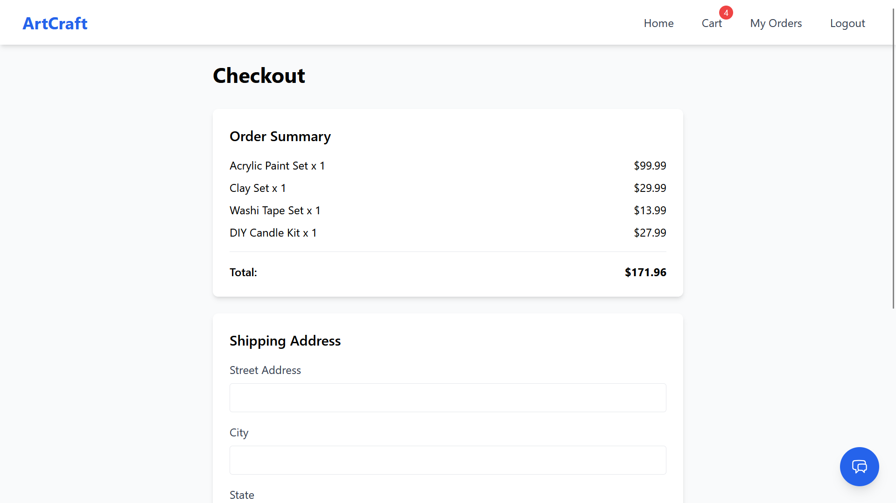Figure 4.1: Desktop View – Checkout Page

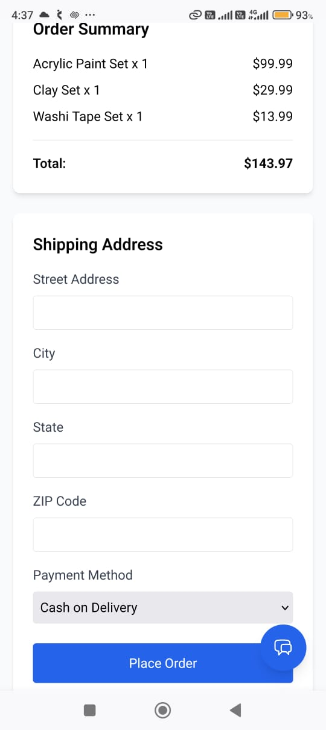
Figure 4.2: Mobile View – Checkout Page

Admin Dashboard
Description:
Admin-only interface featuring product management, order management, and status updates. Designed to be simple, functional, and easy to navigate.

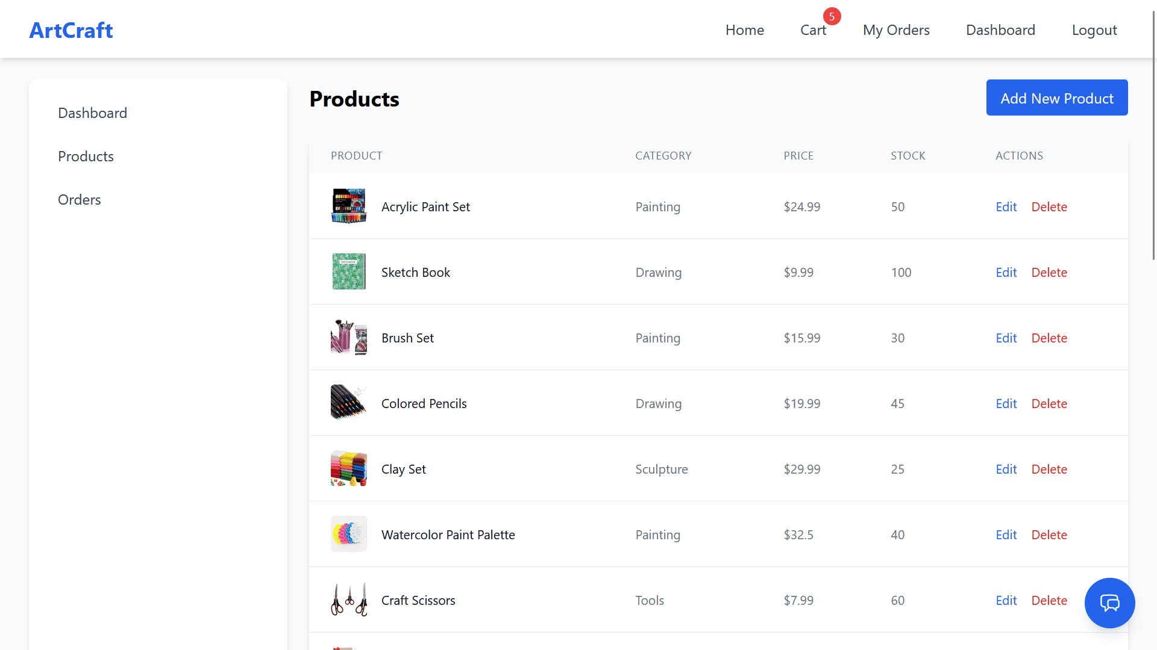Figure 5.1: Desktop View – Admin Dashboard

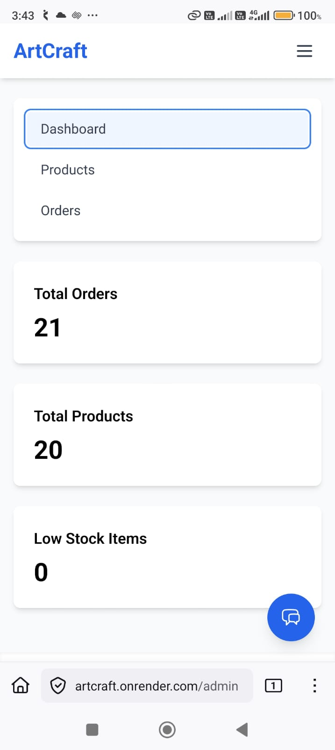

- Figure 5.2: Mobile View – Admin Dashboard

Security Measures

Authentication & Authorization (JWT)

The application uses JSON Web Tokens (JWT) to authenticate users and authorize protected actions. Upon successful login, the server issues a token that is stored in the browser’s localStorage. The token has a 1-day expiry, after which users must log in again. There is no refresh-token mechanism in the current version.
Protected routes verify the JWT on every request, ensuring that only authenticated users can access restricted functionality such as checkout, viewing orders, or accessing the admin dashboard.

Password Hashing

Passwords are currently stored as plain text due to the academic nature of the project. While this simplifies development, it is not secure for production environments.
Industry-standard practice recommends hashing all passwords using libraries such as bcrypt, ensuring:
- one-way encryption
- salted hashes to prevent rainbow-table attacks
- improved security during data breaches
Future versions of the project will adopt bcrypt-based hashing.

Input Validation

The system performs input validation on both frontend and backend to ensure data integrity and prevent malformed requests.
Validation includes:
- empty field checks
- numeric validation (quantity, price)
- email format checks
- Mongoose schema-level validation for required fields and datatypes
Although lightweight, this approach prevents common user input errors and enforces consistency across all modules.

API Protection

The backend implements middleware-based route guarding to secure API endpoints.
Key protections include:
- JWT verification middleware for all authenticated routes
- Admin-only middleware for restricted operations such as product management and order status updates
These security layers ensure that unauthorized users cannot modify data or access sensitive resources.
Rate limiting and advanced CORS security are not implemented yet but are strongly recommended for future upgrades to improve resilience against abuse and automated attacks.

Role-Based Access

Role-Based Access Control (RBAC) ensures users receive permissions appropriate to their role.

- Admin role: can add, edit, and delete products; manage all orders; update order statuses; and control cancellations.
- User role: can browse products, manage their cart, and place orders.
- Guest users: can browse the catalog and add items to the cart but cannot complete checkout without logging in.
This layered structure provides clear separation of privileges and reduces the risk of unauthorized activities within the system.

Deployment

Deployment Environment

The application is deployed using a monolithic architecture on Render.com, where both the backend (Node.js + Express) and the production React build are hosted together. The React application is compiled using npm run build and served as static files directly from the backend.
Render manages server hosting, environment variables, and deployment logs.
Future deployment plans include migrating to AWS EC2 with a custom domain, which will provide greater scalability, improved performance, and better control over server resources.

Build & Department Steps

Deployment follows a simple manual workflow supported by Git and Render:

- Local Build & Development
  - Frontend development: npm run dev (Vite)
  - Backend development: node server.js
  - Production frontend build: npm run build

- Repository Preparation
  - Code is committed and pushed to GitHub for version control and backup.
  - The repository contains both frontend and backend folders within a single project structure.

- Deploy on Render
  - Create a new Web Service on Render.
  - Connect the GitHub repository manually.
  - Configure build command (e.g., install dependencies and build frontend).
  - Configure start command for backend: node server.js.
  - Upload environment variables through Render’s dashboard.

- Monolithic Serving
  - The backend serves the built frontend index.html from the dist or build folder after npm run build.
  - All client-side routes are forwarded to the frontend build.
  - API routes remain accessible under /api/.

This approach is simple, cost-effective, and avoids managing two separate hosting services.

Environment Variables

The following environment variables are used for secure configuration:
- MONGODB_URI = your-mongodb-atlas-uri
- JWT_SECRET = abcd
- PORT = 5000
- NODE_ENV = production
- GEMINI_API_KEY = your-gemini-api-key
All sensitive variables are stored in Render’s environment panel and excluded from public code repositories.

CI/CD

The current deployment does not use automated CI/CD pipelines. All deployments are triggered manually on Render whenever updated code is pushed to GitHub.
Future enhancements include integrating GitHub Actions for automated testing and deployment, enabling:
- automated builds
- test execution before deployment
- auto-deploy on commits to the main branch
This will improve workflow efficiency and reduce deployment errors.

Challenges and Solutions

Understanding MERN Workflow
Challenge:
Learning the complete MERN workflow was initially difficult, especially connecting React (frontend) with Node/Express (backend) and managing data flow across components and APIs.
Solution:
The team gradually broke the system into smaller modules, implemented API endpoints one by one, and tested them using Postman. This modular approach clarified the flow between frontend, backend, and database.

State Management in React
Challenge:
Managing component state, shared data, and UI updates was confusing in the beginning. React’s component-driven architecture required a deeper understanding of props, state, and re-rendering behavior.

Solution:
The use of React Context API simplified global state handling for cart data, authentication, and user session tracking. Over time, consistent patterns were developed to maintain cleaner and more predictable state logic.

API Errors & Debugging
Challenge:
Frequent API errors, mismatched data types, incorrect endpoints, and backend response issues significantly slowed progress. Some bugs were difficult to trace and almost caused the team to give up at certain stages.
Solution:
Systematic debugging using console logs, Postman testing, and step-by-step validation of API requests helped identify and resolve issues. Improved error handling in both backend and frontend reduced unexpected failures.

Mobile Responsiveness
Challenge:
Several pages broke or appeared misaligned on smaller screens during testing. UI elements were either too large, overlapping, or not adjusting properly.

Solution:
TailwindCSS responsive utilities (sm, md, lg) were used to redesign layouts. The team revisited all components and ensured mobile-first adjustments for better responsiveness across devices.

Floating AI Chatbot Integration
Challenge:
Implementing the floating AI chatbot using a free API was new and involved unfamiliar UI positioning, API calls, and error management.
Solution:
A minimal version was built first, then gradually enhanced. Fixed-position CSS styling was applied, and the API calls were tested separately before integrating with the UI. This step-by-step approach made integration manageable.

Backend Debugging & Data Handling
Challenge:
Most time was spent debugging backend logic, particularly order creation, product updates, and error handling with MongoDB schemas.
Solution:
Clearer schema definitions, better console-based debugging, and consistent testing using sample data helped stabilize backend operations.

Time & Motivation Challenges During Placement Season

Challenge:
Placement season caused major delays, reduced motivation, and forced the team to slow down development. Some planned features were postponed or dropped due to time constraints.
Solution:
The team prioritized essential features, created a realistic task list, and focused on completing core modules first. Steady progress over smaller daily targets helped maintain momentum despite busy schedules.

Learning Curve with React

Challenge:
React was the hardest technology to learn, especially understanding components, routing, lifecycle concepts, and reactive rendering.
Solution:
Hands-on practice, building small sample components, and reviewing documentation helped build confidence. Eventually, the team mastered the basics needed for building the full frontend.

Future Enchancements

UPI & Online Payment Integration
A major planned enhancement is adding full UPI-based online payments using providers such as Razorpay. This will allow faster, secure transactions and reduce dependence on Cash on Delivery. Business verification requirements currently limit integration, but once fulfilled, the system will support seamless online checkout.

Advanced Search and Filtering
Future versions will include a more sophisticated product search system with filters for categories, price range, and popularity. This will significantly improve the browsing experience, especially for users looking for specific art and craft supplies.

Improved User Profile & Address Management
The platform will extend the User Module to allow users to update profiles, save multiple addresses, and store past delivery details. This will speed up the checkout process and provide a more personalized shopping experience.

Enhanced Admin Analytics
The admin dashboard will be expanded with analytics such as sales charts, product performance, low-stock alerts, and customer statistics. This will help store owners make data-driven decisions and improve inventory planning.

Dedicated Mobile Application
A future goal is to build a dedicated Android/iOS mobile app using React Native or Flutter. This will improve accessibility for sellers and students who prefer using mobile devices for browsing and order management.

Separate Frontend and Backend Deployment
To improve performance and scalability, the monolithic architecture can be separated into:
- Frontend (React) hosted on Vercel or Netlify
- Backend (Node/Express) hosted on AWS EC2
This architecture will reduce cold-start delays and support larger traffic loads.

Email Verification & Password Reset
Security will be enhanced by implementing:
- email OTP verification
- password reset via email links
- stronger password policies
These improvements will increase authentication reliability and protect user accounts.

Full Inventory Management Enhancements
Advanced inventory tracking features will be added, such as:
- automated stock alerts
- bulk product imports
- low-stock notifications for admins
This will help store owners maintain accurate stock levels efficiently.

AI Chatbot Enhancement
The existing AI chatbot can be improved to support:
- product recommendations
- order tracking
- customer FAQs
- multilingual support
Integrating a more robust AI backend will make the chatbot more helpful and context-aware.

Migration to AWS Infrastructure

Future versions may migrate to AWS EC2, S3, Route53, and CloudFront for improved reliability, speed, and global availability. A custom domain will also be configured for professional deployment.

Conclusion

The ArtCraft E-commerce Platform marks the successful completion of a comprehensive full-stack development journey, combining theory, practical implementation, and real-world problem-solving. The final outcome demonstrates a functional, user-friendly solution that fulfills all core objectives despite time constraints and academic schedules. Completing the essential modules—user authentication, product management, cart and checkout, order workflows, admin dashboard, and mobile responsiveness—reflects the team’s commitment to delivering a solid and reliable platform.

Throughout the development process, the team gained significant experience in the full-stack workflow, particularly understanding how frontend and backend components interact, how APIs are designed and consumed, and how deployment in real hosting environments works. React, Node.js, and deployment practices initially posed challenges, but overcoming them contributed to strong personal growth and technical improvement. Collaboration, task-sharing, and persistence helped the team maintain focus even during placement season, and the successful placement of all team members adds pride and motivation to this achievement.

The platform provides practical value by offering an affordable, simple, open-source solution that benefits store owners, students, and general customers seeking art and craft supplies. Its clean interface, ease of use, and learning-oriented design make it accessible for small businesses and learners who may not have access to expensive software tools. Being open source further strengthens its usefulness by allowing others to study, customize, and build upon the project.
Looking ahead, the system has strong potential to evolve into a production-ready platform with added features such as online payments, enhanced analytics, mobile apps, improved profile management, and cloud-based deployment on AWS with a custom domain. This project forms a solid foundation for future learning, experimentation, and real-world applications, reflecting both the technical competence and dedication developed throughout its creation.

Bibliography & References

This section lists all documentation sources, learning materials, and technical references used throughout the development of the ArtCraft E-commerce Platform.

1. React Official Documentation
ReactJS. “React Documentation.” Meta Platforms, Inc.
https://react.dev
2. Node.js Official Documentation
Node.js Foundation. “Node.js Documentation.”
https://nodejs.org
3. Express.js Official Documentation
Express.js Team. “Express Framework Documentation.”
https://expressjs.com
4. Mongoose / MongoDB ODM Documentation
Mongoose Developers. “Mongoose Documentation.”
https://mongoosejs.com
5. MongoDB Atlas Documentation
MongoDB Inc. “MongoDB Atlas Documentation.”
https://www.mongodb.com/atlas
6. JSON Web Token JWT Documentation
Auth0. “JSON Web Tokens Introduction & Usage.”
https://jwt.io
7. Tailwind CSS Documentation
Tailwind Labs. “Tailwind CSS Documentation.”
https://tailwindcss.com
8. Vite Documentation
Vite Contributors. “Vite Official Documentation.”
https://vitejs.dev
9. MDN Web Docs
Mozilla Foundation. “MDN Web Docs – HTML, CSS, JavaScript, Web APIs.”
https://developer.mozilla.org
10. W3Schools Web Development Tutorials
W3schools.com. “HTML, CSS, JS and Web Development Tutorials.”
https://www.w3schools.com
11. Medium Blogs General Web Development Articles
Medium.com. “Web Development Blogs and Articles.”
https://medium.com
12. GitHub Documentation
GitHub Inc. “GitHub Documentation & Version Control Guide.”
https://docs.github.com
13. Render.com Deployment Documentation
Render. “Render Cloud Hosting Documentation.”
https://render.com/docs
14. Google Gemini API Documentation
Google AI. “Gemini API Developer Documentation.”
https://ai.google.dev/gemini-api
15. Postman API Platform Documentation
Postman. “Postman Documentation.”
https://learning.postman.com
16. Visual Studio Code Documentation
Microsoft. “VS Code Documentation.”
https://code.visualstudio.com/docs
17. ChatGPT OpenAI
OpenAI. “ChatGPT Assistant Usage for Code Explanations and JWT Concepts.”
https://openai.com
18. DeepSeek AI Documentation
DeepSeek. “DeepSeek Code & Assistant Documentation.”
https://deepseek.com
19. Claude AI Documentation
Anthropic. “Claude AI Documentation & Usage.”
https://claude.ai

