AFRICAN WOMEN POWER NETWORK

PROVIDING ICT-BASED TRAINING TO WOMEN FARMERS

IN TARABA STATE, NIGERIA

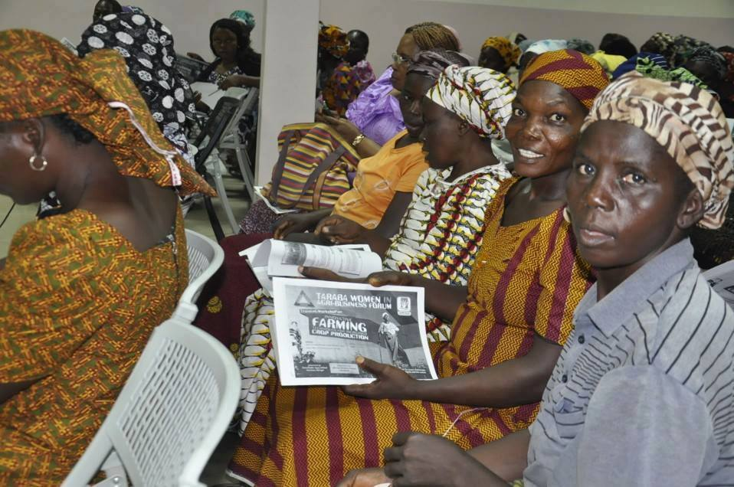*Women at a training in Nigeria. Photo credit: AWP Network*

# Executive Summary

The African Women Power (AWP) Network was founded in 2012 to train, empower, and publicize the stories of African women entrepreneurs. The organization provides a platform for publicity and funding for women and youth entrepreneurs in Nigeria. AWP currently runs three major training programs that combine technology and business education. The first program conducts webinars for African entrepreneurs featuring African experts. The second program provides education in developing business plans and pitch training opportunities to Nigerian students between the ages of 12 and 16. The third program trains women farmers in northern Nigeria, and connects them to improved agricultural methods and materials.

Keywords: mobile training, agriculture, women, Nigeria

# Context

Taraba is a state located in the northeastern part of Nigeria. According to the National Bureau of Statistics of Nigeria, 64.4 percent of Taraba State’s population falls in the “very poor” and “poor” income brackets as of 2009. Taraba has a relatively high literacy rate due to numerous public educational institutions, with a 46.9 percent adult literacy rate for females and a 66 percent adult literacy rate for males. In addition to the ease of access to education centers, computer centers and cyber cafés are prevalent throughout the state. In Taraba, there is a disparity between urban and rural access to mobile devices, as about 90 percent of urban residents have access to a mobile phone while only 60 percent of rural residents have the same.

Taraba’s residents predominantly engage in farming of crops such as cassava, millet, rice, yams, sugarcane, and corn. Some engage in like cattle-, goat-, and sheep-rearing, fishing, pottery, cloth weaving, dyeing, woodcarving, embroidery, and blacksmithing. *According to the National Bureau of Statistics*, Taraba’s total employment in crop farming as of 2006 is on the decline, with current rates at approximately 46 percent for women and about 59 percent for men. In recent years, there have been several initiatives to improve the agriculture sector using information and communications technologies (ICTs). One such example is efarmers.ng, a platform to connect local farmers with businesses to sell crops. Additionally, in 2016, the Federal Ministry of Agriculture and Rural Development in Nigeria – in collaboration with the National Information Technology Development Agency – launched an e-agriculture web portal for stakeholders and farmers to connect and exchange ideas to bolster the agriculture sector.

|  |  |  |  |
| --- | --- | --- | --- |
| Nigeria | | | |
| Population  (UN, 2015) | 183,523,432 | Fixed broadband subscriptions (%)  (ITU, 2016) | 0.01 |
| Population density (per sq. km)  (UN, 2015) | 198.67 | Mobile cellular subscriptions (%)  (ITU, 2016) | 81.82 |
| Median household income  (Gallup, 2006-2012) | US$ 2,667 | Individuals using the Internet (%)  (ITU, 2016) | 25.7 |
| Education  (mean years of schooling)  (UNDP, 2013) | Male: 6.3  Female: 4.2 | Individuals using the Internet by gender (%) (ITU, 2016) | N/A |

# Project Description

The African Women Power Network focuses on three main initiatives. It organizes pitch competitions for young entrepreneurs across Nigeria, supports woman farmers through mobile-based training programs, and helps secondary school students to develop their business plans. Among these initiatives, AWP Network Agropreneur project is a three-day practical agricultural training program, which targets women farmers and helps them improve farming techniques and practices with the goal of increasing yield and production at a reduced cost. It has two main phases. In phase one of the project, female farmers participate in a training program on modern agricultural practices and receive agricultural materials (seedlings, fertilizer, etc.) at no cost. This initial phase, co-funded by a grant from the Planet Earth Institute, provides these farmers improved, innovative farming techniques to increase crop yield and farm more effectively, which they practice on AWP’s demo farm and then on their own farmland. For this training program, AWP partnered with a local entrepreneur and seasoned farmer, who is also the CEO of Farmfields Agro-Allied Services.

In phase two, which is still in development, AWP will continue to provide training and agricultural resources beyond the length of their grant by collecting a percentage of revenue from each farmer’s crop at the end of each growing season. The program had a vision to incorporate mobile technologies widely, but ran into specific challenges due to poor infrastructure. The business model aims to create a sustainable financial future for their entrepreneurial and technical agricultural education in the region. AWP’s emphasis on teaching modern agriculture alongside business practices has the long-range aim of transforming farming from a poverty-level occupation to a successful livelihood.

|  |  |  |  |
| --- | --- | --- | --- |
| Project details | | | |
| Technology | Mobile-based training | Training | 3-day training |
| Year program started | 2014 | Cost to users | Phase 1: Free;  Phase 2: Percent of their yearly crop yield |
| Geography | Rural, Taraba state | Total cost of program | Fixed cost: US$ 15,000;  Operational cost:  1 local farmer instructor/liaison. |
| User profile | 500 women  Late 30s to 60s | Associated organizations | Farmfields Agro-Allied Services,  Oxfam,  The Planet Earth Institute |

# Progress and Results

As of 2017, AWP Network’s agricultural training initiative has trained more than 500 female farmers in northern Nigeria. The network is working on solutions to the challenges the program’s early years have uncovered such as language-barrier issues and infrastructural irregularities to enable the widespread use of mobile technologies for remote training and support.

# Challenges

**Limited and irregular electricity access** – The network’s vision for the program initially included the creation of a mobile application the farmers could access for resources, to support, and supplement the in-person training, but the power supply has proven to be erratic. Mobile phones are widely used in Nigeria, but due to uncertain power supply, mobile applications are seldom used.

**Lack of locally relevant and local language content** – The program was initially conceived with an English-speaking population in mind. The female farmers of northern Nigeria largely speak tribal languages and require content that either caters to local literacy or provides image-based instruction for more universalized adaptation.

# AWP Network’s Suggestions for Future Projects

Partnerships with local community organizations are essential – AWP Network credits its success to the relationships it has built with local community leaders. Where other organizations failed to implement their projects in northern Nigeria, AWP succeeded in gaining the trust of the women it educates. AWP collaborates with individuals respected by the community, businesses and NGOs to better understand the needs of those they serve, demonstrate their respect and trustworthiness, and optimize their implementation practices.

Needs assessment helps save time and efforts – The program did not initially do a needs assessment with the target population to understand their context and needs, but instead they developed the program with an English-speaking population in mind. While on the field, the project team realized that the female farmers of northern Nigeria largely speak tribal languages and require local content or image-based instruction. As a result, they had to revise their training module. Doing a needs assessment helps save time and money.

# Sources

Olushoga, M. (2017, July 28) Personal Interview.

Project website: <https://awpnetwork.com/>