FARMERLINE

PROVIDING ACCESS TO INFORMATION OF FARMERS THROUGH VOICE MESSAGES

IN GHANA

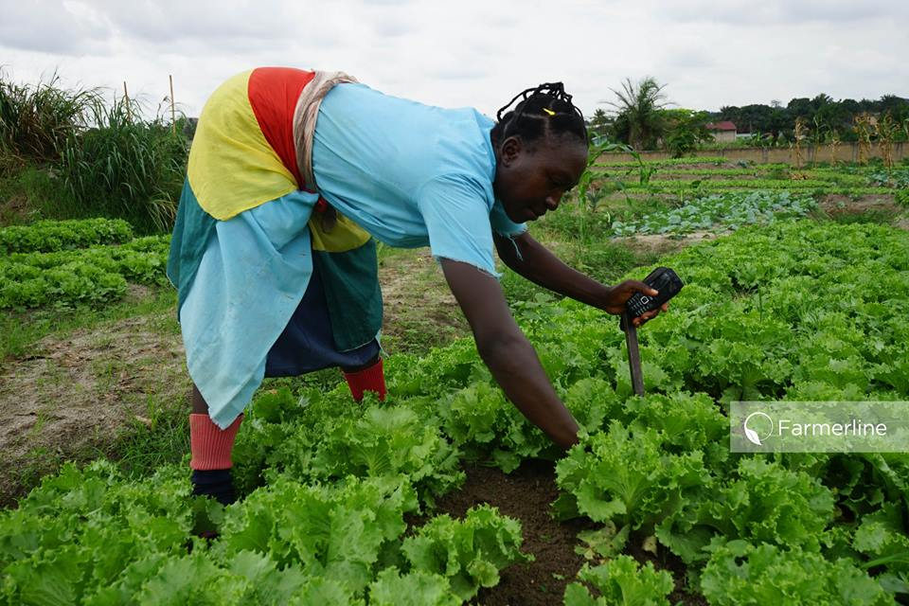*One of Farmerline’s customers. Photo credit: Farmerline*

# Executive Summary

Farmerline is a private company that offers technology-driven solutions to small-scale farmers. With offices in Ghana, Switzerland, and the United States, Farmerline provides affordable services to farmers seeking information on how to better access markets and prices, efficacious cultivation practices, sustainable growth, and increased productivity. In Ghana, where half the population depends on agricultural production for their livelihood and many struggle, Farmerline sells affordable mobile technology aimed at improving those livelihoods into profitable and sustainable practices.

*Keywords: agriculture, mobile phone, voice messaging, farmers, Ghana*

# Context

Agriculture has declined steadily as a major economic sector in Ghana; in 1960, it contributed to 45.2 percent of the gross domestic product (GDP), but reduced to only 19.6 percent in 2016, according to a World Bank report. Yet, about 45 percent of Ghana’s labor force is still engaged in agriculture, according to the United Nations Food and Agriculture Organization (FAO). Low income and employment prospects in rural areas drive the government to prioritize agriculture development to generate more employment opportunities, in addition to ensuring food security and nutrition balance. There are many barriers that hinder Ghanaian farmers from accessing agricultural information to boost productivity, including low literacy rates, lack of technology devices, and nation-wide information and communications technology (ICT) infrastructure, and various local languages. These challenges urge the government and other agencies to find the effective methods to bring new knowledge and information to all farmers.

The Ghana Agricultural Information Network (GAINS) has spearheaded a live, one-hour-long radio show that broadcasts agriculture information and features a question and answer session in partnership with numerous local radio stations since 2004. Thousands of farmers have benefited from these radio programs. In 2013, the Food Africa’s partner IFPRI collaborated with a local network operator called Esoko to provide agricultural market information such as customized crop price information to sample households twice a week via Short Message Service (SMS) messages. Additionally, the Ghanaian government has strived to provide more information to farmers through the E-agriculture Resources website, toll free call center, and a WhatsApp number. Although these efforts are significant, the population of farmers who do not have access to radio, mobile phone devices, or computers will still have difficulty in utilizing the information.

|  |  |  |  |
| --- | --- | --- | --- |
| **Ghana** | | | |
| **Population**  **(UN, 2015)** | 26,984,328 | **Fixed broadband subscriptions (%)**  **(ITU, 2016)** | 0.31 |
| **Population density (people per sq.km)**  **(UN, 2015)** | 113.13 | **Mobile cellular subscriptions (%)**  **(ITU, 2016)** | 139.13 |
| **Median household income**  **(Gallup, 2006-2012)** | US$ 2,050 | **Individuals using the Internet (%)**  **(ITU, 2016)** | 34.7 |
| **Education**  **(Mean years of schooling)**  **(UNDP, 2013)** | Male: 8.1  Female: 5.9 | **Individuals using the Internet by Gender (%) (ITU, 2016)** | N/A |

# Project Description

In 2014-2015, Farmerline conducted a FIRE-funded pilot project bringing telephonic agricultural aid to fish farmers in the Ashanti and Brong Ahafo regions of Ghana. The service consisted of free pre-recorded voice messages sent to farmers’ mobile phones, directed at strategic times during fish cultivation cycles. The participating 3,000 farmers were regular mobile telephone users, relying on voice communication due to illiteracy. The messages were recorded in the region’s local language and contained information about weather, market prices, instructions, facts, and tips to help farmers increase productivity and decrease waste. These farmers had already participated in workshops in which Farmerline researchers and agricultural experts assessed their needs and values. The information provided is helping farmers increase fish production, improve the sustainability of their practice, get better prices at market, and increase their incomes.

The service is now operating with an affordable fee-based business model and currently subscribes 225,000 farmers working on a diverse range of farms. Farmerline’s goal is to subscribe 1 million farmers by 2020.

|  |  |  |  |
| --- | --- | --- | --- |
| Project details | | | |
| Technology | Voice messages | **Training** | Workshops for needs assessment and introduction of technology; check-ins after six months. |
| Year program started | 2014 (-2015) | **Cost to users** | US$ 0.50 every 6 months for a variety of weekly messages. |
| Geography | Rural – Ashanti, Brong, and Ahafo | **Total cost of program** | US$ 10,000 FIRE Africa grant |
| User profile | Varied; 225,000 subscribers | **Associated organizations** | FIRE Africa |

# Progress and Results

Many of the participating fish farmers were inexperienced and untrained. Their cultivation practices were resulting in low yield and high waste. With Farmerline’s recorded information coming at strategic and regular interims, farmers were able to improve their knowledge of proper pond density, feeding amounts and intervals, and cycles of fish production and produce. They were thus able to grow bigger, better quality fish in shorter amounts of time. Participating farmers were able to reduce costs and increase income, with their fish prices at market increasing by 44 percent.

# Challenges

**Network –** Farmerline is able to track if farmers listen to their messages and for how long. This data shows places and moments in which network quality is poor and farmers are not able to successfully access their messages. Farmerline uses this data to adjust its timing for these areas in order to optimize times in which network quality is suitable.

**Water quality –** Water quality is one integral element of fish farming that this distance education is not able to address. Fish quality can vary according to water temperatures and pH levels, which differ pond-by-pond and region-by-region. Farmerline is currently working with local agricultural offices to develop methods to implement devices that would communicate this information from the pond to the farmer and/or local centers.

# Farmerline’s Suggestions for Future Projects

**Training is essential for building and maintaining trust ­–** The training provided by Farmerline serves mostly to build trust between farmers and the business people and experts providing them with information. This trust aids not only in maintaining and increasing subscription levels, but also in the confidence with which the farmers implement Farmerline’s advice, allowing for maximum impact.

**Understanding local user needs is essential while tailoring products –** Education rates in these regions that Farmerline serves are very low, making access to information technology difficult for those who cannot read and/or whose language skills are restricted to local dialects. Farmerline scrapped its early plans to deliver this service via SMS for this reason and instead focuses on curating and timing their information services in local languages, simple structures, frequent intervals, affordably, and by voice.

# Sources

**Wussah, A. (2017, July 27) Personal Interview**

**Project website:** [www.farmerline.co/](http://www.farmerline.co/)