SIYAFUNDA CTC

BRINGING CONNECTIVITY AND DIGITAL LITERACY TO UNDERSERVED COMMUNITIES

IN SOUTH AFRICA

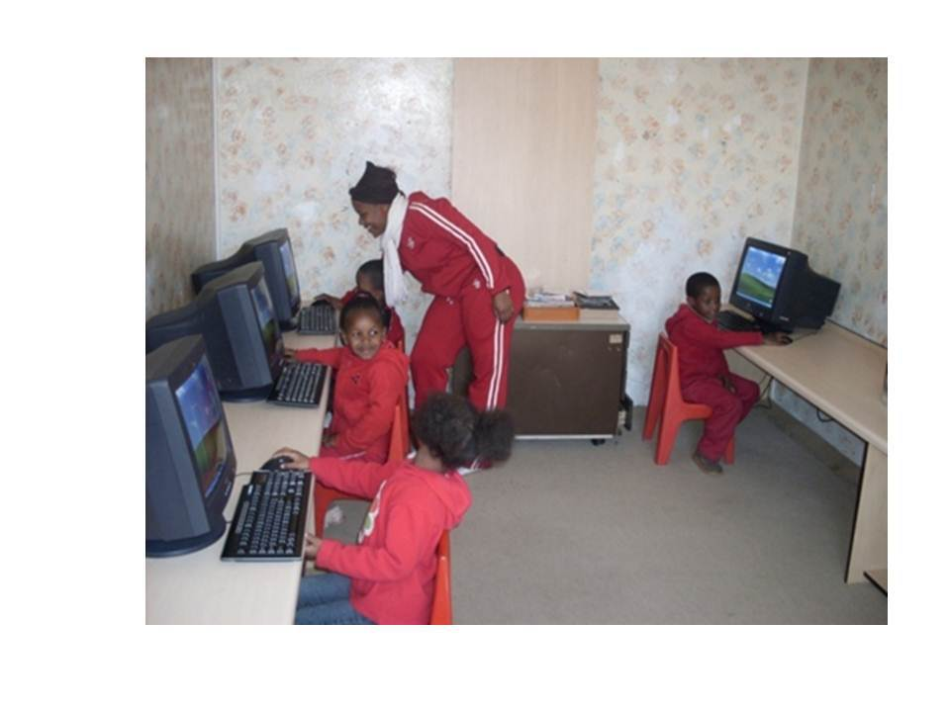*Siyafunda Community Knowledge Center in South Africa, Photo credit: Siyafunda CTC*

# Executive Summary

Siyafunda CTC brings connectivity, technology, and digital literacy to underserviced, generally rural, communities in South Africa. By engaging the government, corporations, and local nongovernmental organizations (NGOs), Siyafunda CTC successfully constructed approximately 180 community knowledge centers (CKCs) in rural villages and schools across the country. These CKCs provide access to the Internet as well as offer low-cost basic and advanced digital literacy training. Siyafunda CTC is an example of a multistakeholder implementation model to produce sustainable connected community centers for traditionally underserviced areas.

*Keywords: digital literacy, rural, deployment, South Africa*

# Context

In South Africa, a majority of households use cellular data to connect to the Internet. The ratio of cellular telephone subscriptions to people is 1.5 to 1. South Africa has focused on information and communications technology (ICT) development in Johannesburg which has competitive prepaid rates, but broadband in the county as a whole remains expensive compared to other developing nations. Broadband subscription penetration is low, at 5.3 subscriptions per 100 people, and speeds are not commensurate with cost.

With an eye toward developing better broadband infrastructure, the government’s “South Africa Connect” project has set two target goals: 90 percent of the South African population should receive internet at 5 megabits per second (Mbps) and 50 percent of the country’s population should connect at average speeds of almost 100 Mbps. While municipalities have plans to install public Wi-Fi hotspots, this deployment does not aid those in rural areas.

|  |  |  |  |
| --- | --- | --- | --- |
| South Africa | | | |
| Population  (UN, 2015) | 53,491,333 | **Fixed broadband subscriptions (%)**  **(ITU, 2016)** | 2.84 |
| Population density  (people per sq.km)  (UN, 2015) | 43.81 | **Mobile cellular subscriptions (%)**  **(ITU, 2016)** | 142.38 |
| Median household income  (Gallup, 2006-2012) | US$ 5217 | **Individuals using the Internet (%)**  **(ITU, 2016)** | 54 |
| Education  (Mean years of schooling)  (UNDP, 2013) | Male: 10.1  Female: 9.8 | **Individuals using the Internet by Gender (%) (ITU, 2016)** | N/A |

# Project Description

Siyafunda CTC launched in November 2006 with an aim to “empower, educate, and econnect communities” guided by the core values of access, affordability, and sustainability. Through the construction of knowledge centers in standalone settings and at schools, Siyafunda offers e-Learning and affordable ICT accredited courses and skills training. Through a blend of peer-, self-, and expert-taught courses, CKCs provide comprehensive digital literacy training. Courses are provided at minimal cost to users, and the average length is approximately a month. Community members not enrolled in courses are also able to use the computers at a low-cost. Funds raised from these fees are reincorporated into the CKC so that it can sustain itself.

The CKCs also provide other services. These include business and entrepreneurial skills development and training, adult literacy programs, bulk Short Message Service (SMS) facilities for community information dissemination, résumé preparation help, and website design and hosting. Siyafunda CTC uses a model the organization refers to as “community public private participation” (CPPP). In practice, this involves leveraging and exploiting as many connections as possible to implement the organization’s goals. Siyafunda CTC partners with all levels of government, universities, NGOs, and corporations seeking donation opportunities.

|  |  |  |  |
| --- | --- | --- | --- |
| Project details | | | |
| Technology | Wireline Internet and devices for access | **Training** | Basic literacy training, Cisco training |
| Year program started | 2006 | **Cost to users** | US$ 75 for computer skills training  US$ 1 for device use |
| Geography | Rural | **Total cost of program** | Undisclosed |
| User profile | School-aged children, youth (ages 18-35), the elderly (~70 percent of which are female) | **Associated organizations** | Cisco,  Intel (She Will Connect), Junior Achievement,  Microsoft,  Ministry of Telecommunications,  Online University,  SAP – ACW Coding |

# Progress and Results

The Siyafunda project has scaled from a single pilot location to more than 180 by 2017. In addition, the organization often implements pilot training programs throughout their network of CKCs. For example, Siyafunda is currently helping to orchestrate a pilot program for 3-D Virtual Learning Environment (3DVLE) in nine schools.

Although the overall number of constituents serviced by the CKCs is unknown, available data paint an optimistic picture. For example, centers in all provinces are responsible for more than 3,000 basic literacy training and 52 advanced Cisco trainings. They have set up nearly 3,500 individuals with email accounts, and 28 people make use of the facilities per day on average. The demographics of the constituency range from school-aged children and youth (ages 18-35) to the elderly. Siyafunda works with partners to ensure that disabled individuals and the visually impaired have access to the CKCs. Notably, 70 percent of Siyafunda CKC users are reported to be female.

Since youth unemployment is almost 30 percent in South Africa, Siyafunda works with students from third and fourth grade all the way to early adulthood to help them use the Internet to learn of employment opportunities and develop their digital skills. The CKCs provide résumé building assistance. Siyafunda CTC also runs government-accredited courses to improve youth employability.

Professional development training at CKCs includes entrepreneurship training. Many constituents run informal businesses and the CKCs help these individuals augment their businesses through online marketing and expansion of potential customer bases. The CKCs are also a hub for two related entrepreneurial programs: Intel’s She Will Connect program that focuses on building the digital skills of women and girls since 2014 and training 10,000 women/girls per quarter on average, and SAP ACW – Africa Code Week that focuses on a coding program, now in its third year in 2017.

Finally, Siyafunda aims to provide useful connectivity to constituents. At a recent women’s training, 30 of the women were agricultural workers. Course leaders taught the women computer skills that have utility to their lives, as opposed to more traditional computing skills such as how to create a spreadsheet.

# Challenges

**Lack of sustained funding** – Since many of the locations where Siyafunda CTC provides resources rely on grants, outside funding cannot be always be guaranteed. Though Siyafunda CTC has been able to generally subsidize the cost of data to charge minimal fees to constituents, overall data fees in Africa keep broadband-enabled technologies out of the hands of disadvantaged citizens.

**Lack of skilled manpower –** In most instances, Siyafunda CTC provides resources to local NGO partners to implement their coursework. The skill-level of each facilitator and their ability to teach digital literacy varies drastically, proving to be a challenge to consistent delivery of courses.

**Lack of locally relevant and local language content –** Most trainings are in English, and work best for users who have dual-fluency in their local vernacular and English.

**Coordination challenges –** There is a gap between national and local government interaction, and this may impede the efficient and successful implementation of policy.

# Siyafunda CTC’s Suggestions for Future Projects

**Engaging effective multi-stakeholder collaborations is helpful –** Siyafunda CTC notes that its ability to build connections between stakeholders, including the tripartite levels of government, corporations, and NGOs is of immense value. Previous attempts to bring connectivity to underserviced areas were not orchestrated in concert and were implemented unevenly and inefficiently. The lack of a centralized plan where stakeholders worked simultaneously led to a considerable amount of redundancy. By incorporating all interested parties into deployment of a project, resources can be distributed equitably and in the most efficient manner possible.

**Connecting vulnerable demographics within the unconnected is of importance –**. Siyafunda CTC actively trains women in its CKCs. The cultural positioning of women in South African society makes them important adopters of technology and leads to more effective community adoption. Siyafunda CTC’s focus on disabled individuals is also important as this constituency is sometimes forgotten even in the most well-meaning endeavors.

# Sources

Smiley, A (2017, July 11) Personal Interview

Project website: <http://www.siyafundactc.org.za/>