IKAMVA YOUTH

IMPROVING THE CAPACITY OF THE YOUTH

IN SOUTH AFRICA

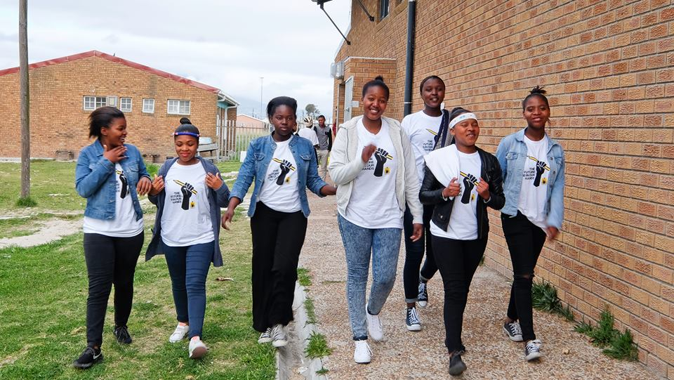

*Photo credit: Ikamva Youth*

# Executive Summary

Ikamva Youth, a nonprofit founded in 2004, equips learners from disadvantaged communities in South Africa with the knowledge, skills, networks, and resources to access tertiary education and/or employment opportunities once they matriculate. Ikamva Youth aims to increase the collective skill level of the population, grow the national knowledge base, and replicate its success in more communities. Ikamva Youth currently operates with branches in five provinces of South Africa: Western Cape, Gauteng, KwaZulu-Natal, Northwest, and Eastern Cape. While learners enroll at Ikamva Youth when they are in grades 9, 10, and 11, the program’s success is ultimately determined by the number of grade 12 learners who access tertiary institutions and/or employment-based learning opportunities when they matriculate. The Ikamva Youth model draws from a large and growing pool of volunteers made up of students from nearby universities and local professionals. Notably, ex-learners who gain entrance to tertiary institutions and return to tutor drive the organization’s sustainability.

*Keywords: digital literacy, youth, employment, South Africa*

# Context

Statistics about literacy rates in South Africa are rather inconsistent. While the United Nations Educational, Scientific, and Cultural Organization (UNESCO) estimated that 98.96 percent of people between the ages of 15 to 24 were literate in 2015, the 2016 Research on Socioeconomic Policy brief showed that 58 percent of Grade 4 learners in South Africa could not read for meaning, while 29 percent are completely illiterate. Nevertheless, the quality of education in South Africa has been lamented by many researchers, policy-makers, and concerned citizens.

The high cost of labor, low skills, difficulty job searching, and persistently low employment outcomes are some of the barriers for South African youth to securing employment. The challenging job search is related to the fact that poor youth cannot afford or are incapable of using the Internet to search for jobs or postsecondary education opportunities, and it is difficult for them to leverage their social network.

The South African government and other organizations have been striving to address youth unemployment issues through various programs. The National Youth Development Agency (NYDA) is an agency established in 2008 that is operating the National Youth Service (NYS) program, which tackles youth unemployment. The Fit for Life, Fit for Work program provides young people with a comprehensive program that offers life skills and work-related skills training, and job search assistance, with a 80 percent success rate. Additionally, the Harambee Youth Employment Accelerator project takes a different approach by advocating employers practice inclusive recruitment that focuses on young people.

|  |  |  |  |
| --- | --- | --- | --- |
| South Africa | | | |
| Population  (UN, 2015) | 53,491,333 | **Fixed broadband subscriptions (%)**  **(ITU, 2016)** | 2.84 |
| Population density (people per sq.km)  (UN, 2015) | 43.81 | **Mobile cellular subscriptions (%)**  **(ITU, 2016)** | 142.38 |
| Median household income  (Gallup, 2006-2012) | US$ 5,217 | **Individuals using the Internet (%)**  **(ITU, 2016)** | 54 |
| Education  (Mean years of schooling)  (UNDP, 2013) | Male: 10.1  Female: 9.8 | **Individuals using the Internet by gender (%) (ITU, 2016)** | N/A |

# Project Description

Ikamva Youth aims to increase the collective skill level of the population, grow the national knowledge base, and replicate success in more communities. Ikamva Youth works with learners from township-based secondary schools to help them improve their grades, access quality post-school opportunities, and return to help others do the same. Ikamva Youth accepts learners based on their motivation to participate, as opposed to their academic results; most learners have averages well below 50 percent when they join, for instance.

Ikamva Youth currently operates with branches in five South African provinces: Western Cape, Gauteng, KwaZulu-Natal, Northwest, and Eastern Cape. They operate 17 centers in total, with 14 computer labs featuring 25 computers each. While learners enroll at Ikamva Youth when they are in grades 9, 10, and 11, the program’s success is ultimately determined by the number of grade 12 learners who access tertiary institutions and/or employment-based learning opportunities when they matriculate.

Ikamva Youth’s services are free for the participants. Those programs include Internet access and Internet and computer literacy training. They offer open Internet access, with the exception that some websites are blocked for educational purposes (e.g., pornographic websites). They partner with Computers for Kids to generate the training curriculum. The training programs focus on supplementary tutoring and homework sessions, career guidance, mentoring, computer literacy and access, the Media, Image, and Expression program – which enables learners to express themselves creatively and assertively as well as build their self-esteem – and the Health and Leadership program that ensures HIV/AIDS, nutrition, and broader health awareness and voluntary testing provides learners with the information and voluntary counseling and testing (VCT) services they need to manage their health. Training lasts for three hours per week over the course of six months, and is conducted after school, on weekends, and during school holidays.

The Ikamva Youth model draws from a large and growing pool of volunteers made up of students from nearby universities and local professionals. Additionally, ex-learners who gain entrance to tertiary institutions and return to tutor drive the organization’s sustainability. More than half of the volunteers at longer-established branches are ex-learners, and more than 80 percent of the Khayelitsha management committee comprises of ex-beneficiaries. Thus, Ikamva Youth provides the additional advantage of allowing ex-Ikamva Youth learners to be agents of change, from beneficiary to benefactor.

|  |  |  |  |
| --- | --- | --- | --- |
| Project details | | | |
| Technology | Basic Internet training | **Training** | 3 hours per week over 6 months |
| Year program started | 2004 | **Cost to users** | Free |
| Geography | 5 provinces of South Africa: Western Cape, Gauteng, KwaZulu-Natal, Northwest, and the Eastern Cape | **Total cost of program** | Fixed cost: 10,000 rand (US$ 843.50) to 500,000 rand (US$ 42,175)  Operational cost (monthly): 5,000 rand (US$ 420) for training, 4,000 rand per year (US$ 380) for the licensing fee, 1,500 rand (US$ 100) for data, and 10,000 rand (US$ 843.5) -- 1 data center |
| User profile | Students in grades 9-12 | **Associated organizations** | Computers for Kids |

# Progress and Results

Since 2004, thousands of committed learners have participated in Ikamva Youth programs, with an attendance rate of 75 percent and higher. There are currently 14 Branches in five provinces across South America, and approximately 1,900 learners currently registered at the branches from grades 8-12. Ikamva Youth currently supports other nonprofit organizations to deliver an after-school tutoring program, which supports approximately 800 learners. Ikamva Youth has consistently achieved between an 80-100 percent high school matriculation pass rate since 2005. Since 2010, 43 percent of learners have achieved bachelor passes (previously, matric exemptions), and 31 percent achieved a diploma. Overall, 65 percent of those learners who have matriculated from high school have accessed tertiary education, an internship, or employment within two-and-a-half months of matriculating. Many matriculating learners from previous classes are staying on to volunteer for the next generation of learners.

The University of Cape Town’s Development Policy Research Unit conducted an independent evaluation of Ikamva Youth’s work, and found that more than 97 percent of graduates reported that the program inspired them to work harder, Moreover, while 83 percent said it changed their expectations of what they can become, 85 percent said it helped them access post-schooling opportunities.

Ikamva Youth’s impact reaches beyond individual successful learners as a result of its democratic approach to leadership and developing civic awareness in the communities they work in. At its core, Ikamva Youth addresses the challenges of urban poverty and inequality perpetuated by South Africa’s education crisis.

The project has received many awards, including a 2014 Global Social Benefit Institute (GSBI) Accelerator program scholarship from the Miller Center for Social Entrepreneurship at Santa Clara University in California, a 2013 Ashoka Fellowship, a 2013 Stars Foundation Impact Award, and a 2010 Drivers of Change award from the Southern African Trust.

# Challenges

**Lack of sustained funding** – The program is expensive to run, especially the costs of data, Internet service, and installation of devices and infrastructure to support connectivity.

**Equipment damage** – Break-ins, theft of equipment, and vandalism of labs is common. Serving low-income populations with uneven commitment to the project in areas with relatively higher amounts of crime means the labs can be vulnerable.

**Limited and irregular electricity access –** Power outages in the serviced areas make connectivity unreliable.

**Technological obsolescence –** Technology is always changing, and laptops are superseding desktops and tablets. Keeping up with the pace of updates is expensive and time consuming, and means users need to be trained constantly on new equipment.

# Ikamva Youth’s Suggestions for Future Projects

**Community participation is key –** To combat vandalism and theft, and raise rates of new user adoption, it is important to make the community a part of the project, with a stake in its maintenance and sustainability.

# Sources

Mashanda, P (2017, October 31) Personal Interview.

Project website: [www.ikamvayouth.org](http://www.ikamvayouth.org)