Tulaa

PROVIDING MARKET ACCESS FOR SMALLHOLDER FARMERS

IN RURAL KENYA

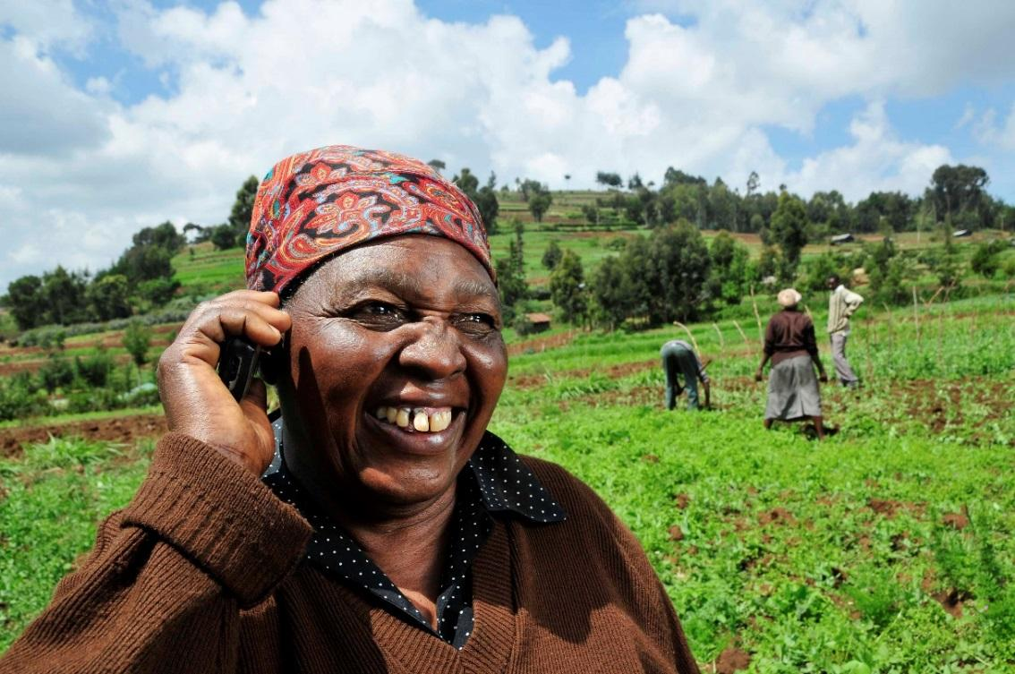

*A woman farmer using mobile phone. Photo credit: Neil Palmer*

# Executive Summary

Tulaa is a marketplace for smallholder farmers, providing them inputs, credit, agronomic advice and market linkages. The company aims to help these workers make more advantageous purchases, sales and agricultural decision-making by offering them skilled brokering, advisory services, and access to information and input financing. Their target demographic is farmers who work with horticulture crops and have about 2-2.5 acres of land. Currently, their focus is on workers in Kenya’s Rift Valley and Eastern Kenya, for which horticulture is a significant part of the economy. Results of an independent analysis showed that approximately 71% of the farmers have never accessed input financing before, and so were financially excluded prior to connecting with Tulaa. Despite women doing most of the labor, men represent the bulk of customers due to gender inequality in agriculture. However, 30% of Tulaa’s clientele are women. Surveyed farmers also self-report increases in incomes over the prior season, including 84% of farmers in the latest season.

*Keywords: mobile technology, AI, financial inclusion, agriculture, rural Kenya*

# Context

Recent years have seen widespread efforts across the developing world to integrate larger swaths of the population into the economic mainstream through innovations in mobile money technology. Increased access to mobile phones have set the foundation for this, particularly as many of these digital services operate on USSD and do not require Internet.   
  
In Kenya, over 70% of adults now have a mobile money account. This high proportion masks the disproportionately lower participation of members of the lower strata, particularly last mile agricultural workers, on these platforms. It is imperative to achieve more financial inclusion for this demographic given the critical that agriculture plays in the economy and food security. Entrepreneurs have been developing targeted digital solutions to increase financial inclusion with their challenges in mind, particularly the lack of economic identity and financial identity which effectively bars suppliers’ access to bank credit for capital and inputs. Due to these simple digital interventions, increasing numbers of smallholder farmers are increasing their productive capabilities and developing mutually beneficial market linkages with a broader set of suppliers and agribusinesses, domestically and internationally.

|  |  |  |  |
| --- | --- | --- | --- |
| **Kenya** | | | |
| **Population**  **(UN, 2015)** | 46,748,617 | **Fixed broadband subscriptions (%)**  **(ITU, 2016)** | 0.33 |
| **Population density**  **(people per sq.km)**  **(UN, 2015)** | 80.55 | **Mobile cellular subscriptions (%)**  **(ITU, 2016)** | 81.28 |
| **Median household income**  **(Gallup, 2006-2012)** | US$ 1,870 | **Individuals using the Internet (%)**  **(ITU, 2016)** | 26 |
| **Education**  **(Mean years of schooling)**  **(UNDP, 2013)** | Male: 7.1  Female: 5.4 | **Individuals using the Internet by Gender (%) (ITU, 2016)** | N/A |

# Project Description

Tulaa, named after a Sanskrit term for "balance” or "equal measure,” leverages mobile technology and artificial intelligence to create an equal playing field in the agricultural supply chain by giving smallholder farmers access to inputs, finance, information and markets in the virtual marketplace. The company was founded in mid-2017, and has since served the Rift Valley and Eastern Kenya, where horticultural crop farming thrives. The majority of farmers who use the platform, literate and semi-literate rural communities, report never having had access to input financing before Tulaa. They also lacked prior access to information and connections that would make them more competitive in the industry. Tulaa helps these suppliers make more profit by connecting them to sellers who are outside of their immediate market and relieving them of exploitative brokers. In these ways, the platform has made inroads into financial inclusion for last mile workers.   
  
Use of the technology does not require access to Internet, only access to a cell phone (as payments are USSD-based). Farmers can place orders for inputs and apply for loans through the platform. If they are approved for a loan, they are sent an electronic voucher to have their order fulfilled by their nearest retailer who also uses the Tulaa app. During the season, the company also sends them agronomic information over SMS, and has a year-round, 10-person-staff (and growing) call center that operates from 8am to 5pm six days a week to answer agronomy inquiries from farmers. While on-the-ground agronomic training is too costly, Tulaa has field agents for customer recruitment and registration, input selection and loan applications. These agents are usually well-respected, tech-savvy farmers, which helps build trust with farmers using the service.  
  
Before harvest, the farmers make bookings with the company—sharing when they will harvest, their prospective yield, and how much they wish to sell on the platform—so that sales can be planned effectively. The company is working on making this process more efficient by building Android applications, algorithms and AI to automate the matching of buyers and sellers. It continues to work on quality improvement using data derived primarily from customer feedback surveys and net promoter score surveys.  
  
Tulaa’s business model includes three streams of revenue: a margin on inputs sold, a margin on credit (including a ~2.5% monthly interest rate), and a margin on off-take transactions (the sale of produce). It raised about $900,000 in equity last year, raised about $600,000 in debt this year, and received approximately $750,000 in grant funding. Tulaa works with a number of multinational companies such as Toyota, Syngenta, and OCP, and is supported by investors including Global Partnerships, Beyond Capital Fund, AHL Venture Partners, and Acumen Fund.   
  
There are a couple of factors that make Tulaa unique among other similarly placed organizations. First, it is one of the only end-to-end marketplace for farmers on the continent, where they can get inputs, credit, agronomy and market linkage. Tulaa aims to be a one-stop shop for farmers. In addition, Tulaa is a technology company at its core, and leverages different kinds of mobile technology and artificial intelligence to work more effectively and impactfully.

|  |  |  |  |
| --- | --- | --- | --- |
| Project details | | | |
| Technology | Mobile technology | **Cost to users** | The information is free, farmers pay for the credit |
| Year program started | July 2017 | **Training** | No training |
| Geography | Rift Valley and Eastern Kenya | **Total cost of program** | Operational cost: N/A |
| User profile | 15,000 small farmers | **Associated organizations** | Acumen  AHL Venture Partners  ARM Mavuno  Beyond Capital Funds  Global Partnerships  OCP  Syngenta  Toyota |

# Progress and Results

There are currently 15,000 farmers on Tulaa’s platform, including active and inactive users. While some farmers only transact during a given season, that means that about 5,000 are active each season. This year Tulaa is on track to sell about $650,000 in inputs on credit and about $750,000 in commodities (sold produce).

Results of an independent analysis showed that approximately 71% of the farmers have never accessed input financing before, and so were financially excluded prior to connecting with Tulaa. Despite women doing most of the labor, men represent the bulk of customers due to gender inequality in agriculture. However, 30% of Tulaa’s clientele are women. Surveyed farmers also self-report increases in incomes over the prior season, including 84% of farmers in the latest season.

# Challenges

**Working with banking institutions** - It was challenging working through the banks and microfinance institutions in the first iteration of the project. There was a disconnect in expectations in terms of the target customer, speed of loan decision-making, etc. This hurt customer experience, and the company realized that to rectify it needed to change course. Fortunately, Tulaa was in a unique position to do some of the work they had previously sought banks and MFIs to assist with because of the business’s relationship with customers, data on customers, and ability to use technology more effectively than a traditional commercial bank. Consequently, Tulaa changed course and began to do underwrite loans independently.   
  
**Fragmented logistics** – Another challenge is related to logistics for market linkage. Third-party logistics are very fragmented in Kenya and that complicates Tulaa’s ability to quickly get product to market.

# Tulaa’s Suggestions for Future Projects

**Have control over customer experience** - Ensure you have enough control over the customer experience, and the entities you choose to work with (banks, MFIs, etc.) are not inadvertently working against that. You must truly understand your customers and what they want. It is easy to allow bias into your understanding and being vigilant about checking assumptions is key.    
  
**Be adaptive** - There are certain things that early on might not seem feasible for a company to do (e.g. underwriting loans), but it has to be open to changing course according to what the data supports.

# Sources

Miller-Wise, H. (2019, June 13). Personal interview.

*Project website:* <https://www.tulaa.io/>

GSMA AgriTech Programme. (2019). “Improving financial inclusion through data for smallholder farmers in Kenya.” Document website: <https://www.gsma.com/mobilefordevelopment/wp-content/uploads/2019/06/GSMA_AgriTech_Improving-financial-inclusion-through-data-for-smallholder-farmers-in-Kenya.pdf>