ENERGIZE THE CHAIN

PROVIDING LAST-MILE VACCINE REFRIGERATORS USING TOWER POWER

IN RURAL ZIMBABWE

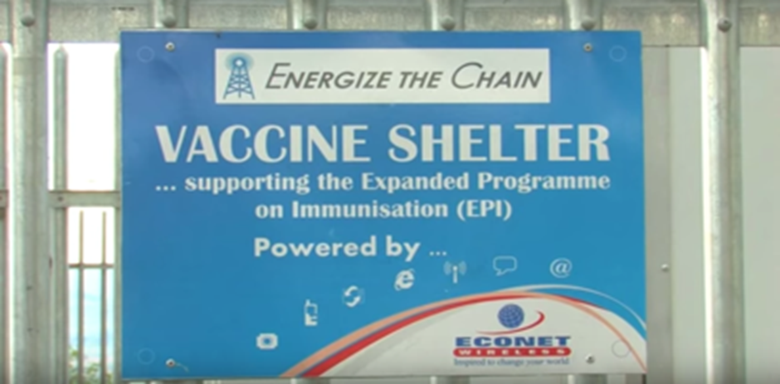*An Energize the Chain vaccine shelter in Zimbabwe. Photo courtesy of Energize the Chain*

# Executive Summary

Econet Wireless is a nonprofit organization that provides reliable green power for mobile towers and homes in off-grid rural areas of Zimbabwe. This electricity also powers vaccine refrigerators in partnership with the Energize the Chain project to provide vaccines for preventable diseases to children in these regions. Presently, there are 312 off-grid mobile towers with vaccine refrigerators and remote health clinics in operation, with implementation plans in other countries in the region, such as Ghana, as well as globally.

*Keywords:* *health, 3G cell towers, deployment, rural, Zimbabwe*

# Context

Zimbabwe has about 16 percent of its population able to access some form of Internet service, remaining among the countries with the lowest rates of penetration in the world. Furthermore, even among Zimbabweans that can connect to the Internet, only 54 percent of the population have access to 3G connectivity – with most others using 2G service and millions having no form of access at all.

For a vaccine to remain effective, it must be kept at temperatures between 2 and 8 degrees Celsius. In practice, this means constant refrigeration from manufacture to administration. The system of storage and mobile refrigeration units are known as the “cold chain.” Last-mile disruptions cause up to 40 percent of vaccines to be wasted.

|  |  |  |  |
| --- | --- | --- | --- |
| Zimbabwe | | | |
| Population  (UN, 2015) | 15,046,102 | **Fixed broadband subscriptions (%)**  **(ITU, 2016)** | 1.1 |
| Population density  (people per sq.km)  (UN, 2015) | 38.51 | **Mobile cellular subscriptions (%)**  **(ITU, 2016)** | 83.18 |
| Median household income  (Gallup, 2006-2012) | N/A | **Individuals using the Internet (%)**  **(ITU, 2016)** | 23.1 |
| Education  (Mean years of schooling) (UNDP, 2013) | Male: 7.8  Female: 6.7 | **Individuals using the Internet by Gender (%) (ITU, 2016)** | Male: 18.3  Female: 14.6 |

# Project Description

Econet Wireless has set up off-grid mobile phone towers powered by robust electrical infrastructure in most rural parts of Zimbabwe. The electrical supply to these towers is provided by turbines, diesel generators, and sometimes, solar energy.

In 2013, Econet Wireless partnered with a group known as Energize the Chain to launch nearly 100 sites across Zimbabwe. In coordination with the Zimbabwe Ministry of Health, the partnership targeted outreach on a need basis, prioritizing regions with poor cold chain equipment performance and poor electrical connectivity.

This “tower power” can provide cellular connectivity to rural Zimbabweans that are in off-grid locations, and often is the first electrical power within many communities. In collaboration with Energize the Chain, Econet Wireless has deployed a model to reduce preventable childhood deaths among the world’s most vulnerable populations by harnessing the power generated at these stations to solve one of the pressing challenges of immunization across the developing world – the cold chain problem.

The co-location model houses a vaccine refrigerator at a mobile tower site adjacent to a health clinic in need. By harnessing the cell tower’s excess power, the refrigerator is kept at the required 2 to 8 degrees Celsius to maintain vaccine efficacy. Vaccine spoilage is minimized, optimizing healthcare workers’ time as well as reaching populations in the most geographically unfriendly places for vaccine standards compliance.

|  |  |  |  |
| --- | --- | --- | --- |
| Project details | | | |
| Technology | 3G cell towers | **Training** | No |
| Year program started | 2013 | **Cost to users** | Free |
| Geography | Rural Zimbabwe | **Total cost of program** | Undisclosed |
| User profile | Healthcare providers | **Associated organizations** | American Tower Company (ATC)  Johnson and Johnson  KNUST  Kumasi Center for Collaborative Research in Tropical Medicine  Ministry of Aviation,  Ministry of Health  Ministry of Transportation  MTN  NexLeaf Analytics  Rockefeller Foundation  USAID  UNICEF  Vayu  Xzeres |

# Progress and Results

Econet Wireless provides the first Internet access and the first electricity to many communities in rural areas of Zimbabwe. It offers home electricity for a US$ 6 installation fee and US$ 1 per week for service. Through its partnership with Energize the Chain, Econet Wireless has made an impact on the health outcomes of the region’s children. As of 2015, more than 250,000 vaccines have been transported through or administered at 111 Energize the Chain sites in Zimbabwe. By 2017, this had increased to 312 sites in the country, which lead to the vaccination of more than 500,000 children.

Moving outside of Zimbabwe, as of 2017, Energize the Chain is implementing a plan in Ghana as well. Centering on the Upper East, Upper West, and Volta regions, the project will provide 31 high-need health clinics. Planning and implementation has also occurred in Lesotho and Burundi. Outside of Africa, Energize the Chain is working in other parts of the world as well. In India, for example, the organization has five sites serving approximately 15,000 children. Finally, Energize the Chain is working on tangential projects such as infant biometrics and real-time surveillance of a host of variables related to the refrigerators, including inventory monitoring and interior and exterior temperatures reporting.

# Challenges

**Lack of affordable access –** Alliance for Affordable Internet (A4AI) estimates that 500 megabytes (MB) of mobile broadband costs nearly 30 percent of Zimbabwe’s gross national income (GNI) per capita of US$ 840, which is much above the 5 percent threshold set by the International Telecommunication Union (ITU).

**Limited and irregular electricity access –** Most of the rural areas in Zimbabwe do not have reliable sources of power, which presents major challenges to connectivity since cellular towers require constant power to remain functional. Immunization programs struggle with several basic obstacles in vaccine refrigeration and delivery due to unreliable energy sources and irregular equipment maintenance as well.

**Insufficient data –** The remoteness of the vaccine shelters make it difficult to know the available inventory, especially in cases of multiple administration vaccines. Energize the Chain and other organizations are seeking ways to have real-time inventory management to insure healthcare providers have the necessary vaccines available as needed.

# Econet Wireless’ Suggestions for Future Projects

**Co-location is important –** The exponential growth of mobile networks in the developing world far outpaces broadband penetration. Since customers demand uninterrupted service, mobile companies work tirelessly to maintain power at mobile towers. By making use of the superfluous power from these towers, refrigerators will always have electricity. In practice, this guarantees a more efficacious vaccine distribution model and saves children’s lives.

**Not-geographically bound ­–** Energize the Chain’s models are not specific to the areas where they have run pilots. Impediments to herd vaccinations and connectivity are generally uniform across the developing world, with only minor alterations. Additionally, it was not difficult for Energize the Chain to export their model from South Africa to the Indian subcontinent.

# Sources

Rubin, H. (2016, September 29) Personal Interview

Project website: <http://www.energizethechain.org/>

Project videos: <https://www.youtube.com/watch?v=B6STcFfKFVU&feature=youtu.be>

<https://www.youtube.com/watch?v=4vGCS9n_Pjs>

Andre, F., et al. (2016). “Vaccination greatly reduces disease, disability, death and inequity worldwide.” Bulletin of the World Health Organization. Available at: <http://www.who.int/bulletin/volumes/86/2/07-040089/en/>

Barbara, C. (2017). “Impact Evaluation Design for Energize the Chain: A Vaccine Cold Chain Intervention in Ghana.” University of Pennsylvania Presentation.Rubin, H. and Conant, A. (2010). “‘Off-grid’ cellphone towers could save lives.” New Scientist.