Karangue

IMPROVING MATERNAL AND INFANT HEALTH USING ICTs

IN SENEGAL

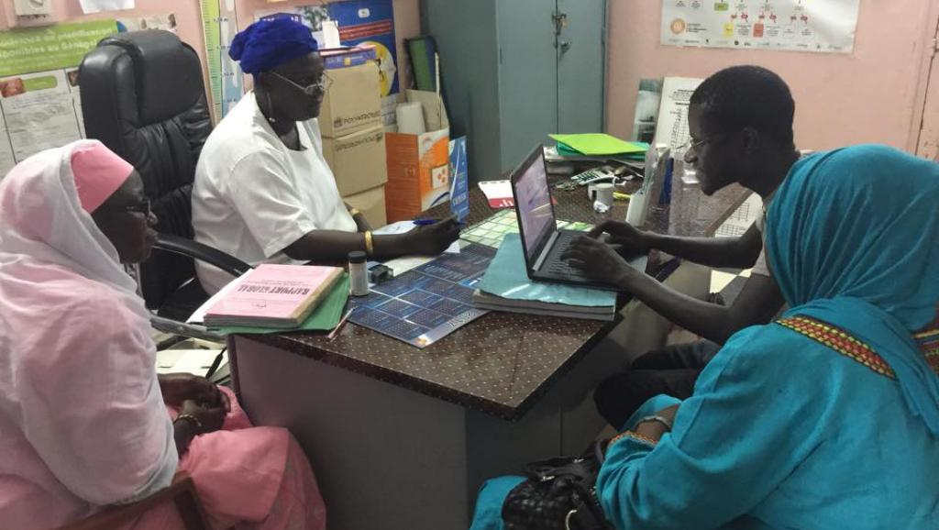

*Photo credit: Karangue*

# Executive Summary

Karangue (“Protection in health” in Wolof, the majority language in Senegal) is a phone application that sends SMS and voice messages to women reminding them of their prenatal, postnatal, and children’s immunization appointments in 5 different local languages. The application automatically sends a message recorded by popular Senegalese music artists to subscribers 48 and 24 hours before their scheduled appointments. Data collected directly from patients via the application will also be used to improve measurements of antenatal care and vaccination rates at a local level in Senegal. A pilot study from September 2017 demonstrated a 20% increase in prenatal care visits, 17% increase in childhood immunization visits, and a 5% increase in postnatal care visits. Karangue has established two contracts, with CLM and UNFPA to deploy their application elsewhere in Senegal, and is in the process of training a further 200 medical professionals in its use.

*Keywords: mhealth application, pregnancy, women, Senegal*

# Context

As of 2015, 49.4 out of 1,000 children die before their 5th birthday in Senegal, and 315 women die for every 100,000 births. In comparison, in the United Kingdom, 4 children out of 1,000 die before their 5th birthday, and only 36 out of 100,000 die giving life. Although Senegal has made improvements in both maternal and child mortality over the last several decades, these statistics equate to still a 1 in 60 lifetime change of dying in childbirth for the average Senegalese woman.

Both the government and private sector have stepped in to improve the health of women and children. Since 2013, the Ministry of Health of Senegal has ensured free access to healthcare for all children under 5 years of age, as part of the global initiative “A Promise Renewed.” Senegal also operates a large program called Bajenu Gox (a Wolof term for “godmother”) that positions respected local women to act as community health workers for pregnant women and women with small children. According to interviews with Senegalese health care workers, mobile phone use predominates among their patients and colleagues; indeed, mHealth interventions to connect women and their children to the healthcare system via SMS messaging have been in place since 2010. However, these interventions have been hampered by the illiteracy rate in Senegal and the large number of local languages (only 45% of adult women in the country can read and write).

|  |  |  |  |
| --- | --- | --- | --- |
| Senegal | | | |
| Population  (UN, 2015) | 14,967,446 | **Fixed broadband subscriptions (%)**  **(ITU, 2016)** | 0.64 |
| Population density (people per sq.km)  (UN, 2015) | 76.08 | **Mobile cellular subscriptions (%)**  **(ITU, 2016)** | 98.68 |
| Median household income  (Gallup, 2006-2012) | N/A | **Individuals using the Internet (%)**  **(ITU, 2016)** | 25.7 |
| Education  (Mean years of schooling)  (UNDP, 2013) | Male: 5.6  Female: 3.4 | **Individuals using the Internet by gender (%) (ITU, 2016)** | N/A |

# Project Description

Karangue (“Protection in health” in Wolof, the predominant language in Senegal) is a phone application that reminds mothers about their prenatal, postnatal, and children’s immunization appointments. While other mHealth interventions in Senegal used SMS to connect patients with the healthcare system, Karangue uses both SMS and voice messages - recorded by famous Senegalese musical artists - in five different local languages: Wolof, Serere, Pullar, Diola, and Mandingue. Subscribers receive messages 48 and 24 hours before their appointment dates, reminding them to attend. The application works offline - subscribers do not have to have an active internet connection to receive messages.

Mothers can subscribe individually to three different reminder services: prenatal care, postnatal care, and childhood vaccinations. Karangue worked with a local telecommunications provide, Orange, to utilize their API. Karange has developed two business models: B2B, or business-to-business, where Karangue is contracted by another entity to deploy the application and collect health data via the app, and B2C, or business-to-consumer, where Kanague markets the application directly to patient consumers via health professionals they’ve trained in its use.

In September 2017, Karangue received financial support from GlaxoSmithKline (GSK) and the Senegal Ministry of Health to undertake a pilot study of their B2C model in the town of Thies, outside of Dakar. Karangue trained health care providers in 21 local health centers on the use of the application, how to educate their patients about its use as well, and compensated them for this new workplace task. Visit data at health centers that received the intervention as well as control health centers was recorded and compared.

|  |  |  |  |
| --- | --- | --- | --- |
| Project details | | | |
| Technology | mhealth application | **Cost to users** | $1 USD for each subscription (prenatal, postnatal, and immunization) |
| Year program started | 2017, September | **Training** | 20 minute training |
| Geography | 21 health facilities in Thies, near Dakar | **Total cost of program** | $20,000 USD  Operational costs: $700 USD per month |
| User profile | 6000 pregnant women, mothers with young children | **Associated organizations** | GSK  Ministry of Health  Orange |

# Progress and Results

Since its launch, Karangue reached to 6000 women with 950 user per month. Health clinics that received training about the Karangue app demonstrated a 20% increase in prenatal visits, 17% increase in childhood immunization visits, and 5% increase in postnatal visits when compared to the control clinics. When asked for feedback on the phone application, medical professionals who were trained in the program affirm the utmost importance of voice messaging in local languages, as opposed to SMS or French language use. Data collected directly from patients via the app will also be used to improve existing measurements of antenatal care and vaccination rates.

Based on the outcomes from the fall 2017 pilot, Karangue has established two new B2C contracts, one with CLM and the other with the United Nations Population Fund (UNFPA), both of which are being deployed in summer and fall 2018. Karangue is also in the process of training 200 health care providers in additional districts in southern Senegal. Mothers will be charged USD $1 for each subscription service in which they enroll.

# Challenges

**Health care workers’ time must be compensated.** Due to the additional time and resources required to receive training and then in turn to educate patients on the use of the Karangue application, health care workers required financial compensation to participate in the intervention. Karangue offered health care workers the equivalent of USD $5 for their training.

**Although cell phone use is widespread, utilization is limited.** Karangue estimates 95% of women in Thies own mobile phones, but like most Senegalese, use them primarily for calls, SMS, WhatsApp, or Facebook, which serve vital functions connecting people across the country. However, there is less awareness of other possibilities to utilize mobile technology for more transformative purposes, such as improving health care.

# Karangue’s Suggestions for Future Projects

**A voice-messaging chatbot will allow patients to get their questions answered.** Karangue is working on developing a voice-messaging chatbot that can answer common questions patients have about their health. They see this as a crucial means by which they can make the Karangue application interactive, and a useful resource for patients. It is especially important in rural Senegal, where Human Resources for health are depleted and it can be challenging to see a provider in person every time you have a concern.

**Prioritize making a social impact before turning a profit.** Karangue advises that the best way to succeed as a startup in the health market is to focus on improving human health first, then look for a way to generate income. Passion and commitment to your values is also an important ingredient for success.

# Sources

Sow, A. (2018, July 2). Personal interview.

*Project website: https://www.facebook.com/karangue/*