PEEK VISION

PROVIDING SMARTPHONE-BASED TECHNOLOGY TO BRING ACCESS TO EYE CARE IN BOTSWANA

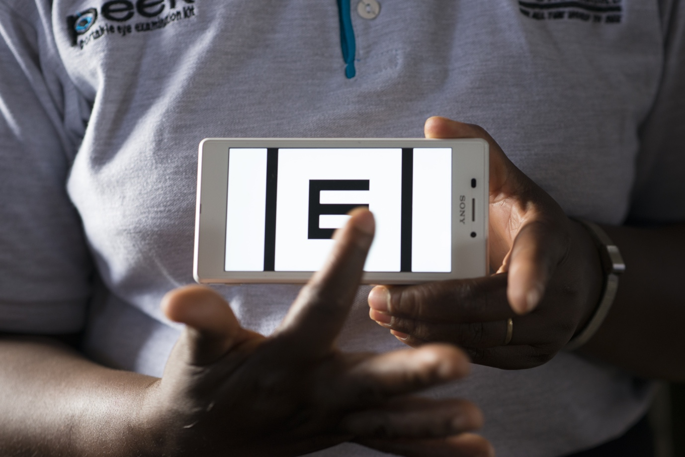

*Photo credit: Rolex / Joan Bardeletti*

# Executive Summary

Peek Vision is a group of eye care professionals, software engineers, hardware engineers and public health specialists who build smartphone applications, medical devices and public health interventions to enhance eye care in low- and middle-income settings across the globe. In 2016, in conjunction with the Botswana Ministry of Health & Wellness, Ministry of Basic Education, and other local partners, Peek rolled out a pilot study of a vision screening program in public schools using a smartphone application, providing glasses to all students who needed them, thanks to support from the programme’s partners. The program is designed to assist the government of Botswana in building capacity to address eye health issues of its citizens, the burden of which has increased by more than 30% over the past decade. The pilot, carried out in fall of 2016 in the Goodhope sub-district of Botswana, trained 243 teachers and healthcare workers on Peek technology, screened over 12,000 public school students over the course of 2 weeks, and provided glasses to over 800 children who screened positive for refractive error. Peek is now working with the Government of Botswana on Pono Yame (“My Vision”), a program to provide vision screening to all of Botswana’s school-age children within five years, as well as improving modular glasses design so that they can be provided at patient’s initial interaction with the health-care system.

*Keywords: smartphone-based vision screening, eye health, Botswana*

# Context

The number of people suffering from blindness and visual impairment (VI) are both increasing in Botswana. Between 2005-2014, a Rapid Assessment of Avoidable Blindness (RAAB) study found that the number of Batswana living with VI increased from 36,000 to 50,000, and the number of blind persons increased from 10,000 to 15,000. This increase occurred in spite of the fact that Botswana possesses the highest per-capita human resources for eye care out of all countries in sub-Saharan Africa (5 ophthalmological surgeons per million, 15 refractionists per million, and 46 ophthalmic nurses per million). Drivers of the epidemic include clustering of health resources in large cities, which are inaccessible to rural Botswana’s remote populations, and that international health aid has directed resources towards addressing predominantly infectious diseases (HIV, etc) over the past several years.

The majority of cases of blindness and VI in Botswana are easily preventable. Over half of cases of VI are due to refractive impairment, which can be treated with glasses. The leading cause of blindness, and the second-leading cause of VI is cataracts, which can be successfully treated with a simple, one-time surgical intervention. School-children, and middle-aged and elderly people are the most affected by eye conditions. The impact of visual impairment in school-age children in particular is felt on a wide scale. On a population level, VI contributes to poor performance in school, which further decreases the child’s productivity as an adult member of the workforce, negatively impacting a country’s GDP.

In response to this crisis, the Botswana government has rolled out a national program called Pono Yame (“My Vision”), a partnership with Peek Vision. The goal of Pono Yame is to provide vision screening to all of the Botswana’s school-age children and teachers within five years, and provide them with eye glasses and/or referrals to advanced eye care. Mobile technology is poised to serve as a valuable resource in this effort, as mobile phone penetrance in Botswana is comparable to the US and Europe, and mHealth interventions have been successfully rolled out in other segments of the health sector, including TB, malaria, and women’s health care.

|  |  |  |  |
| --- | --- | --- | --- |
| Botswana | | | |
| Population  (UN, 2015) | 2,209,197 | **Fixed broadband subscriptions (%)**  **(ITU, 2016)** | 2.62 |
| Population density (people per sq.km)  (UN, 2015) | 3.9 | **Mobile cellular subscriptions (%)**  **(ITU, 2016)** | 146.16 |
| Median household income  (Gallup, 2006-2012) | US $3,603 | **Individuals using the Internet (%)**  **(ITU, 2016)** | 39.36 |
| Education  (Mean years of schooling)  (UNDP, 2013) | Male: 9.0  Female: 8.7 | **Individuals using the Internet by gender (%) (ITU, 2016)** | Male: 40.5  Female: 33.8 |

# Project Description

Peek Vision, in partnership with the Botswana Ministry of Health & Wellness and Ministry of Basic Education, implemented a Peek school screening pilot study , which took place in fall 2016 in the Goodhope sub-district in southern Botswana. The screening project integrated and took place simultaneously with the WHO Expanded Program on Immunization (EPI), an established school-immunization program.

The pilot began with sensitization and training of EPI program staff, including immunizers and nurses, on how to use Peek technology and software to screen students, the state of the Peek project in Botswana, and the implementation workflow. In the first two weeks of August 2016, screenings occurred at all 49 of the Goodhope sub-district’s public schools (42 primary, 6 junior secondary, and 1 senior secondary). The target group for visual screening was initially the cohorts targeted by EPI, children ages 6-14 years. However, after discussion with local and national partners, screenings were offered to all school-children ages 6 and above. Children below age 6 were not tested due to an increased rate of false positive visual problems in this age group, likely due to inability to understand and follow instructions of the screening test.

The roll-out also tested two methods of follow-up to provide refractive services, the “Weekend Campaign” or triage hub model, and the “Direct to School Campaign.” The Weekend Campaign involved teams of optometrists traveling to several centrally-located school, with SMS messages sent to remind parents to return with their children who had screened positive for further care. In the Direct to School arm, teams of ophthalmological professionals traveled to each school to provide glasses to the children there.

|  |  |  |  |
| --- | --- | --- | --- |
| Project details | | | |
| Technology | Smartphone application | **Cost to users** | Free |
| Year program started | 2016-17 pilot | **Training** | 3-5 days twice for different users |
| Geography | Good-hope subdistrict | **Total cost of program** | *US$ 125K |
| User profile | School-children 6 years or older, school teachers and staff, government staff | **Associated organizations** | Botswana-UPenn Partnership,  London School of Hygiene and Tropical Medicine,  Ministry of Health and Wellness,  Ministry of Basic Education,  The Queen Elizabeth Diamond Jubilee Fund, Standard Chartered Bank Botswana, Botswana Optometrists Association |

*In addition, there was also substantial contributions from the Government of Botswana.

# Progress and Results

In total, during a two-week period of 2016 12,877 children were screened using the Peek school screening phone application, 2,065 of which were referred to refractive services campaigns, and 835 of those received glasses (target: 438). Ninety-four children were also treated for non-refractive-error VI, and an additional 63 were referred for more specialized ophthalmic services. Peek is conducting a follow-up study of these 63 children to determine who and where, and if they are able to successfully access care.

Due to the success of Phase I, partners have requested that future screenings be expanded to all members of school communities including teaching and auxiliary staff, as well as Ministry of Health & Wellness and Ministry of Basic Education employees. Peek is currently working with the Government of Botswana to incorporate Peek technology into Pono Yame and the National Eye Health Strategy, as well as designing and producing ready-made glasses with modular lenses that can be provided to patients directly, during their initial health-care encounter.

# Challenges

**Partner and stakeholder management –** There is a high rate of turnover of staff, both federally at the Ministry of Health & Wellness and locally, in terms of ophthalmological providers familiar with the Peek project. This makes it challenging to form lasting relationships, and excess time and money is spent training and sensitizing newcomers.

**Human resources for health -** Ophthalmological health care providers are overwhelmingly concentrated in large towns and cities; however, Botswana is a large country with a highly dispersed population. Incentives are needed to bring health care providers to rural areas to provide services. Peek’s triage hub approach minimizes the costs of doing so while maximizing the number of rural Batswana who are able to receive care.

**Health workers and technological literacy -** Older health care practitioners are often more uncomfortable with using smartphones and Peek technology. However, both practitioner trainings and the school screenings themselves are conducted by staff working in groups. In these cases, younger practitioners successfully self-deputize to manage smartphone tasks, while older personnel gravitate towards workflow and sensitization, and all appreciate the importance and utility of Peek tools.

# Peek Vision’s Suggestions for Future Projects

**Staff training on smartphone application should occur directly before screening rollout -** In the school screening campaign, training on Peek technology took place several days to weeks before staff began screening patients. Screeners had to be refreshed on how to use the application the first day of the campaign. Peek Vision received unified feedback from its staff that training on their smartphone application should occur directly before the campaign for smoothest rollout and to maximize the amount of information retained.

**Health systems strengthening is ultimately necessary to connect people with health care -** Although Peek currently facilitates the screening and treatment of the most common cause of visual impairment, refractive error, other eye conditions require more complex management. The ultimate effect of a screening program is to increase demand on a health system, and the health care system of Botswana has room to improve in the areas of health care access (how rural patients access expensive health care services in the city) and human resources (training more ophthalmological health care workers) to effectively meet increased demand.

**Increased smartphone ownership could decrease expense, complexity of future projects** - When the Botswana-UPenn Partnership first began training staff on smartphone applications in 2011, few people owned smartphones and much training time was spent teaching people how to interact with touch screens. For Peek in 2016, approximately half of the screeners already owned smartphones. It may not be necessary to purchase as many smartphones for future interventions and merely request staff download particular applications in a BYOD or “bring-your-own-device” model.

# Sources

Littman-Quinn, R. (2018, June 29). Personal interview.

*Project website:* https://peekvision.org/