FunDza

PROVIDING ACCESS TO LOCAL CONTENT FOR THE YOUTH

IN SOUTH AFRICA

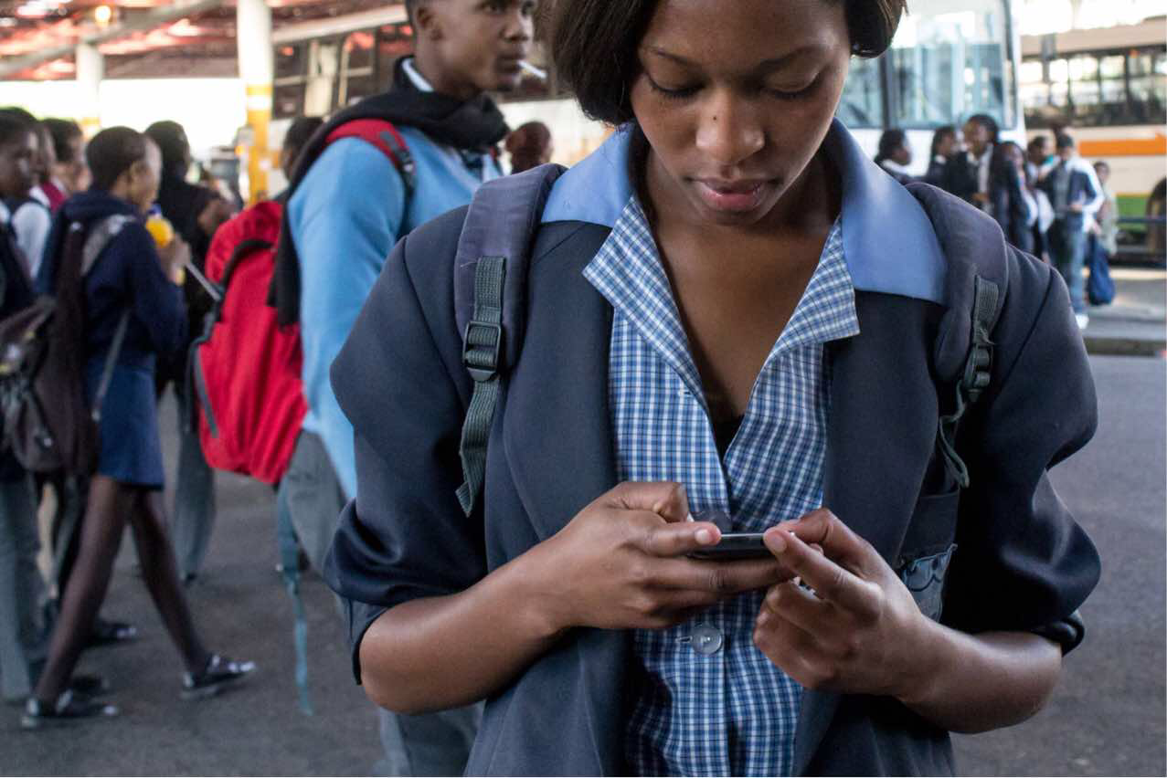

*Photo credit: FunDza*

# Executive Summary

FunDza is a non-profit organization operating in South Africa since 2011, which provides print copies of reading material to partnering schools. FunDza also operates a mobile application (fundza.mobi) that provides original fiction and non-fictional content, writing and publishing opportunities, reading comprehension education and career skills to South African youth. Their mission is to improve teen and youths' ability, confidence and frequency of reading in order to improve their sense of self-agency, their employability, and their ability to make change in their communities and the world. They partner with the Free Basics platform so the FunDza application is available without additional data costs, often a barrier to low-income young people in South Africa. Since launching their application, FunDza has acquired almost 600,000 readers who have viewed over 5 million pages of content; they have also hosted 28 writers workshops and published the works of nearly 1000 young authors.

*Keywords: mobile application, young adults, reading and writing, digital literacy, Free Basics, South Africa*

# Context

The 2016 Progress in International Reading Literacy Study (PIRLS) found that 78% of grade 4 children in South Africa were unable to meet the lowest international benchmark for literacy. Out of all 50 countries surveyed, South Africa placed last in terms of reading ability. Youth in South Africa face a number of barriers to education. Students in rural areas must travel long distances to schools; public schools in both urban and rural areas are chronically under-funded and under-resourced, including a lack of books. At the province level, the proportion of schools meeting minimum standards for reading materials (which is approximately one box of a books in a single classroom) varies from 25-85%. Intertwined with these problems is a lack of a 'culture of reading' - for example, even South Africans who are literate spend almost twice as much time each week watching TV.

Several "mobile library" approaches have been adopted to increase access to books in South Africa. Strategies include busses carrying thousands of books that travel with an on-board librarian, libraries established in refurbished infrastructure with lower overhead costs, and modular bookshelves that come pre-stocked with books purchased by international literacy organizations. However, these projects are limited in their reach and focus on younger children in primary school. Furthermore, hard-copy print materials are often prohibitively expensive to produce or purchase in South Africa.

'Literacy' has taken on an even greater significance in the digitizing world. The information gap between those who can read and access the internet and the rest of the population is greater than ever before. On one hand, South Africa has the highest cell phone penetrance of all countries in Africa. However, South African data plans are also the most expensive on the continent, eliminating the possibility for many young people to use their mobile devices for reading material.

|  |  |  |  |
| --- | --- | --- | --- |
| South Africa | | | |
| Population  (UN, 2015) | 53,491,333 | **Fixed broadband subscriptions (%)**  **(ITU, 2016)** | 2.84 |
| Population density (people per sq.km)  (UN, 2015) | 43.81 | **Mobile cellular subscriptions (%)**  **(ITU, 2016)** | 142.38 |
| Median household income  (Gallup, 2006-2012) | US $5,217 | **Individuals using the Internet (%)**  **(ITU, 2016)** | 54 |
| Education  (Mean years of schooling)  (UNDP, 2013) | Male: 10.1  Female: 9.8 | **Individuals using the Internet by gender (%) (ITU, 2016)** | N/A |

# Project Description

FunDza began in cooperation with a print publishing partner, Cover2Cover Books, but now operates mainly though a mobile phone application (fundza.mobi). They seek to provide young people in South Africa with reading material and writing opportunities accessible and relevant to youths' lives, in order to improve reading comprehension, career skills, a sense of self-agency and confidence to overcome life's challenges. FunDza was developed specifically for low-income teen and young adults in South Africa. The FunDza application is available on Free Basics, an application pre-installed on many phones that delivers internet.org services to the user: access to certain applications and websites without requiring a data plan. Most of the content is in English, however there are also stories available in Zulu, Xhosa, Afrikaans and other local languages.

The FunDza application includes fiction and non-fiction content selected to be relevant to the often fraught lives of young, impoverished South Africans, but that are also embued with hope and resiliency without being preachy or moralizing. Original content is also produced by local writers that FunDza has trained through their writing mentorship program - a new short story every Friday, and a new children's story every Monday. There are also opportunities for users to write and publish their own work to the application for others to read. FunDza regularly hosts writing competitions, and frequently publishes local poetry, short fiction, and opionion pieces. They also maintain several thematic blogs on the application, including "Work Wise," which shares practical tips on workplace culture, such as how to present yourself at a job interview, and how to write a professional email; "Mind Space," which grapples with the psychosocial stressors of growing up poor in South Africa, and "Bridging Divides," which discusses the values undrpinning the South African constitution in relation to ecnomic, racial, and gender divides. Users are able to comment in the application and share their impressions of blog entries or stories. FunDza also provides a platform for continuing education, including quizzes and instructional modules to help users improve their reading comprehension.

FunDza is a non-profit organization, and the FunDza application is free for users. FunDza is comprised of a staff of 15 employees, and is primarily supported by foundations in South Africa, but also receives monetary support from the Indigo Trust, the Omidyar Network, and others.

|  |  |  |  |
| --- | --- | --- | --- |
| Project details | | | |
| Technology | Mobile application | **Cost to users** | Free |
| Year program started | 2011 | **Training** | None |
| Geography | South Africa | **Total cost of program** | Operating expenses: USD $376,973 |
| User profile | Young people ages 13-25 | **Associated organizations** | Claude Leon Foundation, Potter Foundation, Nussbaum Foundation, Omidyar Network, Indigo Trust, Oppenheimer Memorial Trust |

# Progress and Results

As of 2017, Fundza has delivered over 100,000 print books to receipient schools and universities. They have almost 600,000 readers using their application, and over 5 million pages of content have been viewed. FunDza has help 28 young writer's workshops and published the work of almost 1000 young authors.

FunDza also monitors readership on it's fundza.mobi application and administers an annual survey of users, focusing on their main impact indicators: frequency, enjoyment, and confidence in reading. Results from the 2016 survey of users show that 86% of users access the mobile application through Free Basics, as 39% indicated that the cost of data otherwise limited the time they spent reading. In their most recent annual survey, 91% of FunDza users say the application has improved their language or comprehension skills, and 92% say that the application has helped them "learn something about themselves or the world." Young readers say that reading stories about the challenges that other young people face growing up in South Africa helps them feel less alone, figure out solutions to their own problems, and enact change within their communities.

Users share how FunDza has not only improved their reading skills, but has influenced their lives for the better through the stories they read on the application. Youth describe how reading stories about bullying, family conflict, and gender-based violence have helped them reflect upon and improve their own behavior, as well as given them strength to model change in their own communities. Others talk about how reading stories of others' struggles help them deal with trauma in their own lives. One user says, "FunDza is more than just a website where we reade, but is a page where we learn, experience and grow ... it also helps people to solve their problems... there are stories that some of us relate to and in the end we find solutions." Another user agrees, saying, "[FunDza] has shown me that I am not the only one going through difficult times and this has also given me ideas and strength to tackle my difficult experiences."

# Challenges

**Any associated data costs will be a barrier to entry for some.** Data in South Africa is very expensive compared to other African nations; furthermore, FunDza's target audience is teens and youth, many of whom are still in school and must borrow money from their parents, or are unemployed. As a result, any associated data costs will using the FunDza application will be an insurmountable barrier to at least a portion of their target audience. In response to this, FunDza has incorporated their application into the Free Basics platform. They have also worked to get their application zero-rated by a new mobile phone operator, Rain mobile, and advocate for additional free public wifi zones.

**Fundraising is a constant burden.** FunDza works constantly to ensure they have sufficient donors to cover their expenses. They emphasize the uniqueness of their approach - the fact that they are the only mobile platform for encouraging literacy amoung teenagers and youth in South Africa. They are currently seeking more corporate sources of support.

# FunDza’ Suggestions for Future Projects

**People are hungry to share their stories.** When FunDza was originally developed, there was no platform for writing and publishing within the application, only reading. Users provided feedback that they desperately wanted to share their stories - but didn't think their lives were worthy of a story. After deploying features to allow for publication of users' materials, the enthusiasm for user-created content has been overwhelming. FunDza attributes this to a desire for their voices to be heard.

**Shape content around what the community is interested in, not vice versa.** FunDza has gotten a sense of the content that users want via their comments and their annual survey. FunDza says readers appreciate humor about serious topics that doesn't mask the complexity of issues at hand, stories about complicated relationships, and stories that are compassionate and emotionally moving. FunDza has focused their content on these aspects, adhering to the philosophy of 'any book that helps a child form a habit of reading... is good for him' (in the words of Maya Angelou).

# Sources

Hardie, M. (2018, July 25). Personal interview.

*Project website: http://www.fundza.co.za/*