ZENZELENI NETWORKS

PROVIDING AFFORDABLE WI-FI CONNECTIVITY

TO MANKOSI IN SOUTH AFRICA

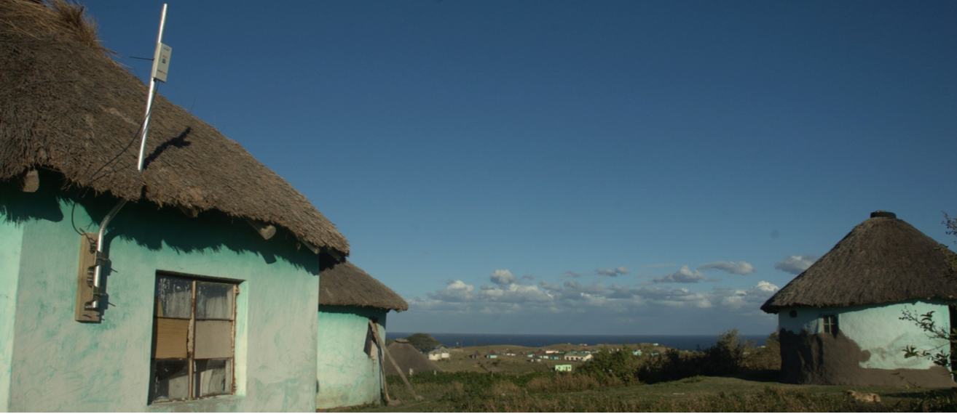

*Mankosi. Photo courtesy Zenzeleni Networks*

# Executive Summary

Zenzeleni Networks is a community network in Mankosi in the Eastern Cape province of South Africa, set up in 2012. It started through a collaboration between researchers at the University of Western Cape and the Tribal Authority in Mankosi. It provides affordable communications access to its 3500 residents, at half the price charged by the then-incumbent operator.

*Keywords: community network, digital literacy, supply, demand, South Africa*

# Context

Mankosi has 564 households, with an overall population of 3500. Sixty-one percent of the population is over 15 years of age, and about 70 percent of the population is female. Only 2.1 percent have access to the electricity grid, and 13 percent complete high school. However, 97.7 percent of the population own a mobile phone, and spend up to 1/3rd of their disposable income on connectivity.

Most of Mankosi’s 3,500 residents live on less than US$ 2 per day, and due to high economic impoverishment, less than a quarter used to be able to be online in a month. Most households do not have savings and 58.6 per cent of the residents do not own a bank account.

|  |  |  |  |
| --- | --- | --- | --- |
| South Africa | | | |
| Population  (UN, 2015) | 53,491,333 | **Fixed broadband subscriptions (%)**  **(ITU, 2016)** | 2.84 |
| Population density  (people per sq.km)  (UN, 2015) | 43.81 | **Mobile cellular subscriptions (%)**  **(ITU, 2016)** | 142.38 |
| Median household income  (Gallup, 2006-2012) | US$ 5,217 | **Individuals using the Internet (%)**  **(ITU, 2016)** | 54 |
| Education  (Mean years of schooling)  (UNDP, 2013) | Male: 10.1  Female: 9.8 | **Individuals using the Internet by gender (%) (ITU, 2016)** | N/A |

# Project Description

The Zenzeleni network initially comprised a mesh network of 12 single-radio wireless nodes scattered around an area of 30 square kilometers. Since 2012, a research team from University of Western Cape actively started engaging with the Mankosi community, and began installation as well as training the community members to host base stations at their households. These houses were chosen to maximize reach of the network, as Mankosi’s twelve villages were in hilly terrain. Local community members learned to fit the aerials, with solar panels and Mesh Potatoes on rooftops, and made wooden boxes to hold the batteries.

Initally, public phones were able to call villages within the community, with an eventual shift to mobile phones on other networks. The system also had a mechanism of revenue generation through charging of the mobile phones at base stations. The committee decided to keep intra-community calls free, but charges for calling mobile phones. Besides these communal phones, Zenzeleni provides internet at low cost to the local school, small businesses and NGOs.

Zenzeleni Networks is registered as a co-operative, and was able to do business with a Voice over Internet Protocol company to place calls to other networks (cellular or landline) for 17% of the normal cost. The co-op charges users 50% of the normal price charged by the incumbent, reducing costs drastically for community members. The billing uses voice menus in IsiXhosa, to cater to local community needs.

|  |  |  |  |
| --- | --- | --- | --- |
| **Project details** | | | |
| **Technology** | Wireless internet | **Training** | Training on set up of base stations and mesh potato routing provided to local community members |
| **Year program started** | 2012 | **Cost to users** | R3.00 (US$ 0.25) per call |
| **Geography** | Rural - Mankosi | **Total cost of program** | Undisclosed |
| **User profile** | Low-income communities | **Associated Organizations** | Internet Society, University of Western Cape,  Right 2 Know |

# Progress and Results

Zenzeleni’s focus is now on setting up backhaul to a fiber network in the nearest city, using a series of wireless relay towers. They have undergone a network upgrade in early 2017. The project has also setup computer labs in the primary and secondary schools and a community WiFi network with donated personal computers (PCs) to provide access to those without smart phones. Zenzeleni’s cooperative board sets rates for the services provided by the network, including costs for charging and calling. Zenzeleni is also involved in training of trainers in Mankosi, and has expanded the network in key ways. Further, Zenzeleni has conducted a digital skill needs assessment, and is gathering educational content for its digital literacy outreach initiatives.

# Challenges

**Coordination challenges –** Implementing community-owned initiatives takes considerable time to negotiate with local power structures and the tribal authority. Coordinating meetings can be challenging due to the lack of electricity. Scarcity of resources necessitates an eye toward considerate appropriation of network resources, and the culture of community work must be respected. This often requires more time than conventional implementations of networks, and can take up to 18 months.

**Social norms: gender norms –** Patriarchal ecosystems often make it difficult to sustain women’s participation in the running of a community network. A woman’s responsibilities at home makes it difficult for her to sustain long-term attendance at training. While three women appeared in the very first sessions of the training, only one could make it to further sessions.

**Social norms –** A community hierarchical structure often poses unique challenges to governance. Working with the tribal authority was chosen as it is the one structure that convenes weekly meetings and exists across all villages in the community. However, as in all communities, perceptions on who is privileged by decisions made by those in power differ significantly and poses challenges that must be overcome by transparent and effective communication.

# Zenzeleni’s Suggestions for Future Projects

**Appreciation and deep respect of the socio-cultural complexities of the context before deployment of a community-owned network in a rural community is helpful to improve take-up within the community** – According to Zenzeleni, working with the community is essential for success of community led projects. Tailoring training and digital literacy efforts to suit local needs is essential to ensuring success of community-wide education initiatives.

**Self-sufficient funding models and participation from all members of the community is necessary to be successful** – Zenzeleni’s team emphasizes the necessity for developing a collaborative and cooperative model to fund and maintain a community network in order to ensure long term sustainability.

# Sources

Rey-Moreno, C. (2016, October 31) Personal Interview

Project website: zenzeleni.net