FUSION PROGRAM AT SARVODAYA

PROVIDING DIGITAL LITERACY TO RURAL COMMUNITIES

IN SRI LANKA

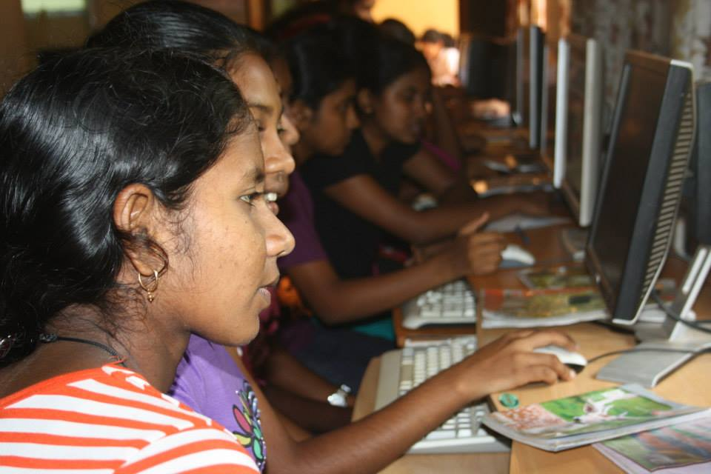*Women part of the Fusion program. Photo credit: Sarvodaya*

# Executive Summary

Fusion is a special, nonprofit program of Sarvodaya, the largest NGO in Sri Lanka. Fusion imparts an education program focused on information and communication technologies (ICTs) aimed at rural communities since 2006. Fusion uses telecenters installed by Sarvodaya and facilitates access to both entrepreneurial and educational opportunities. As of 2017, Fusion operates 80 telecenters across 22 of Sri Lanka’s 25 districts. Through a partnership with local community centers, Fusion manages to cut the travel costs of participants and attracts a large ratio of women. By combining small-scale business opportunities with structured ICT educational resources and classes, Fusion sustainably supports technological literacy in rural Sri Lanka.

*Keywords: education, rural, digital literacy, Sri Lanka*

# Context

According to the Ministry of Finance and Planning, while Sri Lanka’s literacy rate is approximately 91 percent, the ICT literacy rate was only 35 percent in 2012. Urban computer literacy was 25.1 percent, while rural and estate areas were only 15.1 percent and 4.3 percent computer literate, respectively. Low incomes, lack of corresponding literacy programs in the schools with digital facilities, software incompatible with local languages, as well as poor ICT infrastructure in certain areas, are all reasons for low computer literacy rates. Women are especially vulnerable to these barriers due to social stigma, safety concerns, and poverty.

Multiple initiatives exist to improve Internet access and ICT skills for Sri Lankans. At least 4,500 schools have been provided with ICT infrastructure, where 22,500 teachers were trained for student-centered ICT learning since 2006. The Information and Communication Technology Agency of Sri Lanka (ICTA) implemented the Nenasala project to establish knowledge centers in all parts of the country and provide ICT-based services to the people, especially those in rural areas.

|  |  |  |  |
| --- | --- | --- | --- |
| Sri Lanka | | | |
| Population  (UN, 2015) | 21,611,842 | **Fixed broadband subscriptions (%)**  **(ITU, 2016)** | 4.10 |
| Population density  (people per sq.km)  (UN, 2015) | 329.4 | **Mobile cellular subscriptions (%)**  **(ITU, 2016)** | 118.49 |
| Median household income  (Gallup, 2006-2012) | US$ 3,242 | **Individuals using the Internet (%)**  **(ITU, 2016)** | 32.1 |
| Education  (Mean years of schooling) (UNDP, 2013) | Male: 9.4  Female: 10.7 | **Individuals using the Internet by Gender (%) (ITU, 2016)** | N/A |

# Project Description

Rural telecenters in Sri Lanka have earned the majority of their income by offering digital literacy training programs, since their establishment in the late 1990s. Due to large disparities in the quality and methods of these educational offerings, Fusion developed a standardized curriculum, methodology, and completion certificate. Fusion created an effective training course and materials with the help of members of the ICT industry and a local university (the University of Moratuwa). Fusion distributes this course around the country to entrepreneurs running these centers to improve business practices, provide employment opportunities, and improve the quality of ICT education at a low cost. Additionally, the telecenters provide many benefits to women in particular. Women make up 60 percent of students in the courses, and 25 percent of the telecenter operators are women.

Each telecenter manager pays their own operating costs and contributes a small portion of their profits to Fusion. The course costs between LKR 8,000 (US$ 51.81) and LKR 13,000 (US$ 84.19), and takes four-to-six months to complete. This price includes in-class instruction as well as a student guide/textbook, three exams, supplementary online seminars created by university faculty, and an official certification.

Fusion operates a sustainable, social enterprise business model. By collecting a percentage of each telecenter’s revenues for its educational courses and keeping its costs low by relying on entrepreneurs for maintenance and marketing, Fusion is not reliant on government funding and does not require continuous support from outside donors.

|  |  |  |  |
| --- | --- | --- | --- |
| Project details | | | |
| Technology | Digital literacy training | **Training** | 4-6 months training in telecenters  Mandatory online seminar |
| Year program started | 2006 | **Cost to users** | 8,000-13,000 LKR per course (US$ 51.81-84.19) |
| Geography | Rural – 80 centers in 22 districts | **Total cost of program** | 80-20 split between the telecenters and Fusion |
| User profile | >13 years old and above  60% female, 40% male  25% women entrepreneurs operating telecenters | **Associated organizations** | Cisco Networking Academy,  Information & Communication Technology Agency,  Microsoft IT Academy |

# Progress and Results

As of 2017, Fusion operates 80 telecenters across 22 of Sri Lanka’s 25 districts. Fusion has been recognized by the United Nations Conference on Trade and Development (UNCTD), Microsoft, HSBC, and the World Bank for their successes in empowering communities through information technology (IT), building leaders, increasing youth employability, bringing ICT education to marginalized children and youth, and bringing technology to communities impacted by war.

# Challenges

**Lack of sustained funding –** Fusion does not have a budget to assist telecenters in updating their equipment. This poses challenges both to expansion as well as keeping the centers updated in a standardized fashion.

**Lack of locally relevant and local language content –** Education in Sri Lanka is conducted in Sinhala, but the nature of ICT requires a better than basic understanding of English. Training courses are given in English in order to integrate and improve the trainees’ necessary English-language skills to use the course’s software from Microsoft and Cisco, and increase their chances for employability.

**Lack of skilled manpower –** The pace at which technology transforms and requires updating can pose challenges to the program’s structure. Trainers need to be re-trained at least once a year – and sometimes more often than that when new programs are introduced to course.

# Fusion’s Suggestions for Future Projects

**Local centers for ICT education are beneficial–** The benefits of rural villages having access to high-quality training courses in their local town centers are many. Privately operated courses in the city charge higher tuition rates and have associated travel costs. In addition, these local centers, with their proximity to well-known community hubs such as temples, help attract a large ratio of women. Local community centers are safer destinations for women to travel to and more convenient.

**Building local relationships is necessary –** Fusion notes the importance of laying the groundwork for the project among the community members themselves. While not every telecenter successfully adopts the program, the ones that do have strong relationships of trust with Fusion – whose administration works to ensure entrepreneurs understand the level of support they can count on.

**Maintaining donor relations and communication is essential –** Fusion is a small-scale social enterprise whose impact has been recognized by large-scale organizations. There was a learning curve in managing the way Fusion sustained successful communication patterns with their supporters.

# Sources

**Elasinghe, S. (2017, August 8) Personal Interview.**

**Project website:** [www.fusion.lk](http://www.fusion.lk)