MEDHA

PROVIDING DIGITAL LITERACY PROGRAMS AT COLLEGES

IN INDIA

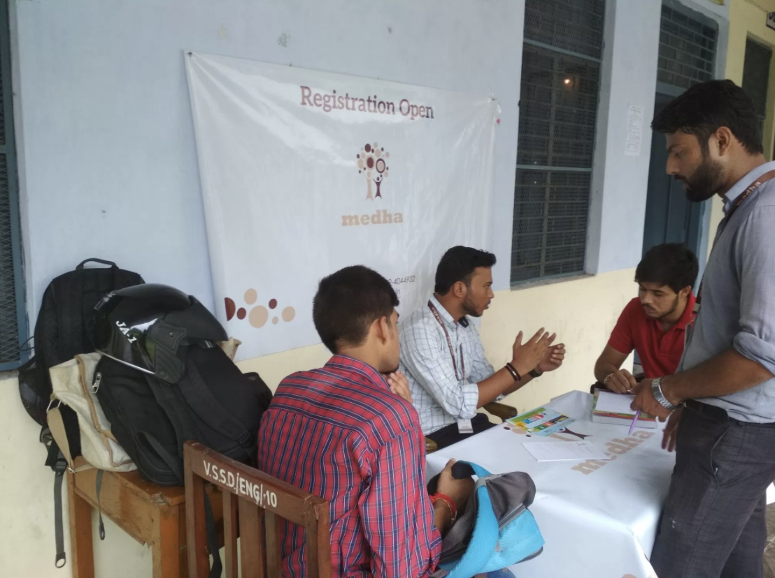*Students at a Medha bootcamp. Photo credit: Medha*

# Executive Summary

Medha is a not-for-profit social enterprise that seeks to improve employment outcomes for youth in under-resourced colleges in India. Medha provides skills training to students in the form of basic information and communications technology (ICT) and digital literacy training, alongside career counseling, support, and workplace exposure. The program is designed to prepare students to secure and excel in their first job. Medha’s training includes 30-60 hours of in-class instruction and activities, and 150 hours of on-the-job training across three advancement programs. The programs include a Career Advancement Bootcamp (CAB), Life-skills Advancement Bootcamp (LAB), and Technical Advancement Bootcamp (TAB). TAB focuses specifically on digital literacy, which includes training in the use of computers, data entry, as well as programs and applications used in the workplace. Medha currently serves six districts in Uttar Pradesh, but has plans for expansion.

*Keywords: digital literacy training, India, employability*

# Context

A stark skills gap exists among Indian youth, crippling a number of them from accessing jobs in a burgeoning industry that serves as a provider of ICT services to companies around the world. A low literacy rate and the education system’s inability to adapt to dynamic industry needs also contribute to youth’s unevenly distributed digital literacy skills. Students’ ICT skills proficiency is correlated with geographic proximity to urban areas, proficiency in English, as well as level of educational attainment.

The Government of India has initiated schemes such as the National Digital Literacy Mission (NDLM) with the goal of making at least one person per household digitally literate, and the Pradhan Mantri Gramin Digital Saksharta Abhiyan (PMGDISHA) program aimed at training 60 million rural households by March 2019. Training for youth has also been provided by nonprofit organizations such as ICT Academy, or companies like the DXC India.

|  |  |  |  |
| --- | --- | --- | --- |
| India | | | |
| Population  (UN, 2015) | 1,282,390,303 | **Fixed broadband subscriptions (%)**  **(ITU, 2016)** | 1.44 |
| Population density (people per sq.km)  (UN, 2015) | 390.11 | **Mobile cellular subscriptions (%)**  **(ITU, 2016)** | 86.95 |
| Median household income  (Gallup, 2006-2012) | US$ 3,168 | **Individuals using the Internet (%)**  **(ITU, 2016)** | 29.5 |
| Education  (Mean years of schooling)  (UNDP, 2013) | Male: 5.6  Female: 3.2 | **Individuals using the Internet by Gender (%)**  **(ITU, 2016)** | N/A |

# Project Description

Headquartered in the state capital of Lucknow, Medha offers its signature instruction in skills training by conducting programs for college youth at their campuses. Their Technical Advancement Bootcamp includes basic digital literacy skills such as data entry, operating a computer, and proficiency in Microsoft Word, Excel, and PowerPoint. The boot camp extends for 60 hours with sessions lasting either one or two hours per day, and it takes about two months to complete. The bootcamps feature around 25 students in each class.

Medha targets students in colleges that are rated by the government as being under-resourced. When the college’s lab is not functional or cannot sustain 25 students, Medha augments available resources with its own computers.

TAB costs 500 Indian Rupees (US$7.85) per student for the full 60 hours of training. Some colleges subsidize this training by choosing to pay an hourly rate of 150 Indian rupees for the instructor’s time. The area manager negotiates college rates on a case-by-case basis. The fee is a mechanism to generate student commitment to the program, raise attendance rates, and prevent attrition.

Medha currently serves six districts in Uttar Pradesh. It trains students at 35 institutions, has a strong cohort of 3,000 alumni, and admits 150 new students each year.

Some of the colleges Medha works with are women-only, which leads to a greater participation by women in their cohorts. This, while not a specific target for Medha, is a welcomed side effect.

Certified Medha students must attend at least 75 percent of the course, and once students complete the program, they qualify for a variety of alumni benefits. Medha supports its alumni in preparation for entrance exams for government jobs that offer pensions, job security, and other benefits.

Medha claims that their program has outpaced other digital literacy programs due to four critical reasons. First, it is offered at college campuses. Second, it is more affordable and not time consuming. Third, it focuses on experiential learning. And finally, it shows a clear path to success in the form of additional support with securing internships and jobs.

|  |  |  |  |
| --- | --- | --- | --- |
| Project details | | | |
| Technology | Digital literacy training | **Training** | One month for instructors;  60 hours of online training for students |
| Year program started | 2015 | **Cost to users** | 500 INR (US$ 8) for students; 150 INR per hour (US$ 2) for colleges |
| Geography | Six rural districts in Uttar Pradesh. | **Total cost of program** | Operational expenses: 12,000 INR per year (US$ 175) |
| User profile | 35 under-resourced colleges.  Second- and third-year college students from low socio-economic backgrounds  65-70 percent are girls | **Associated organizations** | Citi Foundation  EdelGive Foundation  Intel  Michael & Susan Dell Foundation |

# Progress and Results

Leading global foundations such as the Michael & Susan Dell Foundation, Citi Foundation, and EdelGive Foundation support Medha. It has received numerous awards for its work, including the Echoing Green Global Fellowship, the Dasra Girl Power Award, and the Sitaram Rao Livelihoods Asia Award.

Since 2011, Medha has trained more than 3,000 students across 35 educational institutions, placed them into internships and full-time jobs with 200 leading employers, and built a public-private partnership with the Government of Uttar Pradesh to employ qualified graduates.

Medha works to close the gender gap in digital literacy and employment by developing tailored solutions for women and girls. They set up work-from-home alternatives for women so that women can access opportunities without contravening their parents or fighting social constraints placed on women working outside the home.

Medha conducts extensive surveys of alumni regarding job satisfaction and job qualification, and provides support on a continuing basis to alumni. Initially, Medha observed a low 25 percent response rate to its surveys, which prompted efforts to build stronger ties to alumni. Medha measures its own impact across its three programs according to: employment, employability, and life skills. Those parts of the digital literacy training are assessed only according to the metrics of employment and employability.

Medha made efforts to get its own program Intel-certified, as Intel India also deploys digital literacy training. Intel’s program, however, is not just for college-going students, but for the general public. Medha chose some elements of Intel’s program and integrated them into their own program, and had its trainers instructed by a master trainer from Intel. Medha trainers were certified by Intel to train their own students in June 2017.

Medha has plans to scale up the project. They plan to grow to 20,000 students over the next three-to-five years, and to expand across three-to-five more states in India.

# Challenges

**Limited and irregular electricity access –** The colleges they serve have inconsistent electricity. Not all colleges have Internet connectivity, and of those that do, not all have consistent connectivity.

**Lack of access to devices –** Under-resourced colleges do not have the necessary ICT infrastructure. The ICT lab is not fully functional, or is not adequately resourced with sufficient computers to sustain a class of 25 students.

**Limited instruction hours –** The program is only 60 hours, which is not as long as the comparable Intel program, for instance, because they have to work with the constraints of the college schedule and campus availability.

**Social norms –** Parental and societal expectations regarding appropriate conduct for girls and women prevent them from taking internships and jobs for which they are qualified because they are discouraged from working outside the home.

Medha’s Suggestions for Future Projects

**Impact assessments are necessary –** Medha compares their internal impact assessments to data collected by third parties to get a more complete and objective sense of the impact of the project in the real world. Long-term tracking of alumni helps assess impact more realistically, and generates local champions in remote areas and areas in need. Alumni help as mentors (both in training, and in a more diffuse professional network) for incoming Medha students.

**Full-time instructors are preferable to part-time alternatives –** Medha initially hired freelance trainers but had trouble with quality control and instructor commitment to students, necessitating a switch to a full-time trainer model. A next step toward optimization might be to train faculty of the colleges they are working with instead of bringing in their own instructors to reduce costs and enable the project to scale up further.

**Student retention tools must be experimented with –** Medha’s model provides training to students on campus, which cuts down commute time and increases attendance. The project is not-for-profit and donation based, but a nominal fee keeps students committed without putting a financial strain on them.

Sources

Gupta, S. (2017, October 10) Personal Interview

Project website: http://medha.org.in/