NIIT University

TRANSFORMING THE WAY TECHNOLOGY IS INTEGRATED IN SCHOOLS IN INDIA

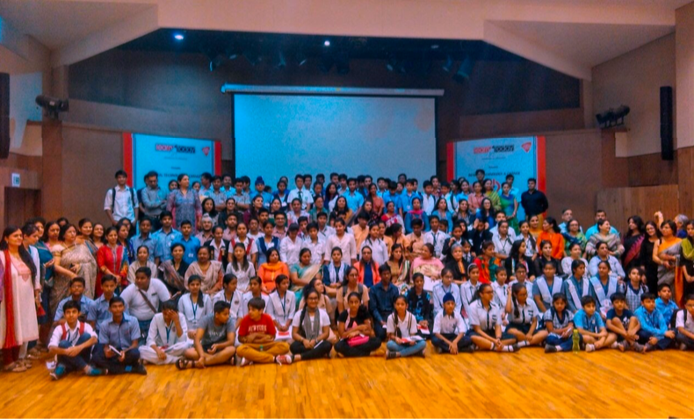

*Ed Tech Summit 2016. Photo credit: Deepti Sawhney*

# Executive Summary

NIIT University (NU) is a not-for-profit University in Neemrana, Rajasthan, India. The multi-discipline university focuses on students’ holistic personality development, combined with equipping them with the knowledge and skill sets independent of time and space to contribute and lead in any technological environment of future industry. Schools that upgrade to digital infrastructures and purchase software and devices often face roadblocks in the successful implementation. ULT’s team has researched and developed methods of professional development that optimize and specify the ways that technology can enhance education, and respond to the pedagogical inertia around ICT in schools. These include value-stream mapping for teachers and collaborative, community-minded ICT projects for students.

*Keywords: education, technology integration, digital literacy, India*

# Context

India is known as a global provider of ICT services, but the digital divide in this country is still at high levels. In 2016, 8 out of 10 Indians owned a mobile phone, but there were still nearly one billion Indians not connected to the Internet according to World Bank. A 2014 Deloitte research suggested that among 439,000 mobile network towers nationwide, only 700 can actually support 3G or 4G data use. In terms of Internet speed, India ranks 52th, despite having the third largest population of Internet users in the world.

Although Indian youth are more exposed to technologies and Internet than other age groups, the gap still exists among the group itself. Internet accessibility depends on whether one lives in an urban or rural area, speaking English or not, and what level of education he/she has acquired. Low literacy rate and the rigid education system also contribute to youth’s unevenly distributed digital literacy skills.

The government of India, as well as civil society and other agencies, has taken several initiatives to improve the situation. The National Digital Literacy Mission is a central government scheme with the goal of ensuring at least one person per household to be digitally literate. The Pradhan Mantri Gramin Digital Saksharta Abhiyan program is one of the largest digital literacy programs in the world that aims to make 60 million rural households digitally literate by March 2019. Other initiatives taken by nonprofits and the private sector to train youth with ICT skills include ICT Academy, DXC India, the Sehgal Foundation, Mahattattva Educational Advisory, among others.

|  |  |  |  |
| --- | --- | --- | --- |
| India | | | |
| Population  (UN, 2015) | 1,282,390,303 | **Fixed broadband subscriptions (%)**  **(ITU, 2016)** | 1.44 |
| Population density (people per sq.km)  (UN, 2015) | 390.11 | **Mobile cellular subscriptions (%)**  **(ITU, 2016)** | 86.95 |
| Median household income  (Gallup, 2006-2012) | US$ 3,168 | **Individuals using the Internet (%)**  **(ITU, 2016)** | 29.5 |
| Education  (Mean years of schooling)  (UNDP, 2013) | Male: 5.6  Female: 3.2 | **Individuals using the Internet by Gender (%) (ITU, 2016)** | N/A |

# Project Description

*Teacher Professional Development for Teachers based on Value-Streams*

Keeping the various challenges existing in the Indian schools in mind, the university has been working on developing a model for technology integration in schools using the value-streams based professional development program for technology integration.

The value-stream of a teacher is a Teaching-Learning Interplay and is defined as the complete end-to-end set of integrated tasks, which together create value for the end user, the learner (teacher, institution, education sector, society, as the case may be). A value-stream has a start (learner need) and a finish (learner satisfaction) and its performance is measurable. An integrity value-stream is committed to the learner, the process, the result of the process (further customization, after feedback) and resource optimization (human and physical) at all time. The researcher believes that any learning organization should have a value-stream team (Core Team), which stays alert and senses anything that requires action and collectively provide a solution that aims at innovation and knowledge creation.

Value mapping is a tool introduced to teachers as a method for improving their pedagogy through the use of ICT. Identifying what matters most to them and then brainstorming solutions to local problems is the first step toward guiding teachers toward technological solutions. For example, a special-needs teacher wants to better communicate with the family of her pupil. The family of the special-needs pupil wishes to better integrate the day’s lessons into the structure of their family life. After value mapping, the teacher and family begin to upload progress reports via Google Drive and communicate on WhatsApp. By setting concrete goals and engaging in productive self-reflection, teachers create sustainable methods for integrating technology into their pedagogy.

The project also addresses the problems of the digital divide in Indian schools. By pairing urban and rural schools to collaborate on ICT ventures, the project builds symbiotic relationships between schools with vastly different resources. Each school team must develop their work along the axis of selection that its result needs to benefit all members. Additionally, each team works competitively to create projects that will be featured at an Ed Tech Summit, a yearly showcase for student-led learning.

|  |  |  |  |
| --- | --- | --- | --- |
| Project details | | | |
| Technology | Varied – Google Drive, robotics software, audio-visual platforms | **Training** | Professional development and technology integration based on value-stream mapping |
| Year program started | 2014 | **Cost to users** | Yearly subscription |
| Geography | Varied – urban and rural India | **Total cost of program** | Fixed cost:1000 INR per participant  Operational cost:  10-20,00,000 INR |
| User profile | Teachers and students in primary and secondary schools in approximately  100 Indian schools | **Associated organizations** | Google Educators Groups (GEGs) India  LEGO India  Mindbox  Radius (Authorized Edu Partners for Apple India)  WWF |

# Progress and Results

**Ed Tech Summits.** The first Ed Tech summit in 2014 focused on bringing teachers and administrators together to discuss ICT, professional development and pedagogy. Since then, the summits have focused on showcasing collaborative student projects that stem from technology integration in the classroom and involve the community.

**School Collaborations.** Collaborative projects presented at the summits have been innovative and community-oriented. One pairing between a private school and a school for the blind developed a walking stick equipped with sensors. Another group developed a gender-focused awareness campaign aimed at combating myths that were keeping Muslim women from donating blood.

**University Access.** Due to the school partnerships and Ed Tech summits, students who would have otherwise little access to education professionals capable of supporting them in pursuing higher education, now know teachers and administrators who are willing to help them with letters of recommendation and university application support.

**Future Growth.** Currently, the number of schools served lies somewhere between eighty and one hundred. In order to retain the quality of their programs, the researcher is not actively seeking to grow these numbers. Instead, the goal of growth is long-term—students and teachers who benefit from these methods and activities today will be the ones to continue and promote it tomorrow.

# Challenges

**Lack of access to infrastructure –** Most schools in India do not have the infrastructure to support these initiatives. The problem is not only the lack of availability of hardware, software, and Internet access, but also a social class-based problem where the issue is the lack of opportunities. For example, in public schools where the main problem to be addressed is sufficiently feeding and clothing its pupils, the question of technology is not a priority.

**Lack of funding** – Funding is often in short supply. Well-endowed private schools are more likely to be able to afford consults, while public government schools are much less likely. The partnerships between urban and rural schools help to share this cost, but funding remains a challenge.

**Regressive mindsets to technology use –** The changing face of education is one that must be recognized. Those involved need to understand that textbooks are becoming redundant and that research skills and independent hands-on learning is becoming more and more important.

# ULT’s Suggestions for Future Projects

**Integrating pedagogy and value-stream mapping into the implementation of ICT projects is essential –** Value-stream mapping operates successfully on the principle that in education pedagogy needs to come before technology. The simple introduction of technology in the classroom will not automatically improve pedagogy or even necessarily affect it. Furthermore, these introductions often take the form of impositions by higher-level administrators, neglecting the input and perspectives of teachers. By encouraging teachers to set goals for improving their pedagogy, value-stream mapping allows for the efficacious selection and implementation of technology in the classroom.

**Incentivizing schools and communities to partner and celebrate growth helps to make sustainable projects –** By promoting community-oriented collaboration between students in public and private schools, the organization has seen these schools independently continue their partnerships after the official project has ended. The Ed Tech Summit also incentivizes sustainable partnerships by rewarding those groups that grow an initial project into a multi-year program, building on a previous group’s work to create their own collaborative technological intervention.

# Sources

Sawhney, D. (2017, August 8) Personal Interview.

*This case study is based on the research being conducted by Deepti Sawhney. She is currently pursuing her PhD in Educational Technology on ‘Designing and Implementing Sustainable Teaching-Learning Value-Streams for Teacher Professional Development through Technology Integration in Schools’ at NIIT University, Neemrana.*