THE LIGHTHOUSE DIGITAL LITERACY PROGRAM

PROVIDING DIGITAL LITERACY SKILLS TRAINING

IN MYANMAR

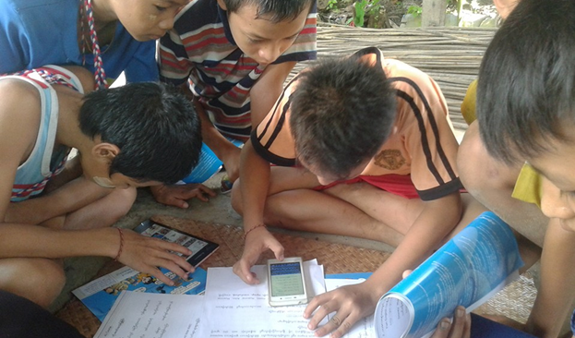*Children using a mobile phone for homework in Myanmar. Photo credit: Telenor*

# Executive Summary

The Lighthouse Digital Literacy program seeks to implement Telenor’s “Internet for All” agenda, and serves people of all ages in rural and urban Myanmar. The program seeks to empower rural and underprivileged communities with basic smartphone-based digital literacy skills through onsite instruction in rural areas and online training. The program seeks to provide affordable employer-recognized professional computer based e-learning digital literacy training, and implement an online “edutainment” training tool, the Digital Lighthouse, to make basic smartphone and professional computer digital literacy training available nationwide. The program adapts to Myanmar’s unique telecommunications environment where smartphone adoption is very high, at 80 percent – outpacing rates of traditional literacy. The program commenced in January 2014 with a projected rollout completion date of December 2018.

*Keywords: digital literacy training, Myanmar, education, rural*

# Context

Myanmar’s telecommunications sector witnessed rapid growth over the past five years. The country’s media censorship law was abolished in 2012, and two international operators were allowed to enter the market in 2014. This led to a boost in mobile phone penetration and Internet usage in the country, as the price of subscriber identification module (SIM) cards fell from US$ 250 to US$ 1.50 within a year. Moreover, smartphone penetration reached 80 percent in 2017, on par with the United States.

Internet use is quite widespread in the country due to the availability and affordability of smartphones, mobile data, and the popularity of social media platforms such as Facebook and Viber. More than 95 percent of the population is currently covered with mobile data access by all three of the country’s mobile network operators as well. Despite high smartphone penetration, digital literacy in Myanmar is low, however, prompting efforts by the government, businesses, and civil society organizations to bridge this gap. A majority of Myanmar smartphone users do not use their smartphones for more than one application due to low levels of digital literacy – in fact, while 66 percent of people in Myanmar own a smartphone, only 34 percent use applications.

|  |  |  |  |
| --- | --- | --- | --- |
| Myanmar | | | |
| Population  (UN, 2015) | 54,164,262 | **Fixed broadband subscriptions (%)**  **(ITU, 2016)** | 0.06 |
| Population density (people per sq.km)  (UN, 2015) | 80.06 | **Mobile cellular subscriptions (%)**  **(ITU, 2016)** | 89.26 |
| Median household income  (Gallup, 2006-2012) | N/A | **Individuals using the Internet (%)**  **(ITU, 2016)** | 25.1 |
| Education  (Mean years of schooling)  (UNDP, 2013) | Male: 3.8  Female: 4.1 | **Individuals using the Internet by Gender (%)**  **(ITU, 2016)** | N/A |

# Project Description

Telenor’s Lighthouse Digital Literacy program aims to build 200 “lighthouses” – digital literacy centers with smartphone and computer-based training and online education. The project provides in-person and hands-on training, and will soon provide online self-learning tools. There are special programs educating children about the safe and effective use of the Internet, and general services for information and communication technology (ICT) users with a variety of needs and a variety of levels of digital literacy. The Myanmar ICT for Development Organization (MIDO) has been working with Telenor to provide the Lighthouse program since January 2014.

The project currently has 61 Digital Lighthouses staffed by 100 trainers. A total of 65 percent of these Lighthouses are outside the most developed states of Yangon, Mandalay, and Naypyidaw. The Lighthouses are permanent spaces for ICT access, training, and assistance that are free or affordably priced to users in Myanmar. They provide roughly three computers per Lighthouse, and ask people to bring their own smartphones for instruction and assistance. They have six training modules for smartphones and four training modules for PCs.

Telenor Myanmar introduced a “Digital Education Project” in June 2016 with the purpose of making primary education accessible for underprivileged, out of school children across the country. This project is in partnership with Monastic Education Development Group (MEDG) with 40 schools in Rakhine, Mon, Kachin, and Shan states, and Tanintharyi, Yangon, Mandalay, Magwe, Bago, Sagaing, and Ayeyarwaddy regions. Furthermore, “Tech Classrooms” were established with Telenor Myanmar’s co-funding and technical support, alongside “Educate a Child” (EAC). Live lessons are delivered from Phaung Daw Oo studio in Mandalay, and broadcasted to all participating schools nationwide. Students study two hours per day and six days per week. The Digital Education Project specifically aims to provide high-quality, non-formal primary education (NFPE) to out-of-school children from 40 schools, and 1,000 students will gain an education equivalent to the government primary curriculum before the end of 2017. The project provides teacher training, financial support, and technical training opportunities to its instructors as well.

|  |  |  |  |
| --- | --- | --- | --- |
| Project details | | | |
| Technology | Online and in-person digital literacy training | **Training** | In-person and hands-on training, and online self-learning |
| Year program started | 2014 | **Cost to users** | Free |
| Geography | Rural | **Total cost of program** | Undisclosed |
| User profile | ~80,000 (~60% of which are female) | **Associated organizations** | MIDO,  Monastic Education Development Group |

# Progress and Results

Telenor assesses progress based on the number of people trained. The Digital Lighthouse Program has trained approximately 80,000 people as of November 2017, and approximately 60 percent are female. They have implemented 61 Digital Lighthouses, 30 percent of which are in rural areas, and 100 trainers staff the lighthouses. The program aims to have 200 Lighthouses in operation by 2018. Telenor began by providing in-person instruction only, but has added online training tools called “Digital Lighthouse” to support their outreach activities.

Outreach efforts include school outreach activities by Telenor volunteers, targeting teachers, parents, and children educating on the safe and effective use of the Internet. They have developed a parental guidebook for Internet safety as well, and online animated videos on responsible Internet use.

# Challenges

**High operational costs** – There are high operational costs for reaching out to rural areas. This presents an obstacle to scaling the scope of the project.

**Lack of access to computers –** According to the latest census, only 3 percent of Myanmar households own computers, compared to the African and Asia-Pacific average of 9 percent and 36 percent, respectively.

# Telenor’s Suggestions for Future Projects

**Digital literacy training should focus on local specificities –** Telenor notes thatdigital literacy programs benefit when tailored to local ICT adoption conditions. In Myanmar, where many have smartphones but few use the apps available for them, digital literacy initiatives with a mobile focus have the most applicability.

**Digital literacy training should accompany smartphone adoption –** In Telenor’s experience, usage among smartphone users is limited to only a few applications; over half of these data service users only used between one and three types of services. Therefore, the general lack of professional computer digital literacy reduces employment prospects for the vast majority of Myanmar’s labor force.

# Sources

Kaung, T.T (2017, July 21) Personal Interview.

Project website: <https://www.telenor.com.mm/pages/Digital-Literacy/332>