ZAYA LEARNING LAB

PROVIDING ICT-BASED TOOLS IN LOW-INCOME SCHOOLS

IN INDIA

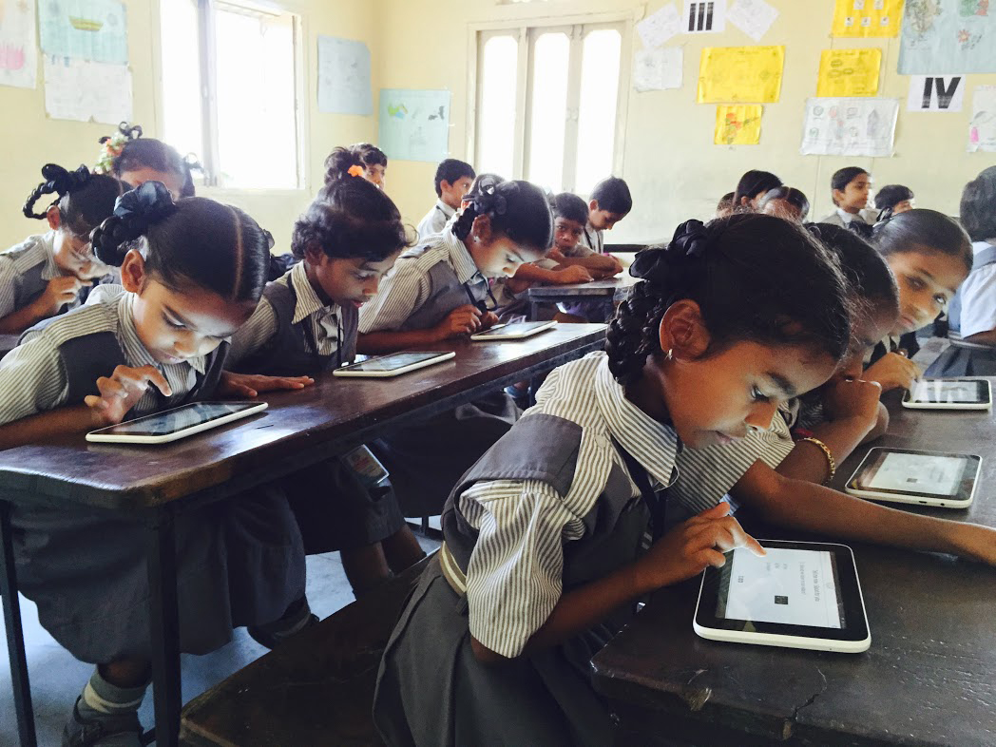*Students using Zaya kits at a school in India. Photo credit: Zaya Learning Lab*

# Executive Summary

Zaya Learning Lab is a non-profit organization providing Wi-Fi access to low-income, English-language schools in India. Established in 2013, their unique learning-focused connectivity devices provide Internet access and educational content at a much lower cost than a regular, open Internet-enabled Wi-Fi connection. Zaya seeks to tailor connectivity solutions to the needs of a specific region, culture, and institution, and leverages technical and person-to-person communication to make Internet access an effective tool for education.

*Keywords: online learning, education, rural, India*

# Context

Zaya Learning Lab is based in Mumbai, India – a city of nearly 19 million people according to the 2011 census. The amount of wired and wireless subscriptions in western India total nearly 35.5 million. A majority of these are mobile broadband (31.9 million). This region also sees stark inequalities in the provisioning of Internet infrastructure. There is no connectivity at all in many rural regions in the surrounding region.

As of 2017, there are more than 900 million Indians without access to the Internet, and Zaya Learning Lab serves schools primarily in these areas. Besides Zaya Learning Lab, other inroads have been made to speed up the deployment of network technologies in unconnected regions. For instance, Google launched an initiative to provide free Wi-Fi hotspots in every railway station in India, while the Indian government unveiled a plan in 2017 to supply free Wi-Fi to more than 1,050 rural villages across the country.

|  |  |  |  |
| --- | --- | --- | --- |
| India | | | |
| Population  (UN, 2015) | 1,282,390,303 | **Fixed broadband subscriptions (%)**  **(ITU, 2016)** | 1.44 |
| Population density (people per sq.km)  (UN, 2015) | 390.11 | **Mobile cellular subscriptions (%)**  **(ITU, 2016)** | 86.95 |
| Median household income (Gallup, 2006-2012) | US$ 3,168 | **Individuals using the Internet (%)**  **(ITU, 2016)** | 29.5 |
| Education  (Mean years of schooling)  (UNDP, 2013) | Male: 5.6  Female: 3.2 | **Individuals using the Internet by Gender (%)**  **(ITU, 2016)** | N/A |

# Project Description

Zaya Learning Lab provides affordable Wi-Fi to low-income Indian schools via a curated secured dynamic device called ClassCloud. This device is both a wireless router and a high-process server. It functions like any cloud service on the Internet, provides a wide-ranging Wi-Fi signal, and runs software all at once. For a yearly fee – roughly the cost of $1 per year per child, in their estimation – Zaya provides interactive and region-appropriate digital content through this device.

This content is based on an educational methodology known as “blended learning,” which harnesses the capabilities of an online classroom in order target students’ individual requirements, education levels, and learning speeds. Not only is the software able to dynamically respond to each student’s progress through a digitized workbook or textbook, but this software is also programmed to communicate student struggles and successes to Zaya and their content providers in order to refine and improve their tools.

Zaya currently has 400 schools spread throughout India subscribing yearly to their service, which reaches about 200,000 children between the ages of 5 and 15. They are currently working on expanding the age range of their software content to 15 and continuing to subscribe additional schools – in and outside of India – to their service.

|  |  |  |  |
| --- | --- | --- | --- |
| Project details | | | |
| Technology | Curated educational tablets with no, semi-, and full connectivity | **Training** | Videos and in-person training (in-person training at extra cost)  WhatsApp-based training with individual teachers |
| Year program started | 2013 | **Cost to users** | US$ 1 per year per child |
| Geography | Rural | **Total cost of the program** | Operational cost: US$ 10,000 per year per school  Internet cost: US$ 450 per year per school |
| User profile | 200,000 students, ages 5-13 | **Associated organizations** | Microsoft,  Pearson |

# Progress and Results

Zaya effectively implemented solutions using diagnostic data analysis to refine the content of its educational software and overcome most of the challenges it faced. They describe their early phase as one focused on data collection and analysis with the goal of creating the most sustainable model possible as they move forward with their development. With confidence in their refined content, implementation methods, and secure networks/devices, they are focused on scaling up to larger and larger numbers of schools that would benefit from their program. Zaya currently has 400 schools subscribed to its program.

In an experiment in which half a class was given the online blended learning tools and the half kept their usual classroom practices, outcomes showed a twofold rate of acceleration in the online group. In addition, Zaya demonstrated that online learning meets previously unaddressed affective and socio-cultural needs in the classroom. Students were shown to be more willing to make mistakes and learn from them in front of a tablet than they were in front of a teacher. Socio-culturally, online learning consciously addresses the specific needs of low-income students who lack the additional support that middle income or wealthy students receive at home.

# Challenges

**Sustaining administrative interest –** Enthusiasm for and interest in online learning by the school’s administration is key to the successful implementation of Zaya’s system. The organization has devised feedback tools (such as fiscal “report cards” showing how much their device has saved a school as compared to a traditional Wi-Fi system), and put effort into communicating the scholastic value of their product. They do this because they have learned that the system cannot relay its benefits effectively without support from a school’s principal. This support, however, cannot always be relied upon. Since the successful implementation of this product involves an effective shift in institutional practices, there is a certain top-down affirmation model needed.

**Lack of widespread connectivity –** Zaya notes that there is an outsider’s myth of easily accessible Internet in India. In fact, infrastructural development for Internet connectivity is not as widespread as assumed. Additionally, in many places in India, a culture of normalizing Internet use has yet to take root. Zaya reports that it is not uncommon for those who have data access on their mobile devices to be uninterested in or afraid of turning it on as well.

**Engaging international aid organizations –** Zaya has effectively partnered with private organizations, such as corporations and nonprofits, but has not yet found a way to involve large-scale aid organizations such as UNESCO or Save the Children in the funding and dissemination of their hardware and content. They are interested in partnering with such groups and are looking for ways to garner their interest and support.

# Zaya’s Suggestions for Future Projects

**Curated content helps learning –** Zaya reports that early attempts to implement open-source Internet access and educational content were unsuccessful as unlimited Internet access was distracting for both students and teachers. In addition, open-source learning software was not effectively translated to the rural lower-income Indian context that the connectivity program targeted. The program’s success lies in its focus on providing schools limited but concentrated access to the Internet. The curated online content, solely intended for educational purposes, made a large impact on classroom learning.

**Classroom impact –** This case demonstrates the positive impact of technology in the classroom. When implemented effectively, online learning has the potential to enhance the level of individual support teachers are able to provide students across the personal developmental and socio-economic spectrums.

**Training and support –** In Zaya’s experience, extensive training and support is necessary in order for its online tools to be efficiently and effectively used in the classroom. Simply providing tools and access (e.g., handing out tablets, installing Wi-Fi, digitizing content, etc.) will not necessary foster better learning outcomes. This support is not limited to how to use the devices and Internet content; it also includes training to face new challenges of classroom management and lesson planning that accompany the introduction of connectivity. This indicates that the more that connectivity is institution-specific and results-oriented, the more training, communication, and technical support will likely be needed for its users.

# Sources

D’Souza, N. (2017, Project website: <https://zaya.in/>

Project videos: <https://www.youtube.com/watch?v=B-wdvyDieUg>

<https://www.youtube.com/watch?v=EYDgQhMXlOM>

Zaya Learning Lab. (2013). From rote to blended: How low-cost private schools in India are spearheading innovation with limited resources. Available at: <https://plp.zaya.in/wp-content/uploads/2013/06/Case-Study_Rote_to_Blended.pdf>