KEDESA.ID

PROVIDING VILLAGE LAW E-GOVERNMENT SERVICES

IN INDONESIA

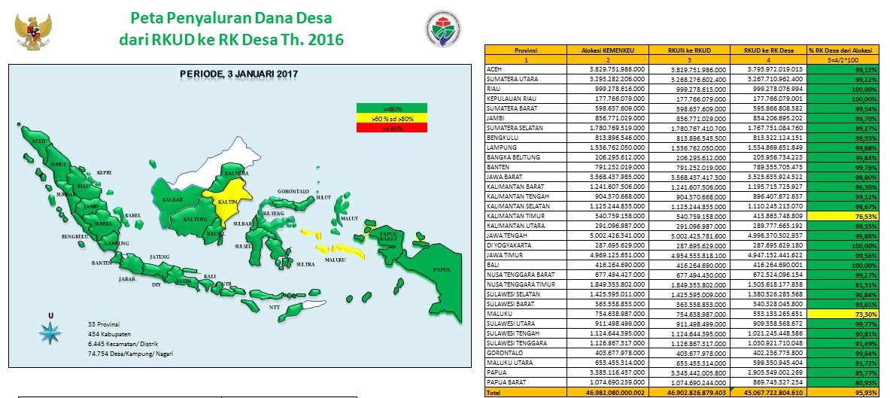*Kedesa portal map and interface. Photo credit: Kedesa.id*

# Executive Summary

Kedesa is a web-based e-government platform developed and implemented nationally across Indonesia. The platform is implemented by the nonprofit research organization PATTIRO. Launched in July 2016, the project’s purpose is to enable stakeholder participation to monitor local government and implementation of the Village Law through online discussion and information exchange. Kedesa.id is an online portal integrating four platforms: a blog, a wiki, a document repository, and a discussion forum. The blog contains short articles on the implementation of laws by users. The wiki provides an annotated version of the law that the users can contribute to. The repository hosts documents related to the implementation of village governance, including policies, reports, and studies on the practice of village governance. The forum serves as an online interactive discussion medium.

Keywords: e-government, multi-channel portal, Indonesia

# Context

Indonesia aspires to become a “just and democratic, and peaceful and united” country, according to the National Long-Term Development Plan (2005-2025). The National Medium-Term Development Plan of 2015-2019 aims to implement a clean, effective, democratic, and reliable government. Information and communications technologies (ICTs) are recognized by the government as an important means to attain this goal. As such, Indonesia has made significant efforts to expand the network and improve Internet use across the country.

The Village Law enacted in 2014 is a significant piece of legislation to come into force since Indonesia commenced its decentralization process in 2001. The law requires the central government to allocate funding annually to Indonesia’s 74,093 villages to enable local self-government. Local governments are in the process of adjusting to this decentralized government approach. For communities not used to participating in decision-making processes, communication among all the stakeholders is crucial to an inclusive, democratic government.

|  |  |  |  |
| --- | --- | --- | --- |
| Indonesia | | | |
| Population  (UN, 2015) | 255,708,785 | **Fixed broadband subscriptions (%)**  **(ITU, 2016)** | 1.89 |
| Population density  (people per sq.km)  (UN, 2015) | 134.26 | **Mobile cellular subscriptions (%)**  **(ITU, 2016)** | 149.13 |
| Median household income  (Gallup, 2006-2012) | US$ 2,199 | **Individuals using the Internet (%)**  **(ITU, 2016)** | 25.4 |
| Education  (Mean years of schooling)  (UNDP, 2013) | Male: 8.1  Female: 6.9 | **Individuals using the Internet by Gender (%) (ITU, 2016)** | N/A |

# Project Description

Kedesa is an online platform to promote stakeholder participation and improve communication regarding the implementation of Village Law between the Village Ministry and Ministry of Home Affairs, the district government, village heads, implementers, the representative council of a village, village facilitators, and residents. Kedesa is a project of PATTIRO, a research and advocacy organization established in 1999 to help promote transparency and equitable governance in Indonesia. PATTIRO assists the community in conducting advocacy with the central and local government to encourage policy reform as well as public service and public finance management improvement.

The Kedesa platform integrates four platforms. A wiki provides users with information on the law and enables real-time collaborative contributions to maximize its readability. An online discussion platform allows users to discuss and exchange information on village development and related issues. A blog encourages users to write a personal journal on their views on topics related to the Village Law and village development. The website [www.kedesa.id](http://www.kedesa.id) also functions as a data repository for legislative and regulatory documents. This enables village stakeholders to access, cite, download, and share data.

The project was developed to combat corruption, provide greater autonomy, and create a discussion platform for multiple stakeholders. Since Internet availability in villages is low, the project is complemented by an offline platform for discussion among the stakeholders to raise awareness and overcome infrastructure challenges. Kedesa also facilitates a WhatsApp group of 160 participants and uses social media platforms for promotion.

|  |  |  |  |
| --- | --- | --- | --- |
| Project details | | | |
| Technology | Online platform including wiki, blog, repository, and forum | **Training** | Not available |
| Year program started | 2016 | **Cost to users** | Free to users |
| Geography | Urban and rural | **Total cost of program** | Fixed cost: US$ 7,400 |
| User profile | Villagers, local and central government officers | **Associated organizations** | Institute of Development Studies at Sussex University,  MAVC,  PATTIRO,  USAID |

# Progress and Results

As of 2017, Kedesa serves 74,000 villages, 34 provinces, and 530 district governments.

Kedesa seeks to be a feedback mechanism and platform for multi-channel communication between the various parties to Village Law. This requires strategic and innovative use of communication methods and media. Infrastructural challenges have presented major obstacles to the implementation of an online platform as several villages do not have Internet access yet, and information dissemination outside of the government structure is difficult.

While Kedesa was widely adopted initially during the rollout period, public reporting, and adoption has dwindled. Efforts to augment the Kedesa online platform with offline face-to-face meetings and discussion forums that seek to restore communication, but it is not clear that those meetings translate back into increased online adoption. This may be due to insufficient awareness since media channels have different adoption rates, and advertising for Kedesa has been uneven across them. It could also potentially be due to disillusionment about government transparency and/or dissatisfaction with efficacy of their participation in government.

# Challenges

**Lack of infrastructure –** Lack of Internet connectivity presents a major obstacle to substantial online participation. The organization reports that face-to-face discussions were successful in getting multiple stakeholders to discuss village-related issues in ways that the online platform has not yet been able to replicate.

**Lack of village level contributors –** PATTIRO continues to face a challenge in increasing community participation in the online platform to form an effective feedback loop.

**Uneven investment across stakeholders and a lack of ministerial support** **–** Ministry media channels have been resistant to publicizing and utilizing the Kedesa platform, hampering its outreach to villages where this is the main mode of communication.

# PATTIRO’s Suggestions for Future Projects

**Online platforms require offline service complementation for e-governance services –** Formal and informal offline discussions help augment the adoption and use of Kedesa, and the implementation of the community insights expressed online.

**Stakeholder identification and communication for outreach plays a role in ensuring success –** Key stakeholders, their roles and responsibilities in the feedback loop mechanism as well as knowledge and involvement, can help make the system more relevant and effective.

# Sources

Rostanty, M. (2017, September 21) Personal Interview

Project website: <http://kedesa.id/id_ID/>