Infolady Social Enterprise Limited- iSocial

PROVIDING ICT-ENABLED SERVICES FOR WOMEN, CHILDREN AND ADOLOSCENTS

IN RURAL BANGLADESH

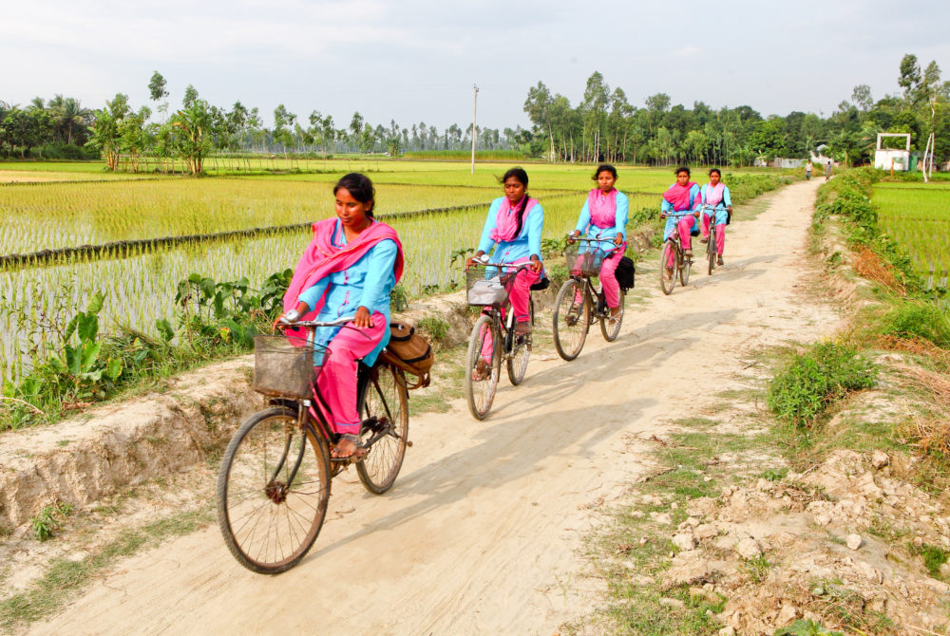

*Photo credit: iSocial*

# Executive Summary

Infolady Social Enterprise Limited (iSocial), began as a project of Dnet, a Bangladesh-based social enterprise in 2004. iSocial developed the Kallyani model (as known as Infolady), a last-mile women-to-women business network that features young women entrepreneurs known as Kallyani (‘Woman who brings wellbeing’ in Bengali) to provide products and services to rural households from a wide range of arenas including sexual and reproductive health, nutrition, adolescent, primary healthcare, agriculture, legal and social safety net entitlement benefits services, data and connectivity. iSocial deployed the original form of its current Kallyani model in Bangladesh in 2010, where young educated women from poor rural communities pays nominal investment which includes their license fee, working capital, and equipment packages from local franchisee ‘Hubs’ in their sub-district, with preferential loans from National Bank Limited. They receive in-depth training in entrepreneurship, sales, and accounting, as well as technical instruction in how to provide simple healthcare services such as blood pressure measurements, diabetes measurement, pregnancy tests, utilizing video chat on laptops, and birth registration proceedings, as well as how to contact iSocial experts if clients have questions or needs beyond what they can provide. Also, they are trained to conduct several agri and poultry related services like cattle vaccination, services on horticulture and aquaculture, fisheries etc. iSocial also provides them with a bicycle and uniform ( Consisting of a branded apron, a cap and a badge) with which they can travel to local villages to sell their services. Local community members in turn pay affordable prices for services they need, generating an income for Kallyanis and their household, and challenging restrictive gender roles that otherwise constrain women’s empowerment in rural Bangladesh. As of a 2015 interim impact evaluation, Kallyanis had overseen over 500,000 sales transactions, generating on average a monthly income of $100-125 USD. The kallyani model is already being replicated globally and “Fanm Powgre” (Kallyani in Haitian language) in Haiti is the first of its kind. iSocial is also planning to replicate this model in Nepal.

*Keywords: ICT-based training, women, Bangladesh*

# Context

The majority of Bangladeshis do not have access to the Internet, and this limitation is particularly pronounced in the country’s rural areas. Bangladesh is a populous country, but a majority of Bangladeshis (over 100,000,000) live outside major cities. These communities in particular are deprived of the valuable resources ICT has to offer: information about improved agricultural practices, information on nutrition and hygiene, grooming on adolescent SRHR (Sexual and reproductive health rights), access to health and medical services, Right to information acts, government benefits they are entitled to and how to collect them, legal aid and resources, and channels for communicating with family working abroad.

At the same time, women in Bangladesh face many obstacles and limitations. The average age of marriage for women is 16.4 years old, and on average women receive only 4.6 years of schooling. Particularly in rural areas, the woman is expected to remain at home manage the household while the husband leaves for work and manages finances. Rates of domestic violence are high, and in some areas, women’s physical mobility is strictly limited: for example, they are pressured to not leave the house, whether to travel between villages or visit a health center. The context of adolescent women are more severe. Every 1 in 5 people in Bangladesh is adolescent and only one in ten adolescents are aware of sexual and reproductive health and hygiene. One in three girls get married before they reach 18 and half of them get pregnant. Although nationwide Bangladeshi women have made strides entering the agricultural and garment industries, it is very rare for women to be employed in other fields.

In response to this information and connectivity shortfall, the government of Bangladesh has played a major role promoting ICT sector growth. Initiatives include a2i, or Access to Information - Bangladesh, which has incorporated more digital resources into the classroom for students and increased support for digital entrepreneurs. The government of Bangladesh has also reaffirmed the key importance of citizens’ access to information, and how empowering this knowledge can be, via the Right to Information Act 2009 (RTIA). The RTI Act guarantees Bangladeshis’ legal rights to public information about government organizations, their operations, how to collect benefits, and so on.

|  |  |  |  |
| --- | --- | --- | --- |
| Bangladesh | | | |
| Population  (UN, 2015) | 160,411,249 | **Fixed broadband subscriptions (%)**  **(ITU, 2016)** | 3.77 |
| Population density (people per sq.km)  (UN, 2015) | 1,113.98 | **Mobile cellular subscriptions (%)**  **(ITU, 2016)** | 77.88 |
| Median household income  (Gallup, 2006-2012) | US $2,819 | **Individuals using the Internet (%)**  **(ITU, 2016)** | 25.4 |
| Education  (Mean years of schooling)  (UNDP, 2013) | Male: 5.6  Female: 4.6 | **Individuals using the Internet by gender (%) (ITU, 2016)** | N/A |

# Project Description

Dnet, a not-for-profit Social Enterprise, launched the Infolady model back in 2004 to test and shape the modern women social entrepreneur model. The first iteration was comprised of ‘rural information centers’, outposts containing a computer with preloaded content on agriculture, health, and legal aid. The information was mostly audio-visual to make it accessible to non-literate individuals, and the center was staffed to help rural Bangladeshis operate the computer as well. However, in their impact evaluation of the original pilot, iSocial found that only men came to use the centers due to different social barriers and cultural norms, the main target group of this project who were the women, somehow were left unreached. In response, Dnet developed a business model in 2010 that would bring last-mile connectivity to rural Bangladeshi women and to marginalized community, as well as empower Bangladeshi women to become entrepreneurs, challenging traditional gender roles. This model was called ‘Infolady’. Later in 2016, Dnet launched a for profit social enterprise iSocial (Infolady Social Enterprise Limited) to run the Infolady model as a social enterprise.

iSocial, a social enterprise in Bangladesh comes right on the scene with a country-wide network of women change agents called Kallyani for delivery of critical strategically important behavioral change communications, relevant services and products for addressing various needs and challenges adolescent girls face.

The Kallyani model (previously called as Infolady) trains rural impoverished women in entrepreneurship and one of five specialization areas: information, health, agriculture, adolescent, nutrition as well as e-commerce, mobile banking, internet use, and other digital services. iSocial provides women uniforms, bicycles to travel from village to village, a tablet PC, health equipment, products to sell, and other durables. Kallyani can receive loans with preferential terms from National Bank, Banladesh, one of iSocial’s partners, to purchase their equipment and training. Kallyani then sell their services for an affordable price to community members who need them, and generate an income for themselves and their household.

Kallyani are trained in entrepreneurship and e-commerce based on content that iSocial has developed. Agricultural and medical technical training (including scope of practice and patient privacy) is conducted by local government officials, experts and doctors. Training incorporates Kallyani’s tablet PC, including pre-loaded audiovisual content for trainees to review on their own. Kallyani also interact with ‘clients’ in simulated scenarios and are evaluated before graduating from the program and becoming certified. Each woman serves a catchment area of 3-4 square kilometers covering 400 households on an average working as many hours per day as she is able. A typical Kallyani is a woman between the ages of 18-35, with at least some secondary education. She provides services in three ways: door-step services to rural community, by way of activation/campaign/at school, at their home to thematic customer groups composed of farmers, women, or adolescents. As of 2018, there are 464 Kallyanis working in 09 districts across Bangladesh.

|  |  |  |  |
| --- | --- | --- | --- |
| Project details | | | |
| Technology | Tablet PC, medical equipment, mobile internet, | **Cost to users\*** | USD $0.13 - $1.30 per service |
| Year program started | 2010 | **Training** | 12-days months training program in entrepreneurship and one of four specialized areas: information, agriculture, health and adolescents |
| Geography | 09 districts, primarily in north, western and central Bangladesh | **Total cost of program\*\*** | Fixed cost: 20,000 BDT (USD $240) |
| User profile | Women in rural areas | **Associated organizations** | ICT Division of Bangladesh,  Manusher Jonno Foundation,  National Bank Limited,  USAIDSPRING Accelerator |

*Cost to rural clients to purchase services from Kallyani.

**Cost to Kallyani to purchase equipment and licensing from iSocial and their working capital.

# Progress and Results

iSocial’s 2015 interim qualitative impact evaluation found that Kallyani were empowered, well-accepted in their communities, and earned between USD $100-150 per month on average. Kallyani are particularly empowered within a familial context, to provide input to household consumption decisions, decisions relating to marriage, education and healthcare. They also demonstrated improved access to economic empowerment, including increased income generating opportunities, and business tools and technologies. Finally, Kallyani also experienced improved socio-cultural abilities, to move freely throughout their villages, interact with different members of their communities, and transform social-cultural belief and practice.

Services Kallyani offer include blood pressure readings, blood glucose monitoring, blood group testing, pregnancy tests, diabetes measurement, antenatal health care, video chat, Internet browsing, audio-visual recording, agricultural information, cattle and poultry vaccination, product sales, and birth registration. Of these, health care services like blood pressure and blood sugar monitoring, and video chatting are the most popular. Blood pressure measurements cost about USD $0.13, and video chatting about $1.30 per hour.

On average, Kallyanis work 4-5 hours per day, engaging in 5-15 service transactions, traveling about 9km by bicycle. When iSocial surveyed Kallyanis’ clients, they found that client satisfaction with the services provided was 8 out of a scale of 10, and customer satisfaction with the Kallyani herself 9 out of 10. Clients in particular enjoyed the affordability of services, quality of equipment, and the empathy and open-mindedness with which services were provided. Over all, over 500,000 service transactions were made by the 102 Kallyani included in the impact evaluation, from 2010 to 2015.

iSocial has been working to deploy a similar program in Haiti since 2016, and is also beginning to work in Nepal.

# Challenges

**Resistance from male relatives and local opinion leaders to women traveling by bicycle.** Some rural Bangladeshi residents believe it is inappropriate for women to travel around different villages, especially by bicycle. iSocial responded to this pushback by engaging local government officials supportive of ICT empowerment, local law enforcement authority, encouraging more progressive opinion leaders to speak on the subject, and holding ‘bicycle campaigns,’ where it encouraged school-children to ride bikes (more socially acceptable). iSocial says that the Kallyanis have personally not been deterred.

**Licensing and fees an important part of social enterprise model, but a barrier to entry for some.** Each Kallyani at the end of her training receives an official license from iSocial and the local government affirming her competence to provide her services. This is important to maintain clients’ confidence in their service providers. Kallyanis must also invest BDT 15,000 for their license, working capital and equipment, which is a crucial component of making iSocial a self-sustaining social enterprise. Even with preferential loan terms, this cost is a barrier to entry for some potential Kallyanis. Though the business potential is higher than any other small business.

**Scaling product partnerships with local companies.** iSocial is working to partner with local companies to provide their products and services to Kallyani to sell, effectively reaching more of the “bottom of the pyramid” market. However, given current delivery costs to rural areas, there are not enough Kallyani to make this profitable for many businesses. iSocial anticipates this problem will improve once the number of Kallyanis in Bangladesh is scaled up. iSocial is also working towards scaling up the number of kallyanis to 20,000 by end of 2021.

# iSocial’s Suggestions for Future Projects

**Opportunities to collect market data on bottom-of-the-pyramid populations.** Because Kallyanis are well-integrated with the communities they serve, Kallyani model represents an opportunity to collect and disseminate data on rural communities’ consumption habits and preferences. This is valuable information for both local and international companies trying to expand their market share, but also for development firms and NGOs.

**Remaining flexible, incorporating new technology, products and services as they become available is key.** The Kallyani model began by supplying entrepreneurs with only mobile phones, when mobile phone penetrance was low and internet connection in rural areas of Bangladesh was impossible. When internet connectivity become reality, Kallyanis’ hardware and software evolved to match, something iSocial identifies as a key cause for success. Similarly, the model began just by providing ICT services, but after a community needs assessment, branched out into health and agricultural services. Recently, there has been increased demand for agricultural products: seeds, fertilizer and non-toxic pesticides, which iSocial is working to supply to customers.

# Sources

Pulak, S. (2018, June 26). Personal interview.

*Project website:* [*http://isocial.com.bd/*](http://isocial.com.bd/)dnet.org.bd